**Preparing for Algebra and Statistics *(3rd Edition)***

**Appendix A - Answer Keys for Chapters 1-7**

**Chapter 1 Answers**

**1A**

1. 70 3. 122 5. 360 7. 770 9. 354 11. 804  
13. 1,327 15. 187 17. 174 19. 7,548 21. 2,811 23. 1,863  
25. 555 27. 559 29. 4,958 31. 454 33. 27,204 35. 428  
37. $608 39. $2,848 41. 5,464 43. $8,141 45. 72 ft 47. 408 ft  
49. $619 51. $1,153

**1B**

1. 52 3. 266 5. 240,000 7. 1,896   
 9. 17,639 11. 120,420 13. 104,468 15. 65,888   
17. 52,800,000 19. 1,512 21. 3,915 23. 3,600,000  
25. 152,306 27. 16,040 29. 934 31. 574   
33. 9,734 35. 64,800,000 37. 81 39. 36   
41. 32 43. 169 45. 625 47. 0  
49. 112 51. 180 53. 2,125 55. 96 in  
57. 452 ft 59. 1,440 cubic in 61. 512 cubic mm 63. $870  
65. 78 pounds

**1C**

1. 17 3. 0 5. Undefined 7. 2,635   
 9. 1 11. 0 13. Undefined 15. 382  
17. 0 19. 11 R 2 21. 7 R 6 23. 8 R 1  
25. 3 R 11 27. 187 29. 70 31. 16 R 3  
33. 266 R 10 35. 384 R 8 37. 30 R 8 39. 192 R 13  
41. 44 R 24 43. 59 R 3 45. 153 R 117 47. 17 ft  
49. 5 mo R $710 51. 9 days R $1 53. 7 (unusual) 55. 3 (unusual)

**1D**

1. 1 3. 4 5. 7 7. 5 9. 10 11. 11  
13. 20 15. 12 17. 30 19. 50 21. 70 23. 53  
25. 61 27. 154 29. 208 31. 39 33. 42 35. 50  
37. 1 39. 4 41. 5 43. 15

**Chapter 1 Review**

1. 94 3. 1,447 5. 1,516 7. 113   
 9. 649 11. 412 13. 108 15. 12,000   
17. 9,600,000 19. 4,745 21. 3,552 23. 86,670  
25. 0 27. 234 29. 48 R 1 31. 16  
33. 13 35. 5 37. 11 R 1 39. 1  
41. 55 43. 196 45. 4 47. 11  
49. 30 51. 2 53. 6 55. $70  
57. $10,603 59. 1,728 sq in 61. 11 63. 13

**Chapter 2 Answers  
  
2A**

1. 0.082 3. 0.0099 5. 0.05 7. 0.378   
 9. 0.0058 11. 0.00175 13. 0.78 15. 9.6  
17. 0.587 19. 1.4 21. 73 23. 0.1  
25. 3.7451 27. $359.02 29. $75 31. $482  
33. 0.335 35. 4 37. 1.294 39. 17.628  
41. 13.8369 43. 17.338 45. 116.003 47. 16.4017  
49. 0.528 51. 9.45 53. 4.419 55. 2.831  
57. 3.553 59. 0.262 61. 0.628 63. 15.452  
65. 29.725 67. 8.203 69. $82.37 71. $2168.23  
73. 4.5 mi 75. 62.7 in 77. 21.2 79. $12.48  
81. $1176.21

**2B**

1. 3.8 3. 2183 5. 456 7. 1290   
 9. 3.58 11. 5.7 13. 336 15. 3.791  
17. 1,000,000,000 19. 4,538,000,000 21. 721,680,000 23. 48,600,000,000  
25. 88,462,000 27. 3,096,000 29. 0.00084 31. 14  
33. 0.00168 35. 0.000102 37. 2.294 39. 0.2508  
41. 0.5588 43. 0.216 45. 0.0336 47. 0.0016  
49. 3.61 51. 0.0081 53. 0.11767 55. 0.07168  
57. 0.00064 59. 6.1544 sq mm 61. 26.4074 63. $100,814.40  
65. 1.728 cu cm 67. 55.3896 cu ft

**2C**

1. 0.0198 3. 0.00051 5. 0.0317 7. 0.138   
 9. 0.72 11. 0.557 13. 0.799 15. 0.07851  
17. 0.00000558 19. 0.43 21. Undefined 23. 0.0361  
25. 32.55 27. 0.007 29. 99.428 31. 0.007  
33. 0.138 35. 0.5425 37. 0.09 39.    
41. 0.154375 43. 1.85 45. 12,000 47.    
49.  51. 0.375 53. 0.12 55. 0.0625  
57.  59. 17 mo 61. 117 pills, yes, 2.96 mg left over   
63. 1.56 65. 

**2D**

1.  3.  5.  7.    
 9.  11.  13.  15.   
17.  19.  21.  23.    
25.  27.  29.  31.    
33.  35.  37. 1,480 39. 4,975,000,000  
41. 0.0925 43. 76,000 45. 2,590,000 47. 0.0315  
49. Small numbers have a negative exponent. Large numbers have a positive exponent.  
51. 0.000003578 , smaller 53. 227,900,000 km 55.    
57. In scientific notation the first number must be between 1 and 10. (0.08 is not)

**2E**

1. 4 3. 1 5. 2 7. 4   
 9. 3 11. 5 13. 6 15. 3  
17. 3 19. 3 21. 4 23. 2  
25. 5 27. 5 29. 1 31. 11.0  
33. 3.1 35. 77.99 37. 20 39. 2.64  
41. 231 43. 54.9 45. 199 47. 1.13  
49. 1.9 51. 10 53. 1.4 55. 4.5  
57. 940 59. 4,000 61. 3 63. 6,000

**2F**

1. 1.7 or 1.8 3. 7.2 or 7.3 5. 8.8 or 8.9 7. 4.7 or 4.8   
 9. 9.7 or 9.8 11. 6.1 or 6.2 13. 9.8 or 9.9 15. 6.6 or 6.7  
17. 4.2 or 4.3 19. 4.8 or 4.9 21. 11.7 or 11.8 23. 8.1 or 8.2  
25. 9.1 27. 9.9 29. 12.1 31. 2.3 or 2.4  
33. 2.9 35. 9.2132 37.  39. 11.27  
41. 0.5717 43. 0.650232 45. 2.6 or 2.7 47. 2.7 or 2.8  
49. $6,050

**2G**

1. Mean = 83.46 3. Mean = $7.87   
 Median = 87.4 Median = $7.95   
 Range = 24.8 Range = $1.70

5. Mean = 8.18 7. Mean = 16,453.56 sq km  
 Median = 8.0 Median = 13,957.1 sq km  
 Range = 11.5 Range = 30,971.3 sq km

9. Mean = 709.47 kilowatt hours 11. Mean = 87.85  
 Median = 623.15 kilowatt hours Median = 87.75  
 Range = 737.1 kilowatt hours Range = 13.3

13. Mean = $943.28 15. Mean = 275.38 pounds  
 Median = $832.93 Median = 262.25 pounds  
 Range = $942.55 Range = 90.5 pounds

17. Mean = $1125.76 19. Mean = 95.179 cents  
 Median = $824.75 Median = 96.01 cents  
 Range = $1925.01 Range = 21.17 cents

**Chapter 2 Review**

1. 3.015 3. 10.168 5. 65.775 7. 11.69  
11. 0.412 13. 11.4 15. 121.5 17. 84  
19. 46.8 21. 0.3552 23. 8.64 25. 0  
27. 0 29.  31. 0.9 33. 1.83  
35. 5.3 37. 0.4675 39. 0.0196 41. 0.07  
43. 1.4 45. 1.380 47.  49. 11,600,000  
51. 6 53. 21.4 55. 20 57. 9.2 or 9.3  
59. 3.7 61. 4.9 63. 17.28 sq in 65. 10.2  
67. $2142.45 69. Mean = $3.20 , Median = $3.17 , Range = $1.04

**Chapter 3 Answers**

**3A**

1.  3.  5.  7.    
 9.  11.  13.  15.    
17.  19.  21.  23.    
25.  27.  29.  31.    
33.  35.  37.  39.    
41.    
43. Each whole is broken up into 5 parts. If we have a total of 13 parts, it will make 2 whole with 3 parts left over.

45. Each whole is broken up into 7 parts. If we have a total of 31 parts, it will make 4 whole with 3 parts left over.

47. Each whole is broken up into 10 parts. If we have a total of 97 parts, it will make 9 whole with 7 parts left over.

**3B**

1.  3.  5.  7.    
 9.  11.  13.  15.    
17.  19.  21.  23.    
25.  27.  29.  31.    
33.  35.  37.  39.    
41.  43.  45. 

**3C**

1. 0.75 3.  5.  7. 0.875   
 9.  11. 0.44 13.  15.    
17.  19. 9.5 21.  23.    
25. 14.21875 27.  29.  31.    
33.  35.  37.  39.    
41.  43.  45.  47.    
49.  51.  53.  55.    
57.  59.  61.  63. 

**3D**

1.  3.  5.  7.    
 9.  11.  13.  15.    
17.  19.  21. 30 23.    
25.  27.  29.  31.   
33.  35. 21,060 children 37. $2,050 39. 8,448 cu cm  
41. 616 ft

**3E**

1. 14 3.  5.  7.    
 9.  11.  13.  15. 

17.  19. 4 21.  23.    
25. 35 27.  29.  cup sugar 31.  cups sugar  
33. 7 cups cocoa 35. 120,000 cu ft

**3F**

1. 39 in 3. 3,200 g 5.  gal 7. 7,500 pounds  
 9. 26.67 cm 11. 40 mph 13. 2,468 mg 15. 7 kg  
17. 49.6 mph 19.  yd 21. 5.6 L 23. 29 cups  
25.  ton 27. 0.2159 m 29. 95.55 fps 31. 23.32 pounds  
33. 207 in 35. 72.88 fps 37. 574 ft 39. 25 CC per min

**3G**

1. 1 3.  5.  7.    
 9.  11.  13.  15.    
17.  19.  21.  23. 

25.  27.  29.  31.    
33.  35.  37.  39. 

41.  43.  pound sugar 45.  inch

**3H**

1.  3.  5.  7.    
 9.  11.  13.  15.    
17.  19.  21.  23.    
25.  27.  29.  31.    
33.  35.  Liter

**Chapter 3 Review**

1.  3.  5.  7.    
 9.  11.  13.  15.    
17. 0.1875 19. 4.68 21.  23.    
25.  27.  29. 24 31.    
33.  35.  37.  39.    
41.  43.  45. 6 in 47. 80 kph  
49. 0.5645 g 51. $184 53. 14 cups flour

**Chapter 4 Answers**

|  |  |  |  |  |  |  |  |  |  |  |  |  |  |  |
| --- | --- | --- | --- | --- | --- | --- | --- | --- | --- | --- | --- | --- | --- | --- |
| **4A** |  |  |  |  | |  | | |  |  |  | |  | |
| 1. | negative | 2. | negative | 3. | | positive | | | 4. | negative | 5. | | positive | |
| 6. | negative | 7. | negative | 8. | | positive | | | 9. | positive | 10. | | negative | |
| 11. | negative | 12. | negative | 13. | | positive | | | 14. | 7 | 15. | | 12 | |
| 16. | 17 | 17. | 18 | 18. | | 23 | | | 19. | 16 | 20. | | 8.5 | |
| 21. | 7.44 | 22. | 2.9 | 23. | | 19 | | | 24. | 32 | 25. | | 49 | |
| 26. | $5\frac{1}{4}$ | 27. | $7\frac{2}{5}$ | 28. | | $9\frac{1}{8}$ | | | 29. | 5.7 | 30. | | $2\frac{3}{4}$ | |
| 31. | 5.913 | 32. | -22 | 33. | | -3.5 | | | 34. | -6.25 |  | |  | |
|  |  |  |  |  | |  | | |  |  |  | |  | |
| **4B** |  |  |  |  | |  | | |  |  |  | |  | |
| 1. | -19 | 2. | -6 | 3. | | -22 | | | 4. | -2 | 5. | | -15 | |
| 6. | 0 | 7. | -28 | 8. | | -25 | | | 9. | -56 | 10. | | -15 | |
| 11. | -40 | 12. | 33 | 13. | | -62 | | | 14. | -25 | 15. | | -71 | |
| 16. | 0 | 17. | -135 | 18. | | -787 | | | 19. | -8.31 | 20. | | -1.74 | |
| 21. | -1.029 | 22. | -9.39 | 23. | | -16.31 | | | 24. | 0.1803 | 25. | | - | |
| 26. | $\frac{23}{35}$ | 27. | - | 28. | | $3\frac{5}{12}$ | | | 29. | - | 30. | | - | |
| 31. | $62 loss | 32. | -9 $℉$ | 33. 61 ft below  sea level | | | | 34. 21 $℉$ | | | 35. | | $5,607 | |
| 36. | -9 | 37. | $514.30 |  | |  | | |  |  |  | |  | |
|  |  |  |  |  | |  | | |  |  |  | |  | |
| **4C** |  |  |  |  | |  | | |  |  |  | |  | |
| 1. | -6 | 2. | -18 | 3. | | 1 | | | 4. | 13 | 5. | | -6 | |
| 6. | 20 | 7. | -9 | 8. | | -23 | | | 9. | 0 | 10. | | -9 | |
| 11. | -27 | 12. | 0 | 13. | | -20 | | | 14. | -5 | 15. | | 7 | |
| 16. | 29 | 17. | 4 | 18. | | -9 | | | 19. | -40 | 20. | | -88 | |
| 21. | 0 | 22. | -15 | 23. | | -37 | | | 24. | 0 | 25. | | -0.109 | |
| 26. | $-\frac{5}{6}$ | 27. | 3.09 | 28. | | $\frac{13}{40}$ | | | 29. | -2.37 | 30. | | - | |
| 31. | The second diver is 13 feet deeper than the first. | | | | | | | |  |  |  | |  | |
| 32. | Mt. Everest is 8,934 meters taller than Death Valley. | | | | | | | | 33. | Mark lost $38 more than Ryan. | | | | |
| 34. | Aria’s electric bill is $39 more for July than that for June. | | | | | | | | | |  | |  | |
| 35. | 496 degrees | 36. | - 9 $℃$ | 37. | | -$13,699 | | | 38. | -53 points |  | |  | |
|  |  |  |  |  | |  | | |  |  |  | |  | |
|  |  |  |  |  | |  | | |  |  |  | |  | |
| **4D** |  |  |  | |  | |  | |  |  |  | |  | |
| 1. | -14 | 2. | 65 | | 3. | | -96 | | 4. | -48 | | 5. | | -99 |
| 6. | 42 | 7. | -5 | | 8. | | 7 | | 9. | 0 | | 10. | | 0 |
| 11. | -3 | 12. | -5 | | 13. | | -96 | | 14. | undefined | | 15. | | 9 |
| 16. | -135 | 17. | 240 | | 18. | | -84 | | 19. | -175 | | 20. | | -161 |
| 21. | 420 | 22. | -5 | | 23. | | 16 | | 24. | 0 | | 25. | | 0 |
| 26. | -4 | 27. | -137 | | 28. | | -76 | | 29. | undefined | | 30. | | 212 |
| 31. | -6.12 | 32. | $-\frac{1}{6}$ | | 33. | | 0.0645 | | 34. | -11.4 | | 35. | | $-\frac{1}{6}$ |
| 36. | 0.168 | 37. | 15 months | | 38. | | -27 $℉$ | | 39. | 12.5 hours | | 40. | | -18 |
| 41. | -$50,000 per month | 42. | $x=3.3665$ | | 43. | | $x=53.156$ | | 44. | $$x=-10.8$$ | |  | |  |
|  |  |  |  | |  | |  | |  |  |  | |  | |
| **4E** |  |  |  | |  | |  | |  |  |  | |  | |
| 1. | -81 | 2. | -16 | | 3. | | 144 | | 4. | 16 | 5. | | -216 | |
| 6. | -400 | 7. | -8 | | 8. | | 100 | | 9. | -64 | 10. | | -1 | |
| 11. | -343 | 12. | 169 | | 13. | | 81 | | 14. | -64 | 15. | | -125 | |
| 16. | 10,000 | 17. | -225 | | 18. | | -36 | | 19. | 5 | 20. | | -48 | |
| 21. | 3 | 22. | 209 | | 23. | | -5 | | 24. | -9 | 25. | | -42 | |
| 26. | -4 | 27. | 24.8 $℉$ | | 28. | | 8.6 $℉$ | | 29. | -3 $℃$ | 30. | | -19 $℃$ | |
| 31. | $14,660 | 32. | Lose $3887.20 | | 33. | | $19780 | | 34. | Made $1,600 | 35. | | -4 yards | |
| **Chapter 4 Review** | |  |  | |  | |  | |  |  |  | |  | |
| 1. | negative | 2. | negative | | 3. | | positive | | 4. | positive | 5. | | negative | |
| 6. | 11 | 7. | 24 | | 8. | | 19 | | 9. | -55 | 10. | | -5.5 | |
| 11. | -9 | 12. | 403 | | 13. | | -2.5084 | | 14. | $-\frac{3}{4}$ | 15. | | -30 | |
| 16. | 23 | 17. | 0 | | 18. | | -9 | | 19. | -17.3 | 20. | | -1 $\frac{3}{8}$ | |
| 21. | -108 | 22. | 36 | | 23. | | -4.68 | | 24. | -16 | 25. | | -0.099 | |
| 26. | 0 | 27. | 0 | | 28. | | - 0. $5\overline{3}$ or - $\frac{8}{15}$ | | 29. | $-\frac{7}{10}$ | 30. | | 2.39 | |
| 31. | undefined | 32. | 0.91 | | 33. | | -169 | | 34. | 16 | 35. | | -34 | |
| 36. | -12 | 37. | $358 loss | | 38. | | 21.2 $℉$ | | 39. | -2 $℃$ |  | |  | |
| 40. | 40 hours --- $1,291.45; 35 hours --- $1,244.2 | | | | | | | |  |  |  | |  | |

**Chapter 5 Answers**

**5A**

1. Numerical Coefficient = 9 ; Variable = L ; 1st Degree

3. Numerical Coefficient = 18 ; No Variable part ; Degree Zero (Constant)

5. Numerical Coefficient =  ; Variable =  ; 2nd Degree

7. Numerical Coefficient =  ; Variable =  ; 5th Degree

9. Numerical Coefficient = 25 ; No Variable part ; Degree Zero (Constant)

11. Numerical Coefficient =  ; Variable =  ; 2nd Degree

13. Numerical Coefficient =  ; Variable =  ; 4th Degree

15. Numerical Coefficient =  ; Variable =  ; 3rd Degree

17. Numerical Coefficient =  ; Variable =  ; 6th Degree

19. Numerical Coefficient =  ; Variable =  ; 8th Degree

21. Numerical Coefficient =  ; Variable =  ; 4th Degree

23. Numerical Coefficient =  ; Variable =  ; 6th Degree

25.  ; 1 term ; Monomial 27.  ; 1 term ; Monomial

29.  ; 1 term ; Monomial 31.  ; 2 terms ; Binomial

33.  ; 2 terms ; Binomial 35.  ; 3 terms ; Trinomial

37.  ; 3 terms ; Trinomial 39.  ; 2 terms ; Binomial

41.  ; 2 terms ; Binomial

**5B**

1.  3.  5.  7. 

9.  11.  13.  15. 

17.  19.  21.  23. 

25.  27.  29.  31. 

33.  35.  37.  39. 

41.  43.  45.  47. 

49. 

**5C**

1.  3.  5.  7. 

9.  11.  13.  15. 

17.  19. 21. 23.

25. 27. 29. 31.

33. 35. 37. 39.

**5D**

1.  3. 5.  7. 

9.  11.  13.  15. 

17.  19.  21.  23. 

25.  27.  29. 31. 

33. 35.  37. 39. 

41. 43. 45. 47.

49.

**5E**

1.  3.  5.  7. 

9.  11. All Real Numbers 13.  15. 

17. All Real Numbers 19.  21. All Real Numbers 23. 

25.  27. No Solution 29. All Real Numbers 31. 

33.  35.  37.  39. 

41.  43.  45.  47. All Real Numbers

**5F**

1.  3.  5. 

7.  9.  11. or

13.  15.  17. 

19.  21. No Solution 23. 

**5G**

1. correctly 3. correctly 5. incorrectly 7. correctly

9. incorrectly 11. correctly 13. correctly 15. correctly

17. correctly 19. incorrectly 21. correctly

23. 

25. 

27. 

29. 

31. 

33. 

35. 

37. 

39. 

41. 

43. 45. 47. 49.

51. 53. 55. 57.

59. 61. 63. 65.

67. All real numbers 69. $-5<x<2$

**Chapter 5 Review**

1.  ; 1 term ; Monomial 3.  ; 1 term ; Monomial

5.  ; 2 terms ; Binomial 7.  ; 2 terms ; Binomial

9.  ; 2 terms ; Binomial

11.  13.  15. All Real Numbers

17.  19. 21. 

23. 25.  27. 

29.  31. Incorrectly 33. Correctly

35. Incorrectly

37. 

39. 

41. 

43. 

45. 

47. 49. 51. 53.

55. 57. 59.

**Chapter 6 Answers**

|  |  |  |  |  |  |  |  |  |  |
| --- | --- | --- | --- | --- | --- | --- | --- | --- | --- |
| **6A** |  |  |  |  |  |  |  |  |  |
| 1. | 28 ft | 3. | 10 cm | 5. | 8 ft | 7. | $10,000 | 9. | 5.4 kilograms |
| 11. | $9$ ft | 13. | 20 months | 15. | 140 calories | 17. | 50.9 hours |  |  |
|  |  |  |  |  |  |  |  |  |  |
| **6B** |  |  |  |  |  |  |  |  |  |
| 1. | 75 % | 3. | $12\frac{1}{2}$% | 5. | $38\frac{8}{9}$% | 7. | 70 % | 9. | $83\frac{1}{3}$% |
| 11. | 43 % | 13. | 5.4 % | 15. | 2.2 % | 17. | 35.2 % | 19. | $\frac{7}{20}$ |
| 21. | $\frac{37}{50}$ | 23. | $\frac{17}{25}$ | 25. | $\frac{1}{3}$ | 27. | 0.239 | 29. | 0.087 |
| 31. | 0.042 | 33. | 0.581 | 35. | 250 deer | 37. | 365.7 people | 39. | 25 times |
| 41. | Brown Hair | 43. | 6 Students | 45. | 4% | 47. | 30% more older adults than young adults | 49. | 7994 |
| 51. | ICU | 53. | 320 | 55. | 63 | 57. | 87 | 59. | 10% more patients went to Telemetry than the ICU. |
| 61. | 1104 | 63. | 11230 | 65. | 8% more married than divorced | 67. | 264 | 69. | 114,530 |
| 71. | 23.98% |  |  |  |  |  |  |  |  |
|  |  |  |  |  |  |  |  |  |  |
| **6C** |  |  |  |  |  |  |  |  |  |
| 1. | $1,600 | 3. | $475,000 | 5. | $4,300 | 7. | 4.5 % | 9. | 4 years |
| 11. | $600 | 13. | 9.5 % | 15. | 50 % | 17. | 30 % | 19. | 30 % |
|  |  |  |  |  |  |  |  |  |  |
| **6D** |  |  |  |  |  |  |  |  |  |
| 1. | 5 | 2. | 8 | 3. | 65 |  |  |  |  |
| 4. | Smaller number: 56, Larger number: 62 | | | | |  |  |  |  |
| **5.** | 19 | | | | | | |  |  |
| **7.** | 7 | | | | | | |  |  |
| **9.** | 90 | | | | | | |  |  |
| **11.** | First number: 15, Second number: 6, Third number 13 | | | | | | |  |  |
| 12. | 39 daisies, 26 roses, 13 sunflowers | | | | |  |  |  |  |
| 13. | Largest angle: 92 degrees, Middle angle: 65 degrees, Smallest angle: 23 degrees | | | | | | | | |
| 14. | 14 boys, 29 girls | | | | | | | | |
| 15. | Liberals: 46 students, Conservatives: 23 students, Moderates: 18 students | | | | | | | | |
| 16. | 200 baseball cards, 67 football cards | | | | | | | | |
| 17. | 59 cars, 17 minivans, 51 SUVs | | | | | . |  | | |
| 18. | 8 twenty dollar bills, 14 five dollar bills, 7 one dollar bills | | | | | | | | |
| 19. | 5 quarters, 8 dimes, 11 nickels | | | | | 20. | 80 pennies, 43 nickels, 40 dimes | | |
| 21. | Length: 80.9 ft, Width: 50 ft | | | | |  |  |  |  |
|  |  | | |  |  |  |  |  |  |
| **Chapter 6 Review** | | | |  |  |  |  |  |  |
| 1. | 11 ft | 3. | 23 cm | 5. | $20,000 | 7. | 80 % | 9. | $57\frac{1}{7}$% |
| 11. | 12.7 % | 13. | 0.63 % | 15. | $\frac{9}{20}$ | 17. | $\frac{4}{75}$ | 19. | 0.025 |
| 21. | 0.0035 | 23. | 61.2 % | 25. | 5.5 % | 27. | 3.5 % | 29. | $400 |
| 31. | $16.1 | 33. | 19 % | 35. | 7,188 FT ; 3,620 PT | 37. | 36 bags house ; 9 bags French ; 8 bags decaf |  |  |

39. Democrat 41. 19.29% (98/508) 43. 142 45. Snapchat

**Chapter 7 Answers**

**7A**

1.

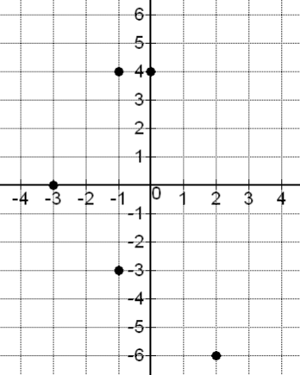

x-intercept: (-3, 0)

y-intercept: (0, 4)

(2, -6) : Quadrant 4

(-1, 4) : Quadrant 2

(-1, -3) Quadrant 3

3.

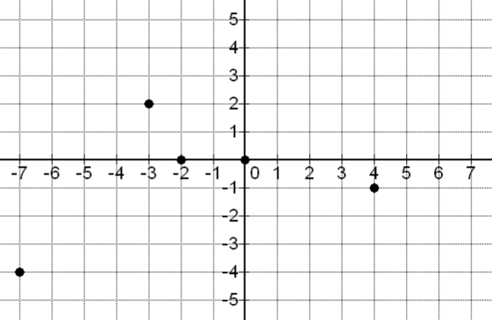

x-intercept: (-2, 0), (0, 0)

y-intercept: (0, 0)

(-3, 2): Quadrant 2

(-7, -4): Quadrant 3

(4, -1): Quadrant 4

7.

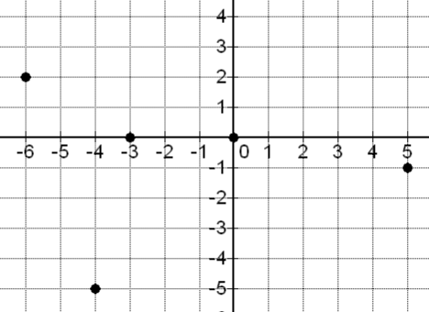

x-intercept: (-3, 0), (0, 0)

y-intercept: (0, 0)

(-6, 2): Quadrant 2

(-4, -5): Quadrant 3

(5, -1): Quadrant 4

5.

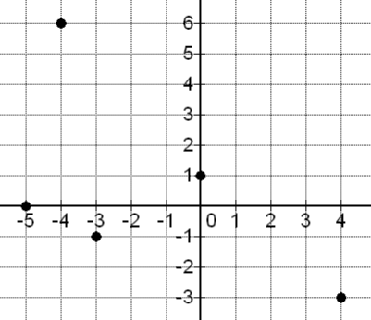

x-intercept: (-5, 0)

y-intercept: (0, 1)

(-3, -1): Quadrant 3

(4, -3): Quadrant 4

(-4, 6): Quadrant 2

11.

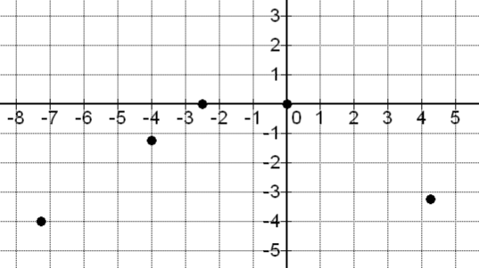

x-intercept: (-2.5, 0), (0, 0)

y-intercept: (0, 0)

(-4, -1.25): Quadrant 3

(-7.25,-4): Quadrant 3

(4.25, -3.25): Quadrant 4

9.

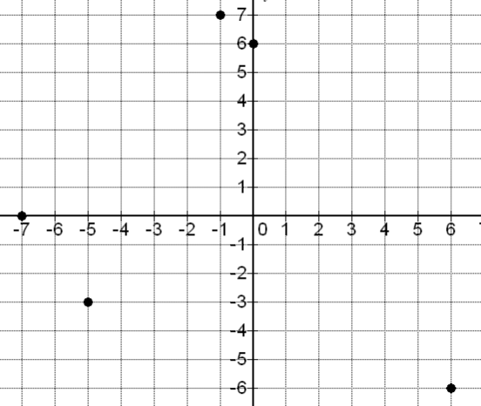

x-intercept: (-7, 0)

y-intercept: (0, 6)

(6, -6): Quadrant 4

(-1, 7): Quadrant 2

(-5, -3): Quadrant 3

13. a) From the top-left,

(0 , 24), (1, 22), (2, 21), (3, 19), (4, 18), (6, 17), (7, 16),   
 (9, 13), (10, 10), (11, 7), (12, 6), (14, 3), (16,0)

The x-intercept is (16,0) . The y-intercept is (0, 24).

b) Yes, the points seem to be close to a line that goes down from the left to right.

c) Decreases

d) Increases

**7B**

|  |  |  |  |  |  |  |  |  |  |
| --- | --- | --- | --- | --- | --- | --- | --- | --- | --- |
| 1. | 2 | 3. | $\frac{1}{5}$ | 5. | undefined |  |  |  |  |

9.

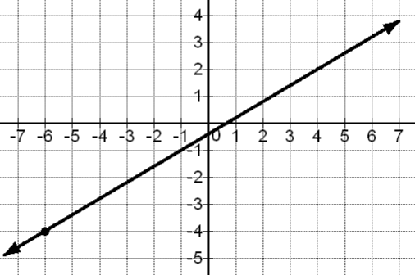

7.

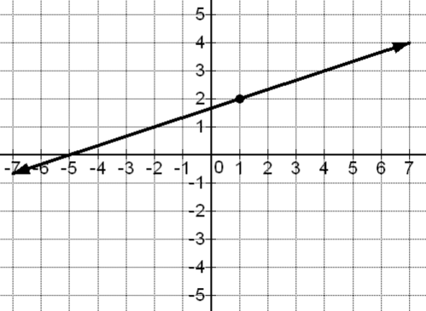

13.

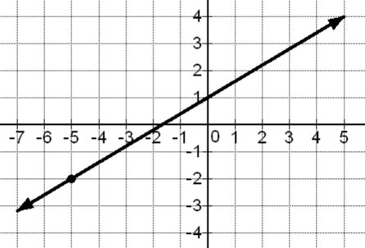

11.

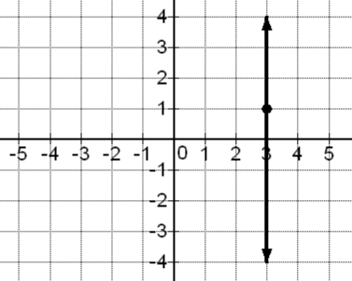

15.

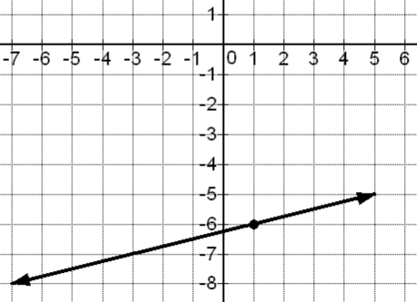

17.

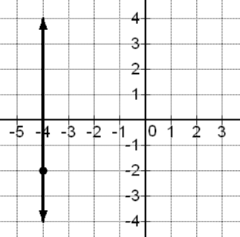

|  |  |  |  |  |  |  |  |  |  |
| --- | --- | --- | --- | --- | --- | --- | --- | --- | --- |
| 19. | $-1\frac{1}{2}$ | 21. | – 4 | 23. | 0 | 25. | $$\frac{1}{11.6} or \frac{5}{58}$$ |  |  |
| 27. | parallel: -13, perpendicular: $\frac{1}{13}$ | | | 29. | parallel: 6, perpendicular: $-\frac{1}{6}$ | | |  |  |
| 31. | parallel: -9, perpendicular: $\frac{1}{9}$ | | | 33. | (2, 62), (10, 67), slope = $\frac{5}{8}$ or $\frac{0.625 thous\$}{1 year}$ | | | | |
| 35. | (9, 85), (23, 15), slope = -5 or | | | | |  |  |  |  |

37. A 39. C

**7C**

3.

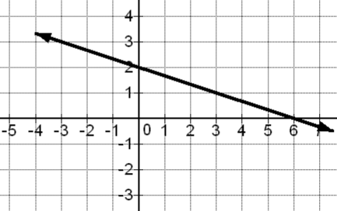

$y=-\frac{1}{3}x+2$

1.

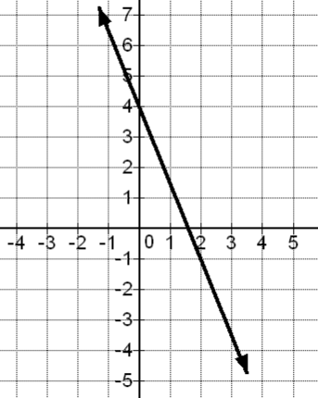

$y=-\frac{5}{2}x+4$

|  |  |  |  |  |  |  |  |
| --- | --- | --- | --- | --- | --- | --- | --- |
| 5. | $y=2x-1$ | 7. | $y=x-3$ | 9. | $y=5x-48$ | 11. | $$y=-6x-64$$ |
| 13. | $y=12x-275$ | 15. | $y=-6x-39$ | 17. | $y=-4x+12$ | 19. | $y=-x+7.7$ |
| 21. | $y=-5x-13$ | 23. | $y=1\frac{1}{3}x+23$ | 25. | $y=-\frac{1}{8}x-9\frac{3}{8}$ | 27. | $x=-9$ |
| 28. | $y=5$ | 29. | $y=7$ | 30. | $x=13$ | 31. | $y=-12$ |
| 32. | $x=-4$ |  |  |  |  |  |  |

35.

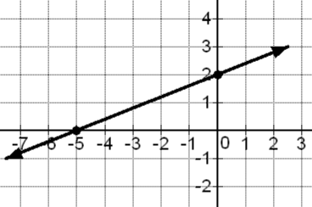

x-intercept = (-5,0)  
y-intercept = (0 , 2)  
Slope = $\frac{2}{5}$

Equation: $y=\frac{2}{5}x+2$

33.

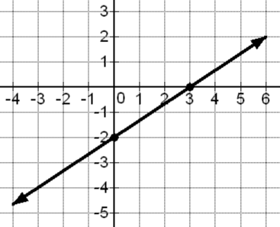

x-intercept = (3,0)  
y-intercept = (0,-2)  
Slope = $\frac{2}{3}$

Equation: $y=\frac{2}{3}x-2$

|  |  |  |  |
| --- | --- | --- | --- |
| 37. | a) $y=800x+44600$ b) $53,400 | 39. | a) $y=2x+32$ b) $128 |
| 41. | a) $y=\frac{5}{8}x+60\frac{3}{4}$ or $y=0.625x+60.75$ b) 73.25 thousand dollars or $ 73,250 | | |

**Section 7D** *(No Answer Key Available)*

**Chapter 7 Review**

1. Point (2,0) is an x-intercept, (0,-3) is a y – intercept.

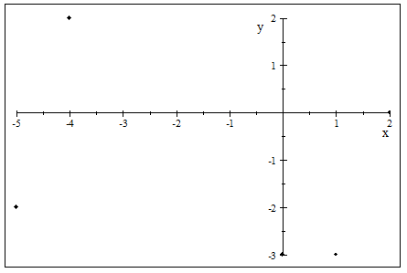

3. Point (-4.5,0) is an x-intercept, (0,2.5) is a y – intercept.

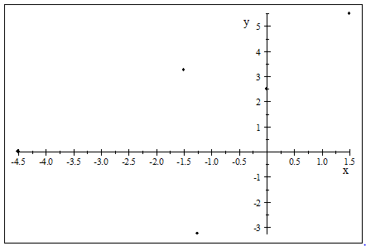

5. 7.

9. 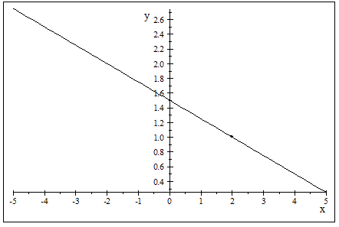

11. 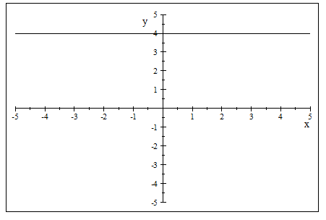

13. 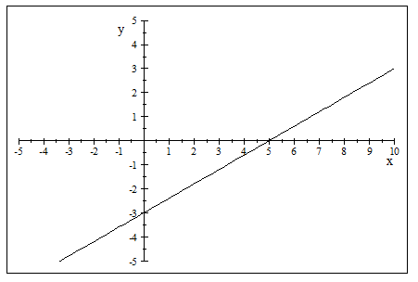

15. 17. 19.

21.

23. 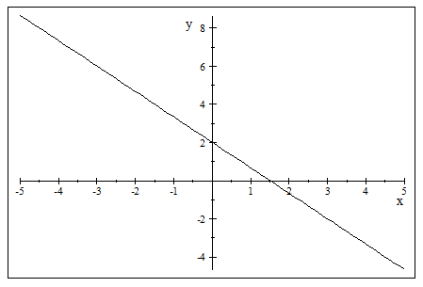

25. 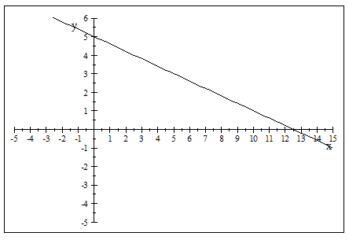

27. 29. 31. 33.

35. 37. 39. 41.

43. (a) ; (b) ;

For every month, the company’s profit is predicted to increase, on average, by $200.

(c) $(0 , 31600)$;

In month zero, the company is predicted to make a profit of $31,600

(d) $34,200

45. Infinitely many solutions. (Dependent)

47.

49. Infinitely many solutions. (Dependent) 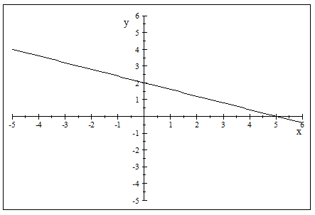

51. 53. No solution. (Inconsistent)