**Chapter 6 – Equation Applications**

Introduction: Solving equations has a ton of applications and is really the backbone of basic algebra. We can back solve formulas to find how tall a water tank should be if it needs to hold 1570 cubic feet of water. We can determine the length of a garden if we know the width and how much fencing was bought to enclose it. All manner of problems can be solved with algebraic equation solving. We may find a regression equation in statistics that gives the cost or profit for a company and by solving it we can determine how much of their product they should make in order to minimize costs and maximize profits.

**Section 6A – Formula Applications**

Look at the following formula  which gives the volume of a circular cylinder water tank. If we use 3.14 as an approximation of  and we know that radius needs to be 5 feet, then how tall should the water tank be if we need it to hold 1570 cubic feet of water? The rule of thumb is to plug in what you know and then use equation solving to figure out what you don’t know.

Look at the formula and plug in , *r* and *V.* Now simplify and solve for *h.*

  
  
Now we solve for *h* by dividing both sides by 78.5 and we find that *h* is 20 feet. So the tank needs to be 20 feet tall!



*(This chapter is from Preparing for Algebra and Statistics , Third Edition  
by M. Teachout, College of the Canyons, Santa Clarita, CA, USA)*



***This content is licensed under a*** [***Creative Commons   
Attribution 4.0 International license***](http://creativecommons.org/licenses/by/4.0/)

We used regression theory in statistics to find the profit formula  for a chain of restaurants. X represents the number of hours that their employees work and P gives the restaurants weekly profit. If the company wants to make $3000 per week in profit, how many hours a week should their employees work? Round your answer to the tenths place.

Since we know the company wants the profits P = 3000, we will plug in 3000 for P.



Now all we have to do is solve the equation for X. We can eliminate the decimals by multiplying both sides by 10.



Since the variable is already on the right side, let’s bring the constants to the opposite side by adding 6435 to both sides.



Now we can divide both sides by 913 to get X by itself. We can round our answer to the tenths place so we do not need to keep dividing past the hundredths place.



So we have found that the company should have its employees work about 39.9 hours per week. It sounds like a 40 hour work week would give them the $3000 in profit.

Try the following example with your instructor:

Example 1: An artist is building a giant cone for an art museum presentation. The volume of a cone is  . The museum wants the radius of the cone to be 10 feet and the cone to be able to hold 5,966 cubic feet of sand. If we approximate , how tall should the cone be?

**Practice Problems Section 6A**

1. The perimeter of a rectangular vegetable garden is P = 2L + 2W. Mike wants to fence off a garden in his backyard. He needs the garden to be 47 feet long and he has 150 feet of fencing. How wide should his garden be?

2. In a previous example, a statistician used regression theory to find the profit formula  for a chain of restaurants. *X* represents the number of hours that their employees work each week and P gives the restaurants weekly profit. Suppose that the company needs to cut the number of hours their employees work, but they still need to make $2500 per week in profit. How many hours should they have their employees work? Round to the tenths place.

3. Look at the formula  which gives the volume of a circular cylinder water bottle. If we use 3.14 as an approximation of  and we know the radius needs to be 4 cm, how tall should the water bottle be if it needs to hold 502.4 cubic centimeters of water?

4. We used regression theory in statistics to find a formula that will predict the weight of a black bear based on its age. The formula was  where *A* is the age of the bear in months and W is the weight. Forest rangers caught a black bear in the wild and found the weight to be 194.8 pounds. How old do we predict the bear to be?

5. The volume of a box is given by the formula  where V is the volume, L is the length, W is the width, and H is the height. A metal container to be used on ships needs to have a length of 28 feet and a width of 14 feet. How tall should the container be if it needs to hold 3136 cubic feet of cargo?

6. We used Regression theory in statistics to find the following formula F = 0.028C-1.98 where C is the number of calories a breakfast cereal has and F is the grams of fat the breakfast cereal has. Suppose a cereal has 1.38 grams of fat. How many calories do we expect the cereal to have?

7. The certificate of deposit formula that banks use is  where P is the principal (amount initially invested), A is the future amount in the account, T is the number of years the money is in the account, n is how many times it compounds per year (how many times they put the interest back in the account) and r is the interest rate. Lucy wants to buy a house in two years and will need a down payment of $11664. How much money (P) should she invest in her certificate of deposit if her interest rate is 8% (r = 0.08), compounded annually (n=1)?

8. We used regression theory in statistics to find the following formula F = 0.028C-1.98 where C is the number of calories a breakfast cereal has and F is the grams of fat the breakfast cereal has. Suppose a cereal has 0.82 grams of fat. How many calories do we expect the cereal to have?

9. A common formula in physics is that force = mass x acceleration () . Suppose we have a force of 13.5 newtons acting on an object which results in an acceleration of 2.5  . Find the mass of the object in kilograms?

10. The surface area of a cylinder is given by the formula  . Suppose a cylinder has a surface area of 2640 square inches and a radius of 14 inches. Find the height of the cylinder. Use  .

11. The area of a triangular region is given by the formula  where *b* is the base of the triangle and *h* is the height of the triangle. Find the height of a triangular shaped boat sail whose base is 3.5 feet and whose area is 15.75 square feet.

12. A common formula in physics is that force = mass  acceleration () . Suppose we have a force of 138 newtons acting on an object that has a mass of 18.4 kg. What would be the acceleration in ?

13. We used regression theory in statistics to find a formula that will predict the weight of a black bear based on its age. The formula was  where *A* is the age of the bear in months and W is the weight. How many months old do we predict a black bear to be if its weight is 119.2 pounds?

14. The certificate of deposit formula that banks use is  where P is the principal (amount initially invested), A is the future amount in the account, T is the number of years the money is in the account, n is how many times it compounds per year (how many times they put the interest back in the account) and r is the interest rate. Jerry wants to save $2080.80 in   
1 year. How much money should he invest (*P*) in his savings account if his interest rate is   
4% (*r* = 0.04), compounded semiannually (*n* = 2)?

15. We used regression theory in statistics to find the following formula F = 0.028C - 1.98 where C is the number of calories a breakfast cereal has and F is the grams of fat the breakfast cereal has. Suppose a cereal has 1.94 grams of fat. How many calories do we expect the cereal to have?

16. The volume of a cone is given by the formula  where r is the radius of the cone and h is the height of the cone. Use the approximation that  . What is the height of a cone that has a volume of 462 cubic centimeters and a radius of 7 centimeters?

17. A statistician used regression theory to find the profit formula  for a chain of restaurants. *X* represents the number of hours that their employees work each week and P gives the restaurants weekly profit. Suppose that the company needs to cut the number of hours their employees work, but they still need to make $4000 per week in profit. How many hours should they have their employees work? Round to the tenths place.

**Section 6B – Bar Graphs, Pie Charts and Percent Applications**

Percentages are a key part of math education. You cannot open a newspaper or go online without seeing percentages, but what are percentages? How do we use them and what are they used for? This section will strive to answer these key questions.

The 100 Principle

The word “Per-Cent” comes from two words “per” meaning to divide and “cent” meaning 100. So the percent symbol % really means divided by 100 or out of 100. The key to understanding percentages is that they are always based on the number 100.

For example, suppose we want to convert 34% into a fraction or decimal. Well as we have seen above, 34% is the same as . All we have to do is write the answer as a fraction or decimal. To convert 34% into a fraction we divide by 100 but write it as a fraction and simplify. So  Hence as a fraction 34% means 17/50. Converting 34% into a decimal is the same. Again, 34% is the same as . If you remember from our decimal chapter, when you divide by 100 you move the decimal two places since there are two zeros in 100. Also dividing by 100 is making the number smaller, so we only need to move the decimal two places to the left. Hence 34% = = 0.34

We see that to convert a percent into a fraction or decimal we simply have to divide by 100.

Let’s look at a more complicated percentage . Suppose we want to write this as a fraction. Again the % means divide by 100. Therefore . If you remember from the fractions chapter we must convert both numbers to improper fractions. Once we convert the numbers into improper fractions, we can divide.



So we see that .

Being able to convert a percent into a fraction or decimal is vital, since in most percent application problems where a percent is given, you must first convert the percent to a fraction or decimal.

What if we want to convert a number into a percent? Remember, the key to percentages is 100. To convert a percent into a number we divide by 100, but if we want to make a number into a percent we need to do the opposite, multiply by 100. To convert a fraction or decimal into a percent, simply multiply by 100 and add on the % symbol.

For example, suppose we want to convert 0.017 into a percent. We just need to multiply by 100%. So 0.017 = 0.017 x 100%. When you multiply by 100 you move the decimal two places (since there are two zeros in 100). Since we are multiplying by 100 we are making the number larger so we must move the decimal to the right to make it larger. Hence we move the decimal two places to the right and we get the following:

So 0.017 = 0.017 x 100%. = 1.7%

The principle of 100 applies to fractions as well. Suppose we want to convert  into a percent. Again to convert into a percent we multiply the number by 100%. So we need to multiply the fraction by 100 and usually we write the percent as a mixed number.



**Principle of 100 rules**: There are only two rules to remember when doing percent conversions, you will either multiply or divide by 100. To convert a fraction or decimal into a percent, we multiply the number by 100% and simplify. To convert a percent into a fraction or decimal we remove the % and divide by 100 and simplify. A good rule of thumb is if you see the symbol %, you will be dividing by 100. If you don’t see the symbol and you want to put one on, then you need to multiply by 100.

Try the following conversions with your instructor. Remember to use the principle of 100.

Example 1: Convert 55% into a fraction Example 2: Convert 7.4% into a decimal.  
 in lowest terms.

Example 3: Convert 0.267 into a percent. Example 4: Convert  into a percent.  
 (Write your percent as a mixed number.)

Using a Proportion

Solving applied percent problems with a proportion works very well. The main proportion to remember is 

This proportion can be used in many applications. Remember, like most formulas, put in what you know and solve for what you do not know.

Note: Because the percent is over 100, it is already converted into a fraction. So we do not have to worry about conversions.

To solve a proportion remember to set the cross products equal and solve.

So  becomes 

Let’s look at an example. It is estimated that about 39% of American adults will develop type 2 diabetes in their lifetime. If there are a total of 3500 people in Julie’s hometown, how many should she expect to develop type 2 diabetes? Notice we know the percent and the total and are looking for the amount. Plugging into the proportion we get the following.



Notice 39% is 39/100. Now we set the cross products equal and solve.



So Julie can expect about 1365 people in her hometown to develop type 2 diabetes in their lifetime.

Let’s look at a second example. A statistician took a random sample of 500 microchips and found that 6 of them were defective. What percent of the microchips were defective?

To solve this problem, we plug in what we know and solve for what we don’t know. In this case, we know the total and the amount, but not the percent. So we get the following.



Setting the cross products equal and solving we get the following.



Note: It is key to remember that because the P was over 100, 1.2% is the answer. We do not need to convert it into a percent. It is already a percent.

Try the following examples with your instructor. Remember to use a proportion.

Example 5: It was estimated that about 48% of Americans had a flu shot last year. Mike lives in a small town in Nebraska and works at the only place in town that gives flu shots. He counted 1632 people in his town that got the flu shot. If the 48% is correct, then how many total people do we think live in Mike’s hometown?

Example 6: Black Friday is one of the biggest shopping days of the year. We took a random sample of 400 people and found that 72 of them plan to shop on black Friday. What percent is this?

Common Graphs for Percentages: Bar Graphs and Pie charts

Percentages are often represented in graphs. Two common graphs in statistics is the “bar graph” (or bar chart) and the “pie chart” (or circle graph). These graphs give a visual comparison of values and percentages from different categories.

Look at the following example.

Example 1: A company offers its employees four options for medical insurance: Kaiser, Aetna, Blue Shield, or no medical insurance. There was a total of 80 employees with 24 preferring Aetna, 17 preferring Blue Shield, 33 preferring Kaiser, and 6 opted for no insurance. If we wanted to describe this information we might like to look at a bar graph and a pie chart.

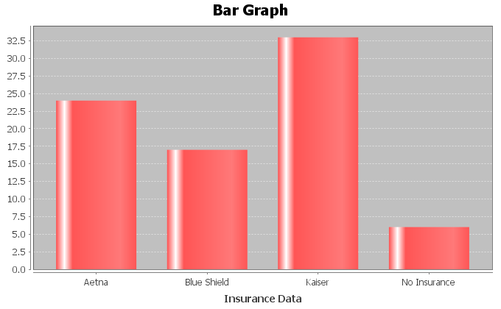

Notice the bar graph is a good way to summarize the data to the company. For example, they can see that that the number of employees that prefer Kaiser is about twice as much as Blue Shield and very few employees opted for no insurance.

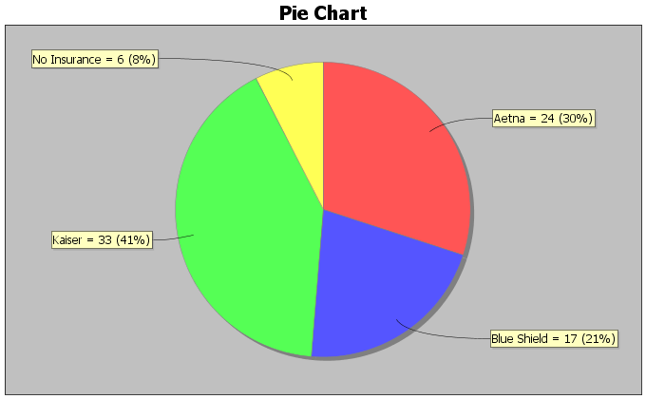

Notice the pie chart gives a part of the whole view and gives both the amount and the percentage. For example, the number of employees that prefer Kaiser is about 11% higher than the number of employees that prefer Aetna.

Now try the following example with your instructor.

Example 7: In Fall of 2015, students in Math 075 classes were asked what type of transportation they use to get to school. Here is the bar graph and pie chart.

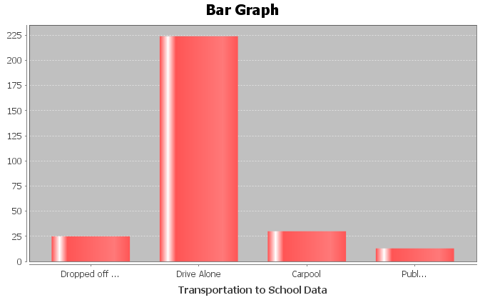

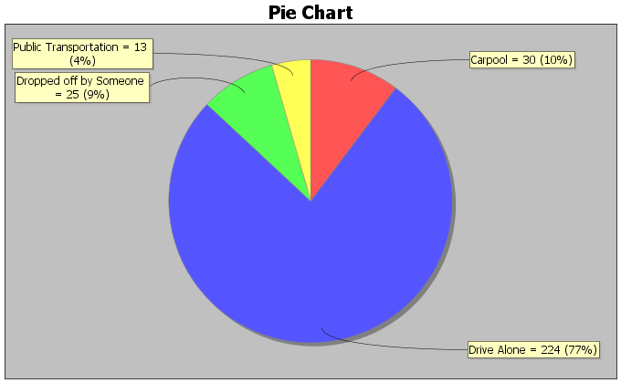

What percentage of the students carpool?

Which type of transportation was most popular?

What was the difference between the percent of students that carpool and the percent   
 of students that take public transportation?

**Practice Problems Section 6B**

Convert the following fractions into percentages by multiplying by 100% and simplifying. Write your answer as a mixed number when appropriate.

1.  2.  3.  4.  5. 

6.  7.  8.  9.  10. 

Convert the following Decimals into percentages by multiplying by 100% and simplifying. Write your answer as a decimal.

11. 0.43 12. 0.387 13. 0.054 14. 0.601

15. 0.022 16. 0.719 17. 0.352 18. 0.0128

Convert the following percentages into fractions by dividing by 100 and simplifying.

19. 35% 20. 28% 21. 74% 22. 95%

23. 68% 24.  25.  26. 

Convert the following percentages into decimals by dividing by 100 and simplifying.

27. 23.9% 28. 3.8% 29. 8.7% 30. 79%

31. 4.2% 32. 0.6% 33. 58.1% 34. 99.9%

Solve the following applied percent problems by using a proportion.

35. To estimate the total number of deer in a forest, forest rangers tagged 75 deer and released them into the forest. Later, they caught a few deer and saw that 30% of them had tags. How many total deer do they estimate are in this part of the forest?

36. A bake shop wants to find out how many of their customers would like to buy a banana cream pie. They took a random sample of 280 customers and found that 96 of them like banana cream pie. Round your answer to the tenth of a percent.

37. It is estimated that about 5.3% of Americans over the age of 65 live in nursing homes. Close to 6,900 adults over 65 live in Santa Clarita, CA. How many do we expect to live in nursing homes, if the percentage is correct?

38. We took a random sample of 600 people living in Santa Clarita, CA. We found that 306 of them were female. About what percent of Santa Clarita is female?

39. A slot machine game in Las Vegas wins about 8% of the time. How many total times would Jeremy have to play the slot machine if he wants to win twice?

40. It is estimated that 10.4% of children in CA have some sort of disability. If there is an estimated 9,400,000 children in CA, how many do we expect to have a disability?

For numbers 41-44 look at the following bar graph describing the hair color of students at a junior high school.

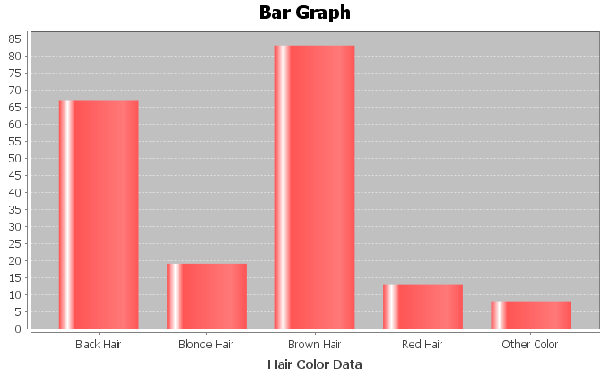

41. What was the most popular color hair at the school?

42. What was the least popular color hair at the school?

43. Approximately how many more students had blond hair than red hair?

44. Approximately how many more students had brown hair than black hair?

For numbers 45-49 look at the following pie chart describing the occupants of a small village as either child, teen, young adult or older adult.

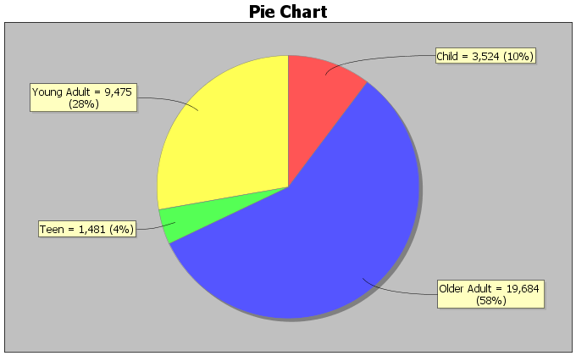

45. What percent of the people in the village are teenagers?

46. How many people in the village are older adults?

47. What is the difference between the percentage of young adults and the percentage of older adults?

48. Are there more teenagers in the town or children?

49. How many more young adults are there in the town than teenagers?

For numbers 50-53, look at the following bar graph describing the floor patients at a hospital were admitted to.

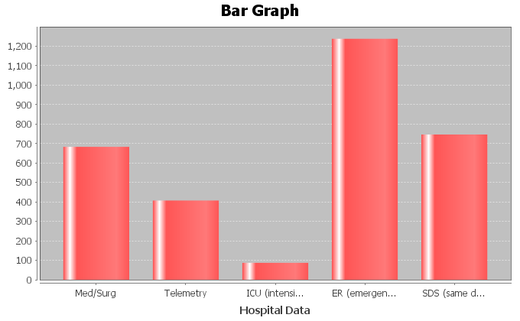

50. Which department had the most patients?

51. Which department had the fewest patients?

52. Did same day surgery (SDS) see more patients than the medical/surgery (Med/Surg) floor?

53. Estimate how many more patients went to Telemetry than ICU?

For numbers 54-59, look at the following pie chart describing the floor patients at a hospital were admitted to.

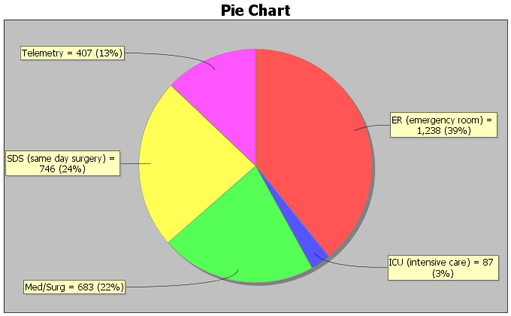

54. What percent of patients were admitted to the telemetry floor?

55. How many more patients went to SDS than Med/Surg?

56. What is the difference between the percent of patients that went to ER and the percent of patients that went to ICU?

57. How many patients did ICU receive?

58. How many more patients went to Med/Surg than Telemetry?

59. What is the difference between the percent of patients that went to Telemetry and the percent of patients that went to ICU?

For #60-63, look at the following bar graph describing the marriage status of students at a community college.

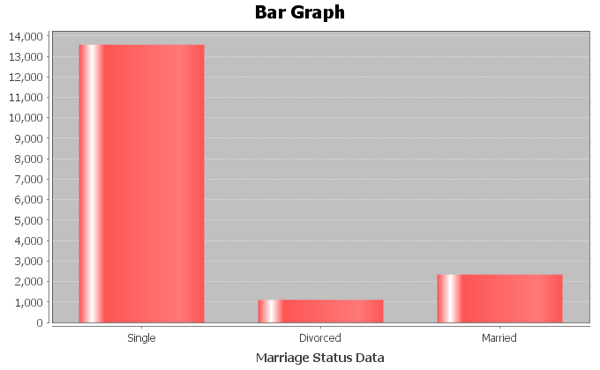

60. Which marriage status is most common at the college?

61. Approximately how many students are divorced?

62. Which marriage status is least common at the college?

63. Approximately how many more students are single than married?

For #64-67, look at the following pie chart describing the marriage status of students at a community college.

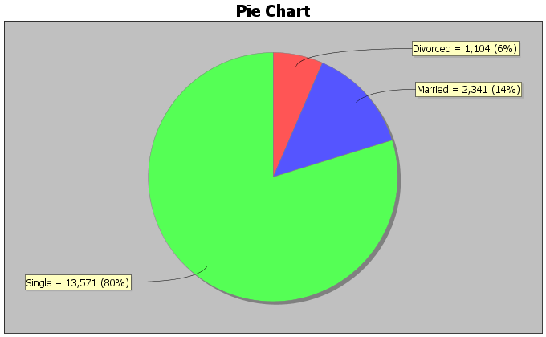

64. Approximately what percent of the college students are married?

65. Approximately what is the difference between the percent of students that are married and the percent of students that are divorced?

66. How many more students are single than divorced?

67. It was estimated that about 11% of Americans are left handed. Stacey’s apartment complex has 29 left handed people who live there. If the 11% is correct, what is the total number of people who live in Stacey’s apartment complex?

68. Super Bowl XLVI between the New York Giants and New England Patriots was the most-watched game in the history of the NFL, peaking with 117.7 million watchers in the final half hour. There were approximately 318.9 million people living in the U.S. that year. What percent of Americans were watching the Super Bowl that year?

69. A random sample of eligible voters shows that about 57.5% of people voted for the last presidential election. If there are approximately 199,182 people who live in Santa Clarita, how many people voted in the last presidential election?

70. A recent Gallup poll shows that 62% of Americans think that the U.S. will be cashless in their lifetime, with all purchases being made by credit cards, debit cards, and other electronic payments. If we were to ask 6075 people this question, how many would we expect to agree that U.S. will be cashless in their lifetime?

71. A doctor took a random sample of his patients. He found that 59 patients out of the 246 sampled were obese. What percent of the doctor’s patients are obese according to this random sample?

**Section 6C – Commission, Interest, Tax, Markup and Discount**

In the last section, we looked at percent conversions and solving simple percent problems with a proportion. We are now going to look at some more complicated percent applications.

Commission

Many people work on commission. In a general sense, you get paid a percentage of what you sell. The more you sell, the more money you make. Usually people have a set commission rate (percent) that they will be paid. The formula for commission is  where *C*  is the amount of commission they are paid, *T* is the total sales and *r* is the commission rate (percent). As with most of these formulas involving percent, we need to be sure to convert the percent to either a fraction or decimal, before plugging in for *r.*

For example, look at the following commission problem. Marsha gets paid 12% of all makeup she sells. She made a total of $216 this week from commission. What was the total sales of makeup for the week? Like with any formula, plug in what you know and solve for what you don’t know. We first must convert the 12% into a fraction or decimal. , so we will plug in 0.12 for *r* and 216 for *C* and then solve for *T.*



So Marsha sold $1800 in makeup this week in order to make the $216 in commission.

Simple Interest

Simple Interest is an important concept for everyone to know. It a big part of financial stability and is vital to understanding savings accounts. The formula for simple interest is  where *P* is the principal (amount invested), *r* is the interest rate (percent), and *t* is time in years.

Let’s look at an example. Jerry deposited $3500 into a simple interest account. He was able to earn $122.50 in interest after 6 months (1/2 year). What was the interest rate the bank used? Write your answer as a percent.

Again, plug in what we know and solve for what we do not know. We know I = 122.5, P = 3500 and t = ½ . Now let’s solve for r.



Now the interest rate is not written as a percent. Do you remember how to convert a decimal into a percent? Remember, if you see the percent symbol, divide by 100, but if you do not see the percent symbol and you want to put one on, multiply by 100.

So r = 0.07 = 0.07 x 100% = 7%

So Jerry’s bank gave him a 7% interest rate.

Try the following example problems with your instructor. Pay close attention to see if you need the commission or simple interest formula.

Example 1: Jimmy sells cars and is paid a commission for the cars he sells. In one day he sold three cars for a total of $43,000 and was paid a commission of $1720. What is Jimmy’s commission rate? Write your answer as a percent.

Example 2: Rick invested $4,000 into a bank account that earns 6% simple interest. How long will it take Rick to make $720 in simple interest?

Taxes and Markup

Most people living in the U.S. have to pay taxes. Whether you buy coffee or a car, you need to pay taxes, but how do taxes work? Taxes in CA can vary depending on where you are. Some areas have a tax rate of 9.25% and other areas have a tax rate of 8.5%. So basically a tax is a percent of increase. The store multiplies the percent times the price of the item to calculate the tax. Then it adds the tax onto the price to get the total you have to pay. A common formula for calculating the total with taxes included is T = A + rA where T is the total paid, A is the original amount of the item before taxes and r is the tax rate percent for the area you live in.

Let’s look at an example. Suppose an electric shaver costs $64 at the store. When you go to pay, the total is $69.92. What is the tax rate? Write your answer as a percent.

Since we know the total T = 69.92 and the amount A = 64, we can solve for r in the formula. Remember, we will need to convert our answer into a percent by multiplying by 100.



Notice a few things. First 64 + 64r is not 128r. Remember these are not like terms. So we need to bring the r terms to one side and constants to the other. This is why we subtract the 64 from both sides. The $5.92 was actually the amount of tax they charged. After solving we got an answer of r = 0.0925 and converting that into a percentage we get r = 0.0925 x 100% = 9.25%. So in the electric shaver problem, we were in an area that charges a 9.25% sales tax.

Another type of problem that uses the same percent of increase problem is a markup. A markup is when a store buys an item from a manufacturer for a certain cost and then sells it to you for a higher price. For example some stores have a 10% markup rate. Meaning whatever the cost of the item, they add an additional 10% onto the price before selling it. This is how stores make money. Since it is a percent of increase, a markup also uses the formula T = A + rA where A is the amount before the markup and T is the total after the markup and r is the markup rate (percent).

Look at the following problem. A store bought a tennis racquet from the manufacturer. If they have a standard 15% markup policy on all items, and they sold the racquet for $72.45 after markup, what was the cost of the racquet from the manufacturer? We first see that we are giving the markup rate at 15%. Again make sure to convert that into a fraction or decimal before plugging in for r.  = r. So we will plug in T = 72.45 and r = 0.15 and solve for A.



Notice a few things. First that A is the same as 1A, so since the 1A and the 0.15A are like terms, we can add them and get 1.15A. Also a common technique to eliminate decimals is to multiply both sides of the equation by a power of 10, which in this case was 100. So the store bought the tennis racquet originally for $63 and then sold it to us for $72.45.

Discount

Our final percent application is discount and sale price. We have all been in stores that sometimes say 25% off or 50% off sale. We know that the sale price is lower than the regular price, but how does a discount work? A discount is really a percent of decrease. The store multiplies 25% times the price of the item. This is called the discount. Then the store subtracts this amount from the price of the item, before charging you. A common formula used in discount problems is T = A – rA. Notice this is very similar to the tax or markup formula but it is a decrease (-) instead of an increase (+). In this formula, A is the amount of the item before the sale and T is the total price of the item after the discount and r is the discount rate (percent).

Let’s look at an example. A car has a regular price of $18000 and is on sale for $14,400. What was the discount rate? Write your answer as a percent.

Plugging into our equation we see that the amount before the sale was A = 18000 and the total price after the sale was T = 14400. Plug in and solve for r. Again we will have to convert r into a percent by multiplying by 100.



Notice a few things. The 18000 is the A not the T. In sale price problems the price decreases so the large amount is the price before the sale. The 14400 is the sale price or the amount after the sale. The -3600 indicates that there was a $3600 discount. Our answer as a percent is   
r = 0.2 = 0.2x100% = 20%. So the car was being sold at a discount of 20%.

Try the following examples with your instructor. Be sure to use the formulas T = A + rA for tax and markup and the formula T = A – rA for discount problems.

Example 3: Rachael lives in an area with a 9.5% sales tax and bought a blouse for $45.99 with tax included. What was the price of the blouse before tax?

Example 4: A clothing store bought some jeans from the manufacturer for $16 and then sold them to their customers for $22.40. What was the markup rate? Write your answer as a percent.

Example 5: Juan bought a rosebush to plant in his backyard. The rosebushes were on sale for 35% off. If the sale price that Juan paid was $15.60, what was the price of the rosebush before the sale?

**Practice Problems Section 6C** *(Don’t forget to convert given percentages rates (r) into a decimal before plugging into the formulas.)*

Commission Problems ()

1. Tina sells software and is paid a 20% commission on all she sells. If she sold a total of $8000 worth of software in one month, how much commission did she make from the sale?

2. Maria sells hair products at the mall and is paid a commission on what she sells. If she sold a total of $860 in hair products and was paid a commission of $154.80, what is her commission rate? Write your answer as a percent.

3. Jim sells homes and earns a 4% commission on all he sells. If he made a commission of $19,000 on one home he sold, what was the total price of the house?

4. Rachel sells cars and is paid a commission on what she sells. If she sold a total of $66,400 worth in cars and was paid a commission of $4,648, what is her commission rate? Write your answer as a percent.

5. Jim sells paintings and earns a 6.5% commission on all he sells. If he made a commission of $279.50 on one painting he sold, what was the total price of the painting?

Simple Interest Problems ()

6. Kai invested $3000 into some stocks that yielded a 6.8% interest rate. How much simple interest did she make after 2 years?

7. Simon invested $2600 into a simple interest account for 2 years. If the account yielded $234 at the end of two years, what was the interest rate? Write your answer as a percent.

8. Elena invested some money into a bond account that yielded $375 in interest at the end of 1 year. If the interest rate was 3%, how much did she originally invest?

9. Yessica invested $5000 into a simple interest savings account that yields 6.5% simple interest. How many years will it take for her to make $1300 in simple interest?

10. Simon invested $3500 into a simple interest account for 2 years. If the account yielded $385 at the end of two years, what was the interest rate? Write your answer as a percent.

Tax and Mark-up Problems 

11. Tim bought a washing machine for a total of $651 with tax included. What was the price of the washing machine before tax if Tim lives in an area with an 8.5% sales tax rate?

12. Julie wants to buy an iPhone that costs $120 before tax. If Julie lives in an area with a 9.25% sales tax, what will be the total price of the iPhone with tax included?

13. Lianna bought a turtleneck sweater for $19.71 with tax included. If the price of the sweater before tax was $18, what is the sales tax rate in Lianna’s area? Write your answer as a percent.

14. Wade works for a store that sells computers and computer parts and has a 20% markup policy. If they bought a computer from the manufacturer for $790, how much will they sell it for after the markup?

15. Patricia works for a clothing store. If the store buys its sweatshirts from the manufacturer for $19 and then sells them for $28.50, what is the stores markup rate? Write your answer as a percent.

Sale Price Problems 

16. A bicycle that regularly sells for $350 is on sale for 25% off. What will the sales price be?

17. If Oscar bought some patio furniture that regularly sells for $275 on sale for $192.50 , what was the discount rate? Write your answer as a percent.

18. Tyrone bought a shed to put in his backyard. If the shed was on sale for 20% off and the sale price was $360, what was the regular price of the shed before the sale?

19. Tara bought a necklace that regularly sells for $450 on sale for $315, what was the discount rate? Write your answer as a percent.

20. Rick bought a book on sale for 40% off and the sales price was $30. What was the regular price of the shed before the sale?

**Section 6D – Classic Algebraic Problem Solving**

Algebra can be a useful tool to solving even when we do not know the formula for the situation. Here are some general steps to using algebra to solve word problems.

**Steps to Solving Problems with Algebra**

1. Read and reread the problem and write down all of the unknowns in the problem on a piece of paper.

2. Let your variable (x) stand for the unknown that you have the least amount of information about.

3. Use the information given in the problem to write algebraic expressions for all of your other unknowns.

4. Once you have algebraic expressions for all your unknowns, then you can use them to write an equation.

5. Solve the equation for the variable (x).

6. Go back and plug in the value of the variable (x) into all the algebraic expressions and find all the unknowns.

7. Check and see if your answers make sense in the context of the problem.

**It is also good to make a list of words and their meaning.**

Addition words: Sum, more than, increased by, total

Subtraction words: Subtract from, less than, less, decreased by, difference

Multiplication words: Multiply, product, times, percent of (multiply by percent),   
 fraction of (multiply by fraction)

Division words: Quotient, ratio, divided by

Words that mean “Equals”: Is, Is equal to, Is equivalent to, Is the same as

Let’s look at an example. When seven is subtracted from the product of a number and four, the result is 69. Find the number.

Step 1-3 - Since there is only one unknown, we will let x be the number.

Step 4 - Now we will translate the words into an equation. Subtracted from means subtract in the opposite order. The product of a number and four means multiply 4 and x. So we get the following.



Step 5 - Now solve the equation. Since there is only one number we are looking for, x is the answer.



Steps 6&7 – The only unknown is the number 19 and that is our answer. The answer does make sense since 4 times the number is 76 and then 7 less than it is 69.

Let’s look at another example. Suppose a political science club is divided into three groups: liberal, moderate and conservative. There are twice as many liberals as moderates and there are seven more conservatives than moderates. If the club has a total of 75 members, how many are in each group?

Step 1 – Write down all unknowns. You should write down the following on a piece of paper.

# of liberals =

# of moderates =

# of conservatives =

Step 2 – Since we know something about liberals and conservatives but nothing about moderates we will let x be the number of moderates.

Step 3 – Twice as many liberals as moderates means we can represent liberals as 2x. Seven more conservatives means we can represent conservatives with x+7.

# of liberals = 2x

# of moderates = x

# of conservatives = x+7

Step 4 – Never try to write an equation until you have algebraic expressions for all your unknowns. Since we know the total is 75 we will add our algebraic expressions and set it equal to 75.

2x + x + x+7 = 75

Step 5 – Now we solve the equation for x using the techniques we learned in the last chapter. Notice that 2x, x and x are like terms on the same side so we can simply add them.



Step 6 – Now that we know x we can find all the solutions. Go back to your unknowns and algebraic expressions. If you plug in 17 for x in all of them you will have your answers.

# of liberals = 2x = 2(17) = 34

# of moderates = x = 17

# of conservatives = x+7 = 17+7 = 24

Step 7 – So our answer is 34 liberals, 17 moderates and 24 conservatives. Does this answer make sense? Yes. There are twice as many liberals and seven more conservatives than moderates and the total is 75.

Let’s look at another example. Jimmy has a bunch of coins in the cushions of his couch. As he is out of money and needs gas in his car, he is searching for as many coins as he can find. The coins he found had a total value of $7.50 . He only found quarters, dimes and nickels. There were three times as many dimes as nickels and eighteen more quarters than nickels. How many of each type of coin did he find?

Step 1 – Write down all unknowns. You should write down the following on a piece of paper. Again the key thing to remember is that for coin problems, the number of coins is not money. If we have 3 quarters, that does not mean I have $3. You need to multiply the number of the coins times the value of the coin. So 3 quarters means 3 x 0.25 = $0.75 . Not only do we need to know how many coins but also we need algebraic expressions that represent the amount of money for each coin.

# of nickels =

# of dimes =

# of quarters =

$ in nickels =

$ in dimes =

$ in quarters =

Step 2 – Since we know something about quarters and dimes but nothing about nickels we will let x be the number of nickels.

Step 3 – Three times as many dimes as nickels means we can represent the number of dimes as 3x. Eighteen more quarters than nickels means we can represent quarters with x + 18. Remember to get the amount of money, we will multiply the number of nickels times its value ($0.05), the number of dimes times its value ($0.10) and the number of quarters times its value ($0.25). We can simplify each expression. For the quarters we will use the distributive property.

# of nickels = x

# of dimes = 3x

# of quarters = x + 18

$ in nickels = 0.05x

$ in dimes = 0.10 (3x) = 0.30x

$ in quarters = 0.25 (x + 18) = 0.25x + 4.5

Step 4 – Never try to write an equation until you have algebraic expressions for all your unknowns. Since we know the total amount of money is $7.50 we will add our algebraic expressions for money and set it equal to 7.5



Step 5 – Now we solve the equation for x using the techniques we learned in the last chapter. Notice that the 0.05x, 0.30x and 0.25x are like terms on the same side so we can simply add them.



Step 6 – Now that we know x we can find all the solutions. Go back to your unknowns and algebraic expressions. If you plug in 5 for x in all of them you will have your answers.

# of nickels = x = 5 nickels

# of dimes = 3x = 3(5) = 15 dimes

# of quarters = x + 18 = 5 + 18 = 23 quarters

$ in nickels = 0.05x = 0.05 (5) = $0.25

$ in dimes = 0.10 (3x) = 0.30x = 0.3 (5) = $1.50

$ in quarters = 0.25 (x + 18) = 0.25x + 4.5 = 0.25 (5) + 4.5 = 1.25+4.5 = $5.75

Step 7 – So our answer is 5 nickels, 15 dimes and 23 quarters. Does this answer make sense? Yes. There are three times as many dimes as nickels and 18 more quarters than nickels. The amount of money in nickels ($0.25) + amount of money in dimes ($1.50) + amount of money in quarters ($5.75) = $7.50.

Try the following examples with your instructor:

Example 1: The quotient of a number and three is increased by seventeen. If the result is 39, what is the number?

Example 2: A car salesman has Fords, Chevrolets, and Dodges on his lot. He has twice as many Chevrolets as Dodges and nine more Fords than Dodges. If he has a total of 73 cars on the lot, how many of each kind does he have?

Example 3: Pat has a coin collection consisting of pennies, dimes and nickels. He has four times as many pennies as dimes and six fewer nickels than dimes. If Pat took all the coins to the store and spent them, it would be $4.07 total.

**Practice Problems Section 6D**

1. The sum of twice a number and nine is the same as the number subtracted from twenty-four. Find the number.

2. The product of a number and six is equivalent to the sum of the number and forty. Find the number.

3. Two less than the quotient of a number and five is the same as eleven. Find the number.

4. The smaller of two numbers is six less than the larger. The sum of the two numbers is 118. Find both numbers.

5. The sum of half a number and seven is nineteen. Find the number.

6. Twelve less than a number is eight. Find the number.

7. The product of a number and 4 is equal to the sum of twice the number and fourteen. Find the number.

8. Four less than twice a number is 20. Find the number.

9. A number divided by six added to four is equivalent to the number subtracted by 71.

10. Ten times a number is sixteen more than twice the number. Find the number.

11. Jim has a three-number code to unlock the padlock on his garage door. The second number is seven less than the third number. The first number is two more than the third number. Find all three numbers if the sum of the numbers adds up to 34.

12. Carrie loves to plant flowers in her garden. Her favorites are daisies, roses and sunflowers. She has three times as many daisies as sunflowers and twice as many roses as sunflowers. She as a total of 78 flowers in her garden. How many of each type of flower does she have?

13. The sum of the angles of any triangle add up to 180 degrees. The largest angle of a triangle is four times as large as the smallest angle. The middle angle is 42 degrees greater than the smallest angle. Find all three angles.

14. Mrs. Smith has a total of 43 children in her class. The number of girls is one more than twice the number of boys. How many boys and girls does she have in her class?

15. The students in a political science class are divided up into three categories: liberal, conservative, or moderate. There are five more conservatives than moderates, and twice as many liberals as conservatives. How many of each type are there if there is a total of 87 students in the class?

16. Jimmy collects baseball and football trading cards. The number of baseball cards is one less than three times as many as the football cards. He has a total of 267 cards in his collection. How many baseball cards does he have? How many football cards does he have?

17. Gary owns a car dealership that sells cars, SUVs and minivans. Gary has three times as many SUVs as Minivans. He has eight more cars than SUVs. If he has a total of 127 vehicles on his lot, how many of each type does he have?

18. Harry has a total of $237 in his wallet in twenty dollar bills, five dollar bills, and 1 dollar bills. He has twice as many five dollar bills as one dollar bills. He has one more twenty dollar bill than one dollar bills. How many of each type does he have?

19. Lucia has a total of $2.60 in quarters, dimes and nickels in her purse. She has three more dimes than quarters and six more nickels than quarters. How many of each type does she have?

20. Marcos collects pennies, dimes and nickels. He has twice as many pennies as dimes and three more nickels than dimes. If the total amount of money is $6.95, how many of each type of coin does he have?

21. The ancient Greeks were famous for using the “Golden Rectangle” in their architecture. A golden rectangle is one where the length is approximately 1.618 times the width. A wall of one of the temples in Greece is in the shape of a golden rectangle. If its perimeter is 261.8 feet, what is the width and length of the wall?

**Chapter 6 Review**

Remember the principle of 100 when dealing with percentages. If you see the percent sign %, then divide by 100 and remove the sign. If you don’t see a percent sign and want to put one on, then multiply by 100 and put on the % symbol.

Algebra can be used to solve many different types of problems. If we have a formula that applies to a problem, we plug in what we know and solve for what we do not know. Here are some of the formulas we talked about in chapter 6.

 This formula is used to solve general percent problems. We can find the percent, amount, or total by setting the cross products equal and solving. Remember the percent is already converted because it is over 100.

 This formula is used to calculate the amount of commission made when a person sells *T* amount of money in merchandise and *r*  is the commission rate percent. Remember to convert r into a decimal or fraction before plugging it in. If we solve for *r* , we will need to convert our answer back to a percent.

 This formula is used to calculate the amount of simple interest made when a person invests *P* amount of money in an account at an interest rate *r*  percent for *t* number of years. Remember to convert r into a decimal or fraction before plugging it in. If we solve for *r* , we will need to convert our answer back to a percent.

 This is the classic percent of increase formula that can be used both for taxes and for markup problems. The *A* is the amount before tax or markup. The *T* is the total after tax or markup and *r* is the tax rate or markup rate percent. Remember to convert r into a decimal or fraction before plugging it in. If we solve for *r*, we will need to convert our answer back to a percent.

 This is the classic percent of decrease formula that can be used for discount sales price problems. The *A* is the amount before the discount. The *T* is the total after the discount and *r* is the discount rate percent. Remember to convert r into a decimal or fraction before plugging it in. If we solve for *r*, we will need to convert our answer back to a percent.

To solve a classic algebra problems, remember the steps given below. Also remember if you are dealing with money, the number of bills or coins has to be multiplied by the value of the bill or coin to find the amount of money. 5 dimes does not mean 5 dollars. 5 dimes means 5 x 0.10 = $0.50

Steps to solving problems with algebra

1. Read and reread the problem and write down all of the unknowns in the problem on a piece of paper.

2. Let your variable (x) stand for the unknown that you have the least amount of information about.

3. Use the information given in the problem to write algebraic expressions for all of your other unknowns.

4. Once you have algebraic expressions for all your unknowns, then you can use them to write an equation.

5. Solve the equation for the variable (x).

6. Go back and plug in the value of the variable (x) into all the algebraic expressions and find all the unknowns.

7. Check and see if your answers make sense in the context of the problem.

**Review Problems Chapter 6**

1. Look at the formula  which gives the volume of a circular cylinder propane tank. If we use 3.14 as an approximation of  and we know that the radius needs to be 3 feet, then how tall should the propane tank be if it needs to hold 310.86 cubic feet of propane?

2. We used regression theory in statistics to find a formula that will predict the weight of a black bear based on its age. The formula was  where *A* is the age of the bear in months and W is the weight. Forest rangers caught a black bear in the wild and found the weight to be 227.2 pounds. How old do we predict the bear to be?

3. The volume of a box is given by the formula  where V is the volume, L is the length, W is the width, and H is the height. A toy container needs to have a length of 15 cm and a width of 9 cm. How tall should the container be if it needs to hold 3105 cubic cm of toys?

4. We used regression theory in statistics to find the following formula F = 0.028C - 1.98 where C is the number of calories a breakfast cereal has and F is the grams of fat the breakfast cereal has. Suppose a cereal has 3.06 grams of fat. How many calories do we expect the cereal to have?

5. The formula for compound interest that banks use is  where P is the principal (amount initially invested), *A* is the future amount in the account, *T* is the number of years the money is in the account, *n* is how many times it compounds per year (how many times they put the interest back in the account) and *r* is the interest rate. John and Lacy want to buy a car in two years and will need $22,898. How much money *(P)* should they invest in their savings account if the interest rate is 7% (0.07), compounded annually (n=1)? Round your answer to the nearest dollar.

*Convert the following fractions into percentages. Write your answers as mixed numbers when appropriate.*

6.  7.  8.  9. 

*Convert the following decimals into percentages.*

10. 0.69 11. 0.127 12. 0.014 13. 0.0063

*Convert the following percentages into fractions. Write your answer in lowest terms.*

14. 36% 15. 45% 16. 98% 17. 

*Convert the following percentages into decimals.*

18. 13.8% 19. 2.5% 20. 88.4% 21. 0.35%

*Solve the following applied percent problems by using a proportion.*

22. To estimate the total number of raccoons in a forest, forest rangers tagged 26 raccoons and released them into the forest. Later, they caught a few raccoons and saw that 20% of them had tags. How many total raccoons do they estimate are in this part of the forest?

23. A women’s shoe store wants to find out how many of their customers would like to buy a new style of heels. They took a random sample of 85 customers and found that 52 of them like the new style. What percent of them like the new style? Round your answer to the tenth of a percent.

24. It is estimated that about 5.3% of Americans over the age of 65 live in nursing homes. If a town has a total of 8200 adults over the age of 65, how many do we expect to live in a nursing homes?

*Solve the following problems with the appropriate percent formula.*

25. Lynn sells jewelry at the mall and is paid a commission of what she sells. If she sold a total of $4800 in jewelry and was paid a commission of $264, what is her commission rate? Write your answer as a percent.

26. Mario sells cars and earns a 6% commission on all he sells. If he made a commission of $1,800 on one car he sold, what was the total price of the car?

27. Simon invested $4100 into a simple interest account for 3 years. If the account yielded $430.50 in simple interest at the end of three years, what was the interest rate? Write your answer as a percent.

28. Tianna invested some money into some stocks that yielded $345 in simple interest at the end of 2 years. If the interest rate was 7.5%, how much did she originally invest?

29. Mark bought a flat screen TV for a total of $437 with tax included. What was the price of the TV before tax if Mark lives in an area with a 9.25% sales tax rate.

30. David bought some basketball sneakers for $49.05 with tax included. If the price of the sneakers before tax was $45, what is the sales tax rate in David’s area? Write your answer as a percent.

31. Riley works for a store that sells toys and has a 15% markup policy. If they bought a toy from the manufacturer for $14, how much will they sell it for after the markup?

32. Maria works for a clothing store. If the store buys a skirt from the manufacturer for $23 and then sells them for $28.75, what is the stores markup rate? Write your answer as a percent.

33. If Eric bought some paint that regularly sells for $24 a gallon on sale for $19.44 a gallon, what was the discount rate? Write your answer as a percent.

34. Tyra bought a beautiful red dress to wear to a New Year’s Eve party. If the dress was on sale for 35% off and the sale price was $234, what was the regular price of the dress before the sale?

*Solve the following problems using classic algebraic problem solving techniques.*

35. The number of part time students at a college is 52 less than twice the number of full time students. If there are a total of 10,808 students at the college, how many are part time and how many are full time?

36. A tutoring business offers tutoring for elementary, junior high, and high school students. There is a total of 31 students at the tutoring center right now. There are 3 times as many elementary school students as junior high students. There are 6 more high school students than junior high. How many students of each level are there?

37. A coffee house sells three types of coffee: house blend, French roast, and decaffeinated. They sold 4 times as many bags of house blend as French roast. They sold one bag less of decaffeinated than they did French roast. If they sold a total of 53 bags, how many of each type did they sell?

In Spring of 2016, students in Math 075 classes were asked what their political party they affiliate with. Here is the bar graph of the 508 students that responded.

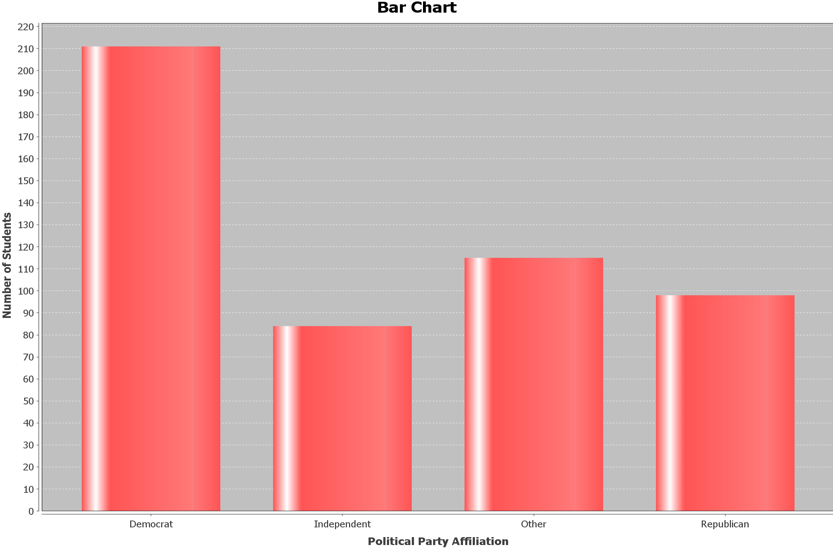

38. Which political party had the fewest students?

39. Which political party is the most popular?

40. Approximately how many more Democrats than Republicans were there?

41. Approximately what percentage of students in the data are Republican?

In Spring of 2016, students in Math 075 classes were asked which social media was their favorite to use. Here is the pie chart of the 512 students that responded.

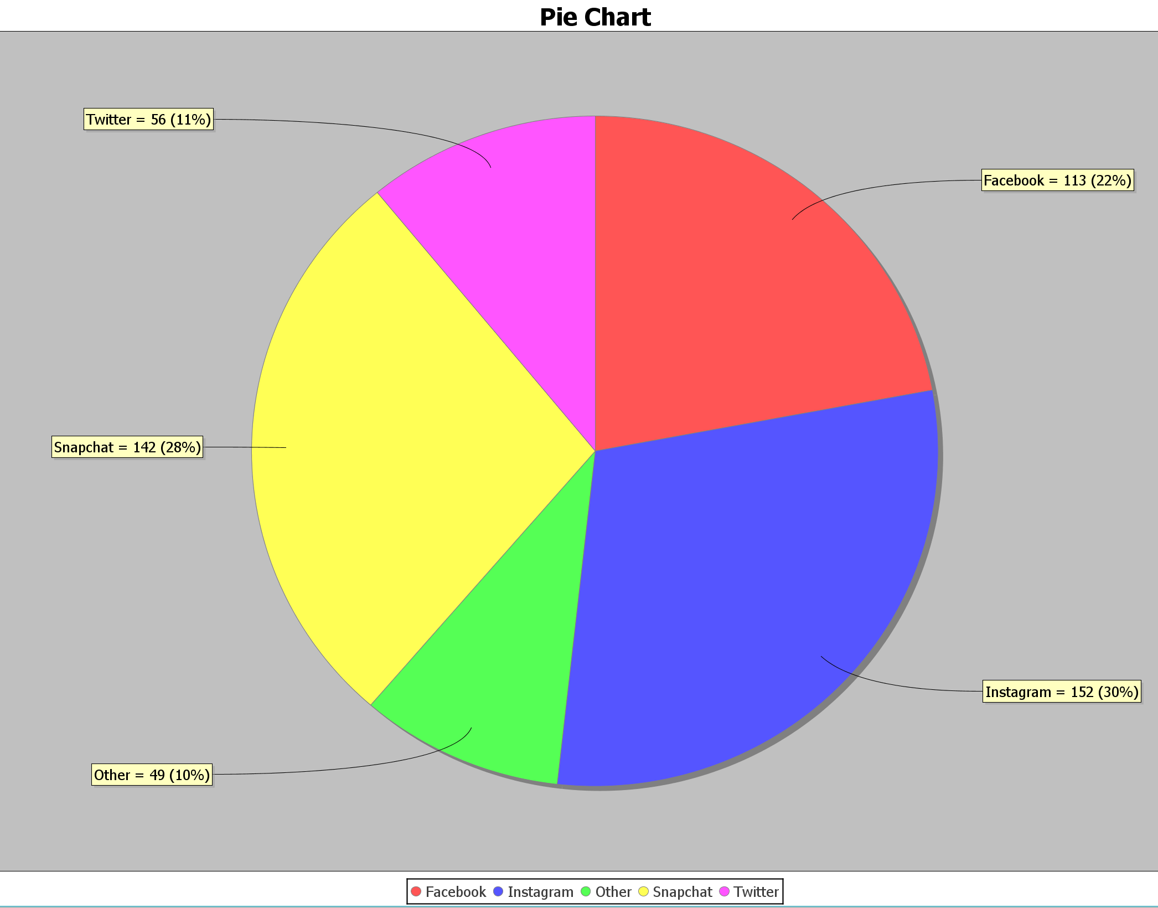

42. What percent of students use Facebook as their favorite social media?

43. How many students chose Snapchat as their favorite social media?

44. What is the difference between the percentage of students that chose Instagram and Twitter as their favorite social media?

45. Do more students use Snapchat or Facebook as their favorite social media?

46. How many more students use Twitter over Other social media not listed as their favorite social media?