**Chapter 7 – Equation of a Line, Slope, and   
the Rectangular Coordinate System**

Introduction: Often, we want to explore relationships between variables. For example we might want to explore the relationship between the unemployment rate each year and U.S. national debt each year. Sometimes variables like this have linear relationships. In this chapter we will not only strive to understand these relationships, but also find the average rates of change (slope) and the equation of a line that can help us make predictions based on that relationship.

**Section 7A – Rectangular Coordinate System and Scatterplots**

Look at the following data which gives the profits of a small cupcake shop over the last twelve months. This is a good example of a relationship between two variables. In this case it is time and profit.

|  |  |
| --- | --- |
| Month | Profit in Thousands of Dollars |
| 1 | 1.5 |
| 2 | 1.8 |
| 3 | 1.9 |
| 4 | 2.2 |
| 5 | 2.4 |
| 6 | 2.7 |
| 7 | 2.8 |
| 8 | 3.0 |
| 9 | 3.1 |
| 10 | 3.4 |
| 11 | 3.5 |
| 12 | 3.8 |

It is important to be able to graph the data so that we can see if there are any trends. The main graph we use in Statistics is a scatterplot. To make a scatterplot we need to review plotting ordered pairs.

In the time/profit data above, we like to choose one variable to be the x-variable and one to be the y-variable. If we chose time as x and profit as y, we would be able to represent this data as ordered pairs.

*(This chapter is from Preparing for Algebra and Statistics, Third Edition,  
 by M. Teachout, College of the Canyons, Santa Clarita, CA, USA)*



***This content is licensed under a*** [***Creative Commons   
Attribution 4.0 International license***](http://creativecommons.org/licenses/by/4.0/)

Ordered pairs have the form (x , y). So for example the profit was 2.8 thousand dollars in the 7th month so that would correspond to an ordered pair of (7 , 2.8). A scatterplot is just a graph of all the ordered pairs.

How do we plot an ordered pair? We need to use the Rectangular Coordinate System. If you remember from previous classes, the horizontal axis is called the x-axis and the vertical axis is called the y-axis. The two axes divide the region into four quadrants. Where the x-axis and   
y-axis meet is the ordered pair ( 0 , 0 ) and is called the origin. Notice the x-axis and y-axis are just like the number line. Numbers to the right of the origin on the x-axis are positive and numbers to the left of the origin are negative. Numbers above the origin on the y-axis are positive and numbers below the origin are negative.

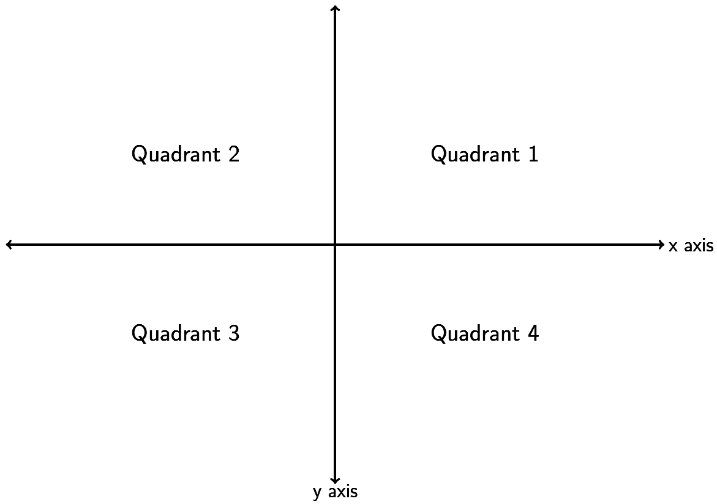

But how do we graph an ordered pair? Find the value on the x-axis and the y-axis and go where the two meet. If you notice it makes an imaginary rectangle. This is why we call this the Rectangular Coordinate System.

Look at the ordered pair (4 , -3). Find 4 on the x-axis and -3 on the y-axis. Where the two meet is the ordered pair ( 4 , -3 ). We often call ordered pairs “points” since we draw a dot to represent that ordered pair.

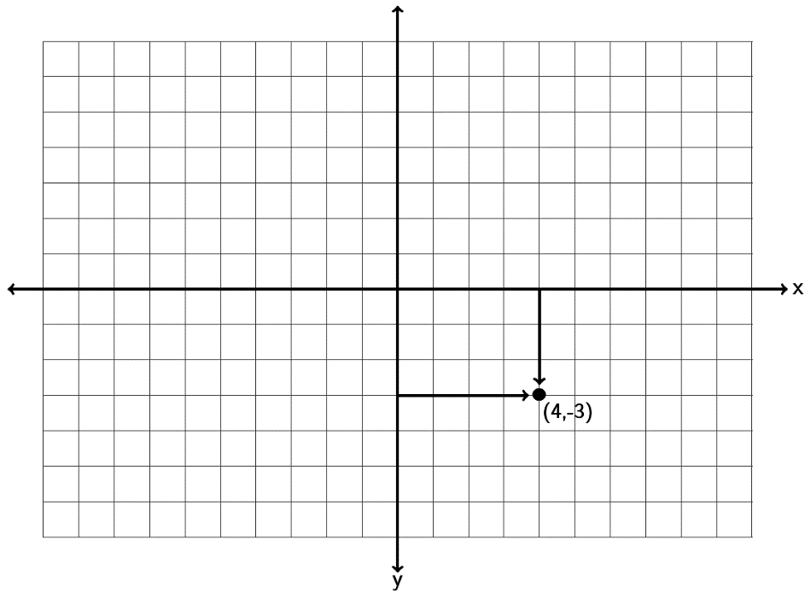

Now let’s plot some more ordered pairs and make a scatterplot. Let’s plot the points (-4 , 2) , (0 , -5) , (6, 0) and (3, 5). Notice that (-4,2) is in quadrant 2 and (3,5) is in quadrant 1. (0 , -5) is a special point as it lies on the y-axis. It is therefore called a “y-intercept.” (6,0) lies on the x-axis so it is called an   
“x-intercept.” Points that lie on an axis are not in any particular quadrant. Notice that a y-intercept has an x-coordinate of zero, while an x-intercept has a y-coordinate of zero.

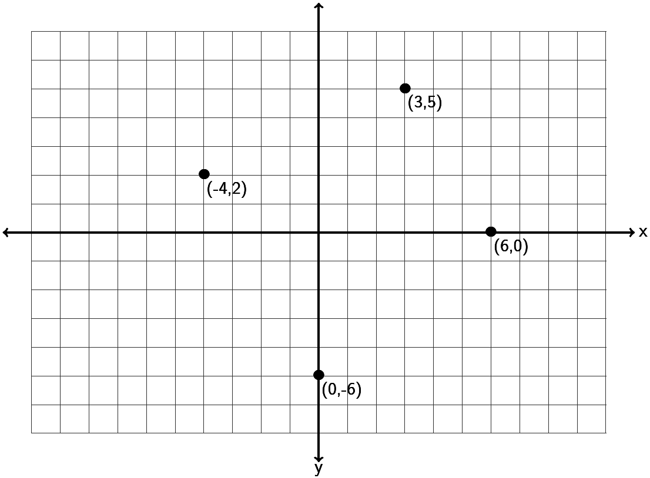

Do the following example with your instructor.

Example 1: Graph the ordered pairs (-3 , -6) , (0,4) , (5, 3) , (-6 , 0) , (4 , -5) on the graph provided. Which point is an x-intercept? Which point is a y-intercept? For the other three points, give the quadrant they lie in.

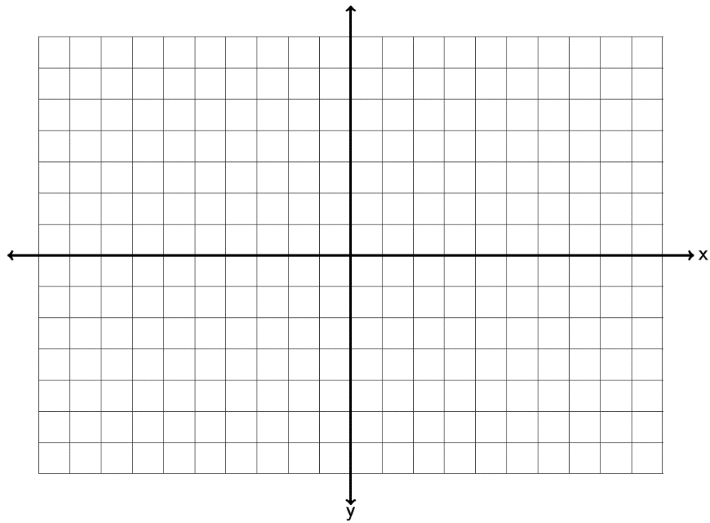

Plotting ordered pairs is vital to finding relationships between variables. Look at the profit data at the beginning of this section. If we plot all of those points we have the following scatterplot.

**Scatterplot**

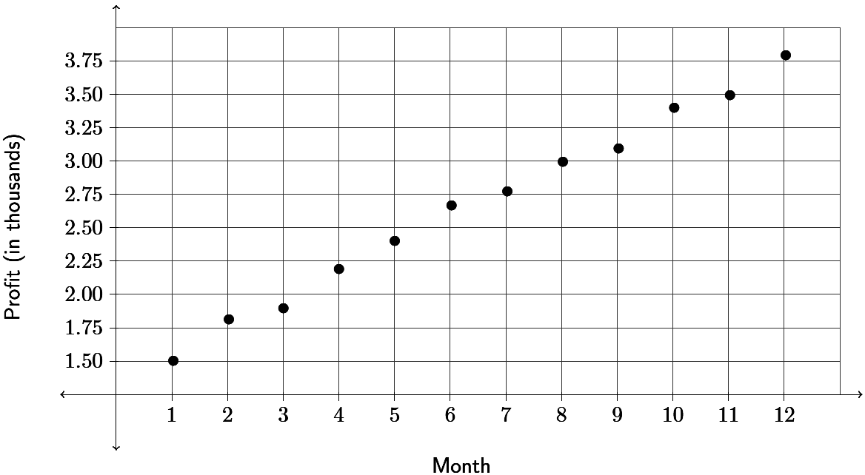

Since all the x and y coordinates are positive in the profit data, the points are all in the first quadrant. The scatterplot is just showing the first quadrant. In scatterplots we look for general trends. For example in this scatterplot, the points look pretty close to a line which suggests a linear trend. It seems as time increases, the profits for the cupcake shop are also increasing.

**Practice Problems Section 7A**

1. Graph the ordered pairs (2 , -6) , (-3,0) , (-1, 4) , (0 , 4) , (-1 , -3) on the graph provided. Which point is an x-intercept? Which point is a y-intercept? For the other three points, give the quadrant they lie in.



2. Graph the ordered pairs (4 , 2) , (0,-1) , (-6, -2) , (3 , 0) , (-1 , -6) on the graph provided. Which point is an x-intercept? Which point is a y-intercept? For the other three points, give the quadrant they lie in.



3. Graph the ordered pairs (-3 , 2) , (-2,0) , (-7, -4) , (0 , 0) , (4 , -1) on the graph provided. Which point is an x-intercept? Which point is a y-intercept? For the other three points, give the quadrant they lie in.



4. Graph the ordered pairs (2.5 , 3.5) , (0,4.5) , (-5.25 , -3.3) , (-5.5 , 0) ,  on the graph provided. Which point is an x-intercept? Which point is a y-intercept? For the other three points, give the quadrant they lie in.



5. Graph the ordered pairs (-3 , -1) , (-5,0) , (4, -3) , (0 , 1) , (-4 , 6) on the graph provided. Which point is an x-intercept? Which point is a y-intercept? For any points not on the x-axis or y-axis, give the quadrant they lie in.



6. Graph the ordered pairs (6 , 1) , (0,-5) , (-2, -4) , (4 , 0) , (-6 , 5) on the graph provided. Which point is an x-intercept? Which point is a y-intercept? For any points not on the x-axis or y-axis, give the quadrant they lie in.



7. Graph the ordered pairs (-6 , 2) , (-3,0) , (-4, -5) , (0 , 0) , (5 , -1) on the graph provided. Which point is an x-intercept? Which point is a y-intercept? For any points not on the x-axis or y-axis, give the quadrant they lie in.



8. Graph the ordered pairs (-1.25 , 4.5) , (0 , -1.33) , (5.5 , -2.3) , (3.5 , 0) ,  on the graph provided. Which point is an x-intercept? Which point is a y-intercept? For any points not on the x-axis or y-axis, give the quadrant they lie in.

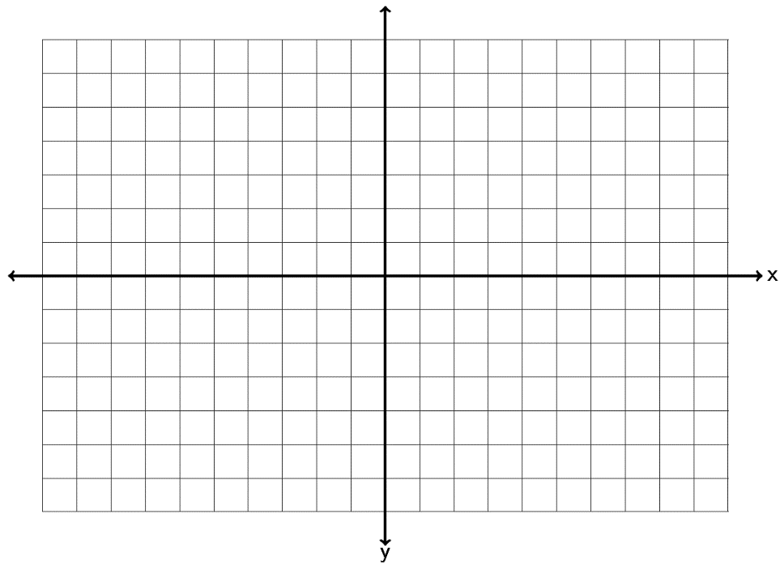

9. Graph the ordered pairs (6 , -6) , (-7,0) , (-1, 7) , (0 , 6) , (-5 , -3) on the graph provided. Which point is an x-intercept? Which point is a y-intercept? For any points not on the x-axis or y-axis, give the quadrant they lie in.



10. Graph the ordered pairs (-3.5 , 2.5) , (0 , -0.5) , (-3.5, -6.5) , (-6.5 , 0) , (-5.5 , -1) on the graph provided. Which point is an x-intercept? Which point is a y-intercept? For any points not on the x-axis or y-axis, give the quadrant they lie in.



11. Graph the ordered pairs (-4 , -1.25) , (-2.5 , 0) , (-7.25, -4) , (0 , 0) , (4.25 , -3.25) on the graph provided. Which point is an x-intercept? Which point is a y-intercept? For any points not on the x-axis or y-axis, give the quadrant they lie in.



12. Graph the ordered pairs (6.75 , 3.25) , ( 0 , -4.75) , (-4.25 , -6.3) , (-5.25 , 0.75) ,  on the graph provided. Which point is an x-intercept? Which point is a y-intercept? For any points not on the x-axis or y-axis, give the quadrant they lie in.



13. The following scatterplot looks at 13 breakfast cereals and the relationship between grams of sugar (x) and grams of fiber (y).

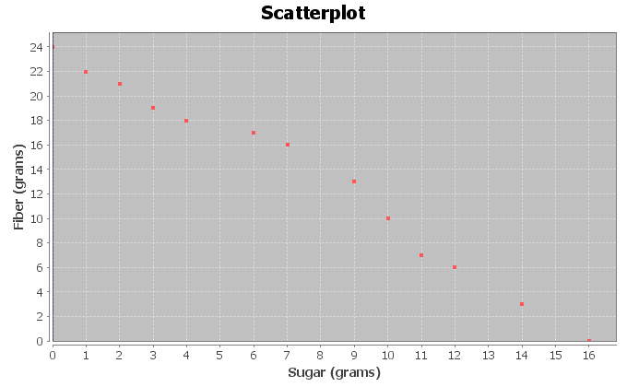

1. For each ordered pair, give the x and y-coordinates. Which is the x-intercept? Which is the y-intercept?
2. Do the points seem to be close to a line? If so does the line go up or down from left to right?
3. Complete the following sentence: As the amount of sugar increases, the amount of   
   fiber _________________.
4. Complete the following sentence. As the amount of sugar decreases, the amount of  
   fiber _________________.

14. The following scatterplot looks at 13 breakfast cereals and the relationship between carbohydrates (x) and total calories (y).

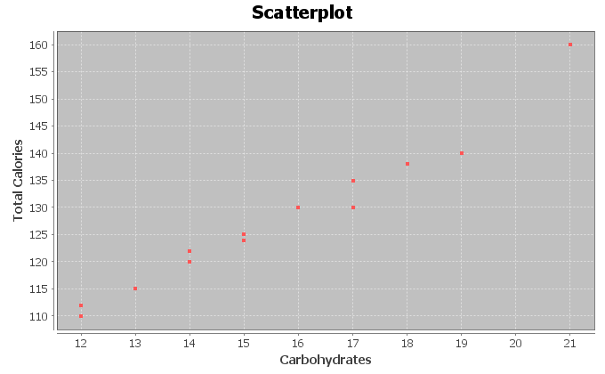

1. For each ordered pair, give the x and y-coordinates. Which quadrant are all these points in?
2. Do the points seem to be close to a line? If so does the line go up or down from left to right?
3. Complete the following sentence: As the number of carbs increases, the total number of calories _________________.
4. Complete the following sentence. As the number of carbs decreases, the total number of calories _________________.

**Section 7B – Slope of a Line and Average Rates of Change**

IBM stock had a price of $186.91 at the end of September 2014. Over the next three months the stock price rose and fell and by the end of December the price was $160.44. Over that three month period, what was the average rate of change of the stock price per month? Questions like this are key to understanding stock prices and business models. How much something is changing on average is often called the “Slope”. In this chapter we will seek to understand the concept of slope and its applications.

What it slope? Slope is defined as vertical change divided by horizontal change. In terms of ordered pairs it is change in y divided by change in x. In math we sometimes write the change in y as “” and the change in x as “”. The symbol  is the Greek letter delta. Remember slope is best understood as a fraction that describes change between variables.

Look at the following graph. Let’s see if we can find the slope of the line.

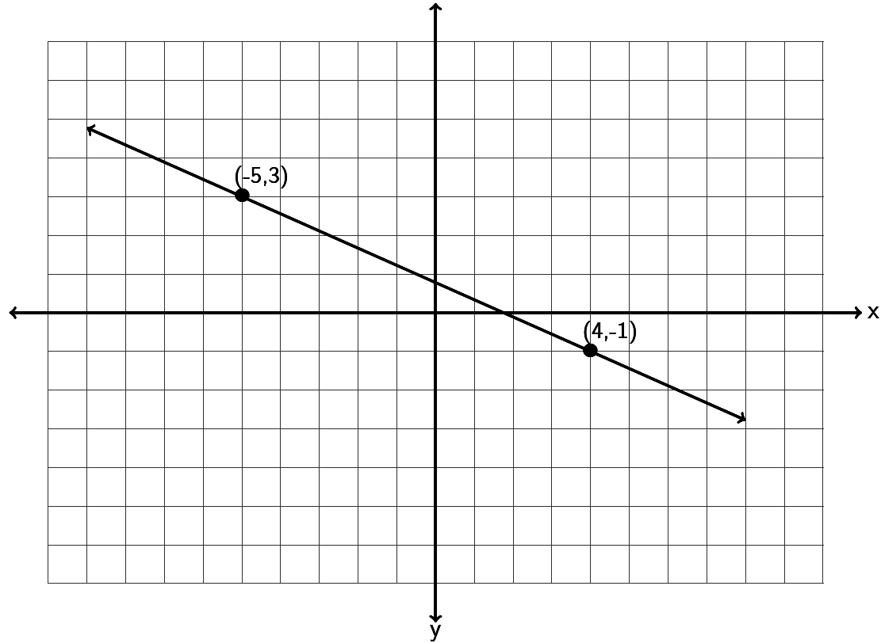

To find the slope of a line, always start by trying to find two points on the line. This line goes through the points (-5,3) and (4,-1). Any two points on the line you use will still give you the same slope. If we start at (-5,3) and go down and to the right to (4,-1) , can you find how much it goes down (vertical change) and how much it goes to the right (horizontal change). Notice to get from one point to the other, we had to go down 4 (-4 vertical change) and right 9 (+9 horizontal change). Remember going up or to the right are positive directions, while going down or to the left are negative directions. The slope is the fraction of the vertical change divided by the horizontal change. Notice that a negative number divided by a positive number gives you a negative answer.



Does the order we pick the points matter? What if we start at (4,-1) and go up and to the left to (-5,3)? Will we get a different slope? Let’s see. To go from (4,-1) to (-5,3) we would need to go up 4 (+4 vertical change) and left 9 (-9 horizontal change). So we would get the following.



Notice the slope is the same. So to review, when we find slope it does not matter the points we pick as long as they are on the line and it does not matter the order we pick them. All will give us the same slope.

Let’s look at a second example. Suppose a line goes through the point (-2, -4) and has a slope of 3. Could you draw the line? The first thing to remember when dealing with slope is that it should be a fraction. Can you write 3 as a fraction? Of course.  , but what does that mean? Remember slope is the vertical change divided by the horizontal change so we see the following interpretation.



When using the slope to graph a line, you always need a point to start at. In this case we will start at   
(-2,-4) and then go up 3 and right 1. You can go up 3 and right 1 as many times as you want and can get more points.  
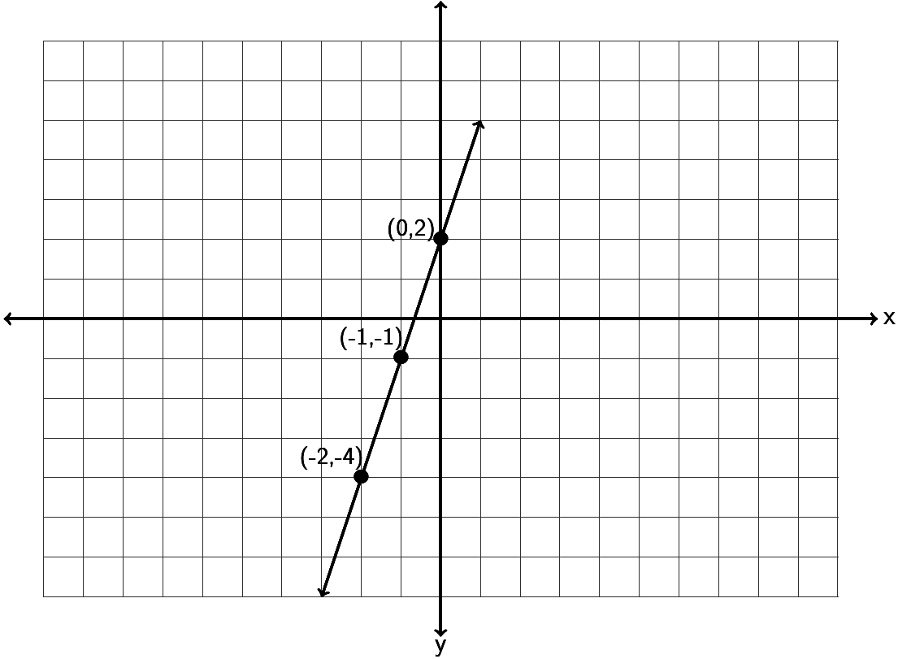

Notice a couple things from the last two examples.

A line with positive slope will be increasing from left to right. A line with negative slope will be decreasing from left to right.

For lines with a negative slope it is better to think of it as a negative numerator and a positive denominator. For example a slope of  . Do not put the negative sign in both the numerator and denominator. . A negative divided by a negative is positive.

Try the following examples with your instructor.

Example 1: Find the slope of the following line by finding the vertical and horizontal change. Be sure to write your answer in lowest terms.

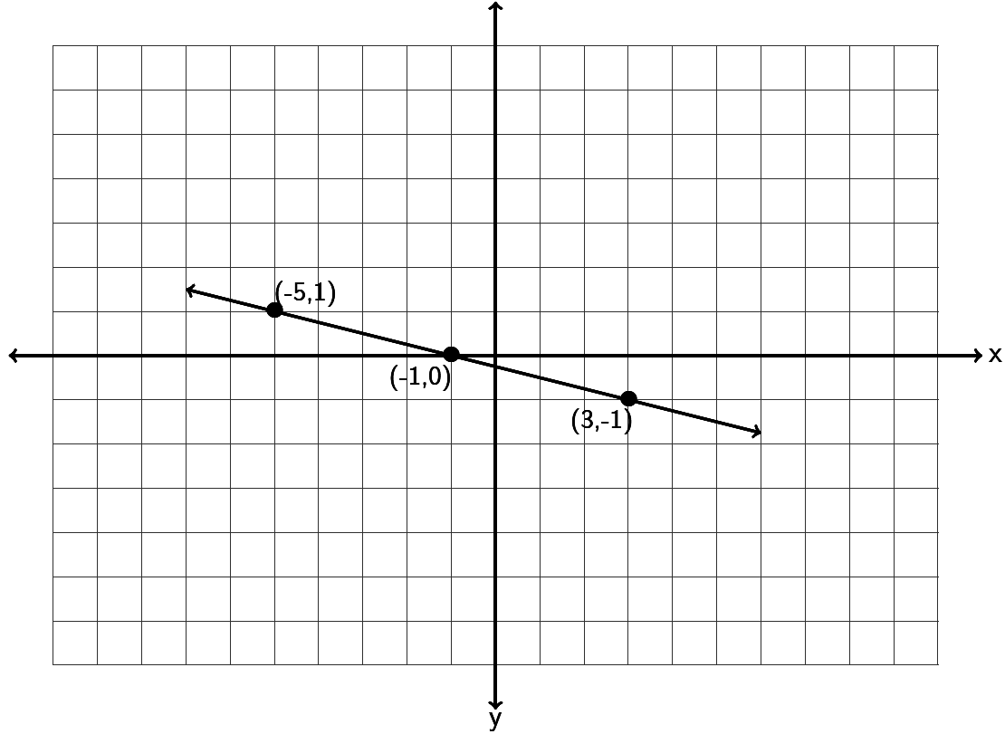

Example 2: Find the slope of the following line by finding the vertical and horizontal change.

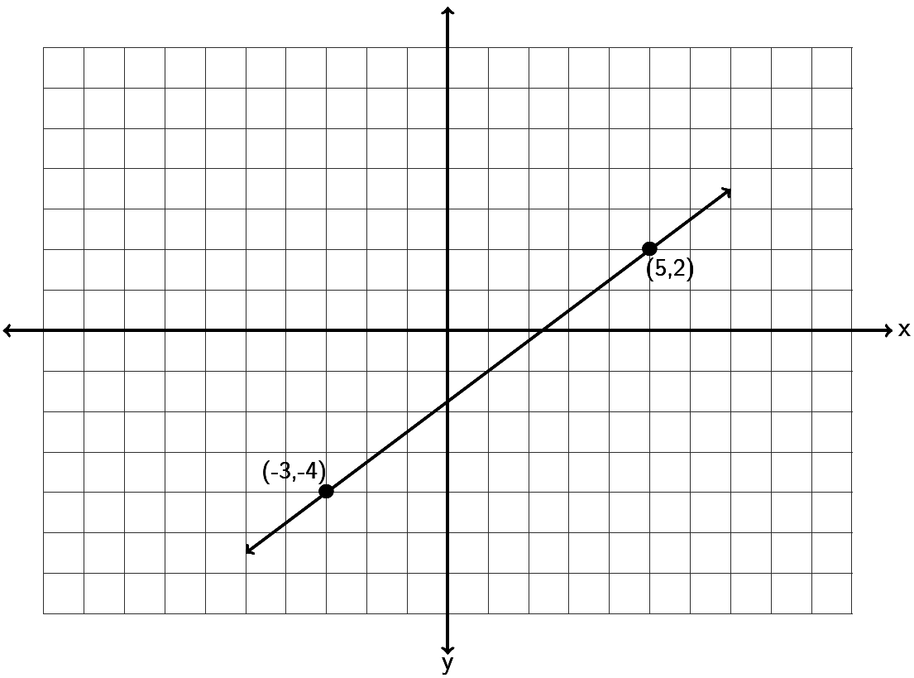

Example 3: Draw a line that goes through the point (-6, 2) and has a slope of  .

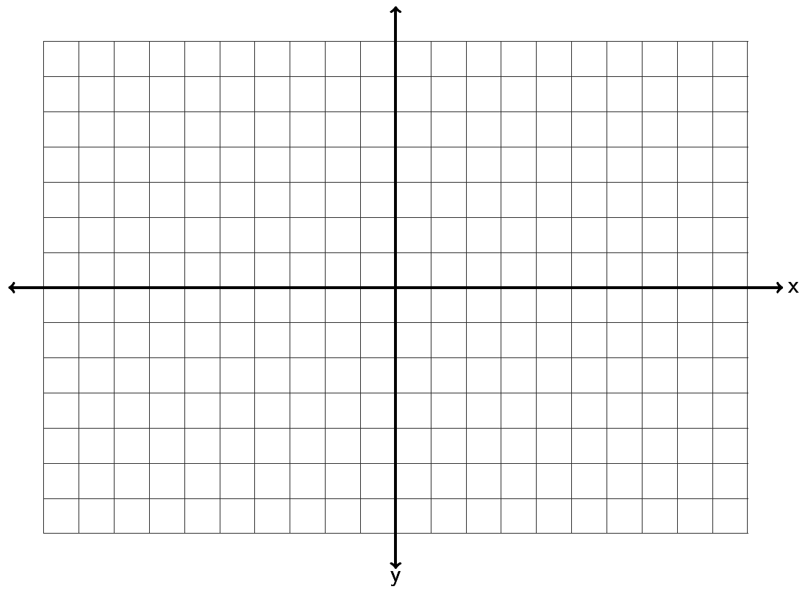

Example 4: Draw a line that goes through the point (-3, -4) and has a slope of  .



What do we do if we want to find the slope between two points, but do not want to take the time to graph the points?

To get the vertical change you can subtract the y-coordinates of the two points. To get the horizontal change, your can subtract the x-coordinates of the two points. Be careful! You need to subtract in the same order. Here is the formula. The slope *(m)* of the line between  is



For example, find the slope of the line between (-7 , 6) and (-3, -4). Identify one of the points as  and the other point as . Remember, with slope it does not matter which point you start with. Suppose we let  be (-7 , 6) and let  be (-3, -4). Plugging in the correct values into the formula gives the following.

. Be careful to subtract in the correct order. Also be careful of negative signs. You may need to subtract a negative. Simplifying gives the following.



Try the following example with your instructor.

Example 5: Find the slope of the line between . Be sure to simplify your answer and write it in lowest terms.

What about the slope of horizontal lines? Horizontal lines change a lot horizontally but have zero vertical change. Hence the slope of a horizontal line is  . So horizontal lines are the only lines that have a slope equal to zero.

What about the slope of vertical lines? Vertical lines have tons of vertical change but have zero horizontal change. Hence the slope of a vertical line is  . Remember we cannot divide by zero. So vertical lines are the only lines that do not have a slope. We say the slope is undefined or does not exist.

A key point to remember is that horizontal lines have a slope = 0, while vertical lines do not have any slope at all (undefined). This is actually one of the ways we identify horizontal and vertical lines.

Try the following examples with your instructor.

Example 6: Find the slope of the following line.

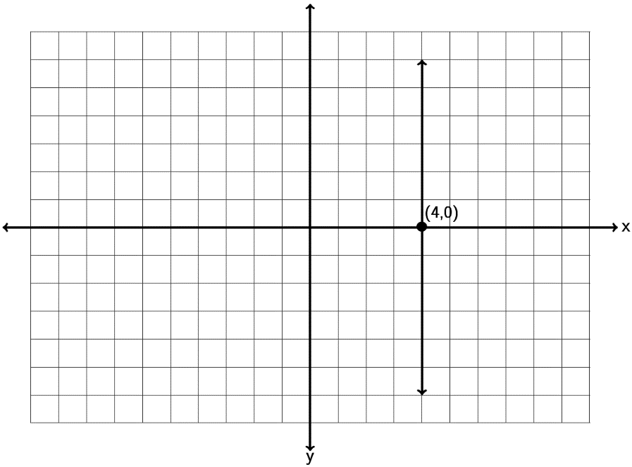

Example 7: Find the slope of the following line.

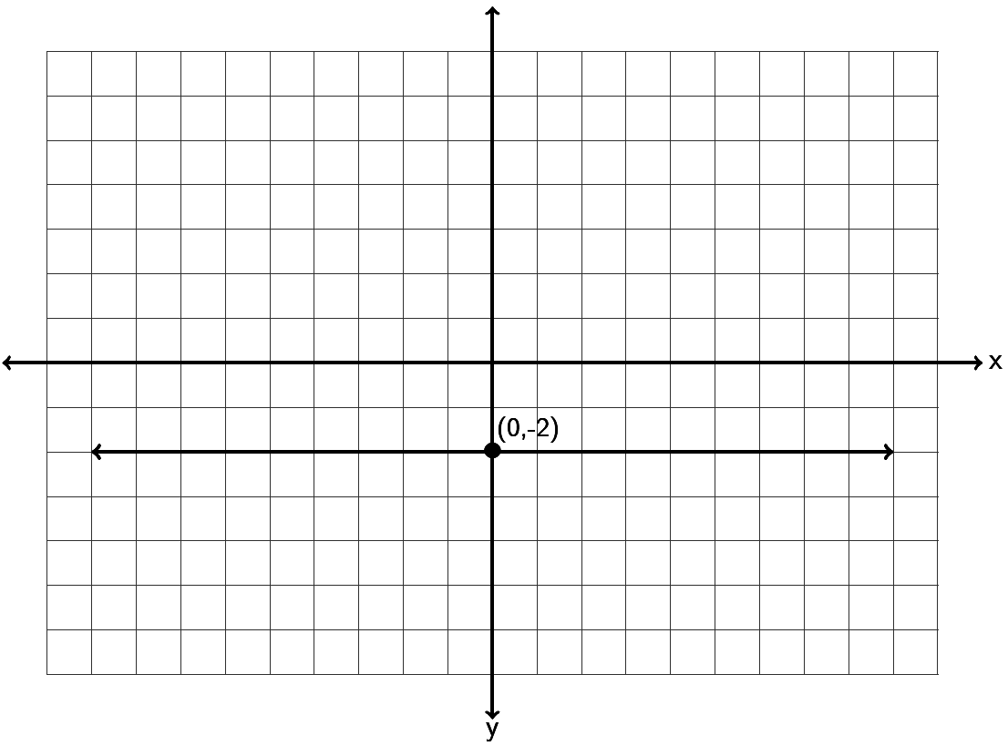

Parallel lines go in the same direction, so they have the same slope. If a line has a slope of 1/3 , then the line parallel to it will also have a slope of 1/3.

Perpendicular lines are lines which meet at a right angle (exactly 90 degrees). Perpendicular lines have slopes that are the opposite or negative reciprocal of each other. Remember a reciprocal is flipping the fraction. The slope of a perpendicular line will not only flip the fraction but will also have the opposite sign. For example if a line has a slope of 2/7 then the perpendicular line will have a slope of -7/2. If a line has a slope of -1/6 then the line perpendicular will have a slope of +6/1 = +6.

Try the following examples with your instructor.

Example 8: A line has a slope of -3/7. What is the slope of a line parallel to it? What is the slope of a line perpendicular to it?

Example 9: A line has a slope of +9. What is the slope of a line parallel to it? What is the slope of a line perpendicular to it?

Applications

At the beginning of this section we looked at IBM stock prices for a 3 month period in 2014. The slope is also the average rate of change. IBM stock had a price of $186.91 at the end of September 2014. Over the next three months the stock price rose and fell and by the end of December the price was $160.44. Over that three month period, what was the average rate of change of the stock price per month?

To answer this question we simply need to find the slope. A couple key things to look at. First of all notice they want to know the change in stock price per month. That is important since it tells us the slope should be price/month. If you remember your slope formula, this implies that the price must be the y-value and month the x-value. Writing the information as two ordered pairs gives us the following.

( month 9 , $186.91 )

( month 12, $160.44)

Letting the first point ( month 9 , $186.91 ) be  and the second point   
( month 12, $160.44) be , we can plug into our slope formula and get the following.



But what does this mean? The key is units. Remember in this problem the y-values were in dollars and the x-values were in months. So the numerator of our answer is in dollars and the denominator is in months.

 Does this mean 1 month of IBM stock was $8.82? No it does not. Remember slope is a rate of change. It is telling us how much the IBM stock is changing over time. It is also negative, so that tells us the stock price is decreasing. So the slope tells us that IBM stock price was decreasing at a rate of $8.82 per month.

Try the following example with your instructor.

Example 10: A bear that is 50 inches long weighs 365 pounds. A bear 55 inches long weighs 446 pounds. Assuming there is a linear relationship between length and weight, find the average rate of change in pounds per inch.

**Practice Problems Section 7B**

1. Find the slope of the following line by finding the vertical and horizontal change. Be sure to write your answer in lowest terms.

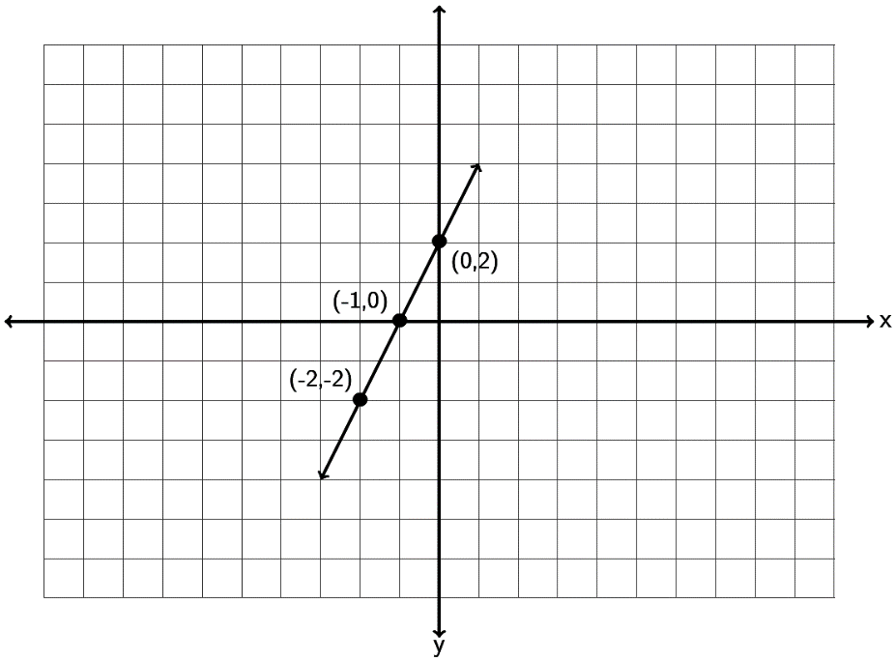

2. Find the slope of the following line by finding the vertical and horizontal change. Be sure to write your answer in lowest terms.

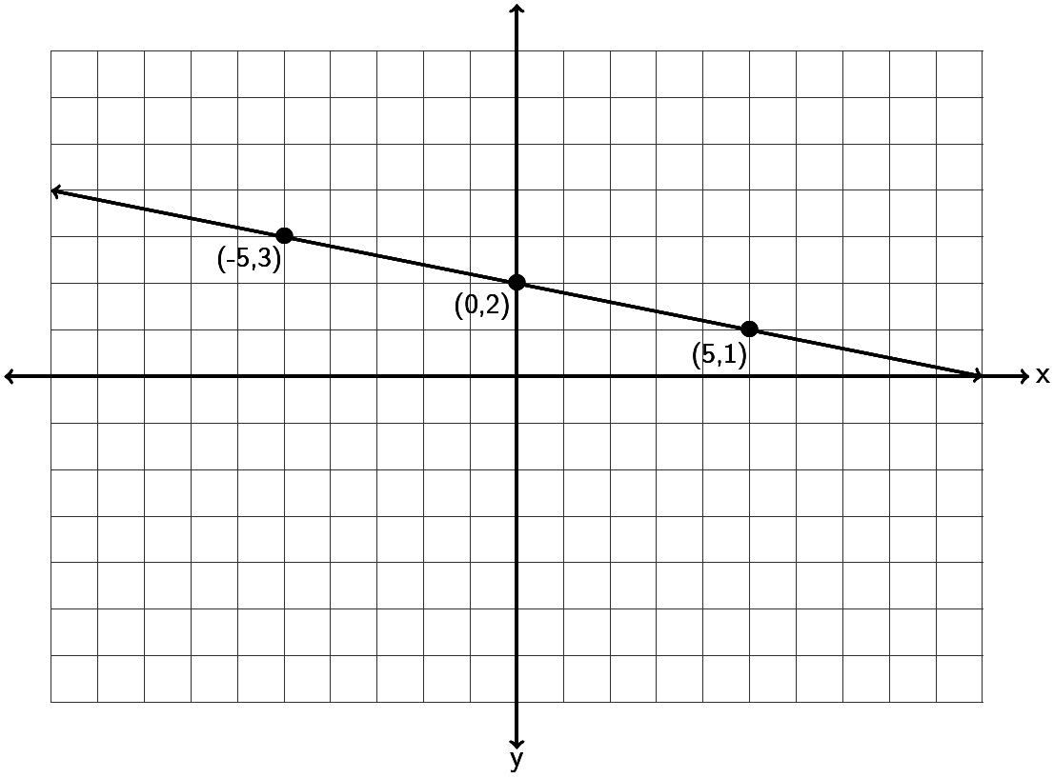

3. Find the slope of the following line by finding the vertical and horizontal change. Be sure to write your answer in lowest terms.

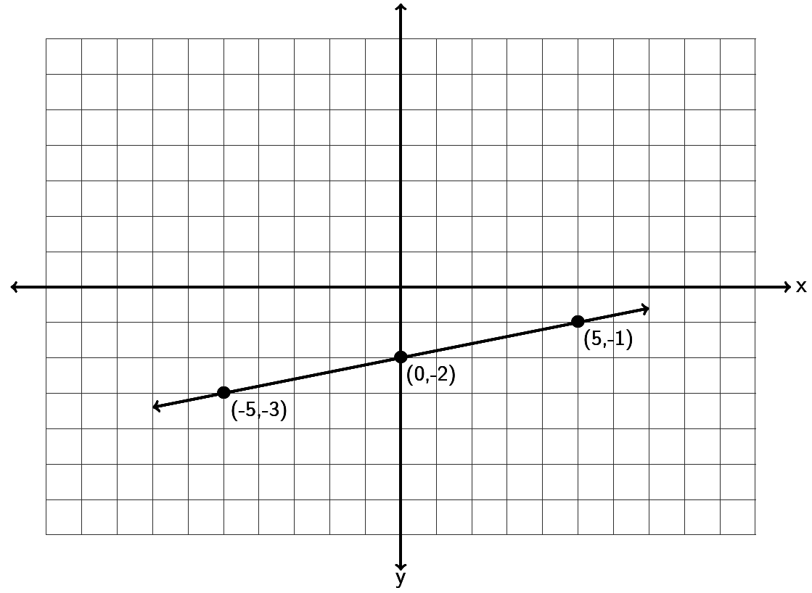

4. Find the slope of the following line by finding the vertical and horizontal change. Be sure to write your answer in lowest terms.

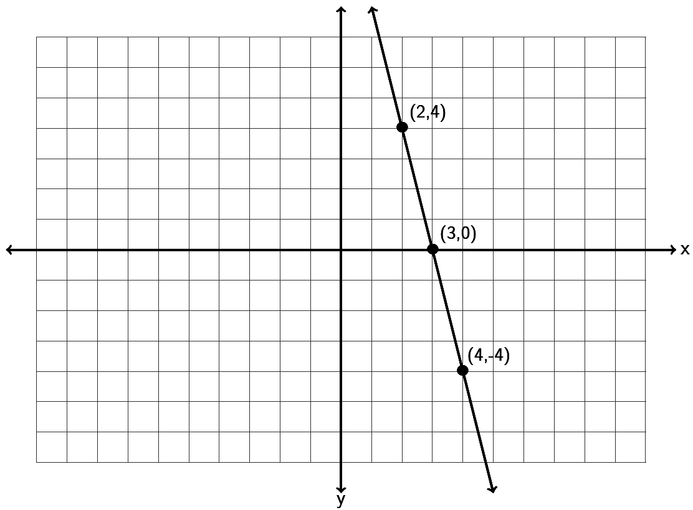

5. Find the slope of the following line by finding the vertical and horizontal change. Be sure to write your answer in lowest terms.

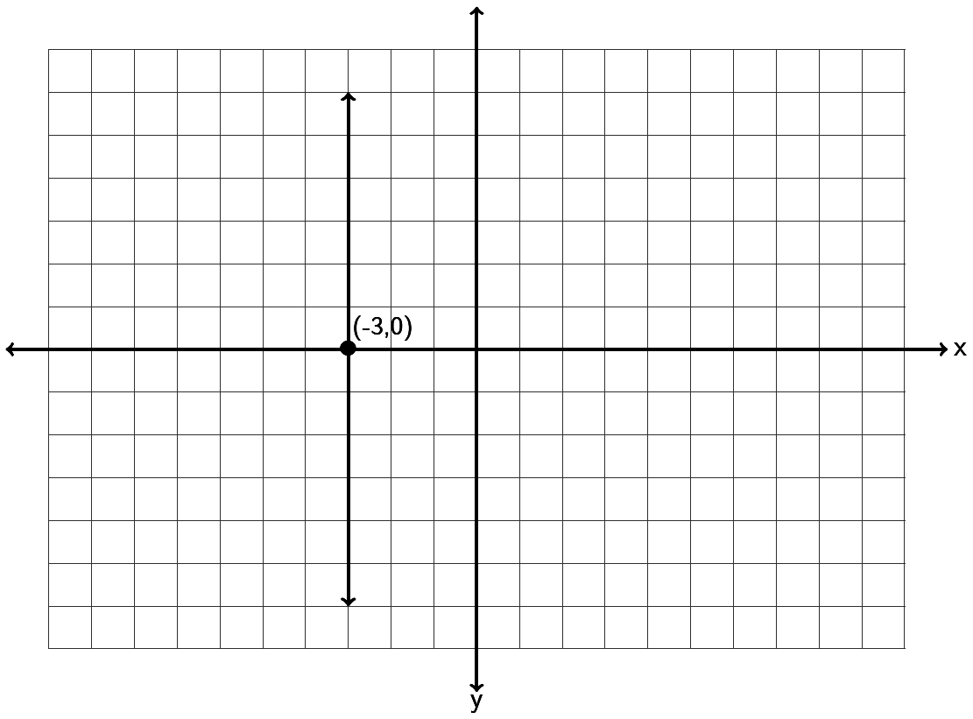

6. Find the slope of the following line by finding the vertical and horizontal change. Be sure to write your answer in lowest terms.

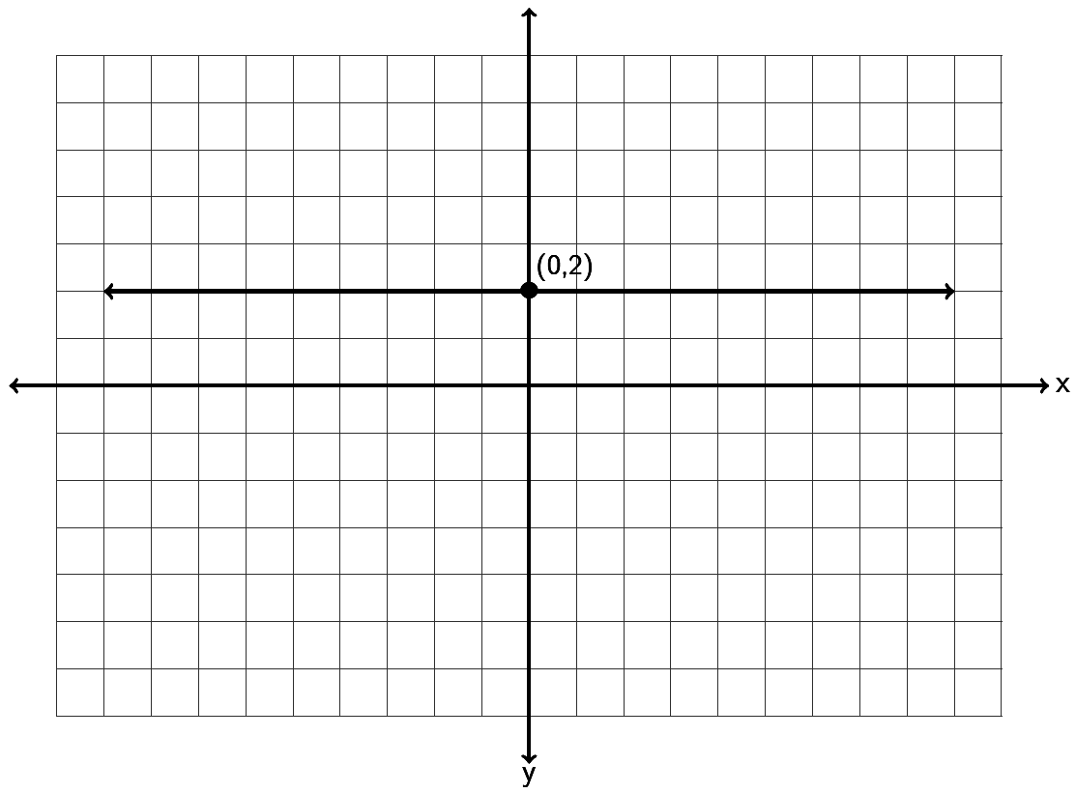

7. Draw a line that goes through the point (1, 2) and has a slope of  .



8. Draw a line that goes through the point (-5, 1) and has a slope of  .



9. Draw a line that goes through the point (-6, -4) and has a slope of  .



10. Draw a line that goes through the point (-4,0) and has a slope of  .



11. Draw a line that goes through the point (3 , 1) and has an undefined slope.



12. Draw a line that goes through the point (0 , -3) and has a slope = 0 .



13. Draw a line that goes through the point (-5, -2) and has a slope of  .



14. Draw a line that goes through the point (-4, 6) and has a slope of  .



15. Draw a line that goes through the point (1, -6) and has a slope of  .



16. Draw a line that goes through the point (2,0) and has a slope of  .



17. Draw a line that goes through the point (-4 , -2) and has an undefined slope.



18. Draw a line that goes through the point (0 , 5) and has a slope = 0 .



19. Use the slope formula to find the slope of the line between . Be sure to simplify your answer and write it in lowest terms.

20. Use the slope formula to find the slope of the line between . Be sure to simplify your answer and write it in lowest terms.

21. Use the slope formula to find the slope of the line between Be sure to simplify your answer and write it in lowest terms.

22. Use the slope formula to find the slope of the line between . Be sure to simplify your answer and write it in lowest terms.  
23. Use the slope formula to find the slope of the line between . Be sure to simplify your answer and write it in lowest terms.

24. Use the slope formula to find the slope of the line between . Be sure to simplify your answer and write it in lowest terms.

25. Use the slope formula to find the slope of the line between . Be sure to simplify your answer and write it in lowest terms.

26. A line has a slope of +5/8. What is the slope of a line parallel to it? What is the slope of a line perpendicular to it?

27. A line has a slope of -13. What is the slope of a line parallel to it? What is the slope of a line perpendicular to it?

28. A line has a slope of -2/9. What is the slope of a line parallel to it? What is the slope of a line perpendicular to it?

29. A line has a slope of +6. What is the slope of a line parallel to it? What is the slope of a line perpendicular to it?

30. A line has a slope of +2/7. What is the slope of a line parallel to it? What is the slope of a line perpendicular to it?

31. A line has a slope of -9. What is the slope of a line parallel to it? What is the slope of a line perpendicular to it?

32. When a toy store has its employees work 40 hours a week, the profits for that week are $4600. If the store has its employees work 45 hours then the profits for that week are $4180 due to having to pay the employee’s overtime. Write two ordered pairs with x being hours worked and y being profit. What is the average rate of change in profit per hour worked?

33. The longer an employee works at a software company, the higher his or her salary is. Let’s explore the relationship between years worked (x) and salary in thousands of dollars (y). A person that has worked two years for the company makes an annual salary of 62 thousand dollars. A person that has worked ten years for the company makes an annual salary of 67 thousand dollars. Write two ordered pairs and find the average rate of change in salary in thousands per year worked.

34. The older a puppy gets, the more the puppy weighs. Let’s explore the relationship between the number of months old a puppy is and its weight in pounds. At 4 months old, a puppy weighed 6 pounds. At 12 months old the puppy weighed 38 pounds. Write two ordered pairs with x being the age of the puppy in months and y being the weight in pounds. Now find the average rate of change in pounds per month.

35. In week 9, a stock sells for $85. By week 23 the stock sells for $15. Write two ordered pairs with x being the week and y being the stock price. Find the average rate of change in dollars per week.

**Questions 36 – 39: Match the equation in slope intercept form to the graphed line**

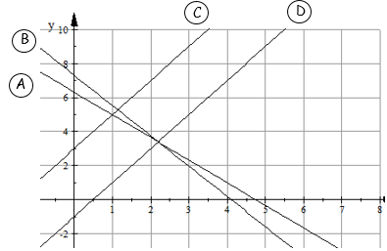

|  |  |
| --- | --- |
| Line | Equation |
| 36. | $$y = 2x – 1$$ |
| 37. | $$y = 6.3 - 1.33x$$ |
| 38. | $$y = -1.78x + 7.3$$ |
| 39. | $$y = 3 + 2x$$ |

**Section 7C – Finding the Equation of a Line**

When we discover a linear relationship between two variables, we often try to discover a formula that relates the two variables and allows us to use one variable to predict the other. At the beginning of this chapter, we said we might like to explore the relationship between the unemployment rate each year and U.S. national debt each year. For example in 2009 the national debt was 11.9 trillion dollars and the unemployment rate was about 9.9 percent. By 2013 the national debt had increased to 16.7 trillion dollars and the unemployment rate had fallen to 6.7 percent. If there is a linear relationship between national debt and unemployment, could we find an equation that might predict the unemployment rate if we know the national debt? Questions such as these are a big part of regression theory in statistics, but how do we find a linear equation such as this?

Slope-Intercept Form

The equation of a line can take many different forms. The one form most widely used and understood is called “Slope-Intercept Form”. It is the equation of a line based on the slope and the y-intercept (where the line crosses the y-axis).

The equation of a line with slope *m* and y-intercept *( 0 , b )* is given by the equation  . Note that the *m* and the *b* are numbers we plug in. The equation of a line should have x and y in the equation as we need these to use the formula to calculate things.

For example, find the equation of a line with slope  and a y-intercept of  . It is important to remember that the *b* is the y-intercept and a point on the y-axis always has 0 as its x-coordinate. So all we would need to do to find the equation is to replace *m* with  and replace *b* with 4 and we would get the following:



This is the answer, the equation of the line.

Slope-intercept form is really a great form for the equation of a line. For example, it is very easy to graph lines when we have their equation in slope-intercept form. To graph the equation  , we would note that the y-intercept is 4 and the slope is -3/5. So we would start by placing a dot at 4 on the y-axis (vertical axis).

Now since the slope is -3/5 we translate that as:

So we will start at the y-intercept 4 and go down 3 and right 5 and put another dot. Now draw the line.

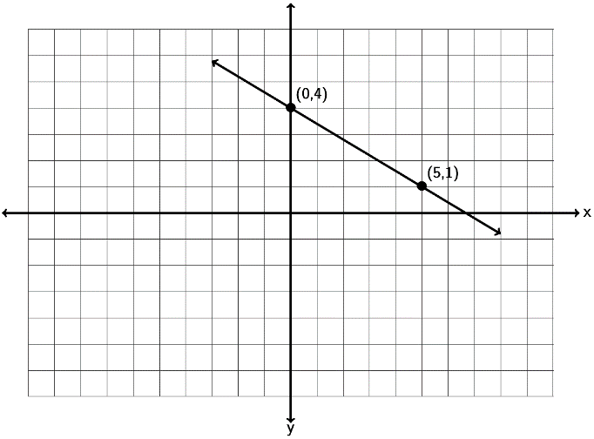

Try a couple examples with your instructor.

Example 1: Graph a line with a y-intercept of ( 0 , -3) and a slope of  . What is the equation of the line you drew in slope-intercept form?



Example 2: Graph a line with a y-intercept of ( 0 , +5) and a slope of  . What is the equation of the line you drew in slope-intercept form?



Note: It is important to remember that the *b* in the slope-intercept form is the y-intercept and not the y-coordinate of some general point. For example if a line goes through (4,-1) , that does not mean that -1 is the *b*. The *b* must be the y-coordinate when the x is zero. So if the line goes through the point (0 , 2) then the *b* is 2 because (0,2) lies on the y axis.

If an equation is not in slope-intercept form there are a couple ways to graph the line. Look at the following example.

Graph the line  .

The first method would be to put the equation in slope intercept form by solving for y. Notice we would get the following.



Since the slope-intercept form of the line  is  we can simply use the   
y-intercept (0,2) and the slope +2/1. So start at 2 on the y axis and go up 2 and right 1 to get another point.

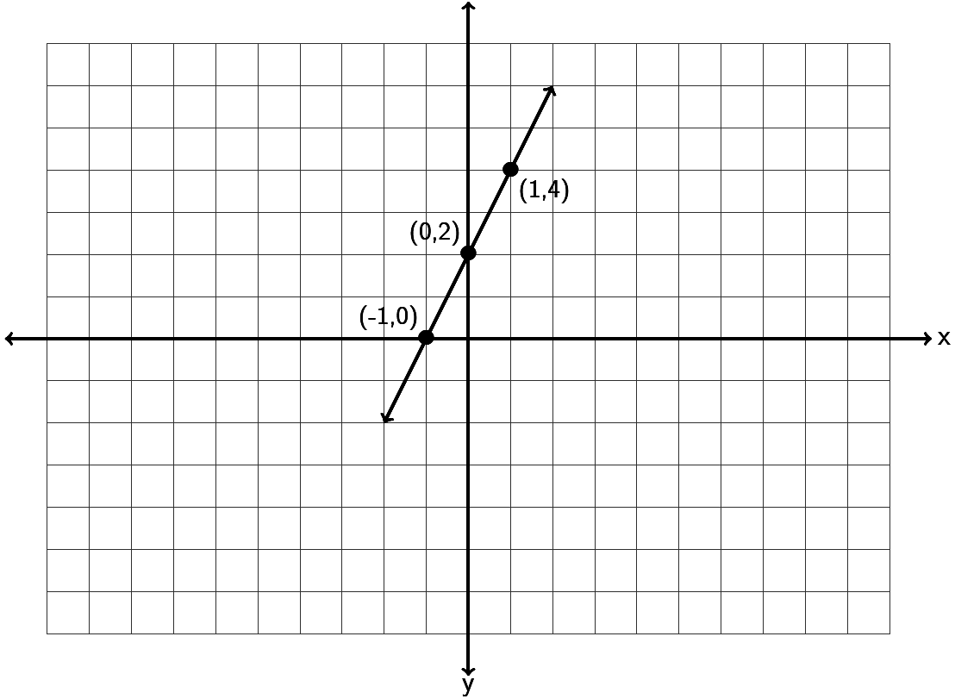

Let’s do the previous problem again, but with a different method. If an equation of a line is in standard form Ax + By = C, often an easy way to graph the line is by finding the x and   
y-intercepts. If you remember x-intercepts have y-coordinate 0, so we would plug in 0 for y and solve for x. y-intercepts on the other hand have x-coordinate zero, so we would plug in 0 for x and solve for y. Once we find the x and y-intercepts we can draw the line.

Look at . To find the x-intercept plug in 0 for y and solve.



So the x-intercept is (-1 , 0)

To find the y-intercept plug in 0 for x and solve.



So the y-intercept is (0 , 2)

Graphing both the x and y-intercepts gives us the following line. Notice it is the same as if we had used the slope-intercept form.

Slope-intercept form can also be used to give the equation of a line when you have the line graphed. Look at the following graph. See if you can find the slope *m* and the y-intercept (0,*b*) and the equation of the line .

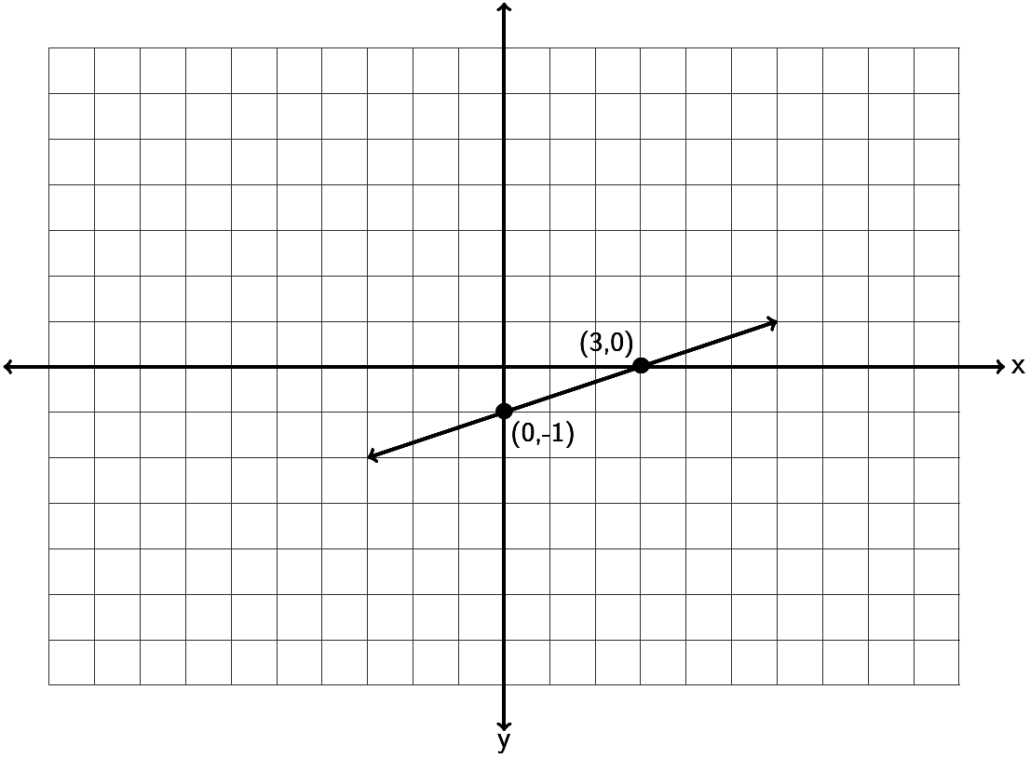

Notice the line crosses the vertical axis (y axis) at -1. Technically the ordered pair for the   
y-intercept is ( 0 , -1 ) but from this we can see that *b = -1.* To find the slope, we measure the vertical and horizontal change. Notice if we start at ( 0 , -1) we can go up 1 (+1 vertical change) and right 3 (+3 horizontal change) before getting another point on the line. Therefore the slope must be +1/3. Hence the equation of this line is  . Since adding -1 is the same as subtracting 1 we can also write the equation as .

Try the next one with your instructor.

Example 3: Find the equation of the line in slope-intercept form described by the following line. Remember, you will need to find the slope *m* and the y-intercept *(0,b)* first.

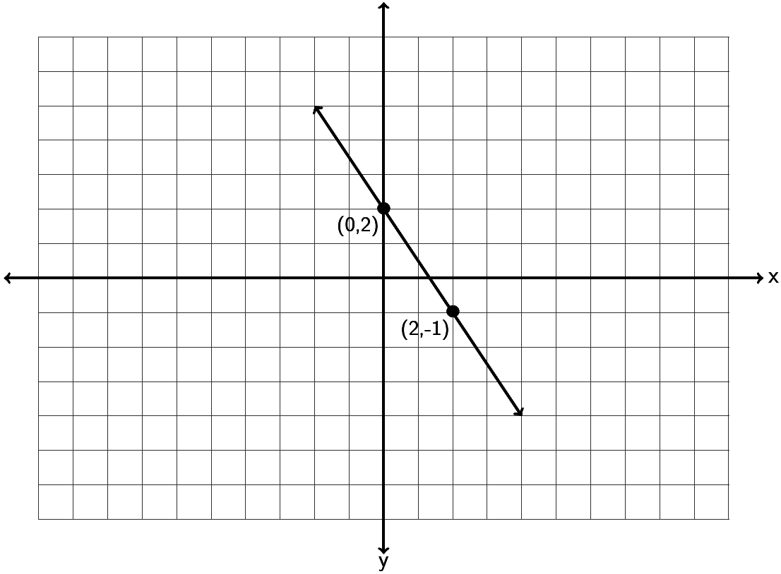

Earlier we said that if the x-coordinate is not zero, then the y-coordinate is not the *b.* What do we do then if we know the slope but only know a point on the line that is not the y-intercept?

There are several ways to find the equation. Probably the easiest way is to use the following formulas.

To find the equation of a line with slope *m* and passing through a point  that is not the y intercept use the following:

The equation is  where *m* is the slope and  .

For example, find the equation of the line with slope  and passing through the point  
 ( -1 , -11 ). Again, it is important to note that the point given to us does not lie on the y-axis and therefore -11 is not the *b.* We know the slope, so . To find *b,* plug in the slope *m* ,  
 -1 for  and -11 for  into the formula

. We will get the following:



So to find the equation of this line we replace *m* with  and *b* with  and get  . Again adding -4 is the same as subtracting 4, so we can also write the equation as  .

Let’s look at another example, find the equation of the line with slope  and passing through the point ( 3 , 2 ). Again, it is important to note that the point given to us does not lie on the   
y-axis and therefore 2 is not the *b.* We know the slope, so . To find *b,* plug in the slope *m* , 3 for  and 2 for  into the formula . We will get the following:



So to find the equation of this line we replace *m* with  and *b* with  and get 

Note: Some Algebra classes may reference a “Point-Slope Formula”. This is a formula when you know the slope *m*  and a point . The formula is  . In the last problem with a slope of  and passing through the point ( 3 , 2 ) we would get



If you simplify this and solve for y, you will get the same answer as we did. 

You can find the equation of a line with either method, though we will focus on finding the slope and the y-intercept and plugging into y = mx + b.

Do the next problem with your instructor. Use the formulas  and 

Example 4: Find the equation of a line with a slope of  and passing through the point 

What happens when we want to find the equation of a line, but we do not know the slope? We will need to find the slope first and then the y-intercept. Look at the following examples.

Suppose we want to find the equation of a line between (4 , -3) and (6 , -8)? Again, our overall strategy is to find the slope m and the y-intercept (0,b) and plug them into y = mx + b.

Using the slope formula  we can calculate the slope and get the following.



Notice that we subtracted the y-coordinates to get the vertical change and the x-coordinates to get the horizontal change. The answer can be written as a fraction or decimal. In algebra classes we tend to leave the slope as a fraction, while in Statistics, we usually write the slope as a decimal.

Now that we know the slope is -2.5, we can use it and either of the two points to find the   
y-intercept using the formula .

  
  
So since the *m = -2.5* and the *b = 7* , we get that the equation of the line is y = -2.5x + 7 .

Let’s try another example. Find the equation of a line that is perpendicular to the line  and passing through the point ( 1 , -4).

Notice that for this problem we have a point but it is not the y-intercept. We also have a line perpendicular to the line we are trying to find. We were not given the slope. If you remember from the last section, the slopes of perpendicular lines are opposite reciprocals of each other. Look at the given line . Is this line in slope-intercept form? If it is, then the number in front of the x is the slope of this line. Since this is in y =mx + b form, that means the slope of this line is  , which also means that the slope of the line we are looking for must be the opposite reciprocal  . So now we know that for our line, the slope is . We can plug into the y-intercept formula to find the *b.* Notice we will need a common denominator to find *b.*



So we need to plug in -7/2 for *m* and -1/2 for *b* and we will get an equation of  . We could also write the answer in decimal form which would be y = -3.5x – 0.5 .

Let’s look at a last example. Find the equation of a line parallel to  and passing through the point (-3,5). As with the previous example we will need to find the slope from the line given. The problem is the equation is not in slope-intercept form y = mx + b. This equation is in standard form. The standard form for the equation of a line has the x and y-terms on the same side and they have also eliminated all fractions and decimals in the equation. The number in front of x is not the slope though, because the equation is not solved for y. So our first step is to solve the equation for y.



Notice a few things. To solve for y, we subtract 2x from both sides so that the y-term is by itself. We then divide by -6 on both sides to get y by itself. When the left hand side is divided by -6 we need to divide all the terms by -6 and simplify.

So the slope of this line is +1/3. Since the line we are looking for is parallel, our line also has a slope of *m =* 1/3.

Now we can plug in our point and the slope into the y-intercept formula and find our y intercept.

.

So the equation is  .

Do the following examples with your instructor.

Example 5: Find the equation of a line through the points  and .

Example 6: Find the equation of a line perpendicular to  and passing through the   
point .

Equations of vertical and horizontal lines

If you remember a vertical line has an undefined slope (does not exist) and a horizontal line has slope = 0, but what about the equations for vertical and horizontal lines? In vertical lines, all the points on the line have the same x-coordinate. For example a vertical line through (6,1) would also go through (6,2) , (6,3) , (6,4) and so on. Since all of them have the same   
x-coordinate 6, the equation of a vertical line would be x = 6. In general, vertical lines have equations of the form “x = constant number.”

In horizontal lines, all the points on the line have the same y-coordinate. For example a horizontal line through (6,1) would also go through (4,1) , (5,1) , (7,1) and so on. Since all of them have the same y-coordinate 1, the equation of a horizontal line would be y = 1. In general, horizontal lines have equations of the form “y = constant number.”

For example, suppose we want to find the equation of a line with zero slope through the point . The only line with zero slope is horizontal. Since horizontal lines have equations   
y = constant number, it is just a matter of figuring out what that number would be. Since it goes through the point we know that all points on the line will also have  as their   
y-coordinate. So the equation is simply .

Suppose we want to find the equation of a line perpendicular to y = 8 and passing through the point (7,3). The line y = 8 is a horizontal line through 8, so a line perpendicular to it would have to be vertical. So we are really looking for a vertical line through (7,3). Since vertical lines have formula x = constant number, it is just a matter of figuring what that number is. Since it goes through the point (7,3) then all the points on the vertical line will also have 7 as their   
x-coordinate. So the equation is simply x = 7.

Do the following example problems with your instructor.

Example 7: Find the equation of a line that has undefined slope and goes through the point 

Example 8: Find the equation of a line perpendicular to the y axis and goes through the point 

Two-variable linear equations have tons of applications in algebra, statistics and even calculus. In statistics we call the study of linear relationships “regression” theory. Look at the following example.

In previous sections, we saw that IBM stock had a price of $186.91 at the end of September 2014. Over the next three months the stock price rose and fell and by the end of December the price was $160.44. We found that this information corresponded to two ordered pairs   
( month 9, $186.91 ) and ( month 12 , $160.44). We also found that the slope between those two points is also called the average rate of change and came out to be about -$8.82 per month. If this linear trend continues, what do we predict will be the price of IBM stock in future months? To make this kind of prediction we will need to find the equation of a line.

So let’s try to find the equation of a line between ( month 9, $186.91 ) and   
( month 12 , $160.44). Once we have the equation of the line, we will be able to use this formula to predict the price of IBM stock in coming months.

We know from previous sections that the slope of the line can be found by using the formula



This tells us that the price of IBM stock is decreasing at a rate of $8.82 per month.

We also know we can find the y-intercept *b* with the formula 

Remember the y-intercept occurs when x is zero. So in month zero, the price of IBM stock was predicted to be $266.32 .

So the equation of the line that describes the price of IBM stock would be  .  
Use the equation to predict the price of the stock in month 14 (Feb 2015). To answer this all we have to do is plug in 14 for x and find y. Plugging in 14 for x gives    
So if this linear trend continues, we predict the price of IBM stock to be $142.84 in month 14 (Feb 2015).

**Practice Problems Section 7C**

1: Graph a line with a y-intercept of ( 0 , 4) and a slope of  . What is the equation of the line you drew in slope-intercept form?



2: Graph a line with a y-intercept of ( 0 , -6) and a slope of  . What is the equation of the line you drew in slope-intercept form?



3. Graph a line with a y-intercept of ( 0 , 2) and a slope of  . What is the equation of the line you drew in slope-intercept form?



4. Graph a line with a y-intercept of ( 0 , -1) and a slope of  . What is the equation of the line you drew in slope-intercept form.



5. Find the equation of the line in slope-intercept form described by the following line? Remember, you will need to find the slope *m* and the y-intercept *(0,b)* first.

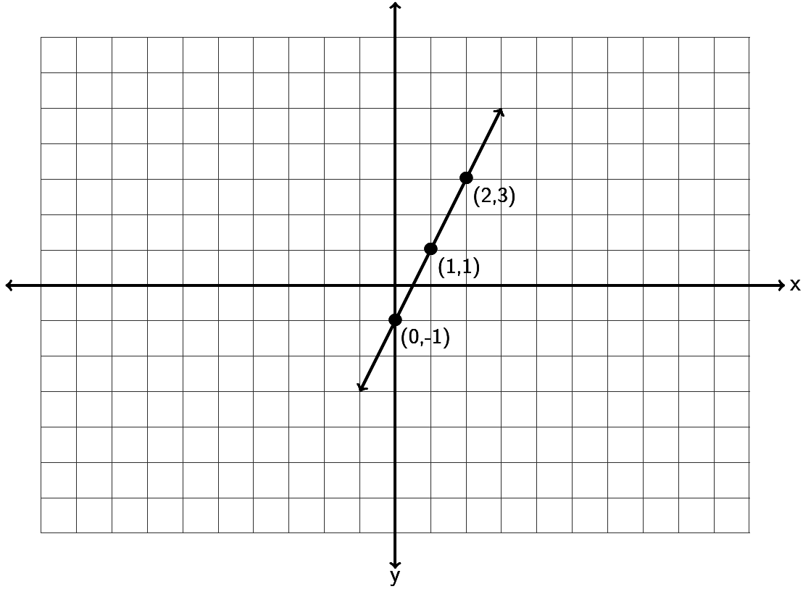

6. Find the equation of the line in slope-intercept form described by the following line. Remember, you will need to find the slope *m* and the y-intercept *(0,b)* first.

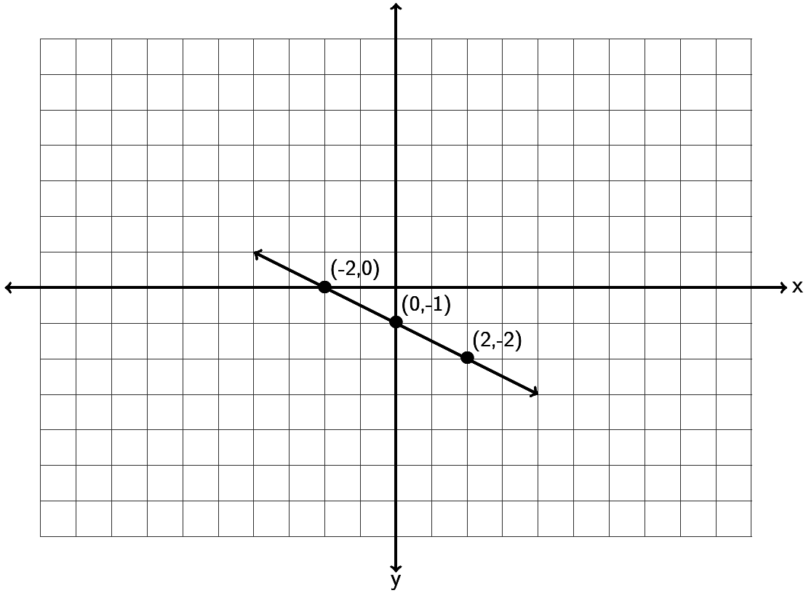

7. Find the equation of the line in slope-intercept form described by the following line. Remember, you will need to find the slope *m* and the y-intercept *(0,b)* first.

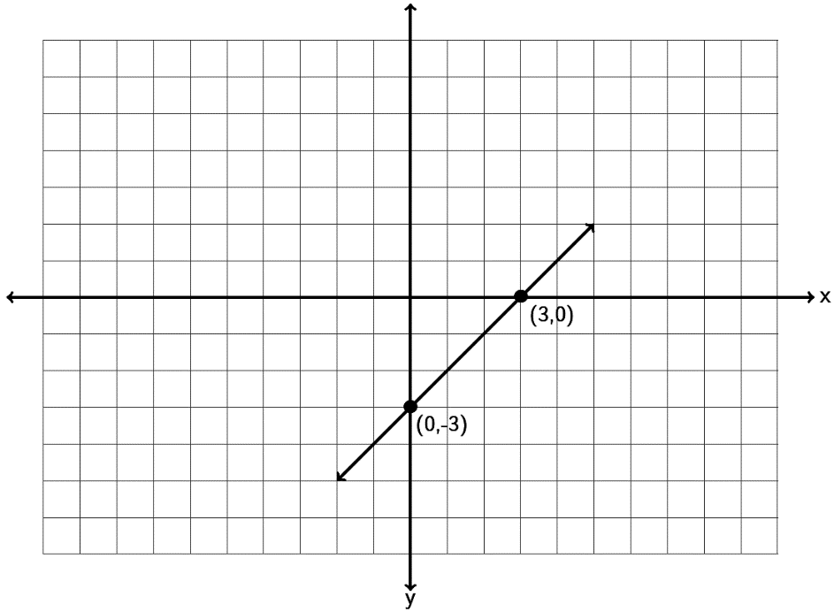

8. Find the equation of a line with a slope of  and passing through the point 

9. Find the equation of a line with a slope of  and passing through the point 

10. Find the equation of a line with a slope of  and passing through the point 

11. Find the equation of a line with a slope of  and passing through the point 

12. Find the equation of a line with a slope of  and passing through the point 

13. Find the equation of a line with a slope of  and passing through the point 

14. Find the equation of a line through the points  and .

15. Find the equation of a line through the points  and .

16. Find the equation of a line through the points  and .

17. Find the equation of a line through the points  and .

18. Find the equation of a line through the points  and .

19. Find the equation of a line through the points  and .

20. Find the equation of a line through the points  and .

21. Find the equation of a line perpendicular to  and passing through the   
point .

22. Find the equation of a line parallel to  and passing through the   
point .

23. Find the equation of a line perpendicular to  and passing through the   
point .

24. Find the equation of a line parallel to  and passing through the   
point .

25. Find the equation of a line perpendicular to  and passing through the   
point .

26. Find the equation of a line perpendicular to  and passing through the   
point .

27. Find the equation of a vertical line that goes through the point  .

28. Find the equation of a horizontal line that goes through the point  .

29. Find the equation of a line with zero slope that goes through the point 

30. Find the equation of a line with undefined slope that goes through the point 

31. Find the equation of a line parallel to the x axis that goes through 

32. Find the equation of a line perpendicular to the x axis that goes through 

33. Find the x and y-intercepts of the line 2x – 3y = 6 . Graph the line below. What is the slope of the line? What is the equation of the line?



34. Find the x and y-intercepts of the line -4x + 5y = -20 . Graph the line below. What is the slope of the line? What is the equation of the line?



35. Find the x and y-intercepts of the line 2x – 5y = -10 . Graph the line below. What is the slope of the line? What is the equation of the line?



36. Find the x and y-intercepts of the line -1x + 3y = 6 . Graph the line below. What is the slope of the line? What is the equation of the line?



37. a) A company that makes lawn furniture found their average cost in year 3 to be   
 $47000 and the average cost in year 8 to be $51000. Find the equation of a line that   
 could be used to estimate the companies costs (y) if we knew the year (x).

b) Use your equation in part (a) to predict the average costs in year 11.

38. a) A bear that is 50 inches long weighs 365 pounds. A bear 55 inches long weighs 446   
 pounds. Assuming there is a linear relationship between length and weight, find the   
 equation of a line that we could use to predict the weight (y) of a bear if we knew its   
 length (x).

b) Use your equation in part (a) to predict the weight of a bear that is 52 inches long.

39. a) In week 7, a stock price is $46. By week 11, the stock price has risen to $54.   
 Assuming there is a linear relationship between week and price, find the equation   
 of the line that we could use to predict the stock price (y) if we knew the week (x).

b) Use your equation in part (a) to predict the stock price in week 48.

40. a) When a toy store has its employees work 40 hours a week, the profits for that week   
 are $4600. If the store has its employees work 45 hours then the profits for that   
 week are $4180 due to having to pay the employee’s overtime. Write two ordered   
 pairs with x being hours worked and y being profit. Find the equation of the line we   
 could use to predict profit (y) if we knew the number of hours worked (x).

b) Use your equation in part (a) to predict the profits if the employees work 43 hours   
 a week. (All employees work three hours of overtime.)

41. a) The longer an employee works at a software company, the higher his or her salary is.   
 Let’s explore the relationship between years worked (x) and salary in thousands of   
 dollars (y). A person that has worked two years for the company makes an annual   
 salary of 62 thousand dollars. A person that has worked ten years for the company   
 makes an annual salary of 67 thousand dollars. Write two ordered pairs and find the   
 equation of a line we could use to predict the annual salary (y) if we knew the   
 number of years the person has worked (x).

b) Use your equation in part (a) to predict the annual salary of someone that has   
 worked 20 years for the company.

42. a) At the beginning of this chapter, we said we might like to explore the relationship   
 between the unemployment rate each year and U.S. national debt each year. For   
 example in 2009 the national debt was 11.9 trillion dollars and the unemployment   
 rate was about 9.9 percent. By 2013 the national debt had increased to 16.7 trillion   
 dollars and the unemployment rate had fallen to 6.7 percent. If there is a linear   
 relationship between national debt and unemployment, could we find an equation   
 that might predict the unemployment rate if we know the national debt? If we let   
 x be the national debt in trillions and let y be the unemployment percent we would   
 get the ordered pairs (11.9 , 9.9) and (16.7 , 6.7). What does the slope tell us? What  
 does the y-intercept tell us? What is the equation of the line?

b) If the national debt is 18 trillion dollars, what will we predict the unemployment   
 rate to be?

**Section 7D – Systems of Linear Equations**

Companies often look at more than one equation of a line when analyzing how their business is doing. For example a company might look at a cost equation and a profit equation. The number of items the company needs to make so that the costs and profits are the same is often called the break-even point. But how can we figure out the break-even point when we have two different equations? This is one of the many applications of Linear Systems.

Three Types of Linear Systems

When two lines are drawn on a graph three things can happen. Either the lines will meet at a point, the lines will be parallel and not meet, or the two lines happen to be the same line and would have all their points in common. These three things correspond to the three types of linear systems. The key is that the solutions are only points that lie on both lines.

In a system where the two lines intersect at a point, the one ordered pair (x,y) where the lines meet is the solution we are looking for. Many books call this an independent system of equations or an independent system for short. In the example below, the solution is (3,1).

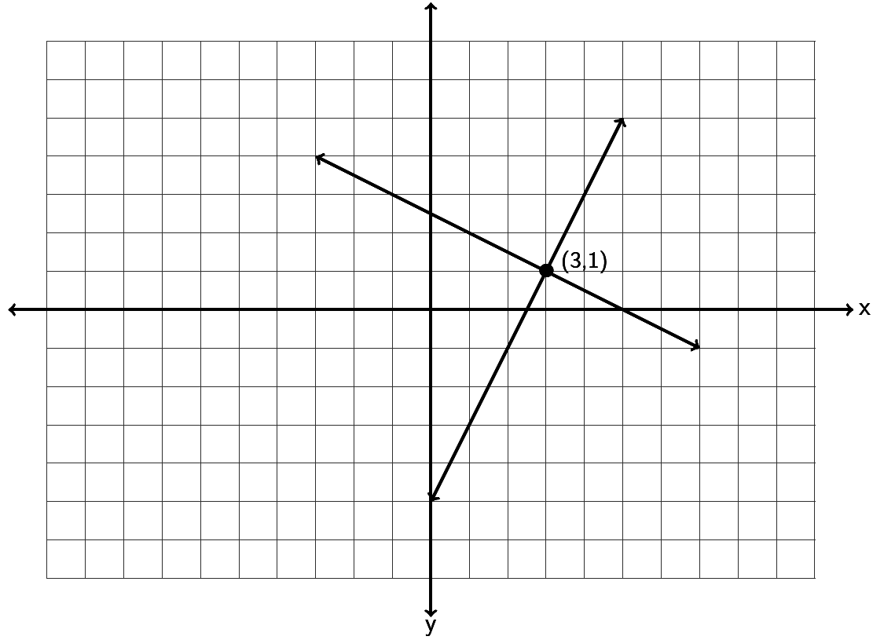

In a system where the two lines are parallel, we see that the lines never meet and no points lie on both lines. So there is “no solution” when the lines are parallel. Many books call this an inconsistent system.

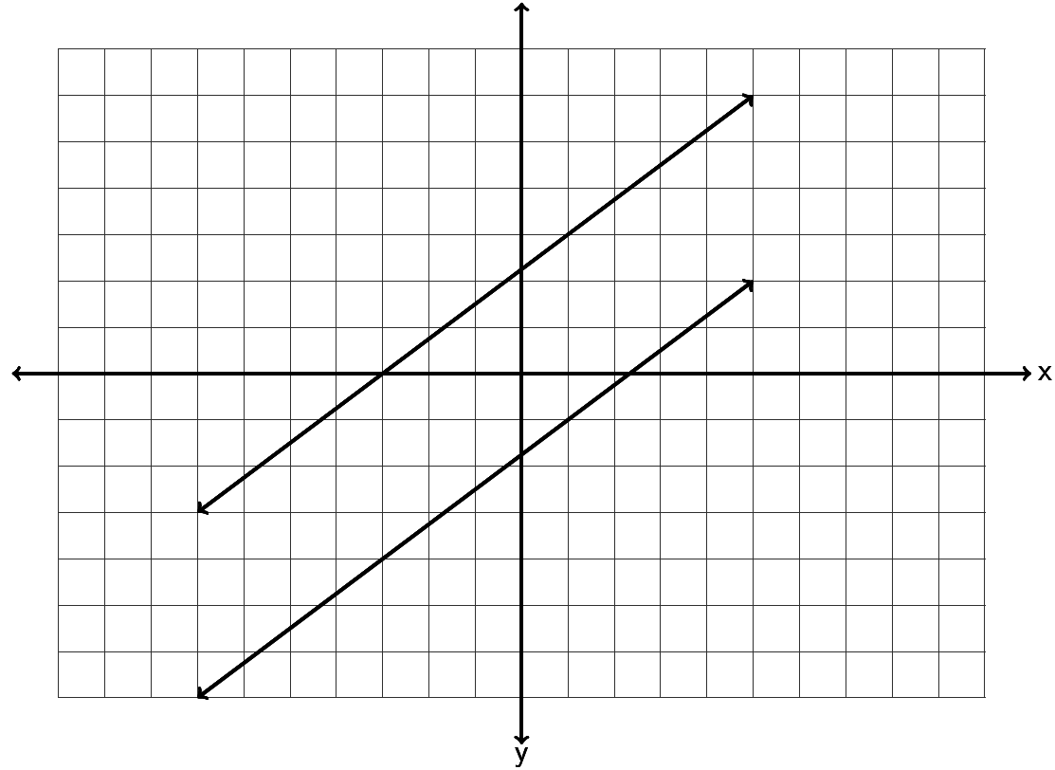

In a system where the two lines happen to be the same line, the two lines have all their points in common. When this happens, the solution is “All points on the line are solutions.” Many books call this a dependent set of equations or a dependent system for short. Notice a dependent system has infinitely many solutions.

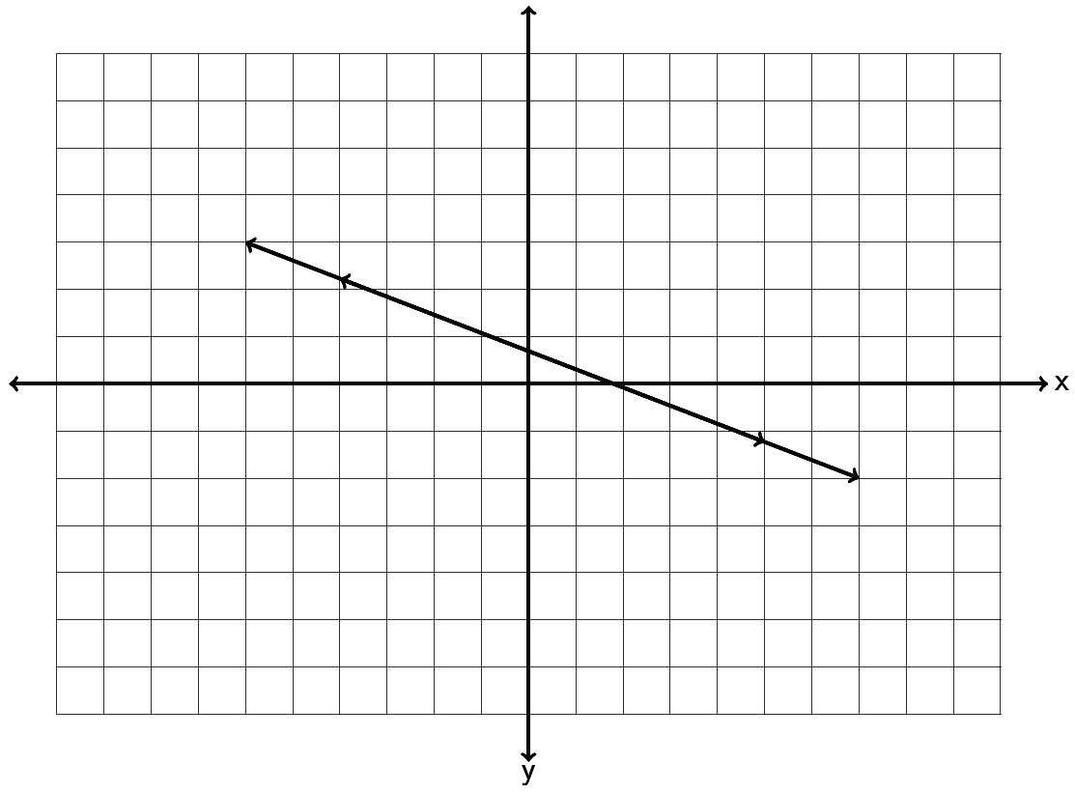

Solving a System by Graphing

To find the solution to a system, we can graph both lines and see if and where they meet. For example, solve the following system by graphing.



Since both equations are in slope-intercept form, we can use the slope and y-intercept to graph each line. The first line has a slope of 3/1 and a y-intercept of (0,-7). So we can start at -7 on the y-axis and go up 3 and right 1. The second line has a slope of ½ and a y-intercept of (0,-2). So we can start at -2 on the y-axis and go up 1 and right 2.

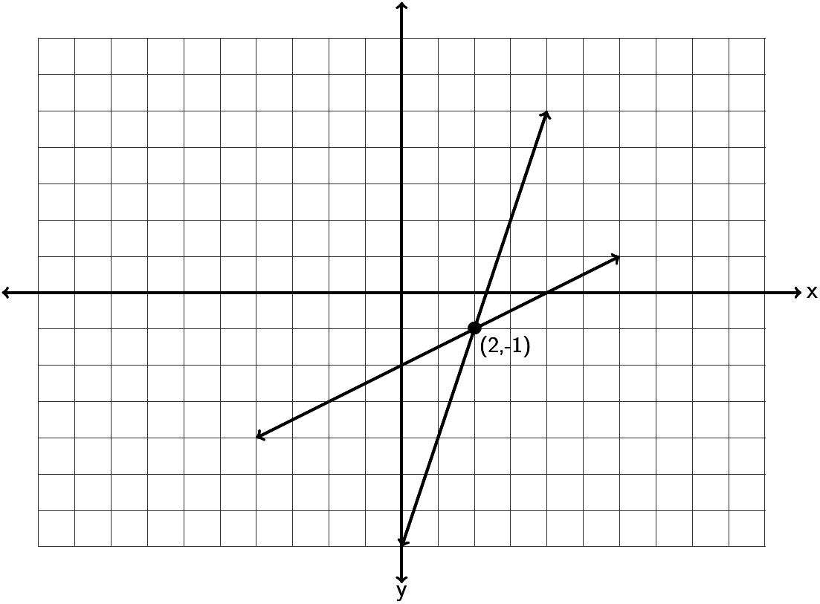

So do the lines intersect and if so where do they intersect? Notice the lines intersect at (2 , -1) so that is the solution to the system. To check the answer plug in 2 for x and -1 for y into both equations. If it makes both equations true, it is the solution.



Let’s try another example. Solve the following system by graphing.



Since the first line is not in slope-intercept form, we can graph it by finding the x and   
y-intercepts. Plugging in 0 for x gives 2y=10 which gives y = 5. So the y-intercept is (0,5). Plugging in y = 0 we get 5x = 10 which gives x = 2. So the x-intercept is (2,0) . We can plot (0,5) and (2,0) and draw the line.

The second line is in slope-intercept form, so we can see the y-intercept is (0,5) and the slope is -5/2. So we will start at 5 on the y-axis and go down 5 and right 2. If you notice this coincides perfectly with the first line we drew.

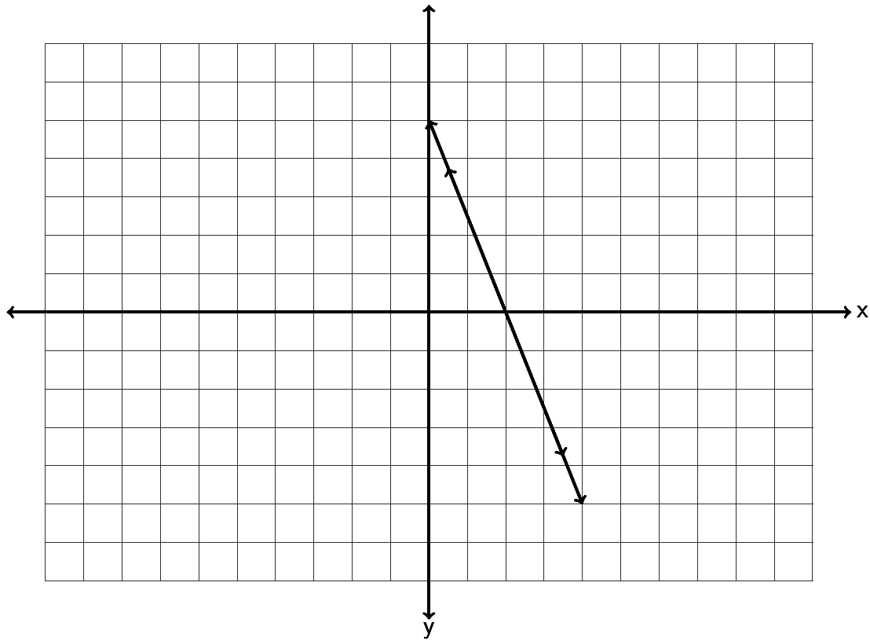

So the two equations we graphed were actually the same line. Since the lines have all their points in common, the solution is “All points on the line are solutions.”

Note: We could have solved this system by looking at the slope-intercept form of the first equation. If we solved the first equation for y we would have gotten the following.



Since both equations have the exact same slope and the exact same y-intercept, they are in fact the exact same line and will have all their points in common.

Look at this example. Solve the following system of equations by inspection. (Just look at the slopes and y-intercepts.)



Notice both equations are in slope-intercept form. Notice they both have the same slope but different y-intercepts. If you recall from the section on slope, these lines are parallel. Notice they have the same slope but they definitely are not the same line. Since the lines are parallel, they will never intersect and the solution to the system is “No Solution.”

Solve the following systems with your instructor either by graphing or by inspection.

Example 1: 



Example 2: 



Solving linear systems by substitution

If you do not want to solve the system by graphing, there is a way to figure out the answer with algebra. The method is called the “substitution method”. Here are the steps to the substitution method.

Steps to solving a system with Substitution

1. Solve one of the equations for one of the variables. (It can be x or y in either equation. If one of your equations is already in slope-intercept form, then you can just use the y in that equation.)

2. Plug in (substitute) the value of the variable in step 1 into the other equation you have not used yet. (You should be left with an equation with only one letter in it.)

3. Solve the one-variable equation. (If the system only has one ordered pair as the answer, then this will give you either the x or y-coordinate of the answer.)

4. Plug in the value of the variable solved for in step 3 into any of the equations and solve for the remaining variable that you don’t know.

5. Check your ordered pair answer by plugging into both equations and seeing if they both make true statements.

Note: If your system consists of parallel lines, then in step 3, you will get a contradiction equation. (All the variables will disappear and you are left with a false statement.) The solution to the system will be “No Solution.”

Note: If your system consists of two equations for the same line, then in step 3, you will get an identity equation. (All the variables will disappear and you are left with a true statement.) In this case, the solution to the system will be “All points on the line are solutions.”

Look at the following example. Solve the following system with the substitution method.



Step 1: Solve for one of the letters. Since you can choose any variable, choose something easy to solve for. (x in equation 2 looks easy)



Step 2: Now plug in 5y+8 for x in the other equation. Notice the equation only has one letter now.



Step 3: Solve the one-variable equation. Notice we need to use the distributive property.



Step 4: We know that our answer is  . We will plug in -1 for y into any of the equations with two variables and solve. Any equation you use will give you the same answer for x.



Step 5: So our answer is  . Let’s check the answer by plugging in 3 for x and -1 for y into both equations and see if both of them are true.



Try the following examples of solving with the substitution method with your instructor.

Example 3:  Example 4: 

Example 5: 

**Practice Problems Section 7D**

Solve the following linear systems by inspection. (Hint: Examine the slope and y-intercepts.) You do not have to do any work for these. Just give the solution to the system.

1.  2.  3. 

4.  5.  6. 

Solve the following linear systems by graphing both lines. You must graph both lines and give the solution to the system.

7.  8.  9. 

10.  11.  12. 

Solve the following linear systems by using the substitution method.

13.  14.  15. 

16.  17.  18. 

**Chapter 7 Review**

In chapter 7, we looked at linear relationships between two variables. We saw that we make ordered pairs by labeling one variable as the “x” coordinate and one variable as the “y” coordinate. We learned that we can plot all of these ordered pairs on the “Rectangular Coordinate System”. The x and y-axis break the rectangular coordinate system into 4 quadrants. When we plot many ordered pairs in a situation, a “scatterplot” is created.

Sometimes variables like time and cost have a linear relationship. We can tell this because the scatterplot of the ordered pairs looks like it makes a line. Using any two ordered pairs, we can find the slope “m” (average rate of change) of this line and the y-intecept (0 , b) of this line and use these to find the “Equation of the line” y = mx + b. Here are the formulas for slope and   
y-intercept between the ordered pairs  and .

(Slope) 

(Y – intercept) 

Remember the slope “m” is also called the average rate of change. In fact it is the change in the y-variable divided by the change in the x-variable. The average rate of change is a very important number in analyzing general trends in business and other applications.

Remember the y-intercept “b” actually is the ordered pair (0 , b). It is in fact the place where the line crosses the y-axis. It always has an x-coordinate of 0. In fact the y-intercept is often the initial value in a linear relationship. In cost data for example, the y-intercept is the initial costs to set up the business.

Plugging in the “m” and the “b” into y = m x + b will give the equation of the line. This equation can be used as a formula to help predict y-values for a given x-value.

We also looked at a system of two linear equations. The solution to a linear system is the ordered pair where the two lines cross. If the lines do not cross at all, there is no solution to the linear system. If the two lines turn out to be the same line, then all points on the line are solutions. A linear system can be solved by graphing or by algebraic methods like the substitution method.

To solve a system by graphing, simply graph both lines and see if you can determine the ordered pair where the two lines cross.

To solve a system by substitution, solve for one of the variables (x or y) in either equation. Then plug in the expression for that variable into the other equation you have not used yet. This substitution will eliminate one of the variables and allow you to solve the remaining equation for x or y. After you have found x or y, plug the number back into any equation and find the other variable.

**Review Problems Chapter 7**

1. Graph the ordered pairs (-5 , -2) , (2,0) , (-4, 2) , (0 , -3) , (1 , -3) on the graph provided. Which point is an x-intercept? Which point is a y-intercept? For the other three points, give the quadrant they lie in.



2. Graph the ordered pairs (-1 , 6) , (0,-5) , (-2, -8) , (-2 , 0) , (4 , 5) on the graph provided. Which point is an x-intercept? Which point is a y-intercept? For the other three points, give the quadrant they lie in.



3. Graph the ordered pairs (1.5 , 5.5) , (0 , 2.5) , (-1.25 , -3.25) , (-4.5 , 0) ,  on the graph provided. Which point is an x-intercept? Which point is a y-intercept? For the other three points, give the quadrant they lie in.



4. Find the slope of the following line by finding the vertical and horizontal change. Be sure to write your answer in lowest terms.

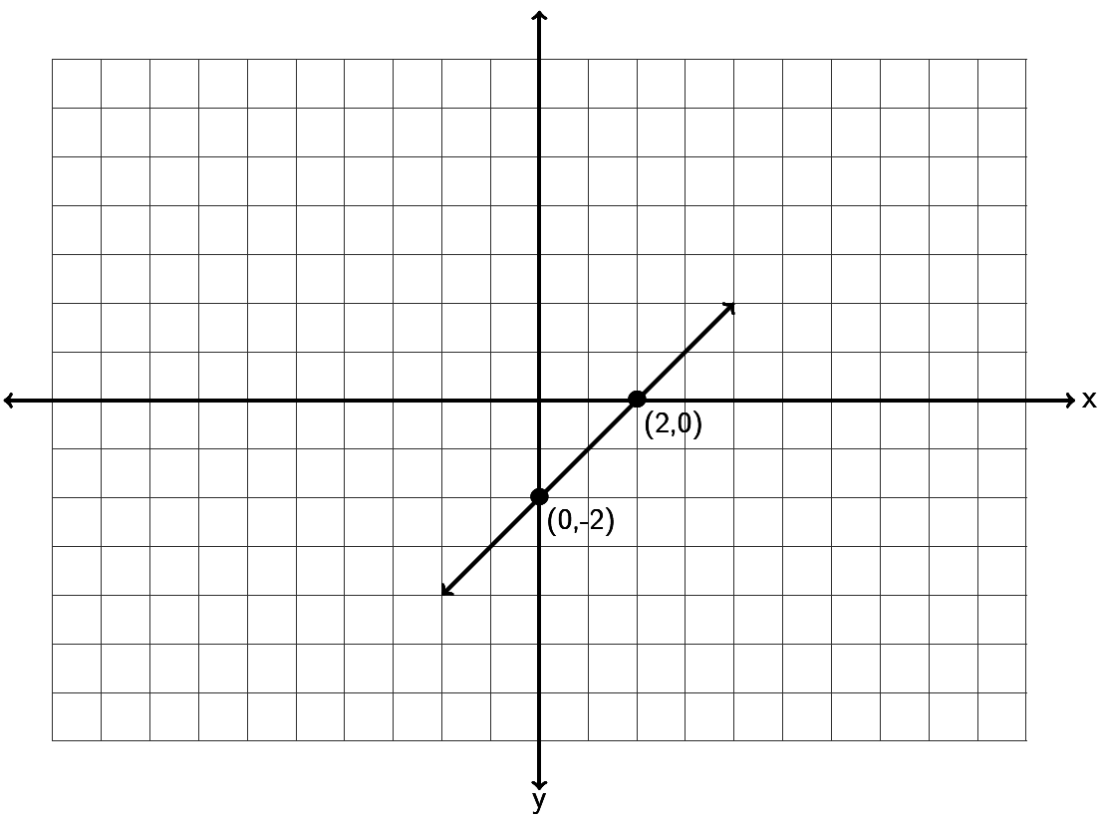

5. Find the slope of the following line by finding the vertical and horizontal change. Be sure to write your answer in lowest terms.

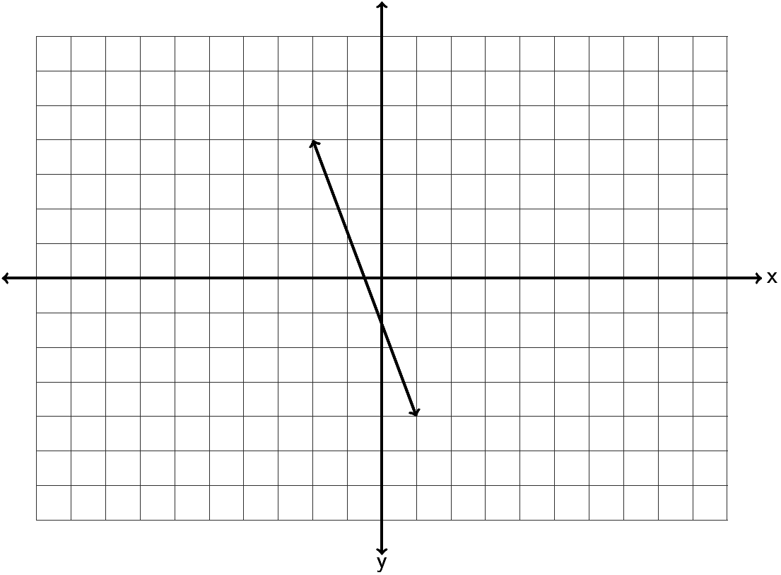

6. Find the slope of the following line by finding the vertical and horizontal change. Be sure to write your answer in lowest terms.

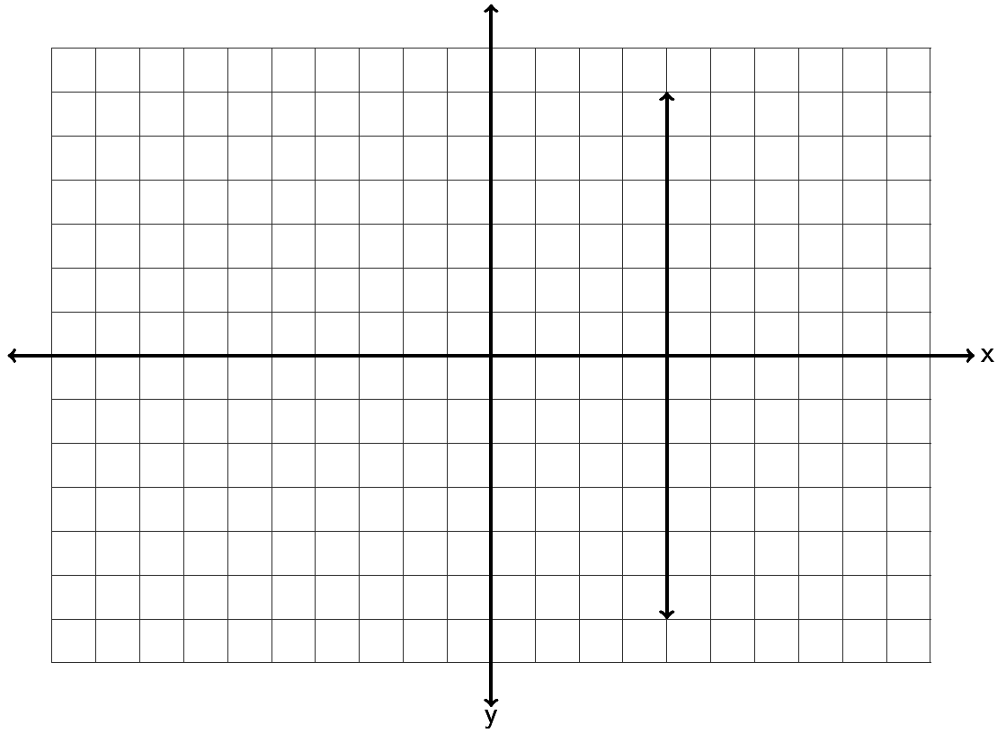

7. Find the slope of the following line by finding the vertical and horizontal change. Be sure to write your answer in lowest terms.

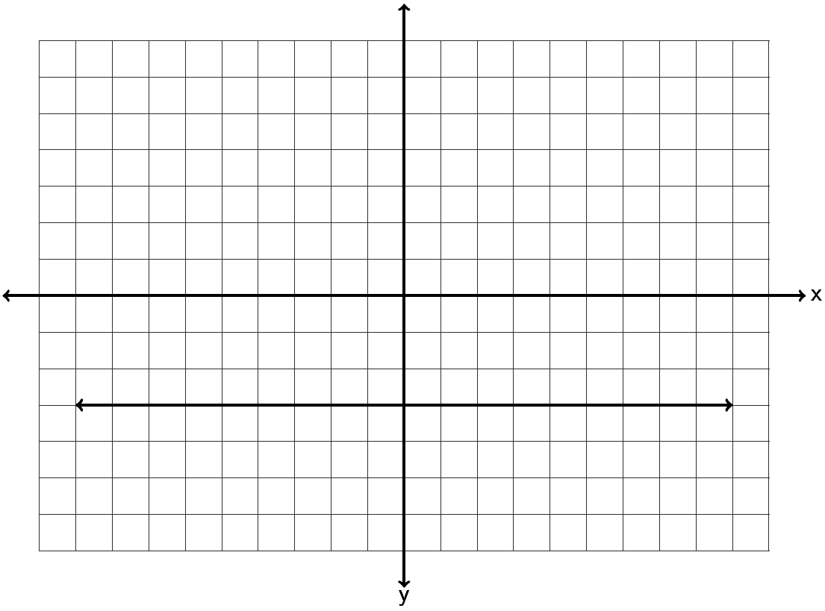

8. Draw a line that goes through the point (-3, -2) and has a slope of  .



9. Draw a line that goes through the point (2 , 1) and has a slope of  .



10. Draw a line that goes through the point (-5 , 3) and has an undefined slope.



11. Draw a line that goes through the point ( -2 , 4) and has a slope = 0 .



12. Graph the line -1x +4y = -4 by finding the x and y-intercepts.



13. Graph the line 3x - 5y = 15 by finding the x and y-intercepts.



14. Use the slope formula to find the slope of the line between . Be sure to simplify your answer and write it in lowest terms.

15. Use the slope formula to find the slope of the line between . Be sure to simplify your answer and write it in lowest terms.

16. Use the slope formula to find the slope of the line between Be sure to simplify your answer and write it in lowest terms.

17. Use the slope formula to find the slope of the line between . Be sure to simplify your answer and write it in lowest terms.

18. Use the slope formula to find the slope of the line between . Be sure to simplify your answer and write it in lowest terms.

19. A line has a slope of +3/5. What is the slope of a line parallel to it? What is the slope of a line perpendicular to it?

20. A line has a slope of  . What is the slope of a line parallel to it? What is the slope of a line perpendicular to it?

21. When a hot dog stand makes 50 hot dogs, the profit for that day is $92. When the hot dog stand makes 45 hot dogs, the profit for that day is $82.80 . Write two ordered pairs with x being the number of hot dogs made and y being profit. What is the average rate of change in profit per hot dog? (Write your answer as a decimal.)

22. The longer an employee works at a coffee company, the higher his or her salary is. Let’s explore the relationship between years worked (x) and salary in thousands of dollars (y). A person that has worked three years for the company makes an annual salary of 32 thousand dollars. A person that has worked seven years for the company makes an annual salary of 34 thousand dollars. Write two ordered pairs and find the average rate of change in salary in thousands per year worked.

23. Graph a line with a y-intercept of ( 0 , 2) and a slope of  . What is the equation of the line you drew in slope-intercept form?



24. Graph a line with a y-intercept of ( 0 , -4) and a slope of  . What is the equation of the line you drew in slope-intercept form?



25. Graph a line with a y-intercept of ( 0 , 5) and a slope of  . What is the equation of the line you drew in slope-intercept form?



26. Find the equation of the line in slope-intercept form described by the following line. Remember, you will need to find the slope *m* and the y intercept *(0,b)* first.

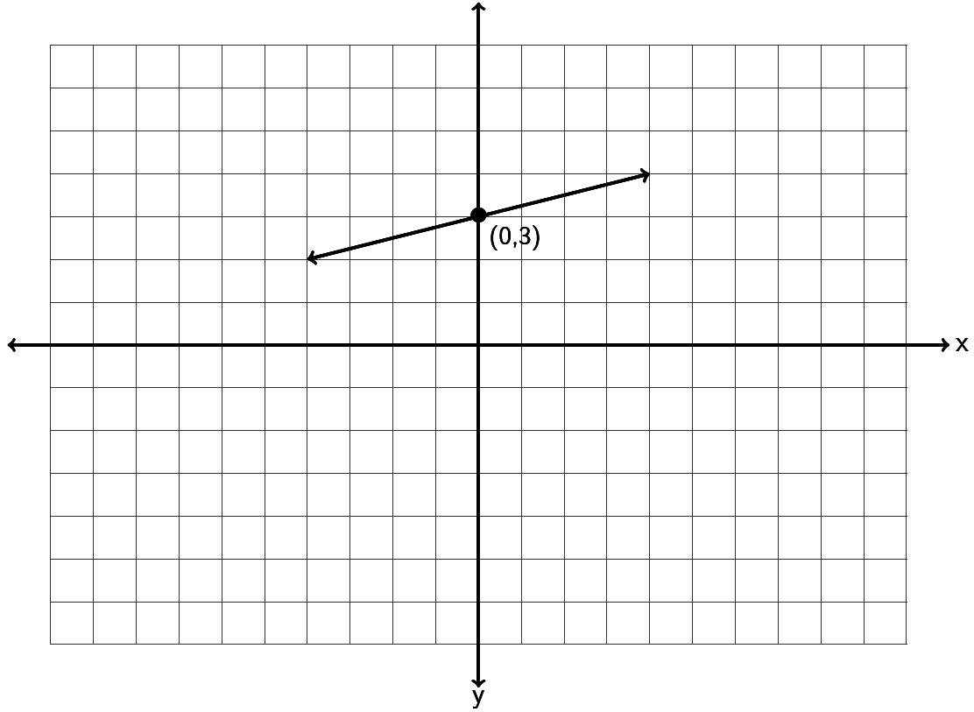

27. Find the equation of the line in slope-intercept form described by the following line. Remember, you will need to find the slope *m* and the y-intercept *(0,b)* first.

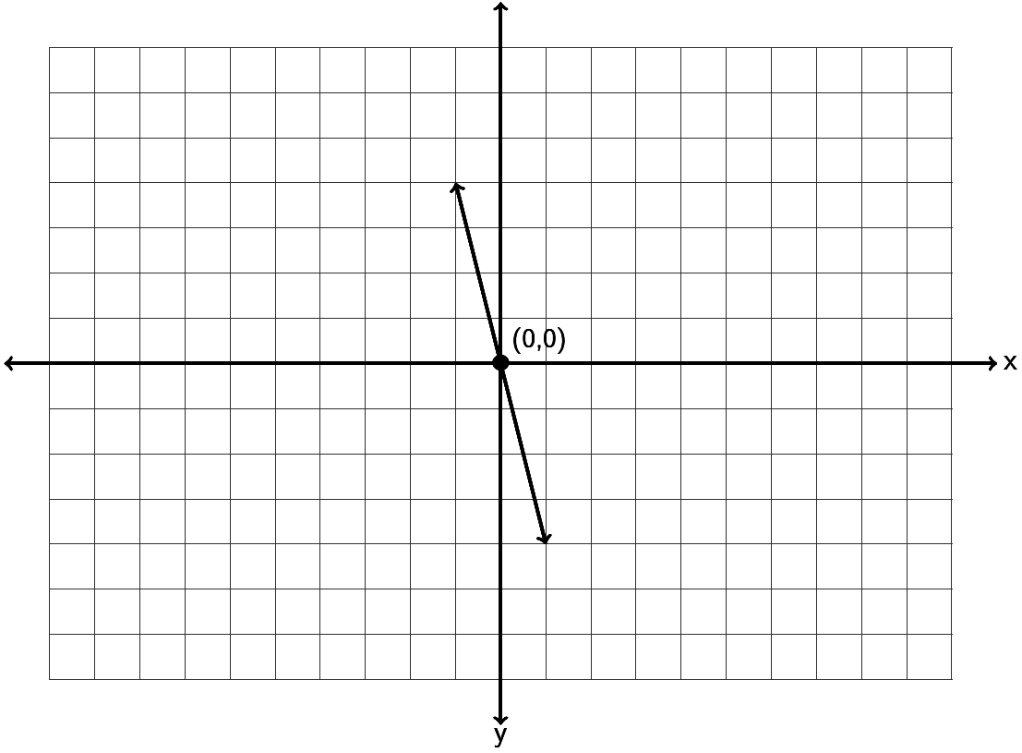

28. Find the equation of the line in slope-intercept form described by the following line. Remember, you will need to find the slope *m* and the y-intercept *(0,b)* first.

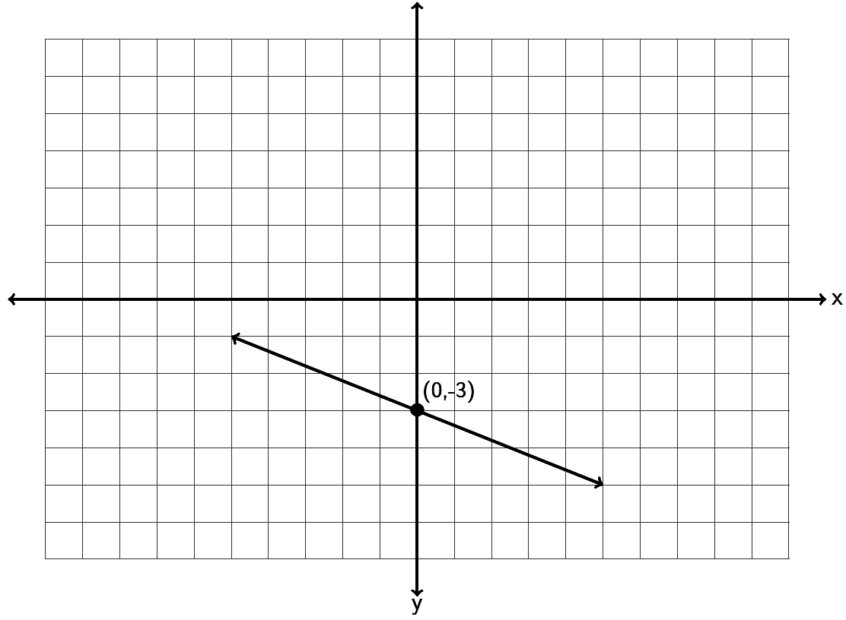

29. Find the equation of a line with a slope of  and passing through the point .

30. Find the equation of a line with a slope of  and passing through the point .

31. Find the equation of a line with a slope of  and passing through the point .

32. Find the equation of a line through the points  and .

33. Find the equation of a line through the points  and .

34. Find the equation of a line through the points  and .

35. Find the equation of a line perpendicular to  and passing through the   
point .

36. Find the equation of a line parallel to  and passing through the   
point .

37. Find the equation of a vertical line that goes through the point  .

38. Find the equation of a horizontal line that goes through the point  .

39. Find the equation of a line with zero slope that goes through the point .

40. Find the equation of a line with undefined slope that goes through the point .

41. Find the equation of a line parallel to the y axis that goes through .

42. Find the equation of a line perpendicular to the y axis that goes through .

43. a) A company that makes metal car components looked at their average profit in  
 month 2 to be $32,000 and the average profit in month 7 to be $33,000. Write two  
 ordered pairs of the form (month , profit). Use the two ordered pairs to find the  
 equation of a line that could be used to estimate the companies average profits (y) if   
 we knew the month (x).

b) What does the slope of the line tell us?

c) What does the y-intercept of the line tell us?

d) Use your equation in part (a) to predict the profit in month 13.

44. a) A horse that weighs 1100 pounds can carry about 230 pounds. A horse that weighs  
 1400 pounds can carry about 290 pounds. Write two ordered pairs of the form  
 (weight of horse , pounds horse can carry). Use the two ordered pairs to find the  
 equation of a line that we could use to predict the number of pounds a horse can  
 carry (y) if we knew the weight of the horse (x).

b) What does the slope of the line tell us?

c) Use your equation in part (a) to predict the how much a horse weighing 1300 pounds  
 can carry?

The following linear systems have been written in slope-intercept form. Solve the following linear systems by inspection. (Hint: Examine the slope and y-intercepts.) You do not have to do any work for these. Just give the solution to the system.

45.  46.  47. 

Solve the following linear system by graphing both lines. You must graph both lines and give the solution to the system.

48. 



Solve the following linear systems by graphing both lines. You must graph both lines and give the solution to the system.

49. 



50. 



Solve each the following linear systems by using the substitution method.

51. 

52. 

53. 