**Preparing For Algebra and Statistics**

*(Third Edition)*

**By Matt Teachout**

**College of the Canyons  
Santa Clarita, CA, USA**

*The 3rd edition of Preparing for Algebra and Statistics was released   
in August 2016 under the following licensing:*



***This content is licensed under a*** [***Creative Commons   
Attribution 4.0 International license***](http://creativecommons.org/licenses/by/4.0/)

**Special thanks to all of the people that made this book possible.**

**Especially Kelly Aceves, Dustin Silva, Ambika Silva,   
Kathy Kubo, Collette Gibson, Joe Gerda, Sab Matsumoto,   
Angela Grigoryan, Jeremy Goodman, James Glapa-Grossklag,   
Brian Weston, Jim Gilmore, Akemi Tyler, Morgan Cole, Mindy Albee,   
the incredible COC math department and faculty, OER office,   
reprographics, and the rest of the COC faculty and staff.   
  
Your help and support made this possible.**

**I would also like to thank my wife Link   
and my daughters Kayla and Kianna.   
You are my inspiration.**

**Introduction** This book was written to combine arithmetic and pre-algebra in order to prepare students for algebra and statistics pathways. The goal of the book is to prepare students not only for beginning algebra (algebra I) courses, but also to prepare students for pre-statistics courses. It was written for students and is for educational use only. This book is not meant to teach someone a concept from scratch, but instead to remind students of material they hopefully have seen before in previous math courses and merely forgotten. Students are welcome to use the digital version of the book on their computer or e-reader, but the book can also be printed and written in. Every section has completed examples as well as example problems to work out with their instructor. Students should take notes in the open regions that say “Do this example with your instructor.” Therefore the book is more of a “workbook” than a textbook and should be used in conjunction with taking a pre-algebra level course. Because the book also prepares students for pre-stat courses, there are quite a few statistics applications and formulas throughout the book. If you are not familiar with some of the letters we use in statistics formulas, here are some of the common ones.

*z* : “z-score” (Used for comparing quantities in statistics.)

 : Greek letter “mu”. (Used to represent a population mean average.)

 : “x-bar” (Used to represent the mean average of sample data.)

 : Greek letter “sigma”. (Used to represent a population standard deviation.)

 : (Used to represent the standard deviation of sample data.)

*p* : (Used to represent a population percentage.)

 : “p – hat” (Used to represent a percentage of sample data.)

**Special Note for Teachers**

I hope this book is useful for you and your students. As I stated above, this book is a resource for the students but should be used in conjunction with receiving instruction from their pre-algebra teacher. I believe that students never learn well from a textbook alone. They need the help and support of a great teacher. Besides having completed examples and explanations of concepts, the book also has space for “instructor examples”, where I want the students to complete the example problem with their teacher and take notes. They will receive better explanation from their teacher than I could ever give in a textbook. Teaching is an art that is incredibly difficult and not always appreciated. I solute your passion and dedication to your students. That is where the real learning begins.  
  
Matt Teachout

Notes about the 3rd edition

After using the 2nd edition of *Preparing for Algebra and Statistics* in the fall semester of 2015 and the spring semester of 2016, COC pre-algebra instructors made changes in order to better serve their students. This new 3rd edition is very similar to the 2nd edition. Changes include a new section on calculating basic statistics (section 2G), a new section on inequalities (section 5G), and bar graphs and pie charts have been added to the section on percentages (section 6B). The 3rd edition also has longer homework sets and answer keys to odd problems in appendix A. Thanks to all of the COC pre-algebra and pre-statistics instructors who contributed during the fall 2015 and spring 2016 semesters.

Notes about OER and Creative Commons Licensing

Many college students across the country struggle to balance work and family with their education. One of the biggest road-blocks to many students is the cost of textbooks. At our college, a significant percentage of students cannot afford the cost of textbooks and chose to attend classes without purchasing a book or materials needed for the class. It goes without saying that this is a major impediment to passing their classes, but the students have no choice. They simply cannot afford $150-$200 textbooks. For this reason, I believe strongly in open educational resources (OER). Open source materials like this book are available and are virtually free for students.

This textbook is licensed through Creative Commons as “Attribution CC-BY”. Creative Commons describes this license as follows: “This license lets others distribute, remix, tweak, and build upon (the author’s) work, even commercially, as long as they (give) credit (to the author) for the original creation.” This is the most accommodating of licenses offered. Recommended for maximum dissemination and use of licensed materials.” If you need to see the license deed or legal code, please go to <https://creativecommons.org/licenses/> and look under the “CC-By” section.

**Table of Contents**

**Ch.1 - Formulas and Whole Numbers** *(pages 7-24)*

**Section 1A – Formulas with Adding and Subtracting Whole Numbers** *(pages 7-10)* **Section 1B – Formulas with Multiplying Whole Numbers and Positive Exponents** *(pages 11-14)* **Section 1C – Formulas with Dividing Whole Numbers** *(pages 15-19)* **Section 1D – Formulas with Square Roots and Order of Operations** *(pages 20-22)* **Chapter 1 Review** *(pages 23-24)*

**Ch.2 – Formulas and Decimals** *(pages 25-58)*

**Section 2A – Rounding, Comparing, Adding and Subtracting Decimals** *(pages 25-30)* **Section 2B – Formulas with Exponents and Multiplying Decimals** *(pages 31-33)* **Section 2C – Formulas with Dividing Decimals** *(pages 34-38)* **Section 2D – Important Application – Scientific Notation** *(pages 39-41)* **Section 2E – Significant Figures and Rules for Rounding** *(pages 42-45)* **Section 2F – Estimating Square Roots and Order of Operations with Decimals** *(pages 46-49)***Section 2G – Basic Statistic Calculations – Mean, Median and Range** *(pages 50-54)* **Chapter 2 Review** *(pages 55-58)*

**Chapter 3 – Formulas and Fractions** (*pages 59-91)*

**Section 3A – Fractions and Mixed Number Conversions** *(pages 59-62)* **Section 3B – Simplifying and Equivalent Fractions** *(pages 63-66)* **Section 3C – Decimal and Fractions Conversions** *(pages 67-70)* **Section 3D – Formulas with Multiplying and Dividing Fractions** *(pages 71-74 )* **Section 3E – Formulas with Multiplying and Dividing Mixed Numbers** *(pages 75-77)* **Section 3F – Unit Conversions** *(pages 78-82)* **Section 3G – Adding and Subtracting Fractions** *(pages 83-85)* **Section 3H – Adding and Subtracting Mixed Numbers** *(pages 86-88)* **Chapter 3 Review** *(pages 89-91)*

**Chapter 4 – Formulas and Negative Numbers** (*pages 92-108)*

**Section 4A – Negative Quantities and Absolute Value** *(pages 92-94)* **Section 4B – Adding Negative Quantities** *(pages 95-97)* **Section 4C – Subtracting Negative Quantities** *(pages 98-100 )* **Section 4D – Multiplying and Dividing Negative Quantities** *(pages 101-103)* **Section 4E – Exponents and Order of Operations with Negative Quantities** *(pages 104-106)* **Chapter 4 Review** *(pages 107-108)*

**Chapter 5 – Simplifying Formulas and Solving Equations** (*pages 109-151)*

**Section 5A – Simplifying Formulas and Like Terms** *(pages 109-112)* **Section 5B – Multiplying Terms with Associative and Distributive Properties** *(pages 113-116)* **Section 5C – Solving Equations with the Addition Property** *(pages 117-119)* **Section 5D – Solving Equations with the Multiplication Property of Equality** *(pages 120-122)* **Section 5E – Steps to Solving General Linear Equations** *(pages 123-130)* **Section 5F – Solving Proportions** *(pages 131-133)***Section 5G – Reading, Understanding, Solving and Graphing Inequalities** *(pages 134-146)* **Chapter 5 Review** *(pages 147-151)*

**Chapter 6 – Equation Applications** (*pages 152-188)*

**Section 6A – Formula Applications** *(pages 152-156)* **Section 6B – Bar Graphs, Pie Charts and Percent Applications** *(pages 157-168)* **Section 6C – Commission, Interest, Tax, Markup and Discount** *(pages 169-175)* **Section 6D – Classic Algebraic Problem Solving** *(pages 176-182)* **Chapter 6 Review** *(pages 183-188)*

**Chapter 7 – Equation of a Line, Slope and Rectangular Coordinates** *(pages 189-269)*

**Section 7A – Rectangular Coordinate System and Scatterplots** *(pages 189-199)* **Section 7B – Slope of a Line and Average Rates of Change** *(pages 200-219)* **Section 7C – Finding the Equation of a Line** *(pages 220-241)* **Section 7D – Systems of Linear Equations** *(pages 242-251)* **Chapter 7 Review** *(pages 252-269)*

**Appendix A: Answer Keys to various Problem Sets** (*pages 270-298)*

**Chapter 1 Answers** *(pages 270-271 , odd answers only)* **Chapter 2 Answers** *(pages 271-273 , odd answers only)* **Chapter 3 Answers** *(pages 274-277 , odd answers only)* **Chapter 4 Answers** *(pages 278-280 , odd and even answers)*  
**Chapter 5 Answers** *(pages 281-286 , odd answers only)* **Chapter 6 Answers** *(pages 287-288 , odd answers only)*  
**Chapter 7 Answers** *(pages 289-298, odd answers for 7A-7C only)*

**Chapter 1 – Formulas and Whole Numbers**

**Introduction:** Formulas are a part of life. There are formulas which banks use to calculate interest and interest rates. There are formulas in science, statistics, finance and geometry. Formulas help us make important calculations and understand the world around us.

Look at the example  . This is a formula which banks use to calculate how much money will be projected to be in a CD (certificate of deposit) after t number of years. If we plugged in numbers into this formula, would you be able to calculate the future value amount? A large part of algebra and statistics revolves around the study and use of formulas. Using formulas correctly is the focus of the first half of our book and a recurrent theme throughout the class.

**Section 1A – Formulas with Adding and Subtracting Whole Numbers**

Look at the following formula. The first formula (P = L + W + L + W) is one we use to calculate the perimeter of a rectangle. “L” represents the length and “W” represents the width of the rectangle. For example could you calculate how many feet of fencing we will need to fence a horse pasture that is 345 feet by 461 feet? Plugging into the formula we get the following 345 + 461 + 345 + 461, but can you work this out and actually get the correct answer? A recurrent problem in science, algebra and statistics classes is that students can plug into a formula, but cannot get the correct answer due to poor arithmetic skills. In my experience of teaching, most students who fail my algebra class cannot add, subtract multiply or divide the numbers correctly in order to get the correct answer. Hence we need to practice our arithmetic.

In this section we are looking at reviewing adding and subtracting and the concepts of carrying and borrowing. Review your addition and subtraction facts. You should be able to add numbers like 8+9 and 7+5 quickly. You should also be able to subtract 13-8 and 17-11 quickly.

Example: Add the following: 368 + 79. Remember, we need to line up the place values. 368 means 300 + 60 + 8 and 79 means 70 + 9. Adding the correct place values is critical. Whenever we go over 10 in a place value we carry (re-group) to the next place value. 8+9 = 17 = 10+7 so we put the 7 and carry 1 ten to the tens place. Adding 1+6+7 = 14 tens = 1 hundred + 4 tens, so we put the 4 in the tens place and carry the 1 to the hundreds place. 1+3 = 4 hundreds. So our answer is 447.

*(This chapter is from Preparing for Algebra and Statistics , Third Edition  
by M. Teachout, College of the Canyons, Santa Clarita, CA, USA)*



***This content is licensed under a*** [***Creative Commons   
Attribution 4.0 International license***](http://creativecommons.org/licenses/by/4.0/)



Do the following examples with your instructor. Pay close attention to carrying correctly.

Example 1 : 354 + 87 Example 2 : 5749 + 2883

Example 3: Now see if you can calculate the perimeter of a rectangular field that is 345 ft by 451 ft using the formula L+W+L+W.

Subtract the following: 513 – 268 . Remember 513 means 500 + 10 + 3. We want to take away 200, take away 60 and take away 8. Problem is how do you subtract 8 from 3 or 60 from 10? The answer is borrowing and regrouping. Any time you borrow, you can add 10 to the next place value. For example if I borrow 1 hundred, I can add 10 tens to the tens place. Borrowing 1 ten, allows us to add 10 ones to the ones place. So 500 + 10 +3 becomes 400 + 100 +13. Now we subtract. 13-8 = 5. 10 tens – 6 tens = 4 tens = 40. 4 hundreds – 2 hundred = 2 hundreds. So the answer is 245.



Subtract the following 3000 – 1386. Subtracting from numbers with a lot of zeros can be a particular challenge. An easy way to do this is to think of 3000 as 300 tens. If we borrow 1 ten from 300, we are left with 299 tens. We can now add 10 to the ones place and subtract.



Do the following examples with your instructor. Pay close attention to borrowing correctly.

Example 4: 5012 – 895 Example 5: 8000 – 1362

**Practice Problems Section 1A**

Perform the indicated operation for #1-42.

1. 29 + 41 2. 16 + 39 3. 78 + 44

4. 671 + 9 5. 302 + 58 6. 77 + 125

7. 358 + 412 8. 47 + 183 9. 138 + 216

10. 4671 + 399 11. 387 + 417 12. 985 + 977

13. 379 + 948 14. 579 + 321 + 851 15. 73 + 24 + 59 + 31

16. 997 + 842 17. 49 + 38 + 87 18. 68,994 + 47,872

19. 6,752 + 796 20. 387 + 4,529 21. 945 + 967 + 899

22. 568 + 47,648 23. 785 + 721 + 357 24. 95 + 29 + 56 + 33

25. 897 – 342 26. 682 – 384 27. 1,523 – 964

28. 2301 – 1298 29. 13,572 – 8,614 30. 5,621 – 3,814

31. 700 – 246 32. 3,000 – 875 33. 40,000 – 12,796

34. 703 – 447 35. 612 – 184 36. 1,431 – 675

37. 2101 – 1493 38. 20,135 – 8,769 39. 3,721 – 873

40. 400 – 273 41. 7,000 – 1,536 42. 30,000 – 9,714

43. Profit = revenue (R) – costs (C). If a company has a revenue of $12,003 this month and their costs were $3,862 , what is their profit?

44. Profit = revenue (R) – costs (C). If a company has a revenue of $85,000 this month and their costs were $24,300 , what is their profit?

45. Let’s use the perimeter formula from earlier P = L + W + L + W to calculate how many feet of crown molding we must purchase for a room that is 21 feet by 15 feet?

46. Let’s use the perimeter formula from earlier P = L + W + L + W to calculate how many meters of fencing we must purchase to go around a rectangular area that is 472 meters by 326 meters.

47. Two of the tallest buildings in NY are the Empire State building and the Chrysler building. The Empire State building is 1454 feet tall, while the Chrysler building is 1046 feet tall. What is the difference between the heights of these two famous buildings?

48. The Eiffel Tower in Paris, France is 1063 feet tall. The Statue of Liberty in NY, USA is 305 feet tall. How much taller is the Eiffel Tower than the Statue of Liberty?

49. Jeremy works as a Taxi driver. On Monday, he made $148. On Tuesday he made $207. On Wednesday he made $264. How much total money did he make for the 3 days of work?

50. Leah sells jewelry at a booth in the mall. On Friday she sold $729 worth of jewelry. On Saturday she sold $1032 and on Sunday she sold $561. Find her total sales for the three day period.

51. Elena has $2574 in her checking account. Elena paid her $1045 rent and her $376 car payment. How much money is now left in her checking account?

52. Tyler has $873 in his checking account. His work paid him $1379 which he deposited in his account. He then paid his water bill of $87 and his electric bill of $147. How much money does he have left in his checking account?

**Section 1B – Formulas with Multiplying Whole Numbers and Positive Exponents**

A common formula in geometry classes is the volume of a box (rectangular prism). The volume formula is  . If we knew the length width and height of the box, could we calculate the volume? Again, many students miss this problem due to poor arithmetic skills. So let’s review multiplication and positive exponents so we can make our Geometry teachers happy.

Remember multiplication is repeat addition. If I have 17 buses each with 45 students in each of them, then I have 45 + 45 +45 + … (17 times). An easy way to figure this out is to multiply 45 x 17 = 765 total students.

Note: It is very advisable to review your multiplication tables. Flashcards work well. There are also games you can play online that review multiplication facts. Either way, being proficient in your multiplication tables is important if you want to do well in your algebra classes.

Let’s start by reviewing multiplication by one and zero. Recall that any number times 1 is itself. So 53 x 1 = 53 and 1 x 728 = 728. Also recall that any number times zero is zero. So 37 x 0 = 0 and 0 x 74 = 0.

Next let’s review multiplying numbers with lots of zeros. There is an easy shortcut to this. Multiply the non-zero numbers and then add on all the zeros. For example let’s look at 12000 x 400. Start with 12 x 4 = 48. We have an additional five zeros so the answer is 4,800,000.

Multiplication can be on the complicated side due to partial products. Let’s look at 36 x 52 for example. Many students think that multiplication works like addition and we simply multiply the place values. That is an extremely wrong idea. 36 x 52 is really (30+6)(50+2) = (30x50)+(30x2) + (6x50) + (6x2). These are called partial products. So the answer is 1500 + 60 + 300 + 12 = 1872. Common algorithms for multiplication can also multiply (2x36) + (50x36) and then add.

Do the following examples with your instructor. Pay close attention to the partial products.

Example 1: 230 x 1,000 Example 2: 5,000 x 71,000

Example 3 : 57 x 78 Example 4: 23 x 496

Many formulas involve exponents. Remember an exponent tells you how many times you should multiply the base times itself.  means 7 x 7 x 7 x 7 (multiply four 7’s). So .

Do the following examples with your instructor. Pay close attention. Which number is the base and which is the exponent?

Example 5: Simplify  Example 6: Simplify 

Note: In formulas involving both exponents and multiplication, we should do the exponents before the multiplication.

**Practice Problems Section 1B**

Perform the indicated operation for #1-48.

1. 4 x 13 2. 52 x 8 3. 14 x 19

4. 300 x 60 5. 240 x 1,000 6. 5,000 x 1,400

7. 24 x 79 8. 51 x 64 9. 31 x 569

10. 120 x 45,000 11. 135 x 892 12. 206 x 784

13. 26 x 4,018 14. 164 x 37 15. 71 x 928

16. 30,000 x 19,000 17. 400 x 132,000 18. 734 x 906

19. 7 x 12 x 18 20. 56 x 4 x 10 21. 29 x 135

22. 1,700 x 50 23. 3600 x 1,000 24. 72,000 x 300

25. 301 x 506 26. 624 x 207 27. 8 x 2005

28. 120 x 0 29. 1 x 934 30. 267 x 0

31. 574 x 1 32. 0 x 75 33. 1 x 9,734

34. 40,000 x 13,000 35. 600 x 108,000 36. 31,000 x 4,000

37.  38.  39. 

40.  41.  42. 

43.  44.  45. 

46.  47.  48. 

49.  50.  51. 

52.  53.  54. 

55. The perimeter of a square is given by the formula  , where *s* is the length of one of the sides of the square. What is the perimeter of a square window where the length of a side is 24 inches?

56. The perimeter of a square is given by the formula  , where *s* is the length of one of the sides of the square. What is the perimeter of a square external hard-drive for a computer where the length of a side is 27 mm?

57. The perimeter of a square is given by the formula  , where *s* is the length of one of the sides of the square. What is the perimeter of a square shaped garden where the length of a side is 113 feet?

58. Use the volume of a box formula  to calculate the volume of a box that is 4 feet by 6 feet by 13 feet.

59. Use the volume of a box formula  to calculate the volume of a box that is 12 in by 8 in by 15 in.

60. Use the volume of a box formula  to calculate the volume of a box that is 23 cm by 16 cm by 100 cm.

61. The volume of a cube is given by the formula  where *s* is the length of a side of the cube. Calculate the volume of a cube that has a side that is 8 mm long.

62. The volume of a cube is given by the formula  where *s* is the length of a side of the cube. Calculate the volume of a cube that has a side that is 20 inches long.

63. Leah started a savings account. Every month $145 will be deposited in her account. How much total money will she have deposited after 6 months?

64. Brian rents a room for $575 per month. If he paid the rent for 8 months, how much total rent would he have paid?

65. The standard deviation in a data set is 26 pounds. How much is three standard deviations?

66. The standard deviation in a data set is 17 inches. How far is four standard deviations?

**Section 1C – Formulas with Division**

A common formula in Statistics is to calculate a z-score. The formula is given by  . Many students have problems getting the correct z-score because they have trouble with division.

Two common applications of division is repeat subtraction and breaking a total into groups. For example Jimmy has $3000 in his account. How many times can he pay his rent of $400 before he runs out of money? Notice he is repeatedly subtracting the quantity $400. This is division. Remember the total should always come first in the division. So we can find the answer by dividing:  = 7 remainder of 200. So he can pay his rent 7 times. After paying 7 times he will only have $200 in his account and will not be able to pay his rent.   
  
Here is another example. Suppose a company has manufactured 13,600 paper bags. The bags are to be sent to five different supermarkets with each market getting an equal number of bags. How many bags were sent to each market? This is also division. Make sure to put the total first in the division. Dividing we get  = 2,720. So each market will get 2,720 bags.

Let’s look at a few special division problems involving zero and one. First of all, any number divided by 1 is the same as the number itself. For example, let’s look at . This is asking how many times we can subtract 1 from 53. The answer is of course 53 times. Note, be careful of the order of division. . The 1 has to be the number you are dividing by (divisor).  can be written as a fraction or decimal. It is not 53!

Any number divided by itself is equal to 1. For example, let’s look at . This is asking how many times you can subtract 37 from 37. The answer is of course 1 time.

You have to be careful with division problems involving zero. Zero divided by any non-zero number is equal to zero. For example, let’s look at . This is asking what number we can multiply by 19 and get an answer of 0. () . The answer of course is zero.

Be careful though. A non-zero number divided by zero is undefined (does not exist). For example, let’s look at . This is asking what number we can multiply by 0 and get an answer of 13. () . This is impossible! Remember any number times 0 is 0. It is impossible to get an answer of 13. That is why we say that a number divided by zero is undefined.

Do the following examples with your instructor. You can use the usual algorithm or the repeated subtraction approach. Leave your answer as quotient and remainder.

Example 1:  Example 2: 

Example 3:  Example 4: 

If you struggle with the standard algorithm of long division, then the repeat subtraction approach may work well for you. Here is how it works. Look at the bag problem. We were trying to figure out . What we are asking is how many times can we subtract 5 from 13600? Take a guess. Say 1000 times. If we subtract 5x1000 we are left with 8600. Subtract 5 another 1000 times. We would be left with 3600. Keep guessing and subtracting. When you can’t subtract a 5 anymore you are done. Just keep track of how many times you subtracted 5. In the end, add up all the times you subtracted 5. The better your guesses get the fewer times you have to subtract.



Do the following examples with your instructor. You can use the usual algorithm or the repeated subtraction approach. Leave your answer as quotient and remainder.

Example 5:  Example 6: 

**Practice Problems Section IC**   
Divide the following using either repeated subtraction or the usual algorithm. You can leave your answer as quotient and remainder.

1.  2.  3. 

4.  5.  6. 

7.  8.  9. 

10.  11.  12. 

13.  14.  15. 

16.  17.  18. 

19.  20.  21. 

22.  23.  24. 

25.  26.  27. 

28.  29.  30. 

31.  32.  33. 

34.  35.  36. 

37.  38.  39. 

40.  41.  42. 

43.  44.  45. 

46.  is a formula in geometry that can be used to calculate the height *(h)* of a triangle if we know the area *(A)* and the base *(b)*. A sail boat has a sail that has an area of 120 square feet. If the base is 6 feet, what is the height of the sail?

47.  is a formula in geometry that can be used to calculate the height *(h)* of a triangle if we know the area *(A)* and the base *(b)*. Another boat sail has an area of 170 square feet and a base of 20 feet. What is the height of the sail?

48. Jerome needs to save $10,080 to buy a car. If he can save $420 per month, how many months will it take him to reach his goal?

49. Mia has $5160 in her checking account. Her monthly rent is $890. If she does not deposit any money into the account, how many months can she pay her rent before the money runs out?

50. Jed is saving up to buy a guitar. The guitar he wants is $2470. He makes $330 per week at his work. If he saves his entire weekly paychecks, how many weeks will he have to work to afford the guitar?

51. Trianna’s loves to buy candy at the corner store before school each morning. Her mom gave her $19 for candy. The candy she loves the best costs $2. How many days can she buy her favorite candy before she runs out of money. Will she have any money left over?

52. Let’s look at the statistics formula for z-score we looked at in the beginning of this section . Because the subtraction is in a parenthesis, we need to do this first. Find the z-score if  . A z-score larger than two is considered unusual. Is this an unusual z-score?

53. Let’s look at the statistics formula for z-score we looked at in the beginning of this section . Because the subtraction is in a parenthesis, we need to do this first. Find the z-score if  . A z-score larger than two is considered unusual. Is this an unusual z-score?

54. Let’s look at the statistics formula for z-score we looked at in the beginning of this section . Because the subtraction is in a parenthesis, we need to do this first. Find the z-score if  . A z-score larger than two is considered unusual. Is this an unusual z-score?

55. Let’s look at the statistics formula for z-score we looked at in the beginning of this section . Because the subtraction is in a parenthesis, we need to do this first. Find the z-score if  . A z-score larger than two is considered unusual. Is this an unusual z-score?

**Section 1D – Formulas with Square Roots and Order of Operations**

A common formula in algebra is the distance between two points. 

This formula gives many students problems as it involves different operations that must be done in a particular order. The different letters and parentheses can be confusing as well. We see that to make sense of a formula like this, we need to not only review square roots, but also review the order of operations.

A square root is a number we can square that gives us the number that is under the square root. For example,  means what number can we square (multiply by itself) to get 49? The answer is 7 of course, since  .

Do the following examples with your instructor.

Example 1:  Example 2: 

The order of operations is the order we perform calculations. If you do a problem out of order, you will often get the wrong answer. Here is the order of operations. It is vital to memorize these!

Order of Operations

1. Parenthesis 

2. Exponents and Square Roots

3. Multiplication and Division in order from left to right.

4. Addition and Subtraction in order from left to right.

For example, lets look at  . We do parenthesis first, so 13 + 17 is 30. We now do exponents, so =8. So now we have 89 – (30) 6 x 8. Multiplication and division in order from left to right is next. Notice a division came first so we do the division before the multiplication. 30 divided by 6 is 5. Now 5 x 8 = 40. So we are left with 89-40 = 49.

Now do the following examples with your instructor. Pay close attention to doing the problems in the correct order.

Example 3: Simplify  Example 4: Simplify 

**Practice Problems Section 1D**

Perform the indicated operation for #1-29.

1.  2.  3. 

4.  5.  6. 

7.  8.  9. 

10.  11.  12. 

13.  14.  15. 

16.  17.  18. 

19.  20.  21. 

22.  23. 

24.  25. 

26.  27. 

28.  29.    
  
30.  31. 

32.  33. 

34.  35. 

Remember the z-score formula in statistics. Here is a tougher z-score formula that many statistics students struggle with. Let’s see if you can calculate it. Remember to use the order of operations. 

36. Find the z-score when  ,  ,  and  .

37. Find the z-score when  ,  ,  and  .

38. Find the z-score when  ,  ,  and  .

39. Find the z-score when  ,  ,  and  .

Now let’s see if we are ready to tackle the distance formula: 

40. Find the distance if 

41. Find the distance if 

42. Find the distance if 

43. Find the distance if 

**Chapter 1 Review**

In Module I, we saw that formulas are used all the time in school and in everyday life. In order to evaluate a formula though, we have to be confident in our arithmetic skills. We reviewed addition, subtraction, multiplication, division, exponents, square roots, and order of operations, but more importantly, we used them to tackle real formulas.

**Chapter 1 Review Problems**

Perform the indicated operation for #1-46.

1. 23 + 14 + 57 2. 156 + 198 + 377 3. 478 + 969

4. 8961 + 4530 5. 875 + 641 6. 905 + 728

7. 200 – 87 8. 3000 – 1472 9. 1500 – 851

10. 531 – 175 11. 1348 – 936 12. 4421 – 3897

13. 6 x 18 14. 7 x 42 15. 300 x 40

16. 130 x 500 17. 1200 x 8000 18. 740 x 10000

19. 65 x 73 20. 84 x 89 21. 24 x 148

22. 75 x 348 23. 135 x 642 24. 307 x 52

25. 16 x 0 26. 14 x 1 27. 1 x 234

28. 0 x 138 29.  30. 

31.  32.  33. 

34.  35.  36.  37. 

38.  39.  40.  41. 

42.  43.  44.  45. 

46.  47.  48.  49.    
  
50.  51. 

52.  53. 

54. Jubal went on a diet to lose weight. Before the diet, he weighed 247 pounds. After the diet he weighed 183 pounds. How much weight did he lose?

55. Aria went to the store to purchase some items. The items cost $13, $8, $2, $19, and $28. What is the total cost of all the items?

56. Kira is an elementary school teacher. She is taking her class on a field-trip to a museum. She has 38 students in her class. Many parents volunteered to drive. If each car holds 3 students, how many cars will Kira need to get all of the students to the museum?

57. Leann works at a department store and gets paid $461 each week. If she works 23 weeks, how much money will she have made?

The surface area of a box is given by the formula  .

58. Find the surface area of a box if *L = 13cm, W = 8 cm, and H = 5 cm.*

59. Find the surface area of a box if *L = 24 in, W = 16 in, and H = 12 in.*

Let’s look at the z-score formula again. 

60. Find the z-score if  .

61. Find the z-score if  .

Let’s look at the distance formula used in Algebra classes. 

62. Find the distance if  .

63. Find the distance if  .

**Chapter 2 – Formulas and Decimals**

**Section 2A – Rounding, Comparing, Adding and Subtracting Decimals**

Look at the following formulas. The first formula (P = A + B + C) is one we use to calculate perimeter of a triangular region where A, B and C are the lengths of the sides of the triangle. Suppose we want to find the perimeter of a triangle with sides 3.1 cm, 2.67 cm and 4.129 cm. Since many of the numbers we want to plug into formulas involve decimals, we need to be able to add and subtract decimals.

As with whole numbers, the key to adding and subtracting decimals is place value. So let us review the place values of decimals. For example, look at the number 3.12589

3 **.** 1 2 5 8 9

Ones Tenths Hundredths Thousandths Ten-Thousandths Hundred-Thousandths

For example tenths means out of 10. So 0.1 means 1 tenth or 1/10. 0.02 means 2 hundredths or 2/100, and so on.

We cannot add or subtract the tenths place with the thousandths place. The place values have to be the same.

Another key to decimals is that you can add zeros to the end of a decimal and it does not change its value. For example 2.7 is the same as 2.70 which is the same as 2.700 which is the same as 2.7000 and so on. This can be helpful when lining up decimal places.

Comparing Decimals

Decimals are often difficult to compare. For example, in statistics we often have to compare a P-value decimal of 0.0035 to 0.05 and see which is larger. The key is to add zeros until both numbers end in the same place value.

*(This chapter is from Preparing for Algebra and Statistics , Third Edition  
by M. Teachout, College of the Canyons, Santa Clarita, CA, USA)*



***This content is licensed under a*** [***Creative Commons   
Attribution 4.0 International license***](http://creativecommons.org/licenses/by/4.0/)

In the above example, to compare 0.0035 to 0.05 we can add two zeros to the end of 0.05. Remember this does not change its value.

0.0500

0.0035

Notice it is now easy to compare them. Which is larger, 500 or 35? Obviously 500 is larger than 35 so 0.05 is larger than 0.0035. (In statistics this tells us that the P-value is significantly low.)

Try another one. Compare 24.3 to 24.2997. Again if we add zeros to the 24.3 so that it ends in the same place value, we get the following.

24.3000

24.2997

Which is larger, 243000 or 242997? Since 243000 is larger than 242997, we see that 24.3 is larger than 24.2997.

Try the following examples with your instructor.

Example 1: Which is larger, 0.004 or 0.03? Example 2: Which is larger, 1.0249 or 1.02?

Rounding Decimals

To correctly round a decimal, we need to decide to which place value we want to round to. We then look to the right of that place value. If the number to the right is 5 or above, we will round up by adding one to the place value. If the number to the right is 4 or below, we will round down by leaving the place value alone. The key to remember is that after rounding, we want to stop after the place value so that the number is simpler to use.

For example, round 0.03792 to the hundredths place. The hundredths place is the 3. Looking to the right of it we see a 7. Since 7 is large (5 or above) we round up by adding 1 to the place value. So the 3 becomes 4 and we cut off the rest of the numbers.



Let’s try another example. Round 1.83597 to the tenths place. The tenths place is the 8. Looking to the right of it we see a 3. Since 3 is small (4 or below) we round down by leaving the place value alone. So the 8 stays as it is and we cut off the rest of the numbers.



Try the following examples with your instructor. Pay close attention to the place values.

Example 3: Round 3.986114 to the Example 4: Round 0.74386 to the   
 thousandths place. ones place.

Example 5: Round 72.973 to the   
 tenths place.

Addition and Subtraction

Let’s look at an example. Let’s add 3.258 + 7.9 ; It is important to line up the place values before adding or subtracting. Let us rewrite 7.9 as 7.900 so that both numbers end in the thousandths place. Now we add exactly as if the numbers were whole numbers.



Similarly to subtract, we can add zeros to make sure the numbers end in the same place value. Now we can line up the place values and subtract. Let’s subtract 9 – 3.2751 First let’s rewrite the 9 as 9.0000 so that the place values line up. Now subtract. Remember an easy way to borrow is to borrow 1 from 9000, which leaves 8999. Then add 10 to the last place value.



Try the next few examples with your instructor.

Example 6: 34.529 + 6.38 Example 7: 14.8 + 9.4726

Example 8: 2.4 – 0.853 Example 9: 134.6 – 89.7751

**Practice Problems Section 2A**

1. Which is larger, 0.082 or 0.0399? 2. Which is smaller, 1.13 or 1.028?

3. Which is smaller, 0.034 or 0.0099? 4. Which is larger, 34.5 or 34.499?

5. Which is larger, 0.05 or 0.00016? 6. Which is smaller, 8.719 or 8.7?

7. Which is smaller, 0.378 or 0.4? 8. Which is larger, 2.41 or 2.4086?

9. Which is larger, 0.0058 or 0.005? 10. Which is smaller, 12.6 or 12.499?

11. Which is smaller, 0.0175 or 0.00175? 12. Which is larger, 68.327 or 68.7?

13. Round 0.7829 to the hundredths place. 14. Round 3.529 to the ones place.

15. Round 9.647 to the tenths place. 16. Round 0.7956 to the thousandths place.

17. Round 0.58699 to the thousandths place. 18. Round 78.462 to the ones place.

19. Round 1.375 to the tenths place. 20. Round 0.7956 to the hundredths place.  
  
21. Round 72.973 to the ones place. 22. Round 0.053289 to the thousandths

23. Round 0.053289 to the tenths place. 24. Round 8.00374 to the hundredths

25. Round 3.745117 to the ten-thousandths 26. Round $48.1277 to the nearest cent  
 place. (hundredths place).

27. Round $359.0244 to the nearest cent. 28. Round $1372.631 to the nearest cent  
 (hundredths place). (hundredths place).

29. Round $74.538 to the nearest dollar. 30. Round $671.284 to the nearest dollar  
 (ones place). (ones place).

31. Round $481.723 to the nearest dollar. 32. Round $10,457.43 to the nearest dollar  
 ones place). (ones place).

For #33-47, add the following decimals. Don’t forget to line up the place values.  
  
33. 0.2 + 0.135 34. 0.89 + 1.35 35. 2.83 + 1.17

36. 12 + 17.431 37. 0.064 + 1.23 38. 13.9145 + 7.528

39. 3.73 + 13.898 40. 0.00827 + 1.443 41. 6.834 + 7.0029

42. 46.1+ 0.439 43. 3.408 + 13.93 44. 0.845 + 6.0851

45. 51.92 + 64.083 46. 0.0072 + 0.02665 47. 9.31 + 7.0917

For #48-62, subtract the following decimals. Don’t forget to line up the place values.  
  
48. 8.4 – 6.9 49. 1.003 – 0.475 50. 9.31 – 6.4227

51. 14.2 – 4.75 52. 2.03 – 0.187 53. 7 – 2.581

54. 17 – 3.26 55. 4.931 – 2.1 56. 8.4 – 0.0035

57. 3.6 – 0.047 58. 0.835 – 0.3724 59. 0.9 – 0.638

60. 19.2 – 3.055 61. 18.528 – 17.9 62. 1.108 – 0.0266

For #56-61, add or subtract the following decimals in order from left to right.   
Don’t forget to line up the place values.

63. 13.4 + 1.58 + 0.472 64. 8 + 2.14 + 6.9 65. 8.235 + 7.49 + 14

66. 4.75 – 1.327 + 0.8 67. 7.3 + 0.94 – 0.037 68. 127 – 33.9 + 4.82

A formula we have seen before is the profit formula P = R – C where P is profit, R is revenue and C is cost.

69. Find the profit if R = $178.14 and C = $95.77

70. Find the profit if R = $13000 and C = $2879.41

71. Find the profit if R = $5,264 and C = $3095.77

72. Find the profit if R = $7,851.26 and C = $5248.99

Another formula we have seen is the perimeter of a rectangular region in geometry.   
P = L +W + L + W . (Use this formula for #73-76)

73. Find the perimeter of a rectangular field that is 1.4 miles by 0.85 miles.

74. Find the distance around the outside of a rectangular room that is 13.5 feet by 10.8 feet.

75. Find the perimeter of a rectangular window that is 17.5 inches by 13.85 inches.

76. Find the distance around the outside of a rectangular garden that is 8.375 meters by 6.284 meters.

77. In statistics, we often need to add up a bunch of numbers in a data set. Let’s practice. Add up the following numbers and find the sum.

2.84 , 3.17 , 1.74 , 2.52 , 3.25 , 2.7 , 1.98 , 3

78. Let’s practice adding up a bunch of numbers. Add the following and find the sum.

39.4 , 36.7 , 37.2 , 40.6 , 41.3 , 42 , 37.5 , 39

79. Greg went to the store to buy some groceries. The prices of the items he purchased (including tax) are listed below. What was the total amount spent at the store?

Apples : $4.89  
Milk: $2.57  
Bread: $1.94  
Eggs: $3.08

80. The temperature before the storm was 22.487 degrees Celsius. After the storm the temperature had dropped to 13.529 degrees Celsius. How much did the temperature drop?

81. Lucia had $1849.22 in her checking account. She deposited a check from her work for $427.38 and then paid her mortgage of $1027.56 and her electricity bill of $72.83 . How much does Lucia now have in her checking account?

**Section 2B – Formulas with Exponents and Multiplying Decimals**

Look at the following formula.  This is a famous formula in geometry that gives the area of a circle with radius r. Remember that . Suppose we want to find the area of a circle with a radius of 1.5 cm. We will need to review multiplying decimals as well as be able to use exponents with decimals.

Let’s start with a review of multiplying decimals. We start by multiplying the numbers as if they were whole numbers. We then count the total number of decimal places to the right of the decimal in both of the numbers being multiplied. The answer will need the same total number of decimals places to the right of the decimal. For example let’s look at 3.5 x 0.81 . First we need to multiply 35 x 81. Remember to use partial products. 35 x 81 = 2835 . The question now is where to place the decimal? 3.5 has one place to the right of the decimal and 0.81 has two. So we have a total of 3 decimals to the right of the decimal. Hence our answer should also have 3 decimal places. So 2.835 is the answer. Notice that unlike addition and subtraction, we do not need to line up the place values when we multiply.

Occasionally we may want to multiply a decimal by a power of 10 (10, 100, 1000, 10000, etc.) When we multiply a decimal by one of these numbers the decimal point moves to the right the same number of places as the number of zeros in the numbers. For example 3.4 x 1000 , the decimal point will move 3 places to the right and we get 3400. Another example is 0.0000754 x 100000. Notice the decimal point will move 5 places to the right and we get 7.54 as our answer.

Try the following examples with your instructor.

Example 1: 0.036 x 1.49 Example 2: 1.2 x 0.0009

Example 3: 1.4562 x 100 Example 4: 1000 x 0.041

Recall that exponents are repeated multiplication. So  means 1.3 x 1.3 = 1.69 . Here is another example:  = 0.2 x 0.2 x 0.2 = 0.008 (answer).

Try the following examples with your instructor.

Example 5: Simplify  Example 6: Simplify 

Example 7: Let’s see if you are ready to find the area of a circle using the formula. Let’s see if we can find the area of a circle with a radius 1.5 cm. (Remember  and we should always do exponents before multiplying.)

**Practice Problems Section 2B**

For #1-33, simplify any exponents and then multiply.

1. 0.038 x 100 2. 1.42 x 1000 3. 218.3 x 10

4. 0.00073 x 10000 5. 4.56 x 100 6. 0.00226 x 1000

7. 1.29 x 1000 8. 0.000352 x 1000 9. 0.0358 x 100

10. 10 x 0.348 11. 10000 x 0.00057 12. 100 x 34.711

13. 1000 x 0.336 14. 100 x 0.9174 15. 0.3791 x 10

16.  (this is called a million and the prefix “mega” is used)

17.  (this is called a billion and the prefix “giga” is used)

18.  (this is called a trillion and the prefix “tera” is used)

19.  20.  21. 

22.  23.  24. 

25.  26.  27. 

28. 0.007 x 0.9 29. 0.012 x 0.07 30. 0.016 x 0.09

31. 8 x 1.75 32. 1.3 x 4.6 33. 0.007 x 0.24

34. 0.136 x 8.2 35. 0.006 x 0.017 36. 19.4 x 13.7

37. 7.4 x 0.31 38. 0.27 x 3.9 39. 41.8 x 0.006

40. 0.096 x 1.33 41. 12.7 x 0.044 42. 212.3 x 0.0082

43. 0.6 x 0.3 x 1.2 44. 0.043 x 10 x 0.7 45. 0.14 x 8 x 0.03

46.  47.  48. 

49.  50.  51. 

52.  53.  54. 

55.  56.  57. 

Use the formulato find the area of the following circles.   
(Remember  and we should always do exponents before multiplying.)

58. Find the area of a circle with a radius of 3.2 feet.

59. Find the area of a circle with a radius of 1.4 mm.

60. Find the area of a circle with a radius of 7.5 inches.

61. Find the area of a circle with a radius of 2.9 cm.

A company makes a monthly profit of $2800.40. The total profit after m months is given by the formula T = 2800.4 x *m* .

62. Find the total profit after 12 months (1 year).

63. Find the total profit after 36 months (3 years).

Find the volume of cube with the formula  where V is the volume and *s* is the length of a side of the cube.

64. Find the volume of a cube if one side of the cube is 0.7 feet long.

65. Find the volume of a cube with if one side of the cube is 1.2 cm long.

The volume of a can (circular cylinder) is given by the formula  where r is the radius and h is the height. (Use )

66. Find out how much water a water tank can hold if the radius of the tank is 1.5 meters and the height is 10 meters. (Use )

67. What is the volume of a cylinder shaped trash can that has a radius of 2.1 feet and a height of 4 feet? (Use )

**Section 2C – Formulas with Dividing Decimals**

Look at the following z-score formula again from statistics.  . Suppose we want to calculate the z-score if . Not only do we need to be able to subtract decimals, but we also need to be able to divide decimals. So let’s review dividing decimals some.

Much like multiplying decimals, the key to dividing decimals is that we need to make sure to put the decimal in the correct place. We need to make sure that the number we are dividing by (divisor) is a whole number. If the divisor is a whole number then the decimal in the answer will be directly above where it is in the number we are dividing. That is pretty confusing, but I hope an example will help clear it up.

Look at  . One thing to note is that the first number (dividend) always goes on the inside of the long division. The number you are dividing by (divisor) goes on the outside.

 Since the divisor is not a whole number, we need to move the decimal one place to the right. We will have to move the decimal inside 1 place to the right as well. Hence the division becomes:

 Notice the dividend does not have to be a whole number. Only the divisor does. Now divide as if they are whole numbers. You may need to add zeros to the end of the dividend if it does not come out even.



Notice we keep adding zeros and dividing until we get a zero remainder or we see a repeating pattern. In this case we got a zero remainder after the thousandths place. Notice also the decimal point is directly above where it is in the dividend. This again is only the case when the divisor is a whole number. We can also use estimation to see if the decimal point is in the right place. 14 is slightly over half of 25, so the answer should be a little bigger than one-half (0.5).

Occasionally we divide decimals by powers of 10 (10, 100, 1000, etc.) Remember when you multiply by a power of 10 the decimal point simply moves to the right. It is similar with division. If you divide by a power of 10, you move the decimal point to the left the same number of places as the number of zeros in your power of 10. For example  moves the decimal point 3 places to the left so 0.00149 is the answer. A good way to remember the left and right rules is to think of it as bigger and smaller. When we multiply by a number like 1000, we are making the number larger, so the decimal point has to move to the right. When we divide by a number like 1000, we are making the number smaller, so the decimal point has to move to the left.

Let’s look at an example with a repeating pattern. Look at  . First we need to make the divisor a whole number. Remember the divisor is the number you are dividing by (0.99). Notice we will need to move the decimal point two places to the right to make 0.99 into a whole number (99). If we move the decimal point two places in divisor we also have to move the decimal point two places in the dividend (first number in the division). Moving the decimal point two places gives us 5.2 . Notice the dividend does not have to be a whole number. Once the divisor 0.99 becomes a whole number, the decimal point of the dividend will be in the correct place for our division. Note: Notice the process of moving the decimal is really the same as multiplying the numerator and denominator of a fraction by the same number (100). This is a common practice with fractions and always gives an equivalent fraction. So  is the same as . Be careful in the order of division. Remember the first number goes inside the long division and the second number goes outside. Notice that the remainders repeat, 52 then 25, then 52, then 25. This will go on infinitely. When this happens, we put a bar over the repeating part. So our answer is  . Notice that we do not need to move the decimal back. It is in the correct place. So  is the same as  . It is also good to note that we only need to put the bar over the first set of numbers that repeat. (For example, we do not need to write the answer as ).



Now you try some examples with your instructor.

Example 1:  Example 2: 

Example 3:  Example 4: 

Fractions can also be converted to decimals simply by dividing the numerator by the denominator. Remember the denominator is the divisor and has to go on the outside of the long division. For example the fraction 5/8 is really  , so if we add zeros to the 5 and divide, we get the following:

 Notice we did not have to move the decimal as our divisor 8 was already a whole number.

Note about zero and one: Remember any number (even a decimal) divided by 1, is itself. Any number divided by zero is undefined, and zero divided by any number (even a decimal) is zero.  
  
Try some more examples with your instructor.

Example 5: Convert 3/16 into a decimal. Example 6: Convert 5/6 into a decimal. Place a bar over any repeating part.

Example 7: Divide:  Example 8: Divide: 

**Practice Problems Section 2C**

Divide the following and write your answer as a decimal or whole number.

1.  2.  3. 

4.  5.  6. 

7.  8.  9. 

10.  11.  12. 

13.  14.  15. 

16.  17.  18. 

19.  20.  21. 

22.  23.  24. 

25.  26.  27. 

28.  29.  30. 

31.  32.  33. 

34.  35.  36. 

37.  38.  39. 

40.  41.  42. 

43.  44.  45. 

Convert the following fractions into decimals. Put a bar over any repeating parts.

46. Convert  into a decimal. 47. Convert  into a decimal.

48. Convert  into a decimal 49. Convert  into a decimal.

50. Convert  into a decimal. 51. Convert  into a decimal.

52. Convert  into a decimal 53. Convert  into a decimal.

54. Convert  into a decimal. 55. Convert  into a decimal.

56. Convert  into a decimal 57. Convert  into a decimal.

58. Jim works in construction and gets paid $1847.30 every four weeks. How much does he make each week?

59. Miko needs $14623.40 for a down payment on a home. If she can save $860.20 each month, how many months will it take her to get the money she needs. (Not counting interest).

60. Elena owns a jewelry store and made $4865.77 in total sales by selling diamond bracelets. If each diamond bracelet costs $374.29 , then how many bracelets did she sell?

61. Wanda is a chemist working for a pharmaceutical company. She has a total of 880.46 mg of a new medicine. She needs to make pills where each pill has 7.5 mg in it. How many pills can she make? Will she have any left-over medicine?

Let’s see if we can solve the z-score problem from the beginning of the section. Use the formula 

62. Find the z-score if .

63. Find the z-score if 

The following formula calculates the volume of a cone in geometry. 

64. Find the volume of a cone with a radius of 4 cm and a height of 1.2 cm. (Use )

65. Find the volume of a cone with a radius of 0.5 yards and a height of 2 yards. (Use )

**Section 2D – Scientific Notation**

Numbers in science and statistics classes are sometimes very small (like the size of an atom) or very large (like the distance from Earth to the Sun). Numbers like that can have a huge amount of zeros and are very difficult to read, let alone interpret. Scientific Notation is a way of writing numbers that makes them more manageable, especially very small and very large quantities.

One number that is very important in statistics is “P-value”. P-value is often a number very close to zero. For example you may see a P-value = 0.000000000173 . This is a difficult number to interpret. Let’s talk about scientific notation and see if there is an easier way of writing this number.

To understand scientific notation we need to first review multiplying and dividing decimals by powers of ten. These concepts were covered in our last two sections. Notice a power of 10 like  is a 1 with four zeros or 10000. When we multiply a decimal by , we move the decimal 4 places to the right (making it larger). When we divide a decimal by , we move the decimal 4 places to the left (making it smaller).

Dividing a decimal by  is the same as multiplying by . The negative exponent means it is in the denominator of a fraction (division). Let’s review this idea. So if I multiply 3.5 x  = 3.5 x 10000 = 35000. If I multiply 3.5 x =  = 0.00035. Multiplying by a negative power of 10 makes the decimal small. Multiplying by a positive power of 10 makes the number large. OK, now we are ready for scientific notation.

Scientific Notation

A number is in scientific notation if it is a number between 1 and 10 , times a power of 10. For example we saw above that 35000 = 3.5 x . This is scientific notation. The first number is between 1 and 10 and we are multiplying by a power of 10. 35000 also equals 35 x  . This is not scientific notation since the first number is not between 1 and 10.

How do we convert a large or small number into scientific notation? Let’s look at an example. Suppose we are looking at a distance in astronomy of 83,000,000 miles. To write this number in scientific notation, ask yourself where the decimal point would be to make it a number between 1 and 10. Right now the decimal point is after the last zero. To be a number between 1 and 10 the decimal point needs to be between the 8 and 3. So our scientific notation number should be 8.3 x some power of 10. What power of 10 should we use? We moved the decimal point 7 places so the power of 10 should be  or , but which one? Do we need 8.3 to get larger or smaller so it will equal 83,000,000 miles? Larger, of course. So we should use the positive exponent since that makes numbers larger. So the scientific notation for 83,000,000 miles is 8.3 x .

Now you try the next couple of examples with your instructor.

Example 1: Write the number 0.0000049 Example 2: Write the number 63,500  
 meters in scientific notation. pounds in scientific notation.

**Practice Problems Section 2D**

Convert the following numbers into scientific notation

1. 2,450 2. 470,000 3. 13,600

4. 0.00031 5. 0.0087 6. 0.00047

7. 570,000 8. 36,000 9. 0.000000647

10. 7,400,000 11. 0.000132 12. 0.00004152

13. 5,200,000 14. 1,450,000 15. 0.0000089

16. 0.0003016 17. 0.00000132 18. 647,000,000

19. 52,600,000 20. 6,111,000,000 21. 0.0000993

22. 0.008144 23. 0.0000306 24. 189,000

25. 13,800 26. 6,458,000 27. 440,000

28. 0.0004881 29. 0.00000055 30. 0.0261

31. 246,670 32. 0.00000132 33. 0.0000011

34. 0.0000816 35. 672,100 36. 94,000

The following numbers are in scientific notation. Write the actual number they represent.

37. 1.48 x  38. 3.9 x  39. 4.975 x 

40. 6.42 x  41. 9.25 x  42. 7.113 x 

43. 7.6 x  44. 4.81 x  45. 2.59 x 

46. 8.94 x  47. 3.15 x  48. 1.45 x 

49. How can we tell if a number in scientific notation represents a large or small number?

50. Let’s see if you are ready to tackle the P-value example from the beginning of the section. Remember the P-value was 0.000000000173 . Write this number in scientific notation. We often compare P-values to 0.05 , so was this P-value larger or smaller than 0.05?

51. Statistics computer programs can also calculate P-values, but they are often given in scientific notation. Here is a printout from the stat program. (P-value = 3.578 x )

What number is this scientific notation representing? Is it larger or smaller than 0.05?

52. A science journal stated that the distance from the Earth to Pluto is approximately 4.67 billion (4,670,000,000) miles. Write this number in scientific notation.

53. An astronomy book stated that the distance between Mars and the Sun is approximately 2.279 x  kilometers. Since this is scientific notation, what is the actual number?

54. A chemistry book estimates that the diameter of a particular atom is about 0.0000000107 centimeter. Write this number in scientific notation.

55. We estimate that a human hair has a diameter of 0.00008 meters. Write this number in scientific notation.

56. A student said that the scientific notation for 6,800 feet is 68 x . Why is this not scientific notation?

57. A student said that the scientific notation for the diameter of a human hair is . Why is this not scientific notation?

**Section 2E – Significant Figure Rules**

When adding, subtracting, multiplying or dividing decimals it is important to know where to round the answer to. Most science classes base their rounding on something called significant figures. When taking science classes, it is vital to know the rules for significant figures.

Let’s start by defining what numbers in a decimal are significant and which are not. This will help us determine how many significant figures a number has.

Significant Figure Rules

* Non-zero numbers (1,2,3,4,…,9) are always significant. For example 2.5834 has five significant figures.
* Zeros between non-zero numbers are also considered significant. For example 20.0003 has six significant figures.
* Zeros at the end of a whole number are not considered significant. For example 31,000 has only two significant figures.
* Zeros to the right of a decimal point and before any non-zero numbers are not considered significant. For example 0.000027 has only two significant figures.
* In a decimal, zeros to the right of a non-zero number are significant. For example 0.3400 has four significant figures.

Significant figures and scientific notation relate well to one another. You will only use significant numbers in the scientific notation representation of the number. For example we said that 0.000027 has only two significant figures. Notice the scientific notation for this number only uses the two significant figures.

Now you try a couple of examples with your instructor.

Example 1: How many significant figures does the number 21.7934 have?

Example 2: How many significant figures does the number 0.004108 have?

Example 3: How many significant figures does the number 30,800,000 have?

Rounding Rules with significant figures   
A. When adding or subtracting decimals, identify the number that has the least number of place values to the right of the decimal. Round the sum or difference to the same place value. For example  (Notice the 2.5 has only 1 decimal place to the right of the decimal. Since this was the least amount we rounded our answer to the same accuracy.)

B. When multiplying or dividing decimals, identify the number that has the least significant figures. Round your answer so that it has the same number of significant figures. For example  (notice that 12.831 has 5 significant figures and 17.4 has 3 significant figures. Since the least is 3, we will want our answer to have 3 significant figures. So we had to round to the ones place to have 3 significant figures.

Now you try a couple more examples with your instructor.

Example 4: Subtract the following, and use significant figure rounding rules to round the answer to the appropriate place.



Example 5: Divide the following, and use significant figure rounding rules to round the answer to the appropriate place.



Example 6: Multiply the following, and use significant figure rounding rules to round the answer to the appropriate place.



**Practice Problems Section 2E**

Determine the number of significant figures for each of the following.

1. 7.569 2. 3.0062 3. 700,000

4. 8.200 5. 0.00051 6. 9,260,000

7. 358.1 8. 0.000572 9. 23.1

10. 90 11. 5.0174 12. 21,350

13. 33.7934 14. 1.00006 15. 28,700

16. 0.000309 17. 12,400 18. 1.3750

19. 0.000480 20. 35,481.2 21. 0.0003031

22. 55,600,000 23. 850 24. 84.007

25. 23.409 26. 200,000 27. 7.1190

28. 0.35 29. 0.000005 30. 0.000000403

Add or subtract the following. Then use significant figure rounding rules to round the answer to the appropriate place.

31.  32. 

33.  34. 

35.  36. 

37.  38. 

39.  40. 

41.  42. 

43.  44. 

45.  46. 

47.  48. 

Multiply or divide the following in order from left to right. Then use significant figure rounding rules to round the answer to the appropriate place.

49.  50. 

51.  52. 

53.  54. 

55.  56. 

57.  58. 

59.  60. 

61.  62. 

63.  64. 

**Section 2F – Estimating Square Roots and Order of Operations with Decimals**

Let’s look at the distance formula again. The distance between two points  and on a plane is  , but suppose the numbers we are plugging in are decimals. What do we do then? We already went over the order of operations. It will be very similar, but how do we estimate a square root when it is not a perfect square like 4 or 9?

Remember, the square root is the number we can square that gives us the number that is under the square root. For example,  means the number we can square (multiply by itself) to get 49. The answer is 7, of course, since  . But what happens when the number under the radical is not a perfect square? Perfect squares are 1,4,9,16,25,36,49,64,81,…

Let’s look at , for example. Can we approximate this radical? What we will do is try to find two numbers that 13 falls in between that we do know the square root of : like 9 and 16. Notice  , but  and  so that implies  . Hence  is a decimal between 3 and 4. Notice 13 is in the middle between 9 and 16, but it is slightly closer to 16 than it is to 9. So think of a decimal in the middle of 3 and 4 but slightly closer to 4. Let’s guess 3.6. Remember we are looking for a number that when we square it (multiply times itself), the answer is close to 13. Well, 3.6 x 3.6 = 12.96, which is very close to 13. Hence 3.6 is a pretty good approximation.

Note: You do not need to be perfect in your estimation. You just need to be close. For example, in the last problem you could approximate  as either 3.6 or 3.7, but 3.2 would be too far away since 3.2 x 3.2 = 10.24 (far from 13).

Do the following examples with your instructor.

Example 1: Estimate as a decimal Example 2: Estimate  as a decimal   
 that ends in the tenths place. that ends in the tenths place.

Let’s review order of operations. The order of operations is the order we perform calculations. Remember, if you do a problem out of order, you will often get the wrong answer. Here is the order of operations.

1. Parenthesis  *(Start with the inner-most parenthesis first)*

2. Exponents and Square Roots

3. Multiplication and Division in order from left to right.

4. Addition and Subtraction in order from left to right.

For example, let’s look at  . We do parenthesis first, so 4.7-4.1 = 0.6 Now do the exponents and square roots, so  So now we have  Multiplication and division in order from left to right is next. Notice the division must be done before any addition or subtraction.  Adding the last two numbers gives us 0.0013 + 0.0036 = 0.0049 as our final answer.

Now do the following examples with your instructor.

Example 3: Simplify 

Example 4: Simplify 

**Practice Problems Section 2F**

Estimate the following square roots as a decimal that ends in the tenths place. Any approximation that is close is acceptable. Be sure to check your answer.

1.  2.  3. 

4.  5.  6. 

7.  8.  9. 

10.  11.  12. 

13.  14.  15. 

16.  17.  18. 

19.  20.  21. 

22.  23.  24. 

25.  26.  27. 

28.  29.  30. 

31.  32.  33. 

Perform the indicated operations for #16-21.

34.  35. 

36.  37. 

38.  39. 

40.  41. 

42.  43. 

44.  (Estimate with a decimal that ends in the tenths place)

Now let’s see if we are ready to tackle the distance formula with decimals. Estimate with a decimal that ends in the tenths place. 

45. Find the distance if 

46. Find the distance if 

47. Find the distance if 

A formula we referenced at the beginning of our book is the certificate of deposit   
formula  .

48. Find the future value *A* of a certificate of deposit after 1 year *(t = 1)* if a person   
invests $2000 *(P = $2000)* with an annual interest rate of 4% *(r = 0.04)* compounded twice a year *(n = 2)*.

49. Find the future value *A* of a certificate of deposit after 2 years *(t = 2)* if a person   
invests $5000 *(P = $5000)* with an annual interest rate of 10% *(r = 0.1)* compounded once a year *(n = 1)*.

50. Find the future value *A* of a certificate of deposit after 1 year *(t = 1)* if a person   
invests $10000 *(P = $10000)* with an annual interest rate of 6% *(r = 0.06)* compounded twice a year *(n = 2)*.

**Section 2G – Statistics Applications with Decimals**

Statistics is the science of collecting and analyzing data to learn about the world around us. Most scientific studies include statistical evidence. It is vital in today’s world to have some training in statistics. The word “statistic” refers to a number calculated from some sample data. In this section, we will be looking at several “statistics”. We will not be learning the meaning behind these calculations yet, but we will instead focus on how to calculate them correctly.

The first statistic we will learn to calculate the mean average. The mean average is found by adding up all the numbers in the data set and then dividing by how many numbers you have. Remember, the mean is a type of average for the data. However it is not the only type of average. The formula for the mean looks like this:  . In this formula the “*x”* refers to individual numbers in the data set, “*n”* refers to how many numbers are in the data set, and means to add.

Let’s look at an example of calculating the mean average.

Calculate the mean average weight of cars for the following data. The weights of the cars were measured in tons.

Car Data: 1.60 , 1.52 , 1.79 , 1.44



We often round statistics like the mean to one more decimal place to the right than is present in the original data. Notice all the numbers in the car data ended in the hundredths place. We will round our answer to one more decimal place to the right than the hundredths place. This means we should round the answer to the thousandths place.

Hence the mean average weight of the cars is approximately 1.588 tons.

The mean is not the only type of average. Another average that is very important in statistics is the median average. To find the median average, you must first put the data in order from smallest to largest. Now count the numbers to the middle. If there are an odd number of values in your data set, there will be a single number in the middle. That middle number is the median. If there are an even number of values in your data set, there will be two numbers in the middle. Add these two middle numbers and divide by 2.

Let’s look at the car weight data again. Remember all the numbers measure weight in tons. This time let’s find the median average.

Car Data: 1.60 , 1.52 , 1.79 , 1.44  
  
First put the data in order from smallest to largest.   
  
1.44 , 1.52 , 1.60 , 1.79

Notice if we count to the middle, there are two numbers in the middle (1.52 and 1.60). Add these two numbers and divide by 2 to get the median.



Hence the median average weight of the cars is 1.56 tons.

The next statistic we will learn to calculate is the overall range of the data. The range is not an average. It is a measure of how spread out the data is. To find the range, you must first identify the highest number in the data set (maximum value) and the lowest number in the data set (minimum value).

*Range = Max – Min*

For an example, let us look at the car data again. Identify the maximum and minimum values in the data and calculate the range.

Car Data: 1.60 , 1.52 , 1.79 , 1.44  
  
Max = 1.79 tons and Min = 1.44 tons

*Range = Max – Min =* 1.79 – 1.44 = 0.35

So the range of the data is 0.35 tons.

Now do the following examples with your instructor.

Example 1: Julie is training to run a marathon. The following data shows how far Julie has ran this week in miles. Calculate Julie’s mean average, median average, and overall range for the running distances this week. Don’t forget to round the answer to one more decimal place to the right than the original data has.

10.7 , 15.3 , 13.9 , 22.5 , 8.3 , 14.1 , 23.3

Example 2: Harry is taking a finance class and has to keep track of how much he spends on lunch Monday through Saturday. (He didn’t eat out on Sunday.) His teacher wants him to calculate the mean average, the median average, and the range. Here is his data. Calculate the mean, median and range. Since this is money, round the answer to the nearest cent (hundredths place).

$7.84 , $9.61 , $6.32 , $11.79 , $8.46 , $14.28

**Practice Problems Section 2G**

*For each of the following data sets, calculate the mean average, median average, and the overall range. Remember to round the answers to one more decimal place to the right than the original data has. In the case of money, round to the nearest cent (hundredths place).*

1. Exam Scores: 92.6 , 73.1 , 69.7 , 87.4 , 94.5
2. Weights of herbal medicine in grams: 5.7 , 5.1 , 4.8 , 6.2 , 4.6 , 5.5 , 6.3 , 5.2
3. Price of movie ticket in dollars (from last ten years):   
   $8.58 , $8.43 , $8.17 , $8.13 , $7.96 , $7.93 , $7.89 , $7.50 , $7.18 , $6.88
4. Height of tree in feet over an eleven year period :   
   6.0 , 9.5 , 13.0 , 15.0 , 16.5 , 17.5 , 18.5 , 19.0 , 19.5 , 19.7 , 19.8
5. Number of milligrams of medicine given to patients at a hospital:   
   5.0 , 10.0 , 8.5 , 7.5 , 2.5 , 5.5 , 6.5 , 9.5 , 10.5 , 12.5 , 14.0 , 7.5 , 3.5 , 11.5
6. Amount of milk in cups from various chocolate cake recipes:   
   1.50 , 0.75 , 1.25 , 1.00 , 1.75 , 2.25 , 0.50
7. Area in square kilometers from various national parks in Alaska:   
   19185.8 , 30448.1 , 13044.6 , 14869.6 , 2711.3 , 7084.9 , 10601.6 , 33682.6
8. Amount of solar energy in kilowatt hours from solar program at a community college in Northern CA (six months of data, April through September) :   
   1437.1 , 1483.6 , 1324.6 , 1372.1 , 1348.1 , 1385.8
9. Amount of solar energy in kilowatt hours from solar program at a community college in Northern CA (six months of data, October through March) :   
   709.1 , 754.5 , 537.2 , 520.1 , 499.4 , 1236.5
10. The amount of money in a savings account in dollars:   
    $500.00 , $638.64 , $751.83 , $960.30
11. The exam scores on a philosophy test: 84.3 , 91.2 , 94.6 , 81.3
12. The number of tons of trash brought by trucks to a trash dump:  
     5.7 , 3.2 , 7.6 , 9.1 , 8.2 , 6.9
13. The cost of various laptop computers: $866.23 , $1524.90 , $582.35 , $ 799.63
14. Height of women on a basketball team in inches: 72.1 , 69.5 , 75.2 , 77.3 , 65.8
15. Weight of men on a professional football team in pounds:  
     255.5 , 310.4 , 269.0 , 247.5 , 330.2 , 239.7
16. Time (in minutes) to run a mile for athletes on a cross country track team:  
     5.25 , 4.85 , 4.30 , 5.05 , 4.52
17. Price of various bass guitars in dollars:  
     $399.99 , $799.50 , $849.99 , $2325.00 , $529.60 , $1850.49
18. Length of various two-by-fours at a lumber yard in meters.

1.75 , 1.50 , 1.35 , 2.25 , 2.75 , 0.80 , 1.25

1. Prices in cents of a pound of Columbian coffee during various months:  
    82.07 , 91.55 , 103.24 , 101.79 , 99.14 , 96.01 , 92.45
2. The average temperature in Fargo, North Dakota during winter in degrees fahrenheit:

9.1 , 12.6 , 0.4 , 3.1 , 7.4 , 18.2 , 5.4 , 1.7 , 6.9

**Chapter 2 Review**

In Module II, we reviewed how to do calculations with decimals. We looked at the importance of place value in addition and subtraction. We looked at how to determine where the decimal point should go in multiplication and division problems. We learned how to write a number in scientific notation and estimate square roots and we reviewed the order of operations. With these tools, we looked at some real formula applications and calculated the mean, median and range.

Here are some key things to remember from chapter 2.

* It is vital to memorize the place values. For example the first number to the left of the decimal is the ones place, the first number to the right of the decimal point is the tenths place, and the second number to the right of the decimal place is the hundredths place…
* To round decimals to a certain place value, look to the number to the right of the place value. If it is 5 or above, round up (add 1 to place value, cut off the rest of decimal). If it is 5 or above, round up (add 1 to place value, cut off the rest of decimal). If it is 4 or less, round down (leave place value alone, cut off the rest of decimal).
* Non-zero numbers are always significant. Zero’s between two non-zero numbers are also significant. Zeros at the end of a whole number are not significant. Zeros at the beginning of a decimal are not significant.
* To add or subtract decimals, you have to line up the decimals and place values. Keep the decimal in the same place in the answer.
* To multiply decimals, multiply the numbers as if the decimals were not there. Count the number of places to the right of the decimal point in the first number. Count the number of places to the right of the decimal point in the second number. Add the total number of places to the right for both numbers. The answer will need the same number of values to the right of its decimal place. For example, if the first number in the product has 3 places to the right and the second number has 2 places then your answer needs 3+2=5 numbers to the right of the decimal point.
* To divide decimals, make sure the number you are dividing (dividend) goes on the inside of the long division and the number you are dividing by (divisor) goes on the outside. Remember the devisor must be whole number. Move the decimal in the divisor to the right until the divisor is a whole number. Move the decimal in the dividend the same number of places. When the divisor is a whole number, the decimal in the dividend is the same as your answer. Just bring the decimal up from the dividend.
* Scientific Notation means a number between 1 and 10 times a power of 10. For example  . Small numbers have a negative power of 10 and large numbers have a positive power of 10.
* To find the mean average, add up all the numbers and divide by how many numbers you have. To find the median average, put the numbers in order from smallest to largest. If there is 1 number in the middle, then that is the median. If there are two numbers in the middle, the median is half way in between the two numbers in the middle. (Add them and divide by 2.) The range is the largest number in the data minus the smallest number in the data.

**Chapter 2 Review Problems**

Perform the indicated operation for #1-40.

1. 2.3 + 0.14 + 0.575 2. 1.56 + 19.8 + 317 3. 0.478 + 9.69

4. 89.61 + 4.530 5. 0.875 + 64.9 6. 90.52 + 72.8

7. 20 – 8.31 8. 3 – 1.472 9. 0.15 – 0.0854

10. 53.1 – 0.175 11. 1.348 – 0.936 12. 4.421 – 3.89

13. 6 x 1.9 14. 0.7 x 0.42 15. 2.43 x 50

16.  17. 1000 x 0.084 18. 7.4 x 10000

19. 6.5 x 7.2 20. 0.84 x 0.89 21. 0.24 x 1.48   
22. 7.5 x 3.48 23. 13.5 x 0.64 24. 307 x 0.52   
25. 1.94 x 0 26. 2.34 x 1 27. 0 x 0.138   
28. 1 x 23.45 29.  30.    
31.  32.  33.    
34.  35.  36.    
37.  38.  39.    
40. 

41. Which number is larger, 0.07 or 0.0699?

42. Which number is smaller, 1.358 or 1.5?

43. Round 1.3856 to the tenths place.

44. Round 0.024879 to the hundredths place.

45. Round 1.379684 to the thousandths place.

46. Write the number 530,000,000 in scientific notation.

47. Write the number 0.00000073 in scientific notation.

48. What number is represented by 4.2 x  ?

49. What number is represented by 1.16 x  ?

50: How many significant figures does the number 21.7 have?

51: How many significant figures does the number 1.00032 have?

52: How many significant figures does the number 22,900,000 have?

For #53-56, perform the operations and use significant figure rounding rules to round the answer to the appropriate place.

53. 

54. 

55. 

56. 

Perform the indicated operations for #57-61. Estimate any square roots with a decimal that ends in the tenth’s place.

57.  58.  59. 

60.  61. 

The surface area of a box is given by the formula  .

62. Find the surface area of a box if *L = 8.3cm, W = 6.3 cm, and H = 5.7 cm.*

63. Find the surface area of a box if *L = 2.4 in, W = 1.6 in, and H = 1.2 in.*

Let’s look at the z-score formula again. 

64. Find the z-score if  .

65. Find the z-score if 

Use the certificate of deposit formula  .

66. Find the future value *A* of a certificate of deposit after 2 years *(t = 2)* if a person   
invests $6000 *(P = $6000)* with an annual interest rate of 4% *(r = 0.04)* compounded once a year *(n = 1)*.

67. Find the future value *A* of a certificate of deposit after 1 year *(t = 1)* if a person   
invests $2000 *(P = $2000)* with an annual interest rate of 7% *(r = 0.07)* compounded twice a year *(n = 2)*.   
  
Mean, Median, and Range problems

68. The largest living lizard is the Komodo dragon. We measured the lengths of these lizards in meters. Calculate the mean average, median average and the range of the Komodo dragon data. Round the answers to one more decimal place to the right than the data has.

Komodo dragon lengths data: 2.7 , 3.3 , 2.6 , 2.5 , 2.9 , 3.4 , 3.1

69. Gas prices in Los Angeles fluctuate a lot. We took a sample of various gas stations around Los Angeles and recorded the price per gallon in dollars. Calculate the mean average, median average and the range of the gas price data. Round the answers to the nearest cent (hundredths place).

Gas Price Data:   
$3.69 , $3.57 , $3.49 , $3.37 , $3.19 , $3.15 , $3.09 , $2.99 , $2.83 , $2.65

**Chapter 3 – Formulas and Fractions**

Introduction: If you asked students what topic they find the most difficult, they would probably say “fractions.” Many students struggle with a good grasp of fractions. What is a fraction? A fraction in a general sense is a ratio of parts to total. For example the fraction 5/9 means 5 parts out of a total of 9 parts. Fractions are important as there are many formulas and applications that require a good understanding of fractions.

**Section 3A – Fractions and Mixed Number Conversions**

Fractions can be seen in a variety of places. For example if a pizza is cut up in 10 pieces and you eat 3 of the pieces, you have eaten 3/10 of the pizza. If you have $40 and you spend $27 you have spent 27/40 of your money. A good understanding of fractions stems from the idea of a parts out of the total. In the fraction 3/10, the number of parts (3) is the numerator and the total (10) is the denominator. One of the key ideas is that the denominator is the total parts in 1 whole. In the pizza example, each pizza is cut up into 10 total pieces so the denominator is 10. The denominator is key as it gives the size of the pieces of pizza. So each piece is 1/10 of a pizza. Notice if we cut up the pizza into 5 pieces, the pieces would each be larger. In fact each piece would be 1/5. From this example we can see that 1/10 is smaller than 1/5. Let’s go back to the pizza cut up into 10 pieces. Suppose we buy a second pizza and cut it up into 10 pieces also. If we ate a total of 13 pieces, we would have eaten 13/10. A common mistake students make is they think it is 20 total pieces. But the denominator is how many total pieces in 1 whole. So eating 13 pieces when each pizza is cut into 10 slices is 13/10 or 1 whole pizza and 3/10. You can see why we say that  . When the numerator (13) is greater than or equal to the denominator (10), the fraction is called an improper fraction. When the numerator (3) is less than the denominator (10) we call that a proper fraction. A mixed number is a whole number plus a proper fraction  . So we see the improper fraction 13/10 can also be written as a mixed number . How do we convert improper fractions to mixed numbers and vice versa? Let’s review.

*(This chapter is from Preparing for Algebra and Statistics , Third Edition  
by M. Teachout, College of the Canyons, Santa Clarita, CA, USA)*



***This content is licensed under a*** [***Creative Commons   
Attribution 4.0 International license***](http://creativecommons.org/licenses/by/4.0/)

To convert a mixed number into an improper fraction we multiply the whole number times the denominator and add the numerator. This becomes the numerator of the improper fraction. The denominator of the improper fraction is the same as the denominator of the mixed number. Look at the mixed number  . To convert this into an improper fraction we multiply the whole (3) times the denominator (6) and then add the numerator (1). Hence the improper fraction will be  .

To convert an improper fraction into a mixed number we need to do the opposite. All fractions are divisions, so to convert the improper fraction into a mixed number simply divide the numerator by the denominator. Careful, remember the numerator always goes on the inside of the division and the denominator goes on the outside. We also do not want to convert to decimal so just leave the division as quotient and remainder. The quotient is the whole part and the remainder is the numerator of the mixed number.

Look at the improper fraction  . To convert into a mixed number we divide 19 by 6.



Since 3 is the quotient that is the whole part. Since 1 is the remainder that is the numerator. The denominator stays the same. Hence the mixed number is .

Practice the following examples with your instructor.

Example 1: Convert  into an Example 2: Convert  into an   
improper fraction. improper fraction.

Example 3: Convert  into a Example 4: Convert  into a   
mixed number. mixed number.

**Practice Problems Section 3A**

Convert the following mixed numbers into improper fractions.

1.  2.  3. 

4.  5.  6. 

7.  8.  9. 

10.  11.  12. 

13.  14.  15. 

16.  17.  18. 

19.  20.  21. 

Convert the following improper fractions into mixed numbers.

22.  23.  24. 

25.  26.  27. 

28.  29.  30. 

31.  32.  33. 

34.  35.  36. 

37.  38.  39. 

40.  41.  42. 

Draw fraction diagrams and write a few sentences explaining why the following improper fractions and mixed numbers are equal.

43.  44.  45. 

46.  47.  48. 

**Section 3B – Simplifying and Equivalent Fractions**

Another idea we need to review is the idea of equivalent fractions. Suppose I have $40 total and I spend $20 of it. So I have spent 20/40 of my money. But isn’t $20 half of $40? Of course it is. In fact  . This is an example of equivalent fractions (fractions that look different but are actually equal). If you recall, ½ is actually called “simplest form” or “lowest terms” because ½ is simpler than 20/40. Let’s see if we can make sense of the relationship between equal fractions. Notice if you multiply the numerator and denominator of a fraction by the same number you get an equal fraction. So we can see why ½ is the same as 20/40.

 . You can convert any fraction to an equal fraction with this principle.

Let’s convert  into an equal fraction with a denominator of 54. The denominator is 6 so what do we have to multiply 6 by to get 54? 9 of course. The key is that if I multiply the denominator by 9, then we should also multiply the numerator by 9. So we will get our equal fraction.



This is an important skill when we add and subtract fractions.

Try a couple of examples with your instructor.

Example 1: Convert  into an equal Example 2: Convert  into an equal  
fraction with a denominator of 28. fraction with a denominator of 56.

We saw above that , but which is in simplest form? 5/6 of course, but if we are given a fraction like 45/54, how can we find the simplest form? The key is dividing (canceling) common factors. Notice the following. We divided out any numbers that go into both the numerator and denominator.



Look at the following example. Write the fraction  in simplest form. Are there any numbers that go into both 24 and 72? These are called common factors. How about 8? So we can divide out the 8 and the fraction will be simpler. The key is that you have to divide the top and bottom by the same number.



Is this in simplest form though? The fraction left is 3/9. Can you think of any numbers that go into both 3 and 9? What about 3? Then we can divide out the 3 as well.

 . There are no numbers that go into 1 and 3 besides 1. So we are at the simplest form.

Try the following examples with your instructor.

Example 3: Convert the fraction  Example 4: Convert the fraction   
into simplest form. into simplest form.

**Practice Problems Section 3B**

1. Convert  into an equal fraction with a denominator of 28.

2. Convert  into an equal fraction with a denominator of 15.

3. Convert  into an equal fraction with a denominator of 36.

4. Convert  into an equal fraction with a denominator of 21.

5. Convert  into an equal fraction with a denominator of 66.

6. Convert  into an equal fraction with a denominator of 72.

7. Convert  into an equal fraction with a denominator of 39.

8. Convert  into an equal fraction with a denominator of 63.

9. Convert  into an equal fraction with a denominator of 24.

10. Convert  into an equal fraction with a denominator of 75.

11. Convert  into an equal fraction with a denominator of 84.

12. Convert  into an equal fraction with a denominator of 243.

13. Convert  into an equal fraction with a denominator of 64.

14. Convert  into an equal fraction with a denominator of 98.

15. Convert  into an equal fraction with a denominator of 192.

16. Convert  into an equal fraction with a denominator of 104.

17. Convert  into an equal fraction with a denominator of 69.

18. Convert  into an equal fraction with a denominator of 76.

19. Convert  into an equal fraction with a denominator of 120.

20. Convert  into an equal fraction with a denominator of 154.

21. Convert  into an equal fraction with a denominator of 56.

22. Convert  into an equal fraction with a denominator of 45.

23. Convert  into an equal fraction with a denominator of 310.

24. Convert  into an equal fraction with a denominator of 108.

Convert the following fractions into simplest form.

25.  26.  27. 

28.  29.  30. 

31.  32.  33. 

34.  35.  36. 

37.  38.  39. 

40.  41.  42. 

43.  44.  45. 

**Section 3C – Decimal and Fraction Conversions**

How about fraction and decimal conversions? We saw in the last chapter that we can convert a fraction into a decimal just by dividing the numerator by the denominator. Remember the denominator is the divisor, so it must go on the outside of the long division.

Also remember that some fractions convert into a repeating decimals. Look at the example of 2/11. We just need to divide 2 by 11.



Notice 2/11 = 0.18181818… =  Remember to put a bar over the repeating part. Note: 2/11 is not 0.18 or 0.1818 since these are terminating decimals. 2/11 is equivalent to an infinitely repeating decimal. Similarly the fraction 1/3 is not 0.3, 0.33 or 0.333 . These decimals terminate. 1/3 = 0.333333333… =  Remember the bar over the number means that those digits continue forever.

Converting mixed numbers into decimals is not much more difficult than converting proper fractions into decimals. The whole part of a mixed number is the same as the digits to the left of the decimal point. So just convert the fraction part into a decimal and add it to the whole part.

For example suppose we want to convert the mixed number  into a decimal. Notice 3/5 means  . If we divide 3 by 5, remember the number dividing by goes on the outside of the long division. So we get the following. Notice 3/5 is the same as 0.6 as a decimal.



Now the whole part of the mixed number 9 is the same as the digit to the left of the decimal. So 

Try the following examples with your instructor.

Example 1: Convert the fraction  into a Example 2: Convert the fraction   
decimal. (Put a bar over any repeating digits.) into a decimal.

Example 3: Convert the mixed number  into a decimal. Hint: Just convert the fraction 5/33 into a decimal and add it to the 7 by putting a 7 in the ones place. (Don’t forget to put a bar over any repeating digits.)

What about converting a decimal into a fraction? Decimal to fraction conversions stem on the idea of understanding decimal places. Remember 0.7 means 7 tenths since it ends in the tenths place. So 0.7 = 7/10. When we write a fraction, we are often asked to write our answer in simplest form. Notice 7/10 is in simplest form since there are no numbers that go into 7 and 10 except the number 1. What about converting 0.024 into a fraction? The fraction ends in the thousandths place so 0.024 = 24/1000. Dividing the numerator and denominator by 8 gives us the simplest form of 3/125.

Try these examples with your instructor also.

Example 4: Convert the decimal 0.26 into Example 5: Convert the decimal 0.044  
a fraction in simplest form. into a fraction in simplest form.

**Practice Problems Section 3C**

Convert the following fractions and mixed numbers into decimals. Don’t forget to put a bar over any repeating parts.

1.  2.  3. 

4.  5.  6. 

7.  8.  9. 

10.  11.  12. 

13.  14.  15. 

16.  17.  18. 

19.  20.  21. 

22.  23.  24. 

25.  26.  27. 

28.  29.  30. 

Convert the following decimals into fractions or mixed numbers in simplest form.

31. 0.75 32. 0.07 33. 0.6

34. 0.005 35. 0.24 36. 0.066

37. 0.13 38. 0.048 39. 0.35

40. 0.0018 41. 0.078 42. 0.42

43. 0.00026 44. 0.092 45. 0.85

46. 0.0054 47. 0.128 48. 0.032

49. 14.5 50. 8.25 51. 9.72

52. 6.084 53. 20.38 54. 13.8

55. 4.0002 56. 7.065 57. 5.44

58. 136.99 59. 2.0055 60. 14.828

61. 9.62 62. 44.076 63. 16.033

**Section 3D – Formulas with Multiplying and Dividing Fractions**

A common formula in geometry is the volume of a cone  where *r* is the radius and *h* is the height. A common approximation is  . Suppose we want to find the volume of a cone with a radius of 5 in and a height of 21 inches. As you can see, to do this type of problem will require us to multiply fractions. Let’s review multiplying and dividing fractions.

Remember, to multiply two fractions, simply multiply the numerators and multiply the denominators and simplify your answer.

For example look at  . Multiplying the numerators and denominators gives us the following:  Notice the answer is already in simplest form since there are no common factors between 2 and 15.

Let’s look at another example. . Multiplying the numerators and denominators gives us

. This is not in simplest form since 9 and 5 both go into the numerator and denominator. So let’s simplify the answer.  .

An easier way to do the problem would have been to cancel the common factors first. Here is how to do the problem by cancelling common factors.



The volume formula above had a square in it, but how do we square or cube a fraction? Remember exponents just mean repeat multiplication. Look at the following example:



Try the following multiplication problems with your instructor and simplify your answers.

Example 1:  Example 2: 

Example 3: Are we ready to try the formula problem from the beginning of the section? Use the formula  and  to find the volume of a cone with a radius of 5 inches and a height of 21 inches. Remember to do the exponent before multiplying.

A common application of multiplying fractions is when we need to find a fraction of a total. To find a fraction of a total, we simply multiply the fraction times the total and simplify.

For example suppose we want to find three-fourths of $3000. All we need to do is multiply the fraction 3/4 times 3000. Remember 3000 can be written as the fraction 3000/1. Multiplying the fractions, we get the following:



So three-fourths of $3000 is $2,250.

Try the following example with your instructor.

Example 4: About three-fifths of all students at a college are said to have part-time employment. If the college has a total of 4800 students, approximately how many students have a part time job?

What about dividing fractions? To divide fractions we multiply by the reciprocal. If you remember, the reciprocal is flipping the fraction. So to divide fractions we flip the divisor (second fraction) and multiply. Look at the example.

 . This is not in simplest form since the numerator and denominator have a common factor of 6. Dividing the 6 gives us the answer in simplest form.  .

Try a couple of division problems with your instructor.

Example 5:  Example 6: 

**Practice Problems Section 3D**

Multiply or divide the following fractions and put your answer in simplest form. If your answer is an improper fraction, convert that to a mixed number also.

1.  2.  3. 

4.  5.  6. 

7.  8.  9. 

10.  11.  12. 

13.  14.  15. 

16.  17.  18. 

19.  20.  21. 

22.  23.  24. 

25.  26.  27. 

28.  29.  30. 

31.  32.  33. 

The following problems involve taking a fraction of a total. Remember, just multiply the fraction times the total and simplify.

34. Maria owed a total of $12,000 in student loans. She has paid two-thirds of the loan. How much has she paid? How much is left?

35. It is estimated that 9/10 of children in the U.S. have had their vaccinations. If there are a total of 23,400 children in a small town, how many of them are estimated to have had their vaccinations? How many have not had their vaccinations?

36. Ricky is a boy scout and is selling popcorn to raise money. It has been his experience that about  of the people he talks to will buy popcorn. If Ricky talks to 140 people on Saturday, how many does he expect to buy popcorn?

37. Trevor wants to purchase a car for $24,600 , but the car company wants one-twelfth of the money up front. How much money will Trevor need to pay up front?

Use the formula for the volume of a cone  and the approximation  to find the following. Don’t forget to do exponents before multiplication. Simplify your answers.

38. Find the volume of a cone with a radius of 7 in and a height of 12 in.

39. Find the volume of a cone with a radius of 24 cm and a height of 14 cm.

40. Find the volume of a cone with a radius of 10 feet and a height of 21 feet.

41. The distance around a circle is called the circumference and is given by the formula  where *r* is the radius. A track is in the shape of a circle with a radius of 98 feet. Find the distance around the circle. Use the approximation  .

**Section 3E – Formulas with Multiplying and Dividing Mixed Numbers**

A recipe calls for  cups of flour, but Julie wants to make only half of the recipe. We learned in the last section that to take a fraction of a number, we need to multiply the fraction by the number. So it stands to reason that Julie will need to multiply 1/2 times the mixed number   
. We see that to figure out how much flour Julie needs, we will need to review multiplying and dividing mixed numbers.

To multiply or divide mixed numbers, we need to first convert them to improper fractions. Multiply or divide the fractions, simplify, and then if needed convert your answer back into a mixed number.

Look at the problem  . We first convert the mixed numbers into fractions. Remember we multiply the whole part times the denominator and then add the numerator. So  and . Hence .

Now we multiply by the reciprocal of the divisor and simplify. .

Try the following examples with your instructor.

Example 1:  Example 2: 

**Practice Problems Section 3E**

Multiply or divide the following mixed numbers. Write answers as a simplified proper fraction or as a mixed number.

1.  2.  3. 

4.  5.  6. 

7.  8.  9. 

10.  11.  12. 

13.  14.  15. 

16.  17.  18. 

19.  20.  21. 

22.  23.  24. 

25.  26.  27. 

Are you ready to help Julie? Remember Julie needs to figure out half of the amounts in her recipe. Multiply all of the recipe amounts by 1/2.

28. Help Julie find  of  cups of flour.

29. Help Julie find  of  cups of sugar.

30. Help Julie find  of  teaspoons of nutmeg.

Tyra owns a cupcake shop. Tyra has a great recipe for double chocolate cupcakes. Tyra need to make 4 times the number of cupcakes that the recipe makes. Her cupcake shop is busy. Help Tyra by multiplying all of the recipe amounts by 4.

31. Help Tyra by finding 4 times  cups of sugar.

32. Help Tyra by finding 4 times  cups of flour.

33. Help Tyra by finding 4 times  cups of cocoa powder.

34. The distance around a circle is called the circumference and is given by the formula  . Juan raises horses and is building a fence around a circular region on his property with a radius of  meters. Find the distance around the circle. Use the approximation   
 . Write your answer as a mixed number.

35. The volume of a square based pyramid is given by the formula  where *s* is the side of the base and *h* is the height of the pyramid. Find the volume of a pyramid if one of the sides is 100 feet long and the pyramid is 36 feet tall.

**Section 3F – Unit Conversions**

If you talked to most science teachers, one of the things they need their students to do is to be able to convert from one unit of measurement to another. For example, in a physics class, it is common to need to convert from miles per hour (mph) to feet per second (fps). How do we convert units? If you know about fractions, you can convert to any unit you need to.

To convert units, take two quantities that are equal and make a fraction out of them. This is sometimes called a unit fraction because it equals one. The key is you can use the unit fraction to convert units. Let’s look at an example.

Suppose we want to convert 34 feet into inches. Start with the two equal quantities. How many inches in a foot? 12. So we know that 1 ft = 12 in. We can make two unit fractions out of the equal quantities  . Now start with the quantity we want to convert (34 ft). We want to multiply 34 ft by one of the two unit fractions. The key though is we need the units to cancel. So we need to pick the unit fraction that has feet in the denominator. Now multiply by the unit fraction and simplify. Your conversion is complete.



Notice that the key was to cancel the feet and be left with inches. This process of cancelling units is often called dimensional analysis. Once we cancelled the units, we just needed to multiply the fractions and simplify. Remember if you are multiplying a whole number, such as 34, times a fraction, we can rewrite the 34 as a fraction  . This is also a common technique when converting units.

Let’s look at a second example: Suppose we have 10.5 cups of solution in our chemistry class. How many liters is this? To convert the units, we need to know how many cups are in 1 Liter. You can often look these quantities up in a book or online. We found that  . Let’s use this to make the conversion.

Again, first use the equal quantities to make a unit fraction. Since we are trying to convert cups to something else, we need a unit fraction with cups in the denominator. 

Now all we have to do is multiply the 10.5 cups by our unit fraction.



Notice again, we cancelled the cups and were left with units. We wrote the decimal 10.5 as a fraction  and then multiplied the fractions. Notice to simplify at the end we needed to divide decimals.

Now you try a few examples with your instructor.

Example 1: 1 cup = 8 fluid ounces. Use this information to convert 140 fluid ounces into cups. Write your answer as a mixed number.

Example 2: 1 mile = 5280 feet. Use this information to convert  miles into feet.

Example 3: Are you ready to do the physics conversion in the beginning of this section? A car is driving 60 mph down the freeway. How fast is this in feet per second (fps)? We looked up the conversion online and found that 1 mph = 1.47 fps. Write your answer as a decimal.

**Practice Problems Section 3F**

1. Convert  feet into inches. (1 ft = 12 in)

2. Convert 54 inches into feet. Write your answer as a mixed number. (1 ft = 12 in)

3. Convert 3.2 kilograms into grams. (1 kg = 1000 g)

4. Convert 4600 grams into kilograms. (1 kg = 1000 g)

5. Convert 22 quarts into gallons. Write your answer as a mixed number. ( 1 gal = 4 qt )

6. Convert  gallons into quarts. ( 1 gal = 4 qt )

7. Convert  tons into pounds. (1 ton = 2000 pounds)

8. Convert 3500 pounds into tons. Write your answer as a mixed number.   
(1 ton = 2000 pounds)

9. Convert 10.5 inches into centimeters.  Write your answer as a decimal.

10. Convert 41.91 centimeters into inches.  Write your answer as a decimal.

11. Convert 58.8 feet per second into miles per hour. (1 mph = 1.47 fps)

12. Convert 65 miles per hour into feet per second. Write your answer as a decimal   
(1 mph = 1.47 fps)

13. Convert 2.468 grams into milligrams. (1 g = 1000 mg)

14. Convert 759 milligrams into grams. Write your answer as a decimal. (1 g = 1000 mg)

15. Convert 15.4 pounds into kilograms. (1 kg = 2.2 pounds)

16. Convert 25 kilograms into pounds. (1 kg = 2.2 pounds)

17. Convert 80 kilometers per hour into miles per hour. ( 1 kph = 0.62 mph )

18. Convert 31 miles per hour into kilometers per hour. ( 1 kph = 0.62 mph )

19. Convert  feet into yards. Write your answer as a mixed number. (3 ft = 1 yd)

20. Convert  yards into feet. (3 ft = 1 yd)

21. Convert 5,600 milliLiters into Liters. Write your answer as a decimal. (1 L = 1000 mL)

22. Convert 8.25 Liters into milliLiters. (1 L = 1000 mL)

23. Convert  quarts into cups. ( 1 quart = 4 cups )

24. Convert  cups into quarts. Write your answer as a mixed number. ( 1 quart = 4 cups )

25. Convert 3,500 pounds into tons. (1 ton = 2000 pounds)   
 Write your answer as a mixed number.

26. Convert 2.75 tons into pounds. (1 ton = 2000 pounds)   
 Write your answer as a mixed number.

27. Convert 21.59 centimeters into meters. Write your answer as a decimal. (1 m = 100 cm)

28. Convert 3.6 meters into centimeters. (1 m = 100 cm)

29. Convert 65 miles per hour into feet per second. (1 mph = 1.47 fps)

30. Convert 3450.8 milligrams into grams. (1 g = 1000 mg)

31. Convert 10.6 kilograms into pounds. (1 kg = 2.2 pounds) Write your answer as a decimal.

32. Convert 52.7 miles per hour into kilometers per hour. ( 1 kph = 0.62 mph )

33. Convert  yards into inches. (1 yard = 36 inches)

34. Convert 126 inches into yards. Write your answer as a mixed number. (1 yard = 36 inches)

35. Convert 80 kilometers per hour into feet per second. Write your answer as a decimal.

36. Convert 25 meters into feet. Write your answer as a decimal. 

37. Convert 175 meters into feet. Write your answer as a decimal. 

38. Convert 150.88 feet into meters. 

39. In hospitals, another name for a milliliter is a “CC” (cubic centimeter). A nurse gives fluid to a patient at the rate of 1.5 Liters per hour. How many CC’s per minute is this? To set this up, complete the following fraction problem. Make sure to cancel the units.



40. Let’s try another hospital problem. A nurse needs to give a patient 4.5 Liters of fluid in 6 hours. How many CC’s per minute is this? To set this up, complete the following fraction problem. Make sure to cancel the units. Write your answer as a decimal.



**Section 3G – Adding and Subtracting Fractions**

Lizzy has pound of sugar left in one bag and  pound of sugar in another bag. How much total sugar does she have? Questions like this are why we need to know how to add and subtract fractions.

Let’s review. Remember the denominator of a fraction is how many parts one whole is cut up into and the numerator is the number of parts you have. So if a pizza is cut up into 10 pieces and we now have 3 pieces left, then we have 3/10 of the pizza left. So suppose two medium pizzas were each cut into 10 pieces. We have 3 pieces left in the first pizza and 2 pieces left from the second pizza. How much pizza do we have left total?



First of all notice that the pieces are the same size. That is critical. We would not want to have 1 giant piece of pizza and 1 tiny small piece of pizza and say we have 2 pieces. To add the pieces we need to have the same size piece. In fractions, that means the fractions need to have the same denominator. This problem does. How many total pieces do we have? 3+2=5.



The first key is that we do not add the denominators. The denominator is how many pieces 1 piece is cut up into. We did not cut the pizza into 20 pieces, it was cut up into 10 pieces. So the denominator stays the same. We add the numerators and keep the denominator the same. At the end we put the answer in simplest form (1/2).

What do we do if the pizzas are not cut into the same number of pieces? Suppose one pizza was cut into 10 pieces and the other was cut into 4 pieces. We cannot add the pieces because they are not the same size. To make them the same size we can take the 10 piece pizza and cut all of the pieces in half (20 total pieces). We can take the 4 piece pizza and cut all those pieces into 5 pieces each. (That also gives 20 pieces). This is the concept behind getting a common denominator. Let’s look at an example. Let’s suppose we have 3/10 of the pizza left, but now we want to eat ¼ of the pizza. How much will be left?

 . We first find the common denominator. This is the Least Common Multiple of the denominators. So we need the smallest number that 4 and 10 divide evenly into. We see from the last example that this is 20. Now we convert both fractions into equal fractions with 20 as the denominator.



Now that they have the same denominator (each piece is 1/20 of the pizza), we can subtract. Remember we keep the denominator the same.

. There will be 1 piece left.

Try a couple examples with your instructor.

Example 1:  (Write your answer as Example 2:  (Simplify your  
a mixed number and simplify if needed.) answer if needed.)

**Practice Problems Section 3G**

For #1-24, perform the indicated operation and write your answers in simplest form. If an answer is improper, convert it into a mixed number.

1.  2.  3. 

4.  5.  6. 

7.  8.  9. 

10.  11.  12. 

13.  14.  15. 

16.  17.  18. 

19.  20.  21. 

22.  23.  24. 

25.  26.  27. 

28.  29.  30. 

31.  32.  33. 

34.  35.  36. 

37.  38.  39. 

40.  41.  42. 

43. Are you ready to help Lizzy? Remember she has  pound of sugar left in one bag and  pound of sugar in another bag. How much total sugar does she have?

44. Jim ran 3/4 of a mile on Monday but only 1/5 of a mile on Tuesday. How much farther did he run on Monday than Tuesday?

45. Three boards are nailed together when making a cabinet. The first board has a width of  inch, the second board has a width of  inch and the third board has a width of  inch. What is the total width of the three boards nailed together? Write your answer as a mixed number.

**Section 3H – Adding and Subtracting Mixed Numbers**

A chef has  pounds of custard. If she uses  pounds of custard in making deserts, how many pounds of custard does she have left? Applications like this are why we need to review how to add and subtract mixed numbers.

Remember, a mixed number is whole number added to a fraction. So when we add or subtract mixed numbers, we need to add or subtract the fraction parts and add or subtract the whole parts.

For example look at the following example.

 . To add the fraction parts we are going to need a common denominator. The smallest number that 3 and 5 divide evenly is 15. Converting both fractions into equal fractions with a common denominator of 15 gives the following.

. Now add the whole parts and the fraction parts. Remember when adding fractions, add the numerators and keeping the denominator the same.

. We are almost done. The answer is not a mixed number since the fraction part is improper. We can fix this by converting the improper fraction 22/15 back into a mixed number and then adding the 8.

.

Let’s look at the custard example from the beginning of this section. Since she used up some custard, the problem is subtraction.

. Again, we need a common denominator in order to subtract the fraction parts. The smallest number that 4 and 5 divide evenly is 20, so let’s make the fractions into equal fractions with a denominator of 20. We can multiply the ¼ top and bottom by 5. We can multiply the 4/5 top and bottom by 4.

. Now we have a problem. Did you notice? We cannot take 16/20 away if we only have 5/20. We will need to borrow. Borrow one from the 3 and add it to the ¼. Then convert into an improper fraction. Now we can subtract.



Try a few examples with your instructor.

Example 1:  Example 2: 

Example 3:  (Borrow 1 from the 9 and change the 1 to 5/5)

**Practice Problems Section 3H**

For #1-21, perform the indicated operation and write your answers in simplest form. If an answer is improper, convert it into a mixed number.

1.  2.  3. 

4.  5.  6. 

7.  8.  9. 

10.  11.  12. 

13.  14.  15. 

16.  17.  18. 

19.  20.  21. 

22.  23.  24. 

25.  26.  27. 

28.  29.  30. 

31.  32.  33. 

34. During a triathlon, Jeremy swam  miles, biked  miles, and ran  miles. What was the total distance he traveled swimming, biking and running? Write your answer as a mixed number.

35. In chemistry class, Lacy has a bottle of  Liters of hydrochloric acid. If she used  Liters in a chemical reaction experiment, how much is left in the bottle?

36. Marcy is a pastry chef at a restaurant. At the start of the day, Marcy had  cups of flour. While baking, she has used  cups of flour. How much flour is left?

**Chapter 3 Review**

In chapter 3 we reviewed fraction and mixed number conversions. We also reviewed how to add, subtract, multiply and divide fractions and mixed numbers. We learned that to multiply or divide fractions, we did not need a common denominator, but to add or subtract fractions, we did. We learned about equivalent fractions and how to find the simplest form. We also looked at several applications of fractions and mixed numbers.

**Chapter 3 Review Problems**

Convert the following mixed numbers into improper fractions:

1.  2.  3.  4. 

Convert the following improper fractions into mixed numbers.

5.  6.  7.  8. 

9. Convert  into an equal fraction with a denominator of 96.

10. Convert  into an equal fraction with a denominator of 120.

11. Convert  into an equal fraction with a denominator of 63.

12. Convert  into an equal fraction with a denominator of 162.

Convert the following fractions into simplest form.

13.  14.  15.  16. 

Convert the following fractions and mixed numbers into a decimal. (Don’t forget to put a bar over any repeating parts.)

17.  18.  19.  20. 

Perform the following operations. Convert any improper fraction answers into mixed numbers and write all fraction answers in simplest form.

21.  22.  23. 

24.  25.  26. 

27.  28.  29. 

30.  31.  32. 

33.  34.  35. 

36.  37.  38. 

39.  40.  41. 

42.  43.  44. 

45. Convert 15.24 centimeters into inches. 

46. Convert 7.5 kilograms into pounds. ( 1 kg = 2.2 pounds ) Write your answer as a decimal.

47. Convert 49.6 miles per hour into kilometers per hour. ( 1 kph = 0.62 mph )

48. Convert  yards into inches. ( 1 yd = 36 inches )

49. Convert 564.5 mg into grams. ( 1 g = 1000 mg )

50. Larry ran 5/7 of a mile on Monday but only 2/5 of a mile on Tuesday. How much farther did he run on Monday than Tuesday?

51. A used car salesman told Jessica that her car payment will be reduced to  of her current car payment. If her current car payment is $276, what will her new car payment be?

52. When visiting New York City, many travelers are amazed at how much walking they do to get around. Jesse’s family walked  miles on their first day,  miles on their second day and  miles on their third day. What is the total amount they walked over their 3 day visit?

53. Ray is making a batch of brownies that calls for  cups of flour. If he is making 6 batches of brownies, how much total flour will he need?

**Chapter 4 – Formulas and Negative Numbers**

**Section 4A – Negative Quantities and Absolute Value**

**Introduction:** Negative numbers are very useful in our world today. In the stock market, a loss of $2400 can be represented by a negative value. If you live in cold climates, you may have seen the temperature dip below zero. If the unemployment rate decreases over a given time period, this can be represented as a negative slope. If you ever visited Death Valley, you would know that its altitude is below sea level. There are many other uses for negative numbers. Many functions and formulas stem from a good understanding of negative numbers.

Let’s look at a few examples. Suppose the temperature is 8 degrees below zero. Is this a positive quantity or a negative quantity?

Temperatures above zero are positive, while temperatures below zero are negative. So a temperature of 8 degrees below zero is  .

Suppose we lost $375 on our trip to Las Vegas. Is this a positive quantity or a negative quantity?

A financial gain is positive, while a loss is negative. So our loss of $375 in Las Vegas corresponds to .

Let’s look at an example. Suppose a mountain range is 8,400 feet above sea level. Is this a positive quantity or a negative quantity?

Above sea level is positive, while heights below sea level are negative. So a mountain at 8,400 feet above sea level corresponds to  or just 8,400. (You do not have to write the positive sign, though in this section it is helpful.)

*(This chapter is from Preparing for Algebra and Statistics , Third Edition  
by M. Teachout, College of the Canyons, Santa Clarita, CA, USA)*



***This content is licensed under a*** [***Creative Commons   
Attribution 4.0 International license***](http://creativecommons.org/licenses/by/4.0/)

Another useful topic is absolute value. The absolute value of a number is its distance from zero. So  is asking how far  is from zero on the number line. Since  is 16 places from zero, we know that . Similarly we see that  since  is 10 places from zero. It is not surprising that an absolute value will always be equal to a positive quantity.

Do the following examples with your instructor:

Example 1: Describe the following as a positive or negative quantity.

“ The temperature is now 20 degrees below zero.”

“ We made $2500 in profit from our stocks.”

Example 2: Find the  Example 3: Find the 

**Practice Problems Section 4A**

Describe the following as a negative or positive quantity.

1. The depth of a submarine is 347 feet below sea level.

2. The temperature in Juno Alaska is 13 degrees below zero.

3. An airplane is flying at 600 feet above sea level.

4. Mario lost $650 while gambling at a Casino.

5. The amount of people in a small town has increased by 850.

6. A whale is swimming 120 feet below the surface of the ocean.

7. The temperature in Montana is 19 degrees below zero.

8. An airplane is flying at an altitude of 200 meters above sea level.

9. Niki won $73 while playing poker with her friends.

10. The amount of people in a small town has decreased by 124.

11. A stock price decreased $328 per share.

12. Sierra lost $1,450 while gambling at a Casino.

13. The number of cases of the flu have increased by about 3500.

Find the following absolute values

14.  15.  16. 

17.  18.  19. 

20.  21.  22. 

23.  24.  25. 

26.  27.  28. 

29.  30.  31. 

32.  33.  34. 

**Section 4B – Adding Negative Quantities**

Sally invested in a stock. When looking at the stock’s price per share over that last few weeks, she noticed that the stock price had decreased $4.50, then increased $1.25 and lastly decreased again $5. How much has the stock price fallen overall? These are the types of problems we will be looking at in this section. When the stock decreases, that corresponds to a negative value. When the stock increases, that corresponds to a positive value.

How do we add these quantities? Let’s review.

To add two numbers with the same sign, (both negative or both positive) we add the numbers and keep the sign. For example, what is  ? Since both the numbers are negative, we simply add 10 + 7 = 17 and then keep the negative sign. So .

To add two numbers with opposite signs (one negative and one positive) we subtract the numbers and keep the sign of the larger. For example, what is  ? Since the signs are opposite, we subtract 13 – 8 = 5 and keep the sign of the larger. 13 is larger than 8 and the sign on the 13 is negative, so our answer will be .

Money is a great example of negative numbers. Suppose you owe the bank $240 for your car payment. Notice this would correspond to  . If you were only able to pay them $180  , would you still owe the bank money? If so how much? Since we still owe the bank $60, this would show that  .

Add the following numbers with your instructor.

Example 1:  Example 2: 

Example 3: 

The same rules of addition apply to fractions and decimals. When we add two fractions or decimals with the same sign, we add the numbers and keep the sign. When we add two fractions or decimals with opposite signs we subtract the numbers and keep the sign of the larger.

Add the following numbers with your instructor.

Example 4:  Example 5: 

**Practice Problems Section 4B**

Add the following:

1.  2.  3. 

4.  5.  6. 

7.  8.  9. 

10.  11.  12. 

13.  14.  15. 

16.  17.  18. 

Remember the same rules of addition apply to fractions and decimals. Add the following.

19.  20.  21. 

22.  23.  24. 

25.  26.  27. 

28.  29.  30. 

There are many applications of negative numbers. Try these.

31. Jim gambles on fantasy football. On week 1, Jim lost $23. On week 2, he lost $14. On week 3, he made $8. On week 4, he lost $33. What was his net gain or loss?

32. The temperature on Monday was  . On Tuesday the temperature dropped 7 degrees and on Wednesday it dropped 5 more degrees. What was the temperature on Wednesday?

33. Jesse was scuba diving at a depth of 65 feet below sea level. He then dived an   
additional 19 feet down. He then swam up 23 feet. What was his new depth?

34. In Reno, NV, the temperature at 5:00 AM was . Over the next 7 hours, the temperature had risen . What was the new temperature at noon?

35. A roadside fruit stand has a credit balance of  dollars. In the summer, they make a profit of $6,150. What is their new balance?

36. A basketball player’s “plus/minus” is a number that is calculated by adding all of the positive points her team scores with all of the negative points her team gives up while she is in the game. While the starting point guard was in the game, her team scored 62 points and gave up 71 points. Calculate her plus/minus value.

37. Paloma balancing her checkbook for the month of May. At the beginning of the month, she had a balance of $89.05 in her checking account. She wrote a check for $450, took out $40 from the ATM, and deposited a paycheck worth $915.25. What is Paloma’s new account balance?

**Section 4C – Subtracting Negative Quantities**

Suppose we want to find the difference between 7 degrees below zero and 16 degrees below zero. Remember to find the difference between quantities we need to subtract, but how do we subtract negative numbers? That is the topic of this section.

The key to subtracting signed numbers is the idea of an opposite. Opposites have the same number, but have the opposite sign. For example the opposite of -4 is +4. The opposite of +7.241 is -7.241.

Look at the following key example. Suppose Julie has $24 and then spends $5, how much will she have left? We know from previous experience that this is a take away and can be found by the subtraction 24 – 5 = $19. Notice that losing $5 can also be thought of as adding -5. In fact if we added -5, we get the following.  . Did you notice that we get the same answer? This shows that  . Notice subtracting a quantity is the same as adding the opposite of the quantity. Subtracting +5 is the same as adding the opposite of +5. Since the opposite of +5 is -5, we see that subtracting +5 is the same as adding -5. This principle of adding the opposite can be applied to any subtraction problem. We simply add the opposite.

For example, suppose we want to subtract the following.  . Again we can change the subtraction into adding the opposite. Remember that we want to take the opposite of the number being subtracted. This is the second number. Do not take the opposite of the first number. The opposite of -4 is +4. So subtracting -4 is the same as adding +4. Hence

. Notice the +7 stayed the same.

Let’s look at another example. . Again the opposite of -10 is +10 so we get . Now we need to remember our addition rules for negative numbers. To add two numbers with opposite signs, we subtract the numbers and keep the sign of the larger. Hence 10 – 9 = 1. Since the 10 was positive, our answer will also be positive (+1).

What happens when we add opposites? Look at  . To add two numbers with opposite signs, we subtract the numbers and keep the sign of the larger. So 13-13 = 0. 0 is the only number that is neither positive nor negative. So . Hence when we add two opposites, the answer is always zero.

Subtract the following examples with your instructor.

Example 1:  Example 2: 

Example 3:  Example 4: 

Example 5: 

**Practice Problems Section 4C**

Subtract the following.

1.  2.  3. 

4.  5.  6. 

7.  8.  9. 

10.  11.  12. 

13.  14.  15. 

16.  17.  18. 

19.  20.  21. 

22.  23.  24. 

Remember that the idea of adding the opposite also applies to fractions and decimals. Try the following.

25.  26.  27. 

28.  29.  30. 

There are many applications of subtraction.

31. One scuba diver is 24 feet below sea level. A second scuba diver is 37 feet below sea level. How much deeper is the second scuba diver than the first?

32. Death Valley has a height of 86 meters below sea level. Mount Everest has a height of 8,848 meters above sea level. How much taller is Mount Everest than Death Valley?

33. Mark and Ryan both gamble on horse races. One Sunday, Mark lost $235 and Ryan lost $197. How much more did Mark lose than Ryan?

34. Aria owes the electric company $73 for June and owes $112 for July. What is the difference between the two bills?

35. The daytime temperature on the moon’s surface can reach 253 degrees Fahrenheit, while the nighttime temperature can dip to 243 degrees Fahrenheit below zero. What is the difference between these two temperatures?

36. On a winter day in Dallas, TX, the projected high temperature during the day is 12 degrees Celsius, which is 21 degrees higher than the projected low temperature that night. What is the projected low temperature?

37. A small business that sells hats in a mall kiosk has a credit balance of  dollars. If in the next 2 months they lose $2,460, what will their new balance be?

38. A basketball player’s “plus/minus” is a number that is calculated by adding all of the positive points her team scores with all of the negative points her team gives up while she is in the game. While the starting center was in the game, her team scored 45 points and her plus/minus value was . Subtract 45 from  to determine how many points her team gave up while she was in the game.

**Section 4D – Multiplying and Dividing Negative Quantities**

Every month, Sophie pays her rent and her bank account balance decreases $457. If she pays her rent six months in advance, how much did her account decrease? Since a loss of $457 can be thought of as -$457, Sophie has -457 six times or  , but how do we multiply and divide negative numbers? Let’s review.

If we think about the example above, Sophie loses $457 six times so she has to have lost a total of 6x457 = 2742. Hence her account balance decreased $2742. This gives us insight into the first rule for multiplication. The example shows that . When we multiply or divide two numbers with opposite signs the answer is always negative.

For example, look at . Since they have opposite signs, we multiply the numbers. The answer will be negative. Hence .

Note: This is not true for addition. When we add two numbers with opposite signs, the answer can be negative or positive depending on which is larger. For example:  Don’t confuse addition rules with multiplication.

To multiply or divide two numbers with the same sign, we multiply or divide and the answer will always be positive.

For example, look at . Since they have the same sign (both negative), we multiply the numbers (7x9=63). The answer will be positive. Hence .

Note: You will hear people say “two negatives makes a positive”. This is a bad thing to say and is not always true. This is especially not true for addition. When we add two numbers each with a negative sign, the answer will always be negative. For example:  Don’t confuse addition rules with multiplication!

These rules apply to division as well. Look at  . Since this problem involves division with the same sign the answer will be positive. Hence . Another example is . Since this problem involves division with opposite signs the answer will be negative.

Hence .

Note: Remember any number times 0 will equal 0. Also  will equal 0. Also we cannot divide by zero, so any number  is undefined. These apply to negative numbers as well.

Do the following examples with your instructor:

Example 1:  Example 2: 

Example 3:  (Parenthesis together also means multiply)

Example 4:  Example 5: 

Example 6:  Example 7: 

**Practice Problems Section 4D**

For #1-30, perform the following operations.

1.  2.  3. 

4.  5.  6. 

7.  8.  9. 

10.  11.  12. 

13.  14.  15. 

16.  17.  18. 

19.  20.  21. 

22.  23.  24. 

25.  26.  27. 

28.  29.  30. 

As with all the rules in this chapter, they apply to decimals and fractions as well.

31.  32.  33. 

34.  35.  36. 

There are many applications involving multiplication and division with negative numbers. Look at the following.

37. Juan pays $45 a month for his electric bill. His bank statement indicates that Juan has paid a total of $675 to the electric company. How many months has he paid this bill?

38. The temperature Monday morning was  . During the day the temperature dropped 4 degrees six times. What was the temperature Monday night?

39. Charlie is building a new house that will not be connected to any city water pipes, so he plans to dig a well that will reach  ft deep. If he can dig  ft each hour, how many hours will it take him to reach his goal of  ft?

40. A football team lost 6 yards on each of the first 3 rushing (running) plays. What was the team’s rushing total?

41. An investment banker was fired after losing $600,000 over his first year on the job. On average, how much did he net each month?

A common formula in statistics is  .

42. If  ,  and  , find x. (Remember to do multiplication before addition.)

43. If  ,  and  , find x. (Remember to do multiplication before addition.)

44. If  ,  and  , find x. (Remember to do multiplication before addition.)

**Section 4E – Exponents and Order of Operations with Negative Quantities**

A common formula in Chemistry is the formula to convert degrees Fahrenheit into degrees Celsius.  . Since temperature often involves negative quantities, we see that we need to make sure that we can use the order of operations correctly.

The main key is to remember that the order of operations does not change just because some or all of the numbers are negative. We still do parenthesis first, then exponents, then multiplication or division in order from left to right, and last addition and subtraction from left to right.

Exponents can be particularly tricky with negative numbers. We need to make sure that we keep in mind whether or not the number is in parenthesis or not. For example:

For  , notice that the -7 is in parenthesis, so the negative is applied first, then the square. Hence .

But what happens when there is no parenthesis?

If we see  , this is saying subtract 7 squared. By order of operations we do the square first, then subtract. Hence we see that  , then we subtract. Hence 

Try the following problems with your instructor.

Example 1:  Example 2: 

Example 3: 

Example 4: Use the temperature formula  to convert  into Celsius.

**Practice Problems Section 4E**

Simplify the following.

1.  2.  3. 

4.  5.  6. 

7.  8.  9. 

10.  11.  12. 

13.  14.  15. 

16.  17.  18. 

19.  20. 

21.  22. 

23.  24. 

25.  26. 

Use the chemistry formula  to convert Celsius into Fahrenheit.

27. Convert  into degrees Fahrenheit.

28. Convert  into degrees Fahrenheit.

Use the chemistry formula  to convert Fahrenheit into Celsius.

29. Convert  into degrees Celsius.

30. Convert  into degrees Celsius.

(For #31-33) In statistics, we use regression formulas to help businesses make predictions about things like profits and costs. A company makes flat screen TVs. We used regression to find the formula  where x represents the number of TVs made per day and P represents the profit in dollars.

31. If a company makes 23 TVs in a day, how much profit will they expect to make?

32. If the equipment malfunctions and the company cannot make any TVs on one day, how much money will we expect them to lose?

33. We calculated that the company should strive to make 43 TVs per day, as that value maximizes their profit. What would their maximum profit be if they made exactly 43 TVs in a day?

34. A small business starts out with a net loss of  dollars per month over the first 4 months in operation, and follows that with a net profit of dollars per month over the next 8 months. How much money did the business make or lose in its first year?

35. A football running back loses 4 yards per carry for 5 of his rushing attempts. He also gains 8 yards per carry for 2 of his attempts. What are his total yards gained or lost?

**Chapter 4 Review**

A good understanding of negative numbers is vital for many applications. Finance, business, temperature and altitude are a few examples that frequently use negative numbers. Here are a few key things to remember.

* When adding two negative numbers, add the numbers and keep the sign.
* When adding a negative and positive number, subtract the numbers and keep the sign of the larger.
* When subtracting, we can rewrite any subtraction as adding the opposite. Then we can use the addition rules to finish the problem.
* When multiplying or dividing two negative numbers, the answer will always be positive.
* When multiplying or dividing a negative number and a positive number, the answer will always be negative.
* Don’t confuse the addition and multiplication rules. (Two negatives does not always make a positive!)

**Review Problems Chapter 4**

Describe the following as a negative or positive quantity.

1. The depth of a scuba diver is 53 feet below sea level.

2. The temperature is 16 degrees below zero.

3. An airplane is flying at 2500 feet above sea level.

4. Pat won $250 while gambling at a Casino.

5. The amount of people in a small town has decreased by 87.

Find the following absolute values:

6.  7.  8. 

Add the following:

9.  10.  11. 

12.  13.  14. 

Subtract the following:

15.  16.  17. 

18.  19.  20. 

Multiply the following:

21.  22.  23. 

24.  25.  26. 

Divide the following:

27.  28.  29. 

30.  31.  32. 

Simplify the following:

33.  34. 

35.  36. 

Answer the following application questions:

37. On Monday, John made $234 in the stock market. On Tuesday, he lost $417 and on Wednesday he lost an additional $175. What was his net gain or loss over the three-day period?

38. Use the temperature formula  to convert  into Fahrenheit.

39. Use the temperature formula  to convert  into Celsius.

40. We used Statistics to find the following Cost formula for a company.  (x represents the number of hours their employees work per week and C represents the company’s cost in dollars.) Find the company’s cost if the employees work 40 hours in a week. Find the company’s cost if the employees work 35 hours in a week.

**Chapter 5 – Simplifying Formulas and Solving Equations**

Look at the geometry formula for Perimeter of a rectangle P = L + W + L + W. Can this formula be written in a simpler way? If it is true, that we can simplify formulas, it can save us a lot of work and make problems easier. How do you simplify a formula?

A famous formula in statistics is the z-score formula  . But what if we need to find the x-value for a z-score of -2.4? Can we back solve the formula and figure out what x needs to be?

These are questions we will attempt to answer in chapter 5. We will focus on simplifying expressions and solving equations.

**Section 5A – Simplifying Formulas and Like Terms**

The key to simplifying formulas, is to understand “Terms”. A “term” is a product of numbers and or letters. A term can be a number by itself, a letter by itself, or a product of letters and numbers. Here are some examples of terms:

12b

-11xy

W

-4



As you can see, a term has two parts: a numerical coefficient (number part) and most of the time a variable part (letter). Let’s see if we can separate these terms into their numerical coefficients and variable part.

12b : We see that 12 is the numerical coefficient and b is the variable (letter) part

-11xy: We see that -11 is the numerical coefficient and xy is the variable (letter) part

*(This chapter is from Preparing for Algebra and Statistics , Second Edition  
by M. Teachout, College of the Canyons, Santa Clarita, CA, USA)*



***This content is licensed under a*** [***Creative Commons   
Attribution 4.0 International license***](http://creativecommons.org/licenses/by/4.0/)

W: This is an interesting term as we don’t see a number part. There is a number part though. Since W = 1W, We see that 1 is the numerical coefficient and of course W is the variable (letter) part.

-4: This is also an interesting case as there is no variable part. This is a special term called a constant or constant term. Constants have a number part (-7) but no variable part.

: We see that 7 is the numerical coefficient and  is the variable (letter) part.

The degree of a term is the exponent on the variable part. So since W =  , W is a first degree term. Since  has a square on the variable, this is a second degree term. Notice the number does not influence the degree of a term. A constant like -4 has no variable so it is considered degree zero. Products of letters are tricky. We add the degree of all the letters. So since , the degree is 2+1+1 = 4. It is a 4th degree term.

Try the following examples with your instructor. For each term, identify the numerical coefficient and the variable part (if it has one). Also give the degree of the term.

Example 1:  Example 2: 

Example 3:  Example 4: 

One of the key things to know about terms is that we can only add or subtract terms with the same variable part. So we can only add or subtract x with x and  with  and so on. Terms with the same variable part are called “like terms.” To add or subtract like terms we add or subtract the numerical coefficients and keep the variables (letters) the same.

Look at the example of 5a+3a. Are these like terms? They both have the exact same letter part, so they are like terms. Think of it like 5 apples plus 3 apples. We would have 8 apples, not 8 apples squared or 8 double apples. So 5a + 3a = 8a. We can combine the like terms and keep the letter part the same.

Look at the example of 7a + 2b. Are these like terms? Since they have different letter parts, they are not like terms. Hence we cannot add them. Think of it like 7 apples plus 2 bananas. That will not equal 9 apple/bananas. It is just 7 apples and 2 bananas. That is a good way of thinking about adding or subtracting terms that don’t have the same letter part. Hence 7a + 2b = 7a + 2b. They stay separate. In fact, many formulas have two or more terms that cannot be combined. 7a + 2b is as simplified as we can make it.

We even have special names for formulas that tell us how many terms it has. A formula with only 1 term is called a “monomial”. A formula with exactly 2 terms is called a “binomial”.   
A formula with exactly 3 terms is called a “trinomial”.

Try and simplify the following formulas with your instructor. After it is simplified, count how many terms the simplified form has. Then name the formula as a monomial, binomial or trinomial.

Example 5:  Example 6: 

Example 7:  Example 8: 

**Practice Problems Section 5A**

For each term, identify the numerical coefficient and the variable part (if it has one). Also give the degree of the term.

1.  2:  3: 

4.  5:  6: 

7.  8:  9: 

10.  11:  12: 

13.  14:  15: 

16.  17:  18: 

19.  20:  21: 

22.  23:  24: 

Simplify the following formulas by adding or subtracting the like terms if possible. Count how many terms the simplified form has and then name the formula as a monomial, binomial or trinomial.

25.  26.  27. 

28.  29.  30. 

31.  32.  33. 

34.  35.  36. 

37.  38.  39. 

40.  41.  42. 

**Section 5B – Multiplying Terms with Associative and Distributive Properties**

Remember a term is a product of numbers and/or letters. A term can be a letter by itself or a number by itself or a product of numbers and letters. The key thing to remember about terms is that we can only add or subtract “like” terms, that is ones that have the exact same letter part.

Many formulas have terms that cannot be added together. For example the perimeter of a rectangle is L+W+L+W which when simplified gives 2L+2W. Suppose we want to triple the size of a rectangle. This would triple the perimeter 3(2L+2W). How would we simplify this formula? This is what we will try to figure out in this section.

Let’s start by thinking about multiplying terms. For example, look at 4(5y). The associative property says that a(bc)=(ab)c. This means that  . Notice we cannot add or subtract unlike terms, but we can always multiply terms since they are a product. The key is just to multiply the number parts together. Look at . This is the same as  or  . Notice also that when we multiply two terms, our answer is just one term.

Multiply the following terms with your instructor.

Example 1:  Example 2: 

Example 3: 

Let’s look at the example of tripling the perimeter of a rectangle: 3(2L + 2W). The problem again is that 2L and 2W are not like terms so they cannot be added. So how do we multiply by 3? The answer is by using the distributive property. The distributive property is a(b+c) = ab+ac. So to multiply 3(2L + 2W) , we multiply 3 times 2L and 3 times 2W. Hence  . So the formula for triple the perimeter is 6L+6W.

Let’s try another example.  . It is often helpful to rewrite subtraction as adding a negative. In this example . Now we use the distributive property to multiply. . So the simplified formula is .

Sometimes we want to subtract a parenthesis. For example, look at  . The key is to subtract all the terms inside the parenthesis. This is often called distributing the negative. You can also think of it like multiplying by -1. When we distribute the negative we get the following:

. Notice that when we distribute the negative all the signs of the terms inside the parenthesis have changed to the opposite. -3x became +3x and +8 became -8.

Let’s look at a more complicated example of simplifying.  . In problems like this, order of operations comes into play. In order of operations, we simplify parenthesis first. 9y-4 and -2y+8 are both as simplified as possible. They are not like terms so we cannot add or subtract them. Next we do the multiplications. It is very helpful to rewrite subtractions as adding the negative. So . Now we use the distributive property to multiply. 

We are not quite finished since now there are some like terms we can add. Remember the y terms with the y terms and the constants with the constants.



So when simplified completely this formula is -44y-16. Remember adding -16 is the same as subtracting 16.

Simplify the following with your instructor by using the distributive property. Remember to simplify completely.

Example 4:  Example 5: 

Example 6:  Example 7: 

**Practice Problems Section 5B**

Simplify the following using the associative property. Be sure to simplify completely.

1.  2. 

3.  4. 

5.  6. 

7.  8. 

9.  10. 

11.  12. 

13.  14. 

15.  16. 

17.  18. 

19.  20. 

Simplify the following using the distributive property. Be sure to simplify completely.

21.  22.  23. 

24.  25.  26. 

27.  28.  29. 

30.  31.  32. 

33.  34.  35. 

36.  37.  38. 

39.  40. 

41.  42. 

43.  44. 

45.  46. 

47.  48. 

49.  50. 

**Section 5C – Solving Equations with the Addition Property**

Solving equations is a useful tool for determining quantities. In this section we are going to explore the process and properties involved in solving equations.

For example, in business we look at the break-even point. This is the number of items that need to be sold in order for the company’s revenue to equal the cost. This is the number of items that must be sold so that the company is not losing money and is therefore starting to turn a profit. For example a company that makes blue-ray DVD players has costs equal to 40x+12000 where x is the number of blue-ray DVD players made. The equipment needed to make the DVD players was $12000 and it costs about $40 for the company to make 1 DVD player. They sell the DVD players for $70 so their revenue is 70x where x is the number of players sold. The break-even point will be where costs = revenue (40x + 12000 = 70x). How many DVD players do they need to sell to break even?

To solve problems like this we need to learn how to solve equations like 40x + 12000 = 70x. To solve an equation, we are looking for the number or numbers we can plug in for the variable that will make the equation true. For example, try plugging in some numbers for x in the break-even equation and see if it is true. If we plug in 100, we get the following:  . But that is not true!  so 100 is not the solution. If we plug in 400 we get the following: . This is true since . The two sides are equal! So the company needs to make and sell 400 blue-ray DVD players to break even. After 400, they will start to turn a profit.

As you can see sometimes we can guess the answer to an equation. If you cannot guess the answer, then we need to have ways of figuring out the answer.

Addition Property of Equality

How do we find the answer to an equation when we cannot guess the answer? One property that is very helpful is the addition property. The addition property says that we can add or subtract the same number or term to both sides of an equation and the equation will remain true.

For example look at the equation  . You may or may not be able to guess the number we can plug in for w that makes the equation true. The key is to add or subtract something from both sides so that we isolate the variable w. In equation solving, it is all about opposites. Do the opposite of what is being done to your letter. Since we are adding 19 to our variable w, let’s subtract 19. Look what happens if we subtract 19 from both sides and simplify.



First notice, that we had to subtract the same number from both sides. If you only subtracted 19 from the left side of the equation, the equation would no longer be true. Also subtracting 19 is the same as adding -19 from both sides. This helps when dealing with negative numbers. This shows us that the number we can plug in for w that makes the equation true is -23. How can we check if that is the correct answer? We plug in -23 for w in the original equation and see if the two sides are equal.  is true so -23 is the correct answer! Notice also that this is a conditional equation and is only true when w = -23 and false for any other number.

Try to solve the following equations with your instructor using the addition property. Be sure to check your answers.

Example 1:  Example 2: 

Example 3: 

**Practice Problems Section 5C**

Solve the following equations with the addition property.

1.  2. 

3.  4. 

5.  6. 

7.  8. 

9.  10. 

11.  12. 

13.  14. 

15.  16. 

17.  18. 

19. 20.

21. 22.

23. 24.

25. 26.

27. 28.

29. 30.

31. 32.

33. 34.

35. 36.

37. 38.

39. 40.

**Section 5D – Solving Equations with the Multiplication Property of Equality**

Look at the equation 4c = 17. You probably cannot guess what number we can plug in for the variable that will make the equation true. Also subtracting 4 will not help. If we subtract 4 we will get 4c – 4 = 17-4. That equation is more complicated, not less. This equation requires the multiplication property in order to solve it.

The multiplication property of equality says that we can multiply or divide both sides of the equation by any non-zero number. Remember, the key to equation solving is doing the opposite of what is being done to your variable. In 4c =17 , the variable is being multiplied by 4, so we should do the opposite. The opposite of multiplying by 4 is dividing by 4. Dividing both sides by 4 gives us the following.



4 divided by 4 is 1 and 17 divided by 4 is 4.25 so we get the following:



Hence the answer is 4.25. Again we can check it by plugging in 4.25 into the original equation and seeing if it is equal. 4(4.25) = 17

Let’s look at another example. 

Since we are dividing our variable by 7, we should multiply both sides by 7 in order to isolate the variable.



Since 7/7 = 1 and 7x2.5 = 17.5 and 1y = y, we are left with y = 17.5

Let’s look at a third example. 

The variable is being multiplied by -2/3 so we need to divide both sides by -2/3. If you remember from fractions, dividing by a fraction is the same as multiplying by the reciprocal. So dividing by -2/3 is the same as multiplying by -3/2. So we are going to multiply both sides   
by -3/2.



Notice the reciprocals multiply to positive 1. So we are left with an answer of  or .



Solve the following equations with your instructor by using the multiplication property.

Example 1:  Example 2: 

Example 3: 

**Practice Problems Section 5D**

Solve the following equations. Simplify all fractions completely.

1.  2.  3. 

4.  5.  6. 

7.  8.  9. 

10.  11.  12. 

13.  14.  15. 

16.  17.  18. 

19.  20.  21. 

22.  23.  24. 

25.  26.  27. 

28.  29.  30. 

31.  32.  33. 

34.  35.  36. 

37.  38.  39. 

40. 41. 42.

43. 44. 45.

46. 47. 48.

49. 50.

**Section 5E – Steps to Solving General Linear Equations**

A linear equation is an equation where the variable is to the first power. If a variable has an exponent of 2 (square) or 3 (cube) or higher, then it will require more advanced methods to solve the problem. In this chapter we are focusing on solving linear equations, but first we need to talk about the different types of equations.

3 Types of Equations

There are 3 types of equations: conditional, contradiction and identity.

Conditional equations are only true sometimes. Look at the equation  . This type of equation is a conditional equation because it is only true if x = 7 and is not true if x is any other number. When an equation has a finite number of solutions, it is conditional. Most equations are conditional. Our job is to find the number we can plug in to make the equation true.

Contradiction equations are never true. Look at the equation w+3 = w+5 . This equation is never true. No matter what number we replace w with, we always get a false statement. When an equation has no solution it is called a contradiction equation. When asked to solve a contradiction, something weird will happen. When we subtract w from both sides we are left with 3 = 5 . This is not true. So you know the equation has “no solution”. Look at another example  . A technique in solving equations is to bring the variable terms to one side. But if we subtract 3b from both sides we get +7 = -2. That is never true!! This tells us that the equation is never true no matter what. Hence this is a contradiction equation and the answer is “No Solution”.

The third type of equation is an identity equation. This is one that is always true. Look at y+4 = y+4. We can plug in any number we want for y and it will be true. For example we could plug in 70 and see that 70+4=70+4 (true). We could plug in -549 and see that -549+4 = -549+4. Every time we plug in any number we get a true statement. The solution to an identity equation is “all real numbers”, since it has infinitely many solutions. When solving an identity equation like y+4 = y+4 , we will subtract y from both sides, but then all the variables are gone and we are left with the true statement 4=4. When that happens you know the answer is “all real numbers”. Look at another example  . Did you notice the two sides are exactly the same? If not, we can try to bring the variable terms to one side. But if we subtract 5a from both sides we get +1 = +1. That is always true!! This tells us that the equation is true no matter what we plug in for a. Hence this is an identity equation and the answer is “All Real Numbers”.

General Equation Solving

We have seen that we can solve equations by guessing the answer. If we cannot guess we can use the multiplication and addition properties to help us figure out the answer. Let’s now look at some more complicated equations and the steps to solving them.

**Steps to Solving a Linear Equation** *(It is Vital to Memorize These!!)*

1. Eliminate parenthesis by using the distributive property.

2. Eliminate fractions by multiplying both sides of the equation by the LCD.

3. Eliminate decimals by multiplying both sides of the equation by a power   
 of 10 (10, 100, 1000…)

4. Use the addition property to eliminate variable terms so that there are only   
 variables on one side of the equation.

5. Use the addition property to eliminate constants so that there are only constants   
 on one side of the equation. The constants should be on the opposite side of   
 the variables.

6. Use the multiplication property to multiply or divide both sides of the equation in   
 order to isolate the variable by creating a coefficient of 1 for the variable.

7. Check your answer by plugging it into the original equation and see if the two   
 sides are equal.

Note: After each step, always add or subtract like terms that lie on the same side of the equation.

Note: Remember that an equation can have “no solution” or “all real numbers” as a solution in the cases of contradiction and identity equations.

Let’s look at another example equation  . When dealing with an equation like this, our goal is to bring letters to one side and the constant numbers to the other side. If we want to eliminate the 4x on the right side, we can subtract 4x from both sides.



Notice that there are only x variables on the right side. Can you guess the answer now? If not we can get rid of the 7 by subtracting 7 (adding -7) to both sides.



Notice the number we can plug in for x that makes the equation true is -10. Check if that is the correct answer. Plugging in -10 into the original equation we get the following:



So when we plug in -10, we do get a true statement. Hence -10 is the solution. Note that the two sides were equal and both equal to -43, but -43 is not the solution. The solution is the number we replaced the letter with that made the two sides equal. Also notice this was a conditional equation. It was only true when x = -10 and false otherwise.

Let’s look at an example 

Step 1: Our first step is to distribute and eliminate parenthesis, so we will multiply the -6 times both the 2w and the -8. We will also distribute the negative to the 7w and the 9 and eliminate that parenthesis as well. We should only distribute to the terms in the parenthesis. For example we do not distribute the -6 to the 4w since the 4w is not in the parenthesis.



Always look to simplify after each step. For example in this problem the -12w and 4w are like terms on the same side. Also the 3w and -7w are also like terms on the same side. If you struggle with negatives, you can convert the -7w to adding the opposite. Be careful. Do not add or subtract terms on opposite sides of the equation.



Step 2 and 3: There are no fractions or decimals so we proceed directly to step 4.

Step 4: We need to bring the variables to one side. You can bring variables to either side, but many students like to bring the variables to the left side only. So we will need to eliminate the  
-4w on the right side. Hence we will add the opposite +4w to both sides.



Step 5: We need to bring the constants to the opposite side as the variables. So we need to get rid of the +48. Hence we will subtract 48 (add -48) to both sides. We are then left with   
-4w= -57



Step 6: We now need to get the *w* by itself. Since the *w* is being multiplied by -4, we will divide both sides by -4 to get our answer of 57/4. Notice the answer can be written three ways and all are equally correct 



Step 7: Let’s check our answer by plugging into the original equation. Notice that all of the w’s have to be replaced with 14.25 and don’t forget to use the order of operations when simplifying each side. As you can see, checking your answer can be just as much work as solving the equation.



Let’s try another example. Look at 

Step 1: There are no parenthesis so we proceed to step 2.

Step 2: To eliminate fractions we find the LCD. Since the denominators are 3,5 and 2 the LCD is 30. Hence we will multiply everything on both sides by 30. This will eliminate the fractions. Remember all the terms must be multiplied by 30. When multiplying a whole number (30) by fractions it is good to write the whole number as a fraction (30/1).



Notice we are now left with an equation without fractions.

Step 3: There are no decimals, so we proceed to step 4.

Step 4: We bring all the variables to the left side by subtracting 15*c* (adding -15*c*) to both sides.



Step 5: We bring all the constants to the opposite side. We can eliminate the -18 by adding +18 to both sides.



Step 6: Isolate the variable. Since we are multiplying the w by -5, we divide both sides by -5.



Step 7: Check your answer. By plugging  into the original equation, the two sides are equal.

Let’s try a third example: 

Step 1: We will distribute the 0.24 to the 3*m* and -1 to eliminate the parenthesis. We will make sure to combine any like terms that are on the same side. Notice 0.82*m* and -0.1*m* are like terms on the same side, so we can add them.



Step 2: There are no fractions, so we proceed to step 3.

Step 3: Since the most decimal places to the right is two (hundredths place), we will multiply everything on both sides by 100. If one of the decimals had ended in the thousandths place, we would multiply by 1000 and so on. Notice all the decimals are gone.



Step 4: Bring the variables to one side by subtracting 72*m* from both sides. Notice all variables cancel and we are left with -24 = -24 which is a true statement.



Since we are left with a true statement and all the variables are gone, we need go no further. This is an always true equation (identity). So the answer is “All Real Numbers”.

Try to solve the following equations with your instructor.

Example 1:  Example 2: 

Example 4:  Example 5: 

Example 6:  Example 7:    
 (Remember to eliminate parenthesis before   
 eliminating decimals)

**Practice Problems Section 5E**

Solve the following equations. If your answer is a fraction, be sure to simplify it completely. For #39, #40 and #47, remember to eliminate parenthesis before eliminating fractions or decimals.

1.  2. 

3.  4. 

5.  6. 

7.  8. 

9.  10. 

11.  12. 

13.  14. 

15.  16. 

17.  18. 

19.  20. 

21.  22. 

23.  24. 

25.  26. 

27.  28. 

29.  30. 

31.  32. 

33.  34. 

35.  36. 

37.  38. 

39. 40.



41. 42.



43. 44.



45. 46.



47.



**Section 5F – Solving Proportions**

A special type of equation that has many applications are proportions. A “proportion” is when two fractions are equal to each other. For example . Notice the two fractions are equal to each other. One way to check if two fractions are equal is by looking at the cross products. Notice the numerator of one fraction (3) times the denominator of the other fraction (10) is equal to the other cross product (6x5). Notice both cross products are equal to 30. This is an easy way to check if two fractions are equal.



In general if then .



Try the following examples with your instructor. Determine if the two fractions are equal.

Example 1: Example 2:



Often we need to solve a proportion though. Setting the cross products equal is an easy way to simplify a proportion equation and make it much easier to solve.

Let’s look at an example. Solve the following proportion:



First we notice that this is two fractions set equal, so it is a proportion. If it does not have this form, you need to use the methods discussed in section 5D. Since this is a proportion we can set the cross products equal to each other.



Simplifying gives us 16*h* = 120. Now we solve by isolating the variable (divide both sides by 16).



At the beginning of this chapter, we talked about the famous z-score formula in statistics. . Can we find the x-value (pounds) for a z-score of -2.4? If and can we back solve the formula and figure out what x needs to be?



Plugging in the correct values into the formula gives us the following:



Now if we were to write -2.4 as -2.4/1 we would have a proportion! We could then cross multiply and solve. Let’s try it.



Setting the cross products equal and solving gives us the x value.



So the x value for a z-score of -2.4 is 5.9 pounds.

Solve the following proportion problems with your instructor:

Example 1: Example 2:



**Practice Problems Section 5F**

Solve the following proportion problems. Simplify all fraction answers completely.

1. 2. 3.



4. 5. 6.



7. 8. 9.



10. 11. 12.



13. 14. 15.



16. 17. 18.



19. 20. 21.



22. 23. 24.



**Section 5G – Reading, Understanding, Solving and Graphing Inequalities**

A topic that is very important in statistics, algebra, and in many sciences is being able to use, read and understand inequalities. A linear inequality looks a lot like an equation, but uses the inequality symbols . It is vital to memorize these symbols and know what they mean. For example, statistics students routinely get P-value problems wrong not because they don’t understand P-value but because they don’t know the meaning of “ < ”. Let’s start by going over the meaning of each of these symbols and give examples using the symbols correctly.



“ < “ means “less than”. Notice the symbol looks like an arrow pointing to the left. On   
 the number line, smaller numbers are on the left as in . Notice the   
 closed end of the inequality symbol points toward the smaller number. This is true   
 for all of the inequality symbols. The symbol points toward the smaller number!



“ “ means “less than or equal to”. Notice the symbol looks like the less than symbol   
 “ < ” but now has an extra line below. “Less than or equal to” works like a “less  
 than” symbol with the symbol pointing toward the smaller number. However   
 “less than or equal to” now meets the added criteria that if the two numbers   
 were equal it would still be true. For example: is true and is  
 also true! (Notice that without the equal to part, is not true.)



“ > “ means “greater than”. Notice the symbol looks like an arrow pointing to the right,   
 and on the number line, larger numbers are on the right. Look at the example   
 . This is true. Notice the closed end of the inequality symbol points   
 toward the smaller number and the open end is toward the larger number   
 . This is true for all of the inequality symbols. The symbol points toward the   
 smaller number and the open end opens toward the bigger number.



“ “ means “greater than or equal to”. Notice the symbol looks like the “greater than”   
 than symbol “ > ” but now has an extra line below. “Greater than or equal to”   
 works like a “greater than” symbol with the symbol pointing toward the right.   
 However “greater than or equal to” now meets the added criteria that if the two   
 numbers were equal it would still be true. For example: is true and   
 is also true! (Notice that without the equal to part, is not true.)



“ “ means “not equal to”. Notice the symbol looks like an equal sign with a line   
 drawn through it. This symbol is only true if the two numbers are not equal. For   
 example is true but is not true!



Try the following inequality problems with your instructor.

Directions: Identify which number is larger and which number is smaller or if the two numbers are equal. Then determine if the symbol is used correctly or incorrectly?

Example 1: Example 2:



Example 3: Example 4:



Example 5:



Inequalities are also frequently used in algebra. For example look at the inequality . What does this mean? It is not comparing two numbers like the last examples. There is a variable involved. The most important idea to remember is the following. When we solve an equation, we are trying to find out what number or numbers we can replace the letter by so that the statement will be true. An inequality works the same way.



Ask yourself the following question. What numbers can we replace the x with that makes the inequality true? Would 4 work? If we replace x with 4 we get 4 > 3. Is that true? Yes. Then 4 is one of the solutions to the inequality . But is 4 the only solution? Wouldn’t 3.001 or 4.5 or 5 or 10.6 or 100 or 212.37 also work? They sure would. Any number greater than 3 would work. So represents “all numbers greater than 3”.



Can we graph “all numbers greater than 3” on the number line? What would it look like?

We will draw a number line and shade all the numbers greater than 3. Be careful, it is not just whole numbers, it includes all fractions or decimals greater than 3 as well. In other words all real numbers greater than 3.



Notice that the graph starts at 3 and shades all the number to the right. Notice also that it begins with a parenthesis. When graphing on the number line, a parenthesis means that the starting number is not included. Remember the number 3 is not part of the solution. If we plug in 3 into the inequality we would get which is not true.



Let’s try to graph another example. Let’s graph. What does this mean? The key is to ask yourself what numbers you can replace x with that will give you a true statement? Will 8 work? No. Is not true. How about 1? Yes. 1 is a solution since is a true inequality. Is 1 the only solution? Wouldn’t 4.999 or 4 or 2.7 or 0 or also work? They sure would. Plugging any of those numbers in for x will give a true statement. So we see that “” represents “all real numbers less than or equal to 5. So we want to shade all the numbers to left of 5 on the number line.



Notice that the graph starts at 5 and shades all the number to the left. Notice also that it begins with a bracket. When graphing on the number line, a bracket means that the starting number is included. The key is that the number 5 is part of the solution. If we plug in 5 into the inequality we would get which is true. So ”” means “all real numbers less than or equal to 5”.



Note: What happens if the variable is on the right hand side?

Inequalities really can be confusing when the variable is on the right hand side. For example look at . What does this mean? The key is still the same. What numbers can we replace x with that make this inequality true? Will work? If we plug in into the inequality we get . This is not true! is less than . Let’s try another. Will work? If we plug in into the inequality we get . This is true! is greater than . (A person that loses only $1 is richer than a person that loses $4.)   
What about Won’t they also make the inequality true? Definitely. So what have we learned? Even though the inequality uses a “greater than or equal to” symbol, in reality, “” means “all real numbers less than or equal   
to ”.



Sometimes we like to represent all real numbers in between two numbers. Look at the inequality . Notice the smallest number is on the left and the larger number is on the right. This is just like the number line. The key question again is what numbers can we replace x with that makes the inequality true? Will work? No, is not in between and on the number line. How about 0? Yes 0 is in between and on the number line. Can you name some more numbers in between? How about or or ? These would also make the inequality true. So the inequality “” represents all real numbers in between and on the number line.



Notice again that it begins and ends with a parenthesis. When graphing on the number line, a parenthesis means that the starting number are not included. If we plug in into the inequality we would get statements that are not true.



How would the graph be different if the inequality was written as ? Well notice that now is now a solution, but is still not. So we will need to use a bracket on and a parenthesis on .



What do you think would happen if the inequality was ? If you said there would be brackets on both ends, you are absolutely right!



Sometimes you will see a not equal statement like in algebra classes, but what does this mean? Think about what you can replace x with that would make it true. Notice you can plug in any number you want for x except . So means “all real numbers except . What would the graph of look like? Shade everything on the number line, but leave a parenthesis at .



Try the following inequality problems with your instructor.

Directions: Graph the following inequalities on the number line. Be careful to use either parenthesis and/or brackets correctly and shade the correct direction.

Example 6: Example 7:



Example 8: Example 9:



Example 10:



(Instructor examples continued.)

Directions: Explain each of the following graphs in words and write an inequality with *“x”* that represents it.

Example 11:



Example 12:



Example 13:



Example 14:



Sometimes it is necessary in algebra to solve an inequality for the variable. We are beginning to understand what inequalities like means, but what if it was ? What does that mean? The key is to solve the inequality as if it was an equation. Imagine in your mind that is just like . How would you solve that equation? Using the steps to solving equations, we would subtract 1 from both sides, and then divide by 3. This is exactly what you would do with the inequality as well.



So we see that when we solve for x we get which is all real numbers greater than 2.



A few important notes about solving inequalities

Though in most respects solving inequalities is the same as solving equations, there is 1 important difference. Look at the following example.



So to summarize. We can add or subtract any number we want from both sides of the inequality and the inequality will remain true. Let’s look at another example.



Rules for solving inequalities

* When solving inequalities, follow the same steps that we use to solve equations.
* If you add or subtract any number from both sides, the inequality remains true.
* If you multiply or divide both sides of the inequality by a positive number, the inequality remains true.
* If you multiply or divide both sides of the inequality by a negative number, the inequality is now false and must be switched to the opposite sign.



Note: Solving inequalities for variables in-between two numbers

We have seen inequalities like where the variable is in-between two numbers. We saw that this represents all real numbers between and , including but not including . What if there is an expression in the middle instead of a single variable? What does that mean? The key again is to solve the inequality and isolate the variable. Since there are three sides, we will be performing our solving steps to all three sides.



Remember, if you multiply or divide all three sides by a negative number, you must switch both signs. Look at the following example.



Solve the following inequalities with your instructor. Explain the answer in words.

Example 15: Example 16:



Example 17: Example 18:



Example 19:



**Practice Problems Section 5G**

Solve the following proportion problems.

Directions: Identify which number is larger and which number is smaller or if the two numbers are equal. Then determine if the inequality symbol is used correctly or incorrectly?

1. 2. 3.



4. 5. 6.



7. 8. 9.



10 11. 12.



13. 14. 15.



16. 17. 18.



19. 20. 21.



Directions: Graph the following inequalities on the number line. Your number line should be labeled. Be careful to use either parenthesis and/or brackets correctly and shade the correct direction.

22. 23. 24.



25. 26. 27.



28. 29. 30.



31. 32. 33.



34. 35. 36.



37. 38. 39.



40. 41. 42.



Directions: Explain each of the following graphs in words and write an inequality with *“x”* that represents it.

43.



44.



45.



46.



47.



48.



49.



50.



51.



In statistics, we often have to compare two decimals and determine if one is larger than another. One common example of this is P-value. We often want to know if the P-value is less than or greater than 0.05.

52. Is a P-value of 0.035 less or greater than 0.05? Use an inequality symbol to show your answer symbolically.

53. Is a P-value of 0.21 less or greater than 0.05? Use an inequality symbol to show your answer symbolically.

54. Is a P-value of 0.0007 less or greater than 0.05? Use an inequality symbol to show your answer symbolically.

55. Is a P-value of less or greater than 0.05? Use an inequality symbol to show your answer symbolically.



56. Is a P-value of less or greater than 0.05? Use an inequality symbol to show your answer symbolically.



57. 58. 59.

60. 61. 62.

63. 64. 65.

66. 67. 68.

69. 70.

**Chapter 5 Review**

In chapter 5, we looked at simplifying algebraic expressions by adding and subtracting like terms and by using the associative and distributive properties. Remember like terms have the exact same variable part. We cannot add *7f* to 5*w*. They are not like. If the terms are like, then we can add or subtract the numerical coefficients and keep the variable the same.   
() We can always multiply terms by simply multiplying the numerical coefficients and putting the variables together. When we want to multiply a number or term times a sum or difference, we need to use the distributive property like .



We also looked at solving equations. Remember the solution to an equation is the number or numbers that make the equation true. For example the solution to is because when we plug in 4 for *n* we get 3(4)+1 = 12+1 = 13 (a true statement). Some equations have no solution and some equations have a solution of All Real Numbers.



The steps to solving equations are critical to remember. Here are the steps again in order. Remember that after each step, always add or subtract like terms that lie on the same side of the equation.

Steps to Solving a Linear Equation

1. Eliminate parenthesis by using the distributive property.

2. Eliminate fractions by multiplying both sides of the equation by the LCD.

3. Eliminate decimals by multiplying both sides of the equation by a power   
 of 10 (10, 100, 1000…)

4. Use the addition property to eliminate variable terms so that there are only   
 variables on one side of the equation.

5. Use the addition property to eliminate constants so that there are only constants   
 on one side of the equation. The constants should be on the opposite side of   
 the variables.

6. Use the multiplication property to multiply or divide both sides of the equation in   
 order to isolate the variable by creating a coefficient of 1 for the variable.

7. Check your answer by plugging it into the original equation and see if the two   
 sides are equal.

We looked at two equal fractions called a proportion. We say that we can solve a proportion by setting the cross products equal to each other and solving.

We also went over the meaning of the inequality symbols and learned to graph and understand them. Remember the following.

“ < “ means “less than”. Notice the symbol looks like an arrow pointing to the left. For example is true and means all real numbers less than 4. The graph would be a parenthesis at 4 shaded to the left.



“ “ means “less than or equal to”. This symbol works like a “less than” with the added criteria that if the two numbers were equal it would still be true. For example: is true and is also true! (Remember that without the equal to part, is not true.) means all real numbers less than or equal to 24. The graph would be a bracket at 24 shaded to the left.



“ > “ means “greater than”. Notice the symbol looks like an arrow pointing to the right, For example is true and means all real numbers greater than . The graph would be a parenthesis at shaded to the right.



“ “ means “greater than or equal to”. This symbol works like a “greater than” with the added criteria that if the two numbers were equal it would still be true. For example: is true and is also true! (Remember that without the equal to part, is not true.) means all real numbers greater than or equal to 15. The graph would be a bracket at 15 shaded to the right.



“ “ means “not equal to”. Notice the symbol looks like an equal sign with a line drawn through it. This symbol is only true if the two numbers are not equal. For example is true but is not true! Also represents all real numbers except . To graph shade the entire number line and put a parenthesis at .



Finally, we learned that to solve for an inequality, we will use the same steps to solving as we did equations, but if we have to multiply or divide both sides by a negative number, we must switch the sign.

**Chapter 5 Review Problems**

Simplify the following algebraic expressions. Tell how many terms the answer has and label it as monomial (1 term), binomial (2 terms), trinomial (3 terms) or multinomial (4 or more terms).

1. 2. 3. 7(5cd)



4. 5. 6.



7. 8. 9.



Solve the following equations. Simplify fraction answers completely.

10. 11.



12. 13.



14. 15.



16. 17.



18. 19.



20. 21.



22. 23.



24. 25.



Solve the following proportions. Simplify fraction answers completely.

26. 27. 28.



29. 30.



Determine if the inequality symbol is used correctly or incorrectly?

31. 32.



33. 34.



35. 36.



Graph the following inequalities on the number line.

37. 38.   
  
39. 40.



41. 42.



43. 44.



45. 46.



For each of the following graphs, write an inequality with *“x”* that represents it.

47.



48.



49.



50.



51.



52. Is a P-value of 0.0843 less or greater than 0.05? Use an inequality symbol to show your answer symbolically.

53. Is a P-value of less or greater than 0.05? Use an inequality symbol to show your answer symbolically.



Solve the following inequalities for the variable.   
  
54. 55. 56.

57. 58. 59.

60. $-1<3x + 2 < -7$

**Chapter 6 – Equation Applications**

Introduction: Solving equations has a ton of applications and is really the backbone of basic algebra. We can back solve formulas to find how tall a water tank should be if it needs to hold 1570 cubic feet of water. We can determine the length of a garden if we know the width and how much fencing was bought to enclose it. All manner of problems can be solved with algebraic equation solving. We may find a regression equation in statistics that gives the cost or profit for a company and by solving it we can determine how much of their product they should make in order to minimize costs and maximize profits.

**Section 6A – Formula Applications**

Look at the following formula which gives the volume of a circular cylinder water tank. If we use 3.14 as an approximation of and we know that radius needs to be 5 feet, then how tall should the water tank be if we need it to hold 1570 cubic feet of water? The rule of thumb is to plug in what you know and then use equation solving to figure out what you don’t know.



Look at the formula and plug in , *r* and *V.* Now simplify and solve for *h.*



Now we solve for *h* by dividing both sides by 78.5 and we find that *h* is 20 feet. So the tank needs to be 20 feet tall!



*(This chapter is from Preparing for Algebra and Statistics , Third Edition  
by M. Teachout, College of the Canyons, Santa Clarita, CA, USA)*



***This content is licensed under a*** [***Creative Commons   
Attribution 4.0 International license***](http://creativecommons.org/licenses/by/4.0/)

We used regression theory in statistics to find the profit formula for a chain of restaurants. X represents the number of hours that their employees work and P gives the restaurants weekly profit. If the company wants to make $3000 per week in profit, how many hours a week should their employees work? Round your answer to the tenths place.



Since we know the company wants the profits P = 3000, we will plug in 3000 for P.



Now all we have to do is solve the equation for X. We can eliminate the decimals by multiplying both sides by 10.



Since the variable is already on the right side, let’s bring the constants to the opposite side by adding 6435 to both sides.



Now we can divide both sides by 913 to get X by itself. We can round our answer to the tenths place so we do not need to keep dividing past the hundredths place.



So we have found that the company should have its employees work about 39.9 hours per week. It sounds like a 40 hour work week would give them the $3000 in profit.

Try the following example with your instructor:

Example 1: An artist is building a giant cone for an art museum presentation. The volume of a cone is . The museum wants the radius of the cone to be 10 feet and the cone to be able to hold 5,966 cubic feet of sand. If we approximate , how tall should the cone be?



**Practice Problems Section 6A**

1. The perimeter of a rectangular vegetable garden is P = 2L + 2W. Mike wants to fence off a garden in his backyard. He needs the garden to be 47 feet long and he has 150 feet of fencing. How wide should his garden be?

2. In a previous example, a statistician used regression theory to find the profit formula for a chain of restaurants. *X* represents the number of hours that their employees work each week and P gives the restaurants weekly profit. Suppose that the company needs to cut the number of hours their employees work, but they still need to make $2500 per week in profit. How many hours should they have their employees work? Round to the tenths place.



3. Look at the formula which gives the volume of a circular cylinder water bottle. If we use 3.14 as an approximation of and we know the radius needs to be 4 cm, how tall should the water bottle be if it needs to hold 502.4 cubic centimeters of water?



4. We used regression theory in statistics to find a formula that will predict the weight of a black bear based on its age. The formula was where *A* is the age of the bear in months and W is the weight. Forest rangers caught a black bear in the wild and found the weight to be 194.8 pounds. How old do we predict the bear to be?



5. The volume of a box is given by the formula where V is the volume, L is the length, W is the width, and H is the height. A metal container to be used on ships needs to have a length of 28 feet and a width of 14 feet. How tall should the container be if it needs to hold 3136 cubic feet of cargo?



6. We used Regression theory in statistics to find the following formula F = 0.028C-1.98 where C is the number of calories a breakfast cereal has and F is the grams of fat the breakfast cereal has. Suppose a cereal has 1.38 grams of fat. How many calories do we expect the cereal to have?

7. The certificate of deposit formula that banks use is where P is the principal (amount initially invested), A is the future amount in the account, T is the number of years the money is in the account, n is how many times it compounds per year (how many times they put the interest back in the account) and r is the interest rate. Lucy wants to buy a house in two years and will need a down payment of $11664. How much money (P) should she invest in her certificate of deposit if her interest rate is 8% (r = 0.08), compounded annually (n=1)?



8. We used regression theory in statistics to find the following formula F = 0.028C-1.98 where C is the number of calories a breakfast cereal has and F is the grams of fat the breakfast cereal has. Suppose a cereal has 0.82 grams of fat. How many calories do we expect the cereal to have?

9. A common formula in physics is that force = mass x acceleration () . Suppose we have a force of 13.5 newtons acting on an object which results in an acceleration of 2.5 . Find the mass of the object in kilograms?



10. The surface area of a cylinder is given by the formula . Suppose a cylinder has a surface area of 2640 square inches and a radius of 14 inches. Find the height of the cylinder. Use .



11. The area of a triangular region is given by the formula where *b* is the base of the triangle and *h* is the height of the triangle. Find the height of a triangular shaped boat sail whose base is 3.5 feet and whose area is 15.75 square feet.



12. A common formula in physics is that force = mass acceleration () . Suppose we have a force of 138 newtons acting on an object that has a mass of 18.4 kg. What would be the acceleration in ?



13. We used regression theory in statistics to find a formula that will predict the weight of a black bear based on its age. The formula was where *A* is the age of the bear in months and W is the weight. How many months old do we predict a black bear to be if its weight is 119.2 pounds?



14. The certificate of deposit formula that banks use is where P is the principal (amount initially invested), A is the future amount in the account, T is the number of years the money is in the account, n is how many times it compounds per year (how many times they put the interest back in the account) and r is the interest rate. Jerry wants to save $2080.80 in   
1 year. How much money should he invest (*P*) in his savings account if his interest rate is   
4% (*r* = 0.04), compounded semiannually (*n* = 2)?



15. We used regression theory in statistics to find the following formula F = 0.028C - 1.98 where C is the number of calories a breakfast cereal has and F is the grams of fat the breakfast cereal has. Suppose a cereal has 1.94 grams of fat. How many calories do we expect the cereal to have?

16. The volume of a cone is given by the formula where r is the radius of the cone and h is the height of the cone. Use the approximation that . What is the height of a cone that has a volume of 462 cubic centimeters and a radius of 7 centimeters?



17. A statistician used regression theory to find the profit formula for a chain of restaurants. *X* represents the number of hours that their employees work each week and P gives the restaurants weekly profit. Suppose that the company needs to cut the number of hours their employees work, but they still need to make $4000 per week in profit. How many hours should they have their employees work? Round to the tenths place.



**Section 6B – Bar Graphs, Pie Charts and Percent Applications**

Percentages are a key part of math education. You cannot open a newspaper or go online without seeing percentages, but what are percentages? How do we use them and what are they used for? This section will strive to answer these key questions.

The 100 Principle

The word “Per-Cent” comes from two words “per” meaning to divide and “cent” meaning 100. So the percent symbol % really means divided by 100 or out of 100. The key to understanding percentages is that they are always based on the number 100.

For example, suppose we want to convert 34% into a fraction or decimal. Well as we have seen above, 34% is the same as . All we have to do is write the answer as a fraction or decimal. To convert 34% into a fraction we divide by 100 but write it as a fraction and simplify. So Hence as a fraction 34% means 17/50. Converting 34% into a decimal is the same. Again, 34% is the same as . If you remember from our decimal chapter, when you divide by 100 you move the decimal two places since there are two zeros in 100. Also dividing by 100 is making the number smaller, so we only need to move the decimal two places to the left. Hence 34% = = 0.34



We see that to convert a percent into a fraction or decimal we simply have to divide by 100.

Let’s look at a more complicated percentage . Suppose we want to write this as a fraction. Again the % means divide by 100. Therefore . If you remember from the fractions chapter we must convert both numbers to improper fractions. Once we convert the numbers into improper fractions, we can divide.



So we see that .



Being able to convert a percent into a fraction or decimal is vital, since in most percent application problems where a percent is given, you must first convert the percent to a fraction or decimal.

What if we want to convert a number into a percent? Remember, the key to percentages is 100. To convert a percent into a number we divide by 100, but if we want to make a number into a percent we need to do the opposite, multiply by 100. To convert a fraction or decimal into a percent, simply multiply by 100 and add on the % symbol.

For example, suppose we want to convert 0.017 into a percent. We just need to multiply by 100%. So 0.017 = 0.017 x 100%. When you multiply by 100 you move the decimal two places (since there are two zeros in 100). Since we are multiplying by 100 we are making the number larger so we must move the decimal to the right to make it larger. Hence we move the decimal two places to the right and we get the following:

So 0.017 = 0.017 x 100%. = 1.7%

The principle of 100 applies to fractions as well. Suppose we want to convert into a percent. Again to convert into a percent we multiply the number by 100%. So we need to multiply the fraction by 100 and usually we write the percent as a mixed number.



**Principle of 100 rules**: There are only two rules to remember when doing percent conversions, you will either multiply or divide by 100. To convert a fraction or decimal into a percent, we multiply the number by 100% and simplify. To convert a percent into a fraction or decimal we remove the % and divide by 100 and simplify. A good rule of thumb is if you see the symbol %, you will be dividing by 100. If you don’t see the symbol and you want to put one on, then you need to multiply by 100.

Try the following conversions with your instructor. Remember to use the principle of 100.

Example 1: Convert 55% into a fraction Example 2: Convert 7.4% into a decimal.  
 in lowest terms.

Example 3: Convert 0.267 into a percent. Example 4: Convert into a percent.  
 (Write your percent as a mixed number.)



Using a Proportion

Solving applied percent problems with a proportion works very well. The main proportion to remember is



This proportion can be used in many applications. Remember, like most formulas, put in what you know and solve for what you do not know.

Note: Because the percent is over 100, it is already converted into a fraction. So we do not have to worry about conversions.

To solve a proportion remember to set the cross products equal and solve.

So becomes



Let’s look at an example. It is estimated that about 39% of American adults will develop type 2 diabetes in their lifetime. If there are a total of 3500 people in Julie’s hometown, how many should she expect to develop type 2 diabetes? Notice we know the percent and the total and are looking for the amount. Plugging into the proportion we get the following.



Notice 39% is 39/100. Now we set the cross products equal and solve.



So Julie can expect about 1365 people in her hometown to develop type 2 diabetes in their lifetime.

Let’s look at a second example. A statistician took a random sample of 500 microchips and found that 6 of them were defective. What percent of the microchips were defective?

To solve this problem, we plug in what we know and solve for what we don’t know. In this case, we know the total and the amount, but not the percent. So we get the following.



Setting the cross products equal and solving we get the following.



Note: It is key to remember that because the P was over 100, 1.2% is the answer. We do not need to convert it into a percent. It is already a percent.

Try the following examples with your instructor. Remember to use a proportion.

Example 5: It was estimated that about 48% of Americans had a flu shot last year. Mike lives in a small town in Nebraska and works at the only place in town that gives flu shots. He counted 1632 people in his town that got the flu shot. If the 48% is correct, then how many total people do we think live in Mike’s hometown?

Example 6: Black Friday is one of the biggest shopping days of the year. We took a random sample of 400 people and found that 72 of them plan to shop on black Friday. What percent is this?

Common Graphs for Percentages: Bar Graphs and Pie charts

Percentages are often represented in graphs. Two common graphs in statistics is the “bar graph” (or bar chart) and the “pie chart” (or circle graph). These graphs give a visual comparison of values and percentages from different categories.

Look at the following example.

Example 1: A company offers its employees four options for medical insurance: Kaiser, Aetna, Blue Shield, or no medical insurance. There was a total of 80 employees with 24 preferring Aetna, 17 preferring Blue Shield, 33 preferring Kaiser, and 6 opted for no insurance. If we wanted to describe this information we might like to look at a bar graph and a pie chart.

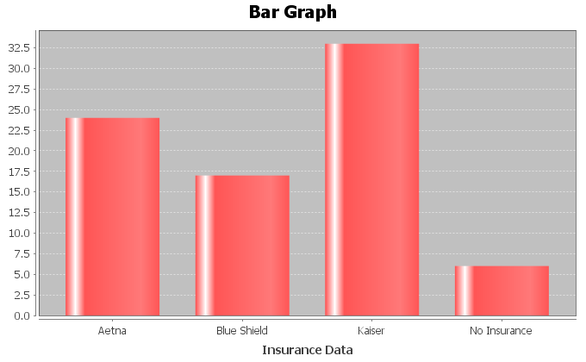

Notice the bar graph is a good way to summarize the data to the company. For example, they can see that that the number of employees that prefer Kaiser is about twice as much as Blue Shield and very few employees opted for no insurance.

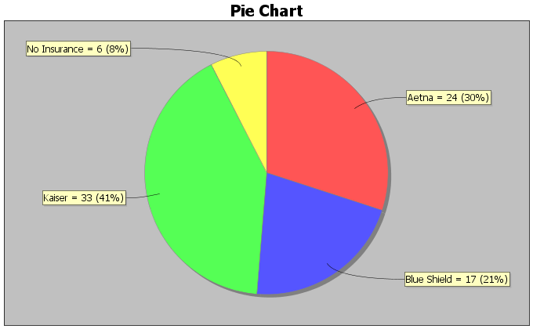

Notice the pie chart gives a part of the whole view and gives both the amount and the percentage. For example, the number of employees that prefer Kaiser is about 11% higher than the number of employees that prefer Aetna.

Now try the following example with your instructor.

Example 7: In Fall of 2015, students in Math 075 classes were asked what type of transportation they use to get to school. Here is the bar graph and pie chart.

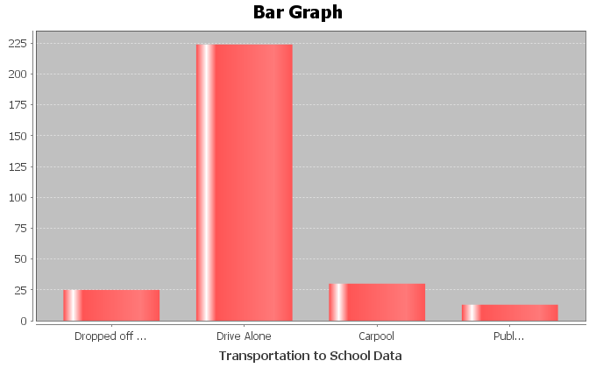

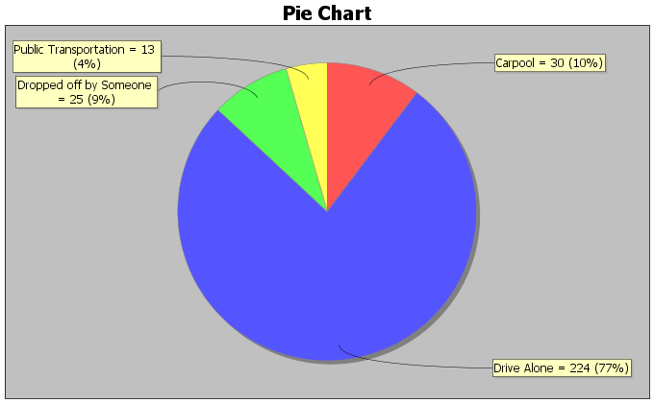

What percentage of the students carpool?

Which type of transportation was most popular?

What was the difference between the percent of students that carpool and the percent   
 of students that take public transportation?

**Practice Problems Section 6B**

Convert the following fractions into percentages by multiplying by 100% and simplifying. Write your answer as a mixed number when appropriate.

1. 2. 3. 4. 5.



6. 7. 8. 9. 10.



Convert the following Decimals into percentages by multiplying by 100% and simplifying. Write your answer as a decimal.

11. 0.43 12. 0.387 13. 0.054 14. 0.601

15. 0.022 16. 0.719 17. 0.352 18. 0.0128

Convert the following percentages into fractions by dividing by 100 and simplifying.

19. 35% 20. 28% 21. 74% 22. 95%

23. 68% 24. 25. 26.



Convert the following percentages into decimals by dividing by 100 and simplifying.

27. 23.9% 28. 3.8% 29. 8.7% 30. 79%

31. 4.2% 32. 0.6% 33. 58.1% 34. 99.9%

Solve the following applied percent problems by using a proportion.

35. To estimate the total number of deer in a forest, forest rangers tagged 75 deer and released them into the forest. Later, they caught a few deer and saw that 30% of them had tags. How many total deer do they estimate are in this part of the forest?

36. A bake shop wants to find out how many of their customers would like to buy a banana cream pie. They took a random sample of 280 customers and found that 96 of them like banana cream pie. Round your answer to the tenth of a percent.

37. It is estimated that about 5.3% of Americans over the age of 65 live in nursing homes. Close to 6,900 adults over 65 live in Santa Clarita, CA. How many do we expect to live in nursing homes, if the percentage is correct?

38. We took a random sample of 600 people living in Santa Clarita, CA. We found that 306 of them were female. About what percent of Santa Clarita is female?

39. A slot machine game in Las Vegas wins about 8% of the time. How many total times would Jeremy have to play the slot machine if he wants to win twice?

40. It is estimated that 10.4% of children in CA have some sort of disability. If there is an estimated 9,400,000 children in CA, how many do we expect to have a disability?

For numbers 41-44 look at the following bar graph describing the hair color of students at a junior high school.

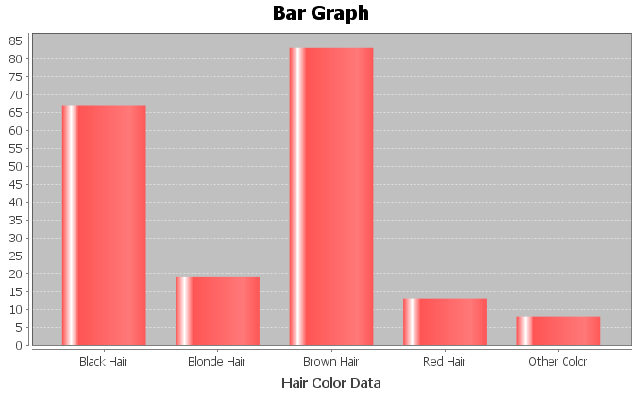

41. What was the most popular color hair at the school?

42. What was the least popular color hair at the school?

43. Approximately how many more students had blond hair than red hair?

44. Approximately how many more students had brown hair than black hair?

For numbers 45-49 look at the following pie chart describing the occupants of a small village as either child, teen, young adult or older adult.

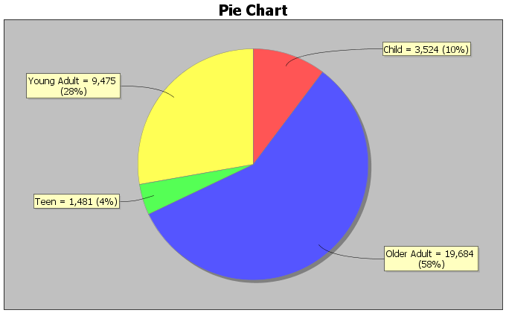

45. What percent of the people in the village are teenagers?

46. How many people in the village are older adults?

47. What is the difference between the percentage of young adults and the percentage of older adults?

48. Are there more teenagers in the town or children?

49. How many more young adults are there in the town than teenagers?

For numbers 50-53, look at the following bar graph describing the floor patients at a hospital were admitted to.

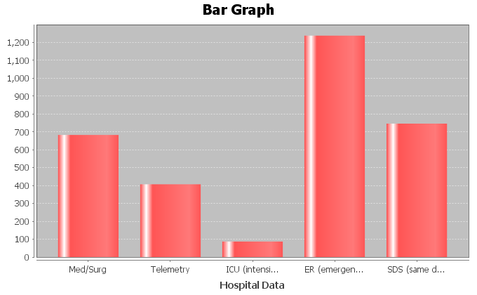

50. Which department had the most patients?

51. Which department had the fewest patients?

52. Did same day surgery (SDS) see more patients than the medical/surgery (Med/Surg) floor?

53. Estimate how many more patients went to Telemetry than ICU?

For numbers 54-59, look at the following pie chart describing the floor patients at a hospital were admitted to.

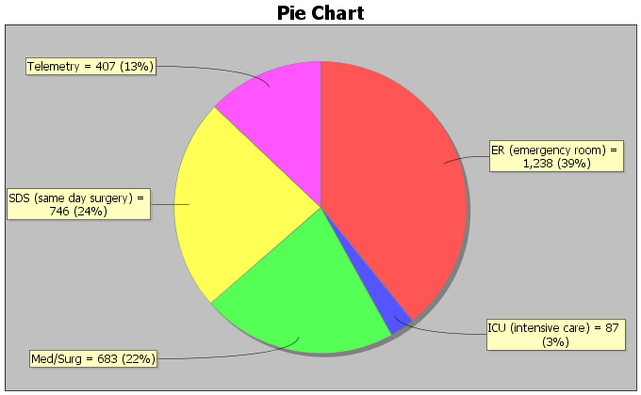

54. What percent of patients were admitted to the telemetry floor?

55. How many more patients went to SDS than Med/Surg?

56. What is the difference between the percent of patients that went to ER and the percent of patients that went to ICU?

57. How many patients did ICU receive?

58. How many more patients went to Med/Surg than Telemetry?

59. What is the difference between the percent of patients that went to Telemetry and the percent of patients that went to ICU?

For #60-63, look at the following bar graph describing the marriage status of students at a community college.

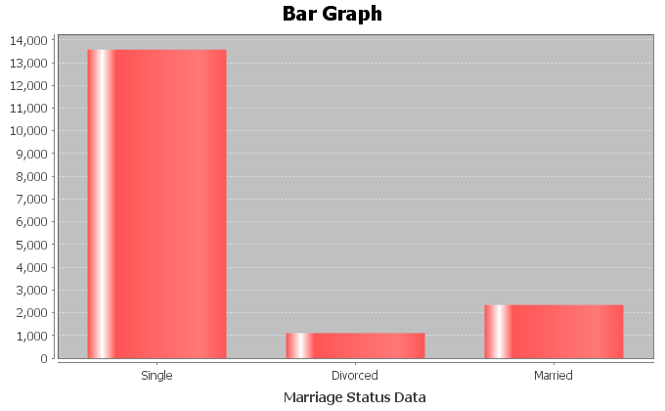

60. Which marriage status is most common at the college?

61. Approximately how many students are divorced?

62. Which marriage status is least common at the college?

63. Approximately how many more students are single than married?

For #64-67, look at the following pie chart describing the marriage status of students at a community college.

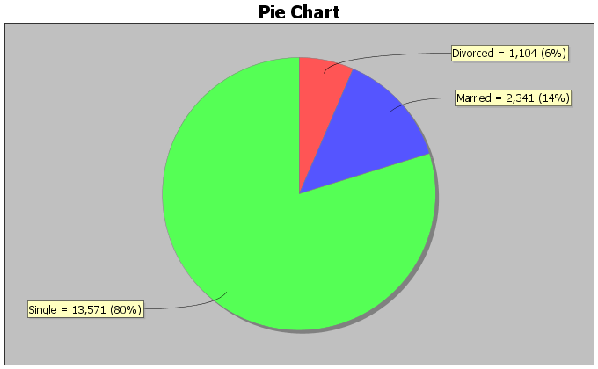

64. Approximately what percent of the college students are married?

65. Approximately what is the difference between the percent of students that are married and the percent of students that are divorced?

66. How many more students are single than divorced?

67. It was estimated that about 11% of Americans are left handed. Stacey’s apartment complex has 29 left handed people who live there. If the 11% is correct, what is the total number of people who live in Stacey’s apartment complex?

68. Super Bowl XLVI between the New York Giants and New England Patriots was the most-watched game in the history of the NFL, peaking with 117.7 million watchers in the final half hour. There were approximately 318.9 million people living in the U.S. that year. What percent of Americans were watching the Super Bowl that year?

69. A random sample of eligible voters shows that about 57.5% of people voted for the last presidential election. If there are approximately 199,182 people who live in Santa Clarita, how many people voted in the last presidential election?

70. A recent Gallup poll shows that 62% of Americans think that the U.S. will be cashless in their lifetime, with all purchases being made by credit cards, debit cards, and other electronic payments. If we were to ask 6075 people this question, how many would we expect to agree that U.S. will be cashless in their lifetime?

71. A doctor took a random sample of his patients. He found that 59 patients out of the 246 sampled were obese. What percent of the doctor’s patients are obese according to this random sample?

**Section 6C – Commission, Interest, Tax, Markup and Discount**

In the last section, we looked at percent conversions and solving simple percent problems with a proportion. We are now going to look at some more complicated percent applications.

Commission

Many people work on commission. In a general sense, you get paid a percentage of what you sell. The more you sell, the more money you make. Usually people have a set commission rate (percent) that they will be paid. The formula for commission is where *C*  is the amount of commission they are paid, *T* is the total sales and *r* is the commission rate (percent). As with most of these formulas involving percent, we need to be sure to convert the percent to either a fraction or decimal, before plugging in for *r.*



For example, look at the following commission problem. Marsha gets paid 12% of all makeup she sells. She made a total of $216 this week from commission. What was the total sales of makeup for the week? Like with any formula, plug in what you know and solve for what you don’t know. We first must convert the 12% into a fraction or decimal. , so we will plug in 0.12 for *r* and 216 for *C* and then solve for *T.*



So Marsha sold $1800 in makeup this week in order to make the $216 in commission.

Simple Interest

Simple Interest is an important concept for everyone to know. It a big part of financial stability and is vital to understanding savings accounts. The formula for simple interest is where *P* is the principal (amount invested), *r* is the interest rate (percent), and *t* is time in years.



Let’s look at an example. Jerry deposited $3500 into a simple interest account. He was able to earn $122.50 in interest after 6 months (1/2 year). What was the interest rate the bank used? Write your answer as a percent.

Again, plug in what we know and solve for what we do not know. We know I = 122.5, P = 3500 and t = ½ . Now let’s solve for r.



Now the interest rate is not written as a percent. Do you remember how to convert a decimal into a percent? Remember, if you see the percent symbol, divide by 100, but if you do not see the percent symbol and you want to put one on, multiply by 100.

So r = 0.07 = 0.07 x 100% = 7%

So Jerry’s bank gave him a 7% interest rate.

Try the following example problems with your instructor. Pay close attention to see if you need the commission or simple interest formula.

Example 1: Jimmy sells cars and is paid a commission for the cars he sells. In one day he sold three cars for a total of $43,000 and was paid a commission of $1720. What is Jimmy’s commission rate? Write your answer as a percent.

Example 2: Rick invested $4,000 into a bank account that earns 6% simple interest. How long will it take Rick to make $720 in simple interest?

Taxes and Markup

Most people living in the U.S. have to pay taxes. Whether you buy coffee or a car, you need to pay taxes, but how do taxes work? Taxes in CA can vary depending on where you are. Some areas have a tax rate of 9.25% and other areas have a tax rate of 8.5%. So basically a tax is a percent of increase. The store multiplies the percent times the price of the item to calculate the tax. Then it adds the tax onto the price to get the total you have to pay. A common formula for calculating the total with taxes included is T = A + rA where T is the total paid, A is the original amount of the item before taxes and r is the tax rate percent for the area you live in.

Let’s look at an example. Suppose an electric shaver costs $64 at the store. When you go to pay, the total is $69.92. What is the tax rate? Write your answer as a percent.

Since we know the total T = 69.92 and the amount A = 64, we can solve for r in the formula. Remember, we will need to convert our answer into a percent by multiplying by 100.



Notice a few things. First 64 + 64r is not 128r. Remember these are not like terms. So we need to bring the r terms to one side and constants to the other. This is why we subtract the 64 from both sides. The $5.92 was actually the amount of tax they charged. After solving we got an answer of r = 0.0925 and converting that into a percentage we get r = 0.0925 x 100% = 9.25%. So in the electric shaver problem, we were in an area that charges a 9.25% sales tax.

Another type of problem that uses the same percent of increase problem is a markup. A markup is when a store buys an item from a manufacturer for a certain cost and then sells it to you for a higher price. For example some stores have a 10% markup rate. Meaning whatever the cost of the item, they add an additional 10% onto the price before selling it. This is how stores make money. Since it is a percent of increase, a markup also uses the formula T = A + rA where A is the amount before the markup and T is the total after the markup and r is the markup rate (percent).

Look at the following problem. A store bought a tennis racquet from the manufacturer. If they have a standard 15% markup policy on all items, and they sold the racquet for $72.45 after markup, what was the cost of the racquet from the manufacturer? We first see that we are giving the markup rate at 15%. Again make sure to convert that into a fraction or decimal before plugging in for r. = r. So we will plug in T = 72.45 and r = 0.15 and solve for A.



Notice a few things. First that A is the same as 1A, so since the 1A and the 0.15A are like terms, we can add them and get 1.15A. Also a common technique to eliminate decimals is to multiply both sides of the equation by a power of 10, which in this case was 100. So the store bought the tennis racquet originally for $63 and then sold it to us for $72.45.

Discount

Our final percent application is discount and sale price. We have all been in stores that sometimes say 25% off or 50% off sale. We know that the sale price is lower than the regular price, but how does a discount work? A discount is really a percent of decrease. The store multiplies 25% times the price of the item. This is called the discount. Then the store subtracts this amount from the price of the item, before charging you. A common formula used in discount problems is T = A – rA. Notice this is very similar to the tax or markup formula but it is a decrease (-) instead of an increase (+). In this formula, A is the amount of the item before the sale and T is the total price of the item after the discount and r is the discount rate (percent).

Let’s look at an example. A car has a regular price of $18000 and is on sale for $14,400. What was the discount rate? Write your answer as a percent.

Plugging into our equation we see that the amount before the sale was A = 18000 and the total price after the sale was T = 14400. Plug in and solve for r. Again we will have to convert r into a percent by multiplying by 100.



Notice a few things. The 18000 is the A not the T. In sale price problems the price decreases so the large amount is the price before the sale. The 14400 is the sale price or the amount after the sale. The -3600 indicates that there was a $3600 discount. Our answer as a percent is   
r = 0.2 = 0.2x100% = 20%. So the car was being sold at a discount of 20%.

Try the following examples with your instructor. Be sure to use the formulas T = A + rA for tax and markup and the formula T = A – rA for discount problems.

Example 3: Rachael lives in an area with a 9.5% sales tax and bought a blouse for $45.99 with tax included. What was the price of the blouse before tax?

Example 4: A clothing store bought some jeans from the manufacturer for $16 and then sold them to their customers for $22.40. What was the markup rate? Write your answer as a percent.

Example 5: Juan bought a rosebush to plant in his backyard. The rosebushes were on sale for 35% off. If the sale price that Juan paid was $15.60, what was the price of the rosebush before the sale?

**Practice Problems Section 6C** *(Don’t forget to convert given percentages rates (r) into a decimal before plugging into the formulas.)*

Commission Problems ()



1. Tina sells software and is paid a 20% commission on all she sells. If she sold a total of $8000 worth of software in one month, how much commission did she make from the sale?

2. Maria sells hair products at the mall and is paid a commission on what she sells. If she sold a total of $860 in hair products and was paid a commission of $154.80, what is her commission rate? Write your answer as a percent.

3. Jim sells homes and earns a 4% commission on all he sells. If he made a commission of $19,000 on one home he sold, what was the total price of the house?

4. Rachel sells cars and is paid a commission on what she sells. If she sold a total of $66,400 worth in cars and was paid a commission of $4,648, what is her commission rate? Write your answer as a percent.

5. Jim sells paintings and earns a 6.5% commission on all he sells. If he made a commission of $279.50 on one painting he sold, what was the total price of the painting?

Simple Interest Problems ()



6. Kai invested $3000 into some stocks that yielded a 6.8% interest rate. How much simple interest did she make after 2 years?

7. Simon invested $2600 into a simple interest account for 2 years. If the account yielded $234 at the end of two years, what was the interest rate? Write your answer as a percent.

8. Elena invested some money into a bond account that yielded $375 in interest at the end of 1 year. If the interest rate was 3%, how much did she originally invest?

9. Yessica invested $5000 into a simple interest savings account that yields 6.5% simple interest. How many years will it take for her to make $1300 in simple interest?

10. Simon invested $3500 into a simple interest account for 2 years. If the account yielded $385 at the end of two years, what was the interest rate? Write your answer as a percent.

Tax and Mark-up Problems



11. Tim bought a washing machine for a total of $651 with tax included. What was the price of the washing machine before tax if Tim lives in an area with an 8.5% sales tax rate?

12. Julie wants to buy an iPhone that costs $120 before tax. If Julie lives in an area with a 9.25% sales tax, what will be the total price of the iPhone with tax included?

13. Lianna bought a turtleneck sweater for $19.71 with tax included. If the price of the sweater before tax was $18, what is the sales tax rate in Lianna’s area? Write your answer as a percent.

14. Wade works for a store that sells computers and computer parts and has a 20% markup policy. If they bought a computer from the manufacturer for $790, how much will they sell it for after the markup?

15. Patricia works for a clothing store. If the store buys its sweatshirts from the manufacturer for $19 and then sells them for $28.50, what is the stores markup rate? Write your answer as a percent.

Sale Price Problems



16. A bicycle that regularly sells for $350 is on sale for 25% off. What will the sales price be?

17. If Oscar bought some patio furniture that regularly sells for $275 on sale for $192.50 , what was the discount rate? Write your answer as a percent.

18. Tyrone bought a shed to put in his backyard. If the shed was on sale for 20% off and the sale price was $360, what was the regular price of the shed before the sale?

19. Tara bought a necklace that regularly sells for $450 on sale for $315, what was the discount rate? Write your answer as a percent.

20. Rick bought a book on sale for 40% off and the sales price was $30. What was the regular price of the shed before the sale?

**Section 6D – Classic Algebraic Problem Solving**

Algebra can be a useful tool to solving even when we do not know the formula for the situation. Here are some general steps to using algebra to solve word problems.

**Steps to Solving Problems with Algebra**

1. Read and reread the problem and write down all of the unknowns in the problem on a piece of paper.

2. Let your variable (x) stand for the unknown that you have the least amount of information about.

3. Use the information given in the problem to write algebraic expressions for all of your other unknowns.

4. Once you have algebraic expressions for all your unknowns, then you can use them to write an equation.

5. Solve the equation for the variable (x).

6. Go back and plug in the value of the variable (x) into all the algebraic expressions and find all the unknowns.

7. Check and see if your answers make sense in the context of the problem.

**It is also good to make a list of words and their meaning.**

Addition words: Sum, more than, increased by, total

Subtraction words: Subtract from, less than, less, decreased by, difference

Multiplication words: Multiply, product, times, percent of (multiply by percent),   
 fraction of (multiply by fraction)

Division words: Quotient, ratio, divided by

Words that mean “Equals”: Is, Is equal to, Is equivalent to, Is the same as

Let’s look at an example. When seven is subtracted from the product of a number and four, the result is 69. Find the number.

Step 1-3 - Since there is only one unknown, we will let x be the number.

Step 4 - Now we will translate the words into an equation. Subtracted from means subtract in the opposite order. The product of a number and four means multiply 4 and x. So we get the following.



Step 5 - Now solve the equation. Since there is only one number we are looking for, x is the answer.



Steps 6&7 – The only unknown is the number 19 and that is our answer. The answer does make sense since 4 times the number is 76 and then 7 less than it is 69.

Let’s look at another example. Suppose a political science club is divided into three groups: liberal, moderate and conservative. There are twice as many liberals as moderates and there are seven more conservatives than moderates. If the club has a total of 75 members, how many are in each group?

Step 1 – Write down all unknowns. You should write down the following on a piece of paper.

# of liberals =

# of moderates =

# of conservatives =

Step 2 – Since we know something about liberals and conservatives but nothing about moderates we will let x be the number of moderates.

Step 3 – Twice as many liberals as moderates means we can represent liberals as 2x. Seven more conservatives means we can represent conservatives with x+7.

# of liberals = 2x

# of moderates = x

# of conservatives = x+7

Step 4 – Never try to write an equation until you have algebraic expressions for all your unknowns. Since we know the total is 75 we will add our algebraic expressions and set it equal to 75.

2x + x + x+7 = 75

Step 5 – Now we solve the equation for x using the techniques we learned in the last chapter. Notice that 2x, x and x are like terms on the same side so we can simply add them.



Step 6 – Now that we know x we can find all the solutions. Go back to your unknowns and algebraic expressions. If you plug in 17 for x in all of them you will have your answers.

# of liberals = 2x = 2(17) = 34

# of moderates = x = 17

# of conservatives = x+7 = 17+7 = 24

Step 7 – So our answer is 34 liberals, 17 moderates and 24 conservatives. Does this answer make sense? Yes. There are twice as many liberals and seven more conservatives than moderates and the total is 75.

Let’s look at another example. Jimmy has a bunch of coins in the cushions of his couch. As he is out of money and needs gas in his car, he is searching for as many coins as he can find. The coins he found had a total value of $7.50 . He only found quarters, dimes and nickels. There were three times as many dimes as nickels and eighteen more quarters than nickels. How many of each type of coin did he find?

Step 1 – Write down all unknowns. You should write down the following on a piece of paper. Again the key thing to remember is that for coin problems, the number of coins is not money. If we have 3 quarters, that does not mean I have $3. You need to multiply the number of the coins times the value of the coin. So 3 quarters means 3 x 0.25 = $0.75 . Not only do we need to know how many coins but also we need algebraic expressions that represent the amount of money for each coin.

# of nickels =

# of dimes =

# of quarters =

$ in nickels =

$ in dimes =

$ in quarters =

Step 2 – Since we know something about quarters and dimes but nothing about nickels we will let x be the number of nickels.

Step 3 – Three times as many dimes as nickels means we can represent the number of dimes as 3x. Eighteen more quarters than nickels means we can represent quarters with x + 18. Remember to get the amount of money, we will multiply the number of nickels times its value ($0.05), the number of dimes times its value ($0.10) and the number of quarters times its value ($0.25). We can simplify each expression. For the quarters we will use the distributive property.

# of nickels = x

# of dimes = 3x

# of quarters = x + 18

$ in nickels = 0.05x

$ in dimes = 0.10 (3x) = 0.30x

$ in quarters = 0.25 (x + 18) = 0.25x + 4.5

Step 4 – Never try to write an equation until you have algebraic expressions for all your unknowns. Since we know the total amount of money is $7.50 we will add our algebraic expressions for money and set it equal to 7.5



Step 5 – Now we solve the equation for x using the techniques we learned in the last chapter. Notice that the 0.05x, 0.30x and 0.25x are like terms on the same side so we can simply add them.



Step 6 – Now that we know x we can find all the solutions. Go back to your unknowns and algebraic expressions. If you plug in 5 for x in all of them you will have your answers.

# of nickels = x = 5 nickels

# of dimes = 3x = 3(5) = 15 dimes

# of quarters = x + 18 = 5 + 18 = 23 quarters

$ in nickels = 0.05x = 0.05 (5) = $0.25

$ in dimes = 0.10 (3x) = 0.30x = 0.3 (5) = $1.50

$ in quarters = 0.25 (x + 18) = 0.25x + 4.5 = 0.25 (5) + 4.5 = 1.25+4.5 = $5.75

Step 7 – So our answer is 5 nickels, 15 dimes and 23 quarters. Does this answer make sense? Yes. There are three times as many dimes as nickels and 18 more quarters than nickels. The amount of money in nickels ($0.25) + amount of money in dimes ($1.50) + amount of money in quarters ($5.75) = $7.50.

Try the following examples with your instructor:

Example 1: The quotient of a number and three is increased by seventeen. If the result is 39, what is the number?

Example 2: A car salesman has Fords, Chevrolets, and Dodges on his lot. He has twice as many Chevrolets as Dodges and nine more Fords than Dodges. If he has a total of 73 cars on the lot, how many of each kind does he have?

Example 3: Pat has a coin collection consisting of pennies, dimes and nickels. He has four times as many pennies as dimes and six fewer nickels than dimes. If Pat took all the coins to the store and spent them, it would be $4.07 total.

**Practice Problems Section 6D**

1. The sum of twice a number and nine is the same as the number subtracted from twenty-four. Find the number.

2. The product of a number and six is equivalent to the sum of the number and forty. Find the number.

3. Two less than the quotient of a number and five is the same as eleven. Find the number.

4. The smaller of two numbers is six less than the larger. The sum of the two numbers is 118. Find both numbers.

5. The sum of half a number and seven is nineteen. Find the number.

6. Twelve less than a number is eight. Find the number.

7. The product of a number and 4 is equal to the sum of twice the number and fourteen. Find the number.

8. Four less than twice a number is 20. Find the number.

9. A number divided by six added to four is equivalent to the number subtracted by 71.

10. Ten times a number is sixteen more than twice the number. Find the number.

11. Jim has a three-number code to unlock the padlock on his garage door. The second number is seven less than the third number. The first number is two more than the third number. Find all three numbers if the sum of the numbers adds up to 34.

12. Carrie loves to plant flowers in her garden. Her favorites are daisies, roses and sunflowers. She has three times as many daisies as sunflowers and twice as many roses as sunflowers. She as a total of 78 flowers in her garden. How many of each type of flower does she have?

13. The sum of the angles of any triangle add up to 180 degrees. The largest angle of a triangle is four times as large as the smallest angle. The middle angle is 42 degrees greater than the smallest angle. Find all three angles.

14. Mrs. Smith has a total of 43 children in her class. The number of girls is one more than twice the number of boys. How many boys and girls does she have in her class?

15. The students in a political science class are divided up into three categories: liberal, conservative, or moderate. There are five more conservatives than moderates, and twice as many liberals as conservatives. How many of each type are there if there is a total of 87 students in the class?

16. Jimmy collects baseball and football trading cards. The number of baseball cards is one less than three times as many as the football cards. He has a total of 267 cards in his collection. How many baseball cards does he have? How many football cards does he have?

17. Gary owns a car dealership that sells cars, SUVs and minivans. Gary has three times as many SUVs as Minivans. He has eight more cars than SUVs. If he has a total of 127 vehicles on his lot, how many of each type does he have?

18. Harry has a total of $237 in his wallet in twenty dollar bills, five dollar bills, and 1 dollar bills. He has twice as many five dollar bills as one dollar bills. He has one more twenty dollar bill than one dollar bills. How many of each type does he have?

19. Lucia has a total of $2.60 in quarters, dimes and nickels in her purse. She has three more dimes than quarters and six more nickels than quarters. How many of each type does she have?

20. Marcos collects pennies, dimes and nickels. He has twice as many pennies as dimes and three more nickels than dimes. If the total amount of money is $6.95, how many of each type of coin does he have?

21. The ancient Greeks were famous for using the “Golden Rectangle” in their architecture. A golden rectangle is one where the length is approximately 1.618 times the width. A wall of one of the temples in Greece is in the shape of a golden rectangle. If its perimeter is 261.8 feet, what is the width and length of the wall?

**Chapter 6 Review**

Remember the principle of 100 when dealing with percentages. If you see the percent sign %, then divide by 100 and remove the sign. If you don’t see a percent sign and want to put one on, then multiply by 100 and put on the % symbol.

Algebra can be used to solve many different types of problems. If we have a formula that applies to a problem, we plug in what we know and solve for what we do not know. Here are some of the formulas we talked about in chapter 6.

This formula is used to solve general percent problems. We can find the percent, amount, or total by setting the cross products equal and solving. Remember the percent is already converted because it is over 100.



This formula is used to calculate the amount of commission made when a person sells *T* amount of money in merchandise and *r*  is the commission rate percent. Remember to convert r into a decimal or fraction before plugging it in. If we solve for *r* , we will need to convert our answer back to a percent.



This formula is used to calculate the amount of simple interest made when a person invests *P* amount of money in an account at an interest rate *r*  percent for *t* number of years. Remember to convert r into a decimal or fraction before plugging it in. If we solve for *r* , we will need to convert our answer back to a percent.



This is the classic percent of increase formula that can be used both for taxes and for markup problems. The *A* is the amount before tax or markup. The *T* is the total after tax or markup and *r* is the tax rate or markup rate percent. Remember to convert r into a decimal or fraction before plugging it in. If we solve for *r*, we will need to convert our answer back to a percent.



This is the classic percent of decrease formula that can be used for discount sales price problems. The *A* is the amount before the discount. The *T* is the total after the discount and *r* is the discount rate percent. Remember to convert r into a decimal or fraction before plugging it in. If we solve for *r*, we will need to convert our answer back to a percent.



To solve a classic algebra problems, remember the steps given below. Also remember if you are dealing with money, the number of bills or coins has to be multiplied by the value of the bill or coin to find the amount of money. 5 dimes does not mean 5 dollars. 5 dimes means 5 x 0.10 = $0.50

Steps to solving problems with algebra

1. Read and reread the problem and write down all of the unknowns in the problem on a piece of paper.

2. Let your variable (x) stand for the unknown that you have the least amount of information about.

3. Use the information given in the problem to write algebraic expressions for all of your other unknowns.

4. Once you have algebraic expressions for all your unknowns, then you can use them to write an equation.

5. Solve the equation for the variable (x).

6. Go back and plug in the value of the variable (x) into all the algebraic expressions and find all the unknowns.

7. Check and see if your answers make sense in the context of the problem.

**Review Problems Chapter 6**

1. Look at the formula which gives the volume of a circular cylinder propane tank. If we use 3.14 as an approximation of and we know that the radius needs to be 3 feet, then how tall should the propane tank be if it needs to hold 310.86 cubic feet of propane?



2. We used regression theory in statistics to find a formula that will predict the weight of a black bear based on its age. The formula was where *A* is the age of the bear in months and W is the weight. Forest rangers caught a black bear in the wild and found the weight to be 227.2 pounds. How old do we predict the bear to be?



3. The volume of a box is given by the formula where V is the volume, L is the length, W is the width, and H is the height. A toy container needs to have a length of 15 cm and a width of 9 cm. How tall should the container be if it needs to hold 3105 cubic cm of toys?



4. We used regression theory in statistics to find the following formula F = 0.028C - 1.98 where C is the number of calories a breakfast cereal has and F is the grams of fat the breakfast cereal has. Suppose a cereal has 3.06 grams of fat. How many calories do we expect the cereal to have?

5. The formula for compound interest that banks use is where P is the principal (amount initially invested), *A* is the future amount in the account, *T* is the number of years the money is in the account, *n* is how many times it compounds per year (how many times they put the interest back in the account) and *r* is the interest rate. John and Lacy want to buy a car in two years and will need $22,898. How much money *(P)* should they invest in their savings account if the interest rate is 7% (0.07), compounded annually (n=1)? Round your answer to the nearest dollar.



*Convert the following fractions into percentages. Write your answers as mixed numbers when appropriate.*

6. 7. 8. 9.



*Convert the following decimals into percentages.*

10. 0.69 11. 0.127 12. 0.014 13. 0.0063

*Convert the following percentages into fractions. Write your answer in lowest terms.*

14. 36% 15. 45% 16. 98% 17.



*Convert the following percentages into decimals.*

18. 13.8% 19. 2.5% 20. 88.4% 21. 0.35%

*Solve the following applied percent problems by using a proportion.*

22. To estimate the total number of raccoons in a forest, forest rangers tagged 26 raccoons and released them into the forest. Later, they caught a few raccoons and saw that 20% of them had tags. How many total raccoons do they estimate are in this part of the forest?

23. A women’s shoe store wants to find out how many of their customers would like to buy a new style of heels. They took a random sample of 85 customers and found that 52 of them like the new style. What percent of them like the new style? Round your answer to the tenth of a percent.

24. It is estimated that about 5.3% of Americans over the age of 65 live in nursing homes. If a town has a total of 8200 adults over the age of 65, how many do we expect to live in a nursing homes?

*Solve the following problems with the appropriate percent formula.*

25. Lynn sells jewelry at the mall and is paid a commission of what she sells. If she sold a total of $4800 in jewelry and was paid a commission of $264, what is her commission rate? Write your answer as a percent.

26. Mario sells cars and earns a 6% commission on all he sells. If he made a commission of $1,800 on one car he sold, what was the total price of the car?

27. Simon invested $4100 into a simple interest account for 3 years. If the account yielded $430.50 in simple interest at the end of three years, what was the interest rate? Write your answer as a percent.

28. Tianna invested some money into some stocks that yielded $345 in simple interest at the end of 2 years. If the interest rate was 7.5%, how much did she originally invest?

29. Mark bought a flat screen TV for a total of $437 with tax included. What was the price of the TV before tax if Mark lives in an area with a 9.25% sales tax rate.

30. David bought some basketball sneakers for $49.05 with tax included. If the price of the sneakers before tax was $45, what is the sales tax rate in David’s area? Write your answer as a percent.

31. Riley works for a store that sells toys and has a 15% markup policy. If they bought a toy from the manufacturer for $14, how much will they sell it for after the markup?

32. Maria works for a clothing store. If the store buys a skirt from the manufacturer for $23 and then sells them for $28.75, what is the stores markup rate? Write your answer as a percent.

33. If Eric bought some paint that regularly sells for $24 a gallon on sale for $19.44 a gallon, what was the discount rate? Write your answer as a percent.

34. Tyra bought a beautiful red dress to wear to a New Year’s Eve party. If the dress was on sale for 35% off and the sale price was $234, what was the regular price of the dress before the sale?

*Solve the following problems using classic algebraic problem solving techniques.*

35. The number of part time students at a college is 52 less than twice the number of full time students. If there are a total of 10,808 students at the college, how many are part time and how many are full time?

36. A tutoring business offers tutoring for elementary, junior high, and high school students. There is a total of 31 students at the tutoring center right now. There are 3 times as many elementary school students as junior high students. There are 6 more high school students than junior high. How many students of each level are there?

37. A coffee house sells three types of coffee: house blend, French roast, and decaffeinated. They sold 4 times as many bags of house blend as French roast. They sold one bag less of decaffeinated than they did French roast. If they sold a total of 53 bags, how many of each type did they sell?

In Spring of 2016, students in Math 075 classes were asked what their political party they affiliate with. Here is the bar graph of the 508 students that responded.

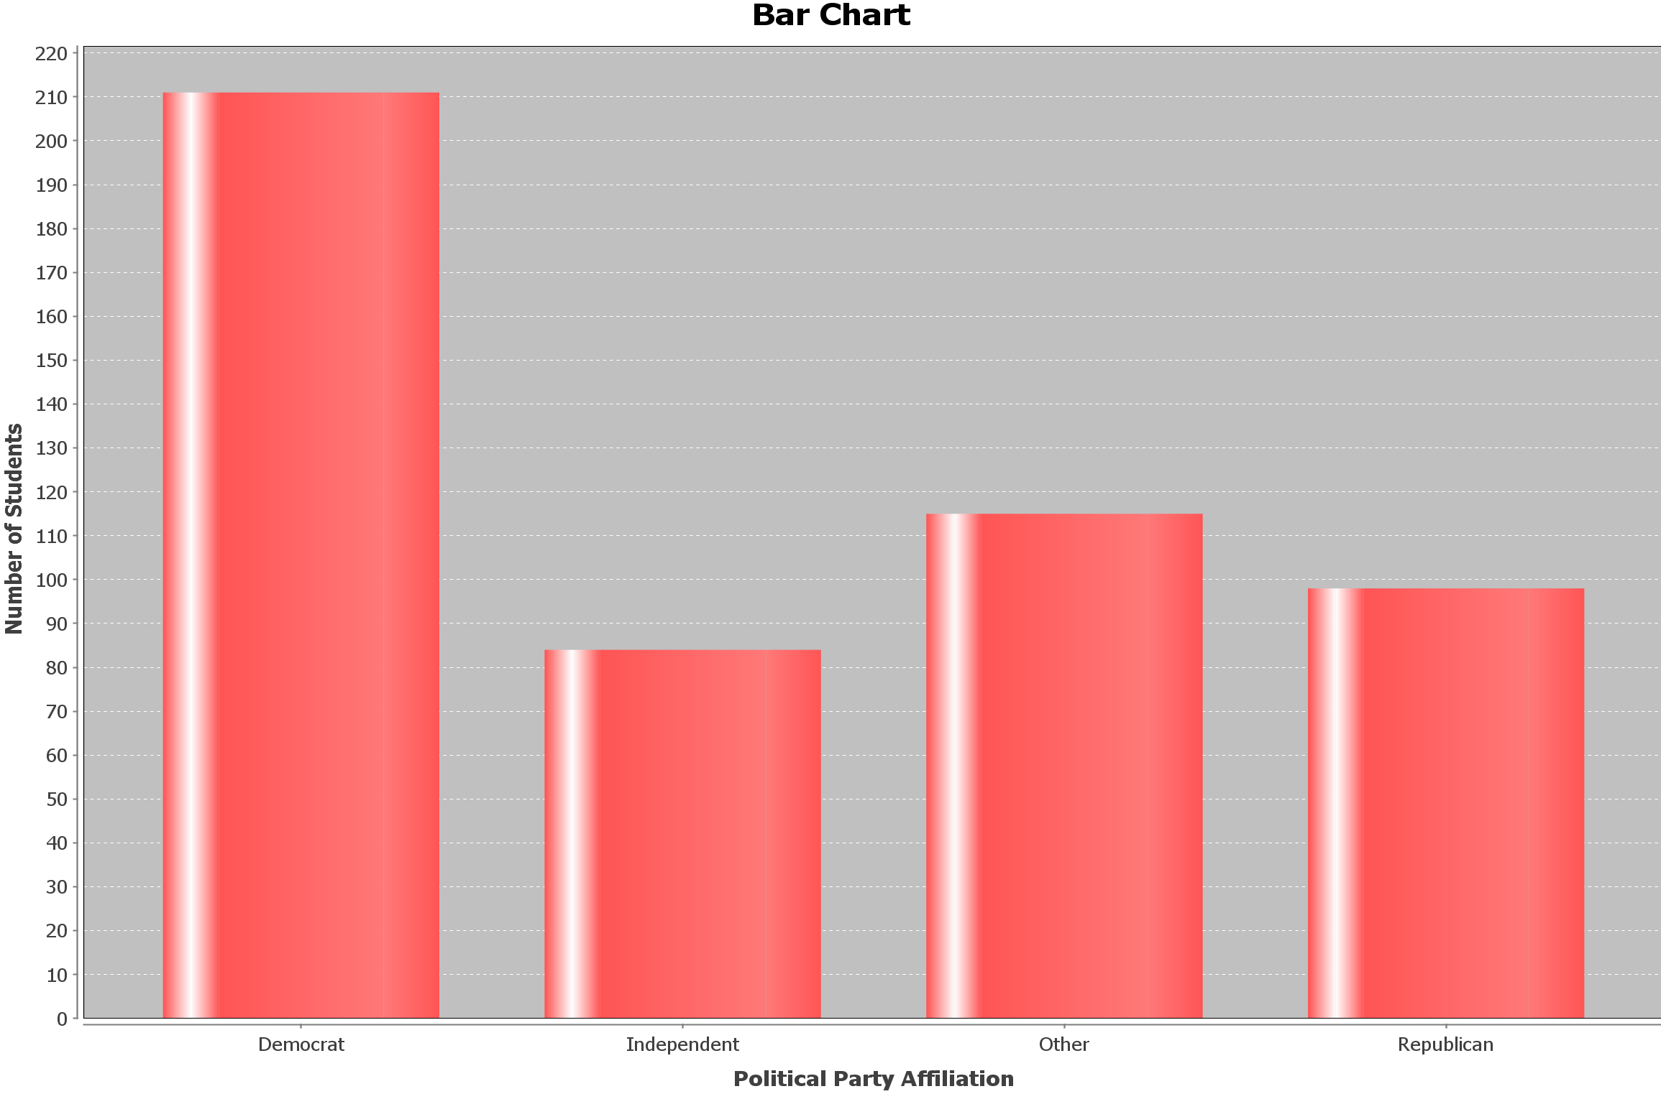

38. Which political party had the fewest students?

39. Which political party is the most popular?

40. Approximately how many more Democrats than Republicans were there?

41. Approximately what percentage of students in the data are Republican?

In Spring of 2016, students in Math 075 classes were asked which social media was their favorite to use. Here is the pie chart of the 512 students that responded.

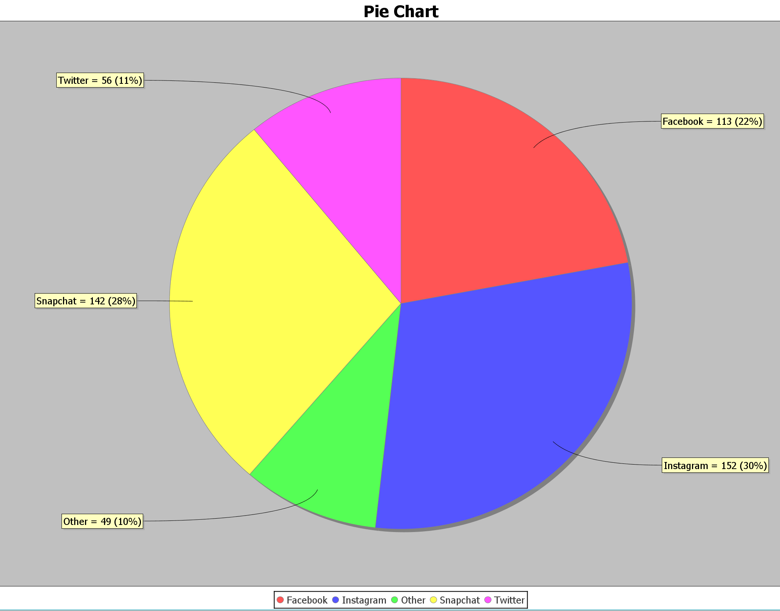

42. What percent of students use Facebook as their favorite social media?

43. How many students chose Snapchat as their favorite social media?

44. What is the difference between the percentage of students that chose Instagram and Twitter as their favorite social media?

45. Do more students use Snapchat or Facebook as their favorite social media?

46. How many more students use Twitter over Other social media not listed as their favorite social media?

**Chapter 7 – Equation of a Line, Slope, and   
the Rectangular Coordinate System**

Introduction: Often, we want to explore relationships between variables. For example we might want to explore the relationship between the unemployment rate each year and U.S. national debt each year. Sometimes variables like this have linear relationships. In this chapter we will not only strive to understand these relationships, but also find the average rates of change (slope) and the equation of a line that can help us make predictions based on that relationship.

**Section 7A – Rectangular Coordinate System and Scatterplots**

Look at the following data which gives the profits of a small cupcake shop over the last twelve months. This is a good example of a relationship between two variables. In this case it is time and profit.

|  |  |
| --- | --- |
| Month | Profit in Thousands of Dollars |
| 1 | 1.5 |
| 2 | 1.8 |
| 3 | 1.9 |
| 4 | 2.2 |
| 5 | 2.4 |
| 6 | 2.7 |
| 7 | 2.8 |
| 8 | 3.0 |
| 9 | 3.1 |
| 10 | 3.4 |
| 11 | 3.5 |
| 12 | 3.8 |

It is important to be able to graph the data so that we can see if there are any trends. The main graph we use in Statistics is a scatterplot. To make a scatterplot we need to review plotting ordered pairs.

In the time/profit data above, we like to choose one variable to be the x-variable and one to be the y-variable. If we chose time as x and profit as y, we would be able to represent this data as ordered pairs.

*(This chapter is from Preparing for Algebra and Statistics, Third Edition,  
 by M. Teachout, College of the Canyons, Santa Clarita, CA, USA)*



***This content is licensed under a*** [***Creative Commons   
Attribution 4.0 International license***](http://creativecommons.org/licenses/by/4.0/)

Ordered pairs have the form (x , y). So for example the profit was 2.8 thousand dollars in the 7th month so that would correspond to an ordered pair of (7 , 2.8). A scatterplot is just a graph of all the ordered pairs.

How do we plot an ordered pair? We need to use the Rectangular Coordinate System. If you remember from previous classes, the horizontal axis is called the x-axis and the vertical axis is called the y-axis. The two axes divide the region into four quadrants. Where the x-axis and   
y-axis meet is the ordered pair ( 0 , 0 ) and is called the origin. Notice the x-axis and y-axis are just like the number line. Numbers to the right of the origin on the x-axis are positive and numbers to the left of the origin are negative. Numbers above the origin on the y-axis are positive and numbers below the origin are negative.

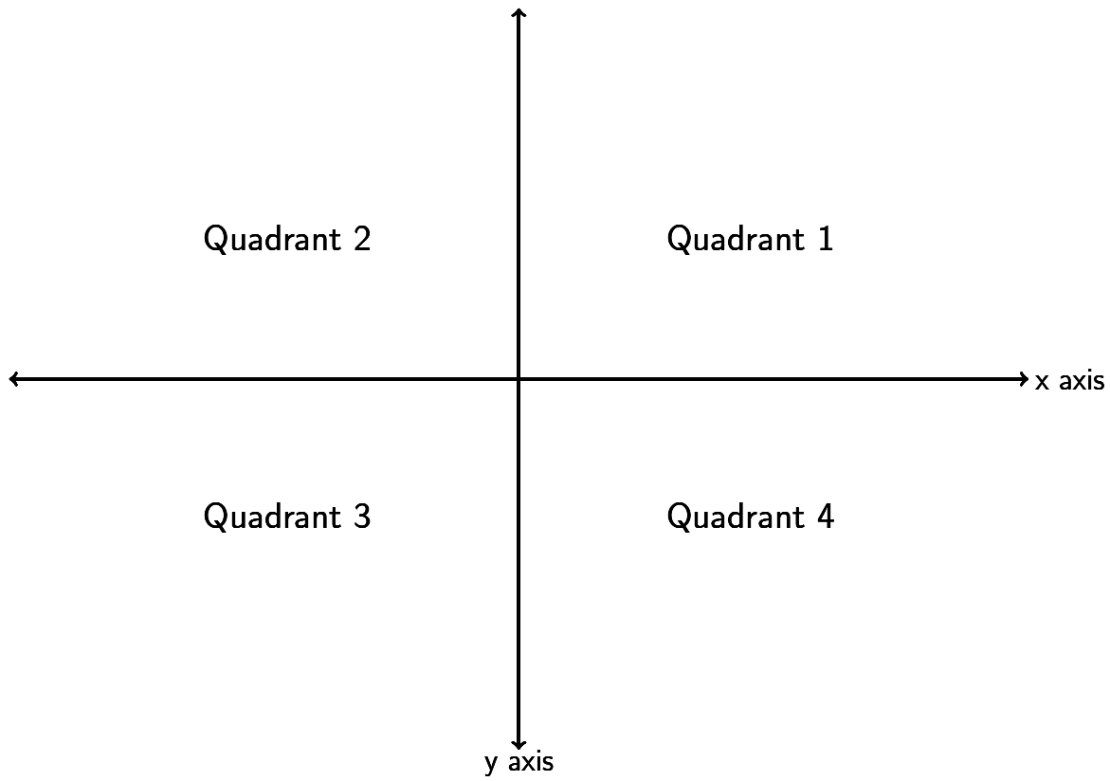

But how do we graph an ordered pair? Find the value on the x-axis and the y-axis and go where the two meet. If you notice it makes an imaginary rectangle. This is why we call this the Rectangular Coordinate System.

Look at the ordered pair (4 , -3). Find 4 on the x-axis and -3 on the y-axis. Where the two meet is the ordered pair ( 4 , -3 ). We often call ordered pairs “points” since we draw a dot to represent that ordered pair.

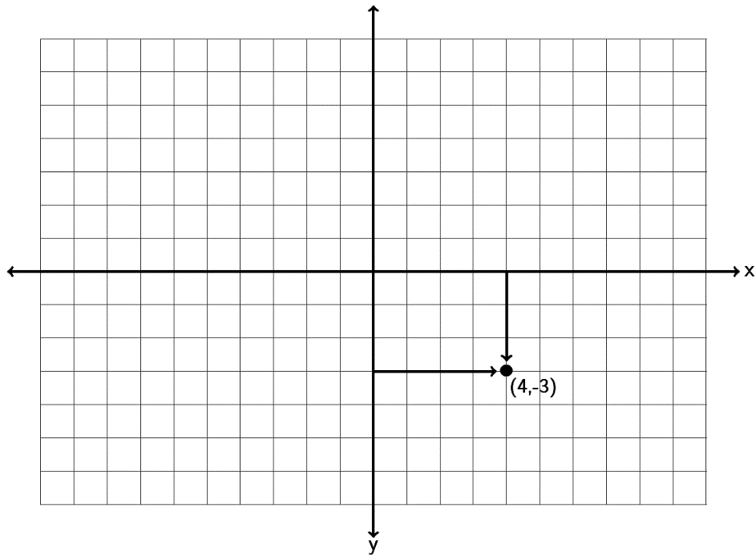

Now let’s plot some more ordered pairs and make a scatterplot. Let’s plot the points (-4 , 2) , (0 , -5) , (6, 0) and (3, 5). Notice that (-4,2) is in quadrant 2 and (3,5) is in quadrant 1. (0 , -5) is a special point as it lies on the y-axis. It is therefore called a “y-intercept.” (6,0) lies on the x-axis so it is called an   
“x-intercept.” Points that lie on an axis are not in any particular quadrant. Notice that a y-intercept has an x-coordinate of zero, while an x-intercept has a y-coordinate of zero.

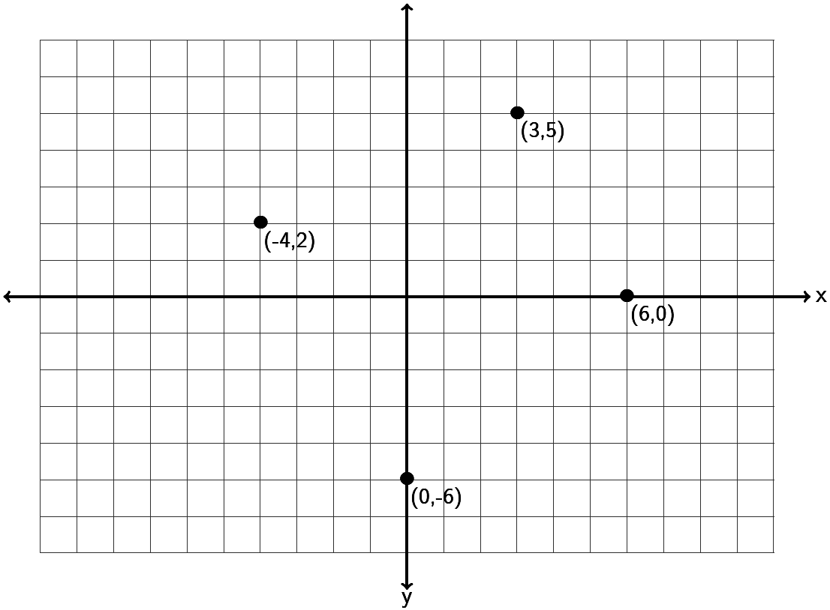

Do the following example with your instructor.

Example 1: Graph the ordered pairs (-3 , -6) , (0,4) , (5, 3) , (-6 , 0) , (4 , -5) on the graph provided. Which point is an x-intercept? Which point is a y-intercept? For the other three points, give the quadrant they lie in.

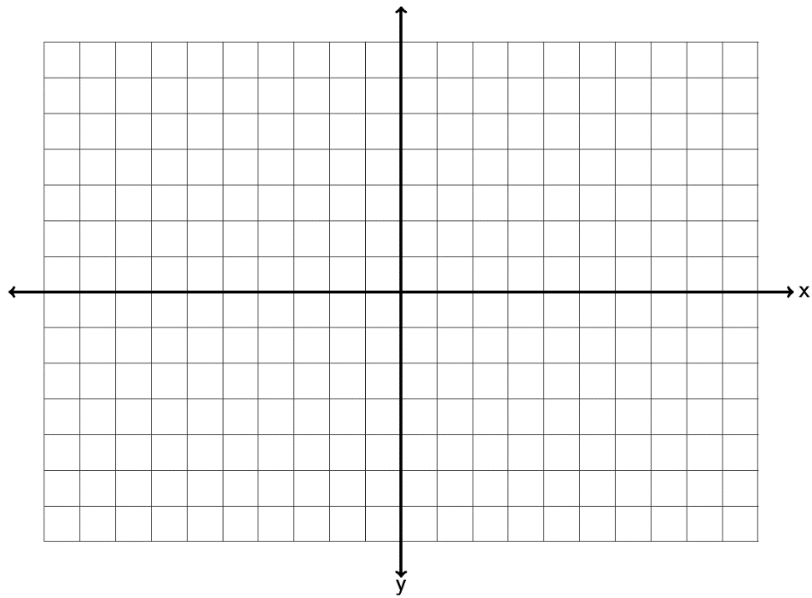

Plotting ordered pairs is vital to finding relationships between variables. Look at the profit data at the beginning of this section. If we plot all of those points we have the following scatterplot.

**Scatterplot**

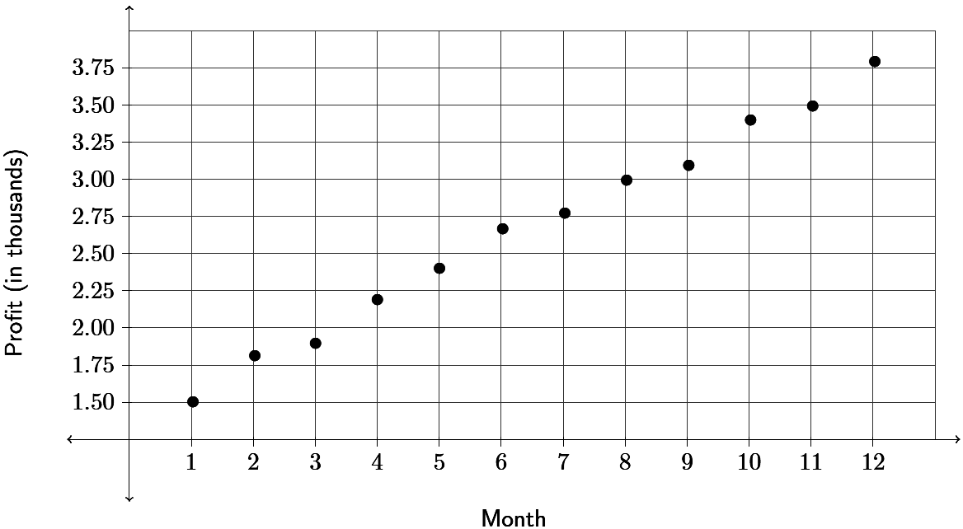

Since all the x and y coordinates are positive in the profit data, the points are all in the first quadrant. The scatterplot is just showing the first quadrant. In scatterplots we look for general trends. For example in this scatterplot, the points look pretty close to a line which suggests a linear trend. It seems as time increases, the profits for the cupcake shop are also increasing.

**Practice Problems Section 7A**

1. Graph the ordered pairs (2 , -6) , (-3,0) , (-1, 4) , (0 , 4) , (-1 , -3) on the graph provided. Which point is an x-intercept? Which point is a y-intercept? For the other three points, give the quadrant they lie in.



2. Graph the ordered pairs (4 , 2) , (0,-1) , (-6, -2) , (3 , 0) , (-1 , -6) on the graph provided. Which point is an x-intercept? Which point is a y-intercept? For the other three points, give the quadrant they lie in.



3. Graph the ordered pairs (-3 , 2) , (-2,0) , (-7, -4) , (0 , 0) , (4 , -1) on the graph provided. Which point is an x-intercept? Which point is a y-intercept? For the other three points, give the quadrant they lie in.



4. Graph the ordered pairs (2.5 , 3.5) , (0,4.5) , (-5.25 , -3.3) , (-5.5 , 0) , on the graph provided. Which point is an x-intercept? Which point is a y-intercept? For the other three points, give the quadrant they lie in.





5. Graph the ordered pairs (-3 , -1) , (-5,0) , (4, -3) , (0 , 1) , (-4 , 6) on the graph provided. Which point is an x-intercept? Which point is a y-intercept? For any points not on the x-axis or y-axis, give the quadrant they lie in.



6. Graph the ordered pairs (6 , 1) , (0,-5) , (-2, -4) , (4 , 0) , (-6 , 5) on the graph provided. Which point is an x-intercept? Which point is a y-intercept? For any points not on the x-axis or y-axis, give the quadrant they lie in.



7. Graph the ordered pairs (-6 , 2) , (-3,0) , (-4, -5) , (0 , 0) , (5 , -1) on the graph provided. Which point is an x-intercept? Which point is a y-intercept? For any points not on the x-axis or y-axis, give the quadrant they lie in.



8. Graph the ordered pairs (-1.25 , 4.5) , (0 , -1.33) , (5.5 , -2.3) , (3.5 , 0) , on the graph provided. Which point is an x-intercept? Which point is a y-intercept? For any points not on the x-axis or y-axis, give the quadrant they lie in.



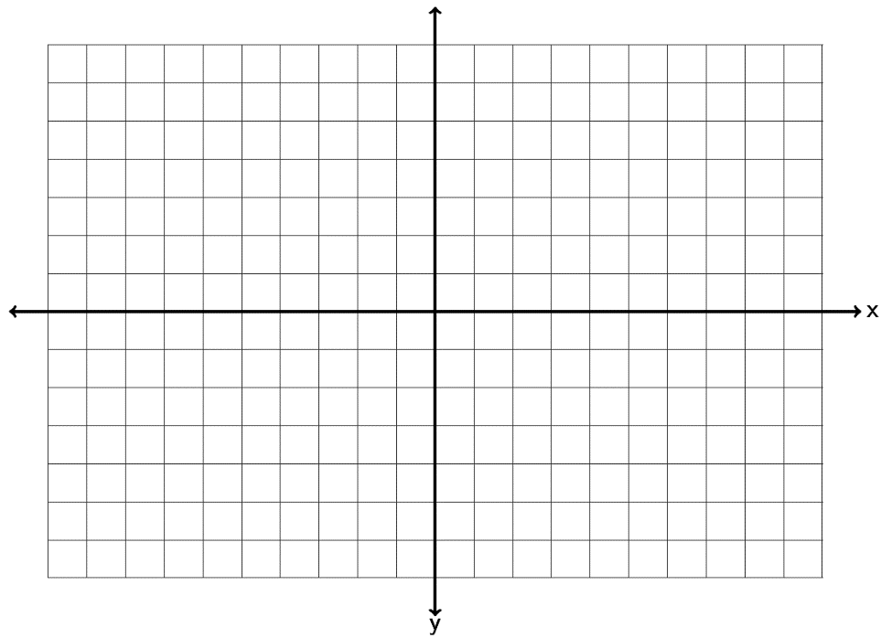

9. Graph the ordered pairs (6 , -6) , (-7,0) , (-1, 7) , (0 , 6) , (-5 , -3) on the graph provided. Which point is an x-intercept? Which point is a y-intercept? For any points not on the x-axis or y-axis, give the quadrant they lie in.



10. Graph the ordered pairs (-3.5 , 2.5) , (0 , -0.5) , (-3.5, -6.5) , (-6.5 , 0) , (-5.5 , -1) on the graph provided. Which point is an x-intercept? Which point is a y-intercept? For any points not on the x-axis or y-axis, give the quadrant they lie in.



11. Graph the ordered pairs (-4 , -1.25) , (-2.5 , 0) , (-7.25, -4) , (0 , 0) , (4.25 , -3.25) on the graph provided. Which point is an x-intercept? Which point is a y-intercept? For any points not on the x-axis or y-axis, give the quadrant they lie in.



12. Graph the ordered pairs (6.75 , 3.25) , ( 0 , -4.75) , (-4.25 , -6.3) , (-5.25 , 0.75) , on the graph provided. Which point is an x-intercept? Which point is a y-intercept? For any points not on the x-axis or y-axis, give the quadrant they lie in.





13. The following scatterplot looks at 13 breakfast cereals and the relationship between grams of sugar (x) and grams of fiber (y).

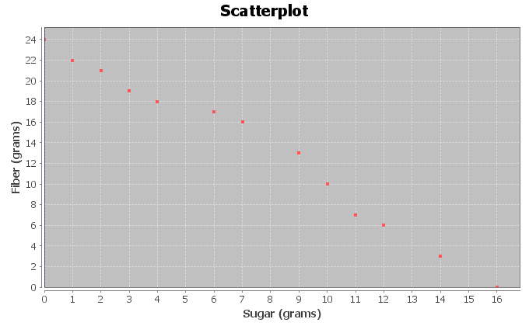

1. For each ordered pair, give the x and y-coordinates. Which is the x-intercept? Which is the y-intercept?
2. Do the points seem to be close to a line? If so does the line go up or down from left to right?
3. Complete the following sentence: As the amount of sugar increases, the amount of   
   fiber _________________.
4. Complete the following sentence. As the amount of sugar decreases, the amount of  
   fiber _________________.

14. The following scatterplot looks at 13 breakfast cereals and the relationship between carbohydrates (x) and total calories (y).

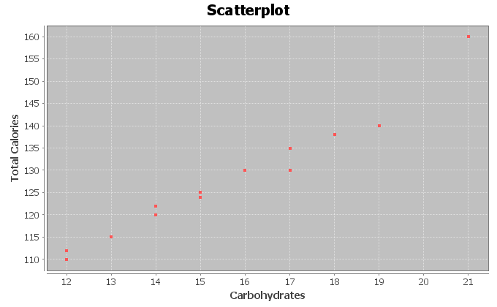

1. For each ordered pair, give the x and y-coordinates. Which quadrant are all these points in?
2. Do the points seem to be close to a line? If so does the line go up or down from left to right?
3. Complete the following sentence: As the number of carbs increases, the total number of calories _________________.
4. Complete the following sentence. As the number of carbs decreases, the total number of calories _________________.

**Section 7B – Slope of a Line and Average Rates of Change**

IBM stock had a price of $186.91 at the end of September 2014. Over the next three months the stock price rose and fell and by the end of December the price was $160.44. Over that three month period, what was the average rate of change of the stock price per month? Questions like this are key to understanding stock prices and business models. How much something is changing on average is often called the “Slope”. In this chapter we will seek to understand the concept of slope and its applications.

What it slope? Slope is defined as vertical change divided by horizontal change. In terms of ordered pairs it is change in y divided by change in x. In math we sometimes write the change in y as “” and the change in x as “”. The symbol is the Greek letter delta. Remember slope is best understood as a fraction that describes change between variables.



Look at the following graph. Let’s see if we can find the slope of the line.

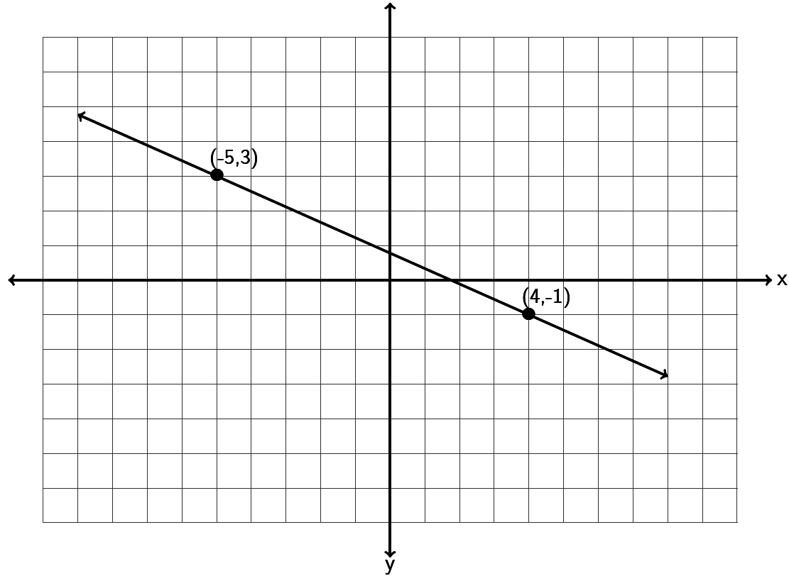

To find the slope of a line, always start by trying to find two points on the line. This line goes through the points (-5,3) and (4,-1). Any two points on the line you use will still give you the same slope. If we start at (-5,3) and go down and to the right to (4,-1) , can you find how much it goes down (vertical change) and how much it goes to the right (horizontal change). Notice to get from one point to the other, we had to go down 4 (-4 vertical change) and right 9 (+9 horizontal change). Remember going up or to the right are positive directions, while going down or to the left are negative directions. The slope is the fraction of the vertical change divided by the horizontal change. Notice that a negative number divided by a positive number gives you a negative answer.



Does the order we pick the points matter? What if we start at (4,-1) and go up and to the left to (-5,3)? Will we get a different slope? Let’s see. To go from (4,-1) to (-5,3) we would need to go up 4 (+4 vertical change) and left 9 (-9 horizontal change). So we would get the following.



Notice the slope is the same. So to review, when we find slope it does not matter the points we pick as long as they are on the line and it does not matter the order we pick them. All will give us the same slope.

Let’s look at a second example. Suppose a line goes through the point (-2, -4) and has a slope of 3. Could you draw the line? The first thing to remember when dealing with slope is that it should be a fraction. Can you write 3 as a fraction? Of course. , but what does that mean? Remember slope is the vertical change divided by the horizontal change so we see the following interpretation.



When using the slope to graph a line, you always need a point to start at. In this case we will start at   
(-2,-4) and then go up 3 and right 1. You can go up 3 and right 1 as many times as you want and can get more points.  
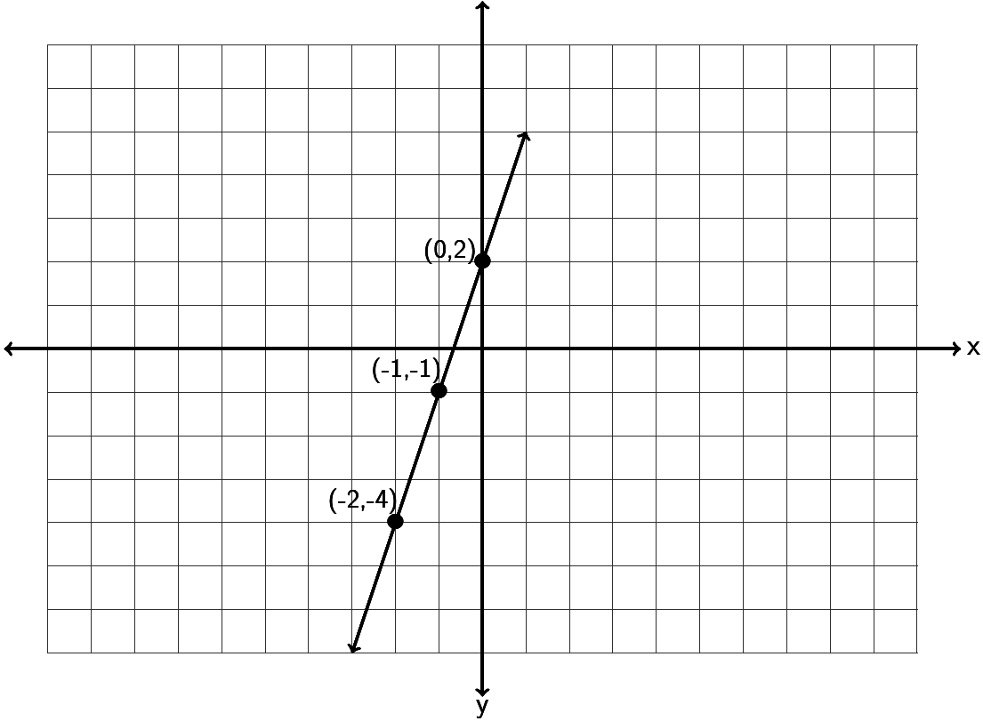

Notice a couple things from the last two examples.

A line with positive slope will be increasing from left to right. A line with negative slope will be decreasing from left to right.

For lines with a negative slope it is better to think of it as a negative numerator and a positive denominator. For example a slope of . Do not put the negative sign in both the numerator and denominator. . A negative divided by a negative is positive.



Try the following examples with your instructor.

Example 1: Find the slope of the following line by finding the vertical and horizontal change. Be sure to write your answer in lowest terms.

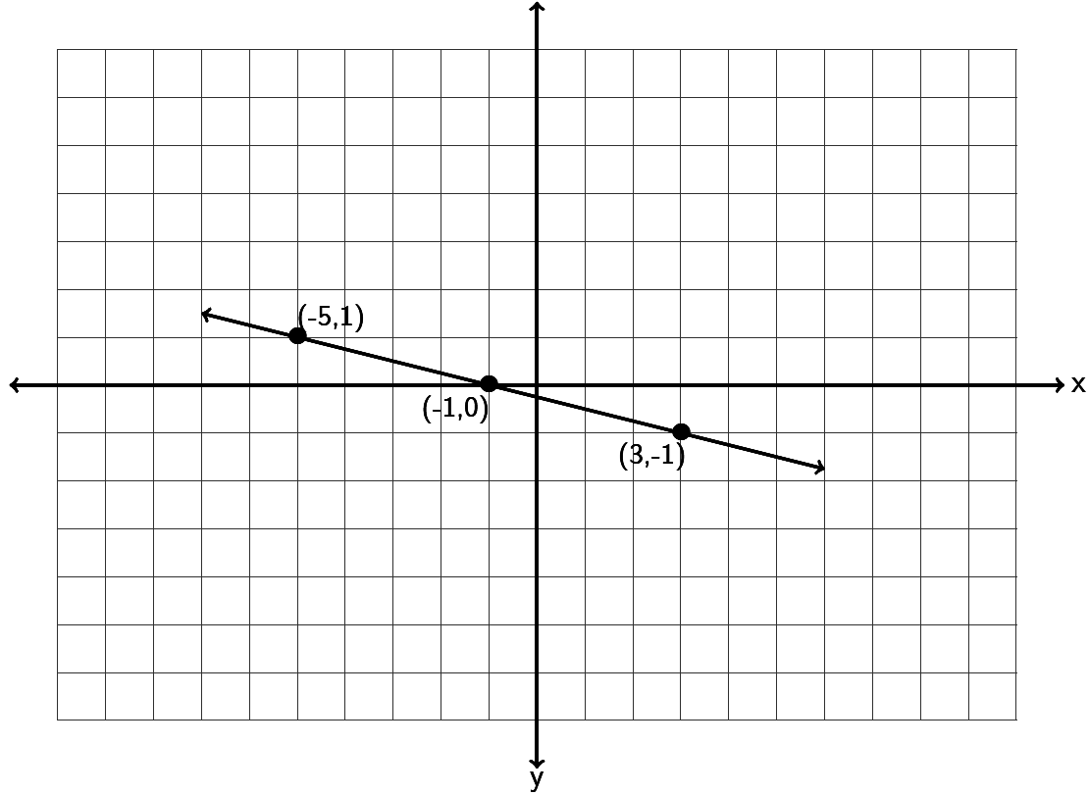

Example 2: Find the slope of the following line by finding the vertical and horizontal change.

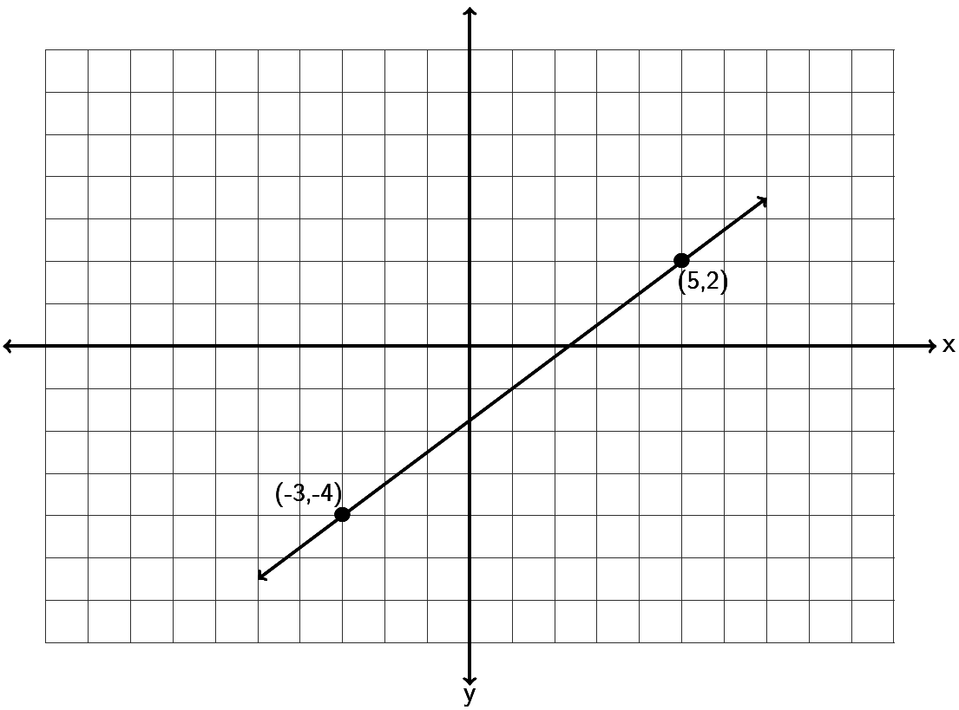

Example 3: Draw a line that goes through the point (-6, 2) and has a slope of .



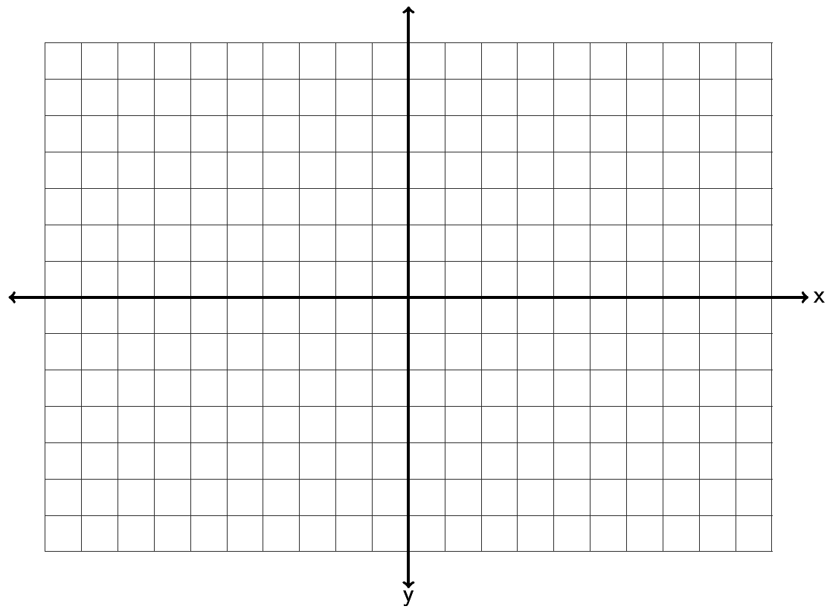

Example 4: Draw a line that goes through the point (-3, -4) and has a slope of .





What do we do if we want to find the slope between two points, but do not want to take the time to graph the points?

To get the vertical change you can subtract the y-coordinates of the two points. To get the horizontal change, your can subtract the x-coordinates of the two points. Be careful! You need to subtract in the same order. Here is the formula. The slope *(m)* of the line between is



For example, find the slope of the line between (-7 , 6) and (-3, -4). Identify one of the points as and the other point as . Remember, with slope it does not matter which point you start with. Suppose we let be (-7 , 6) and let be (-3, -4). Plugging in the correct values into the formula gives the following.



. Be careful to subtract in the correct order. Also be careful of negative signs. You may need to subtract a negative. Simplifying gives the following.



Try the following example with your instructor.

Example 5: Find the slope of the line between . Be sure to simplify your answer and write it in lowest terms.



What about the slope of horizontal lines? Horizontal lines change a lot horizontally but have zero vertical change. Hence the slope of a horizontal line is . So horizontal lines are the only lines that have a slope equal to zero.



What about the slope of vertical lines? Vertical lines have tons of vertical change but have zero horizontal change. Hence the slope of a vertical line is . Remember we cannot divide by zero. So vertical lines are the only lines that do not have a slope. We say the slope is undefined or does not exist.



A key point to remember is that horizontal lines have a slope = 0, while vertical lines do not have any slope at all (undefined). This is actually one of the ways we identify horizontal and vertical lines.

Try the following examples with your instructor.

Example 6: Find the slope of the following line.

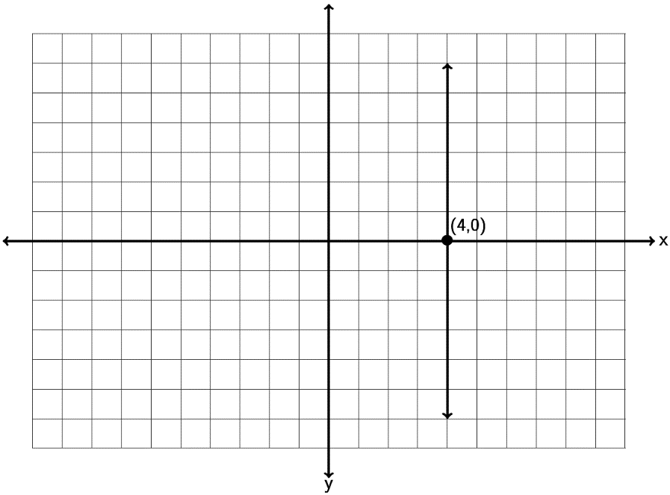

Example 7: Find the slope of the following line.

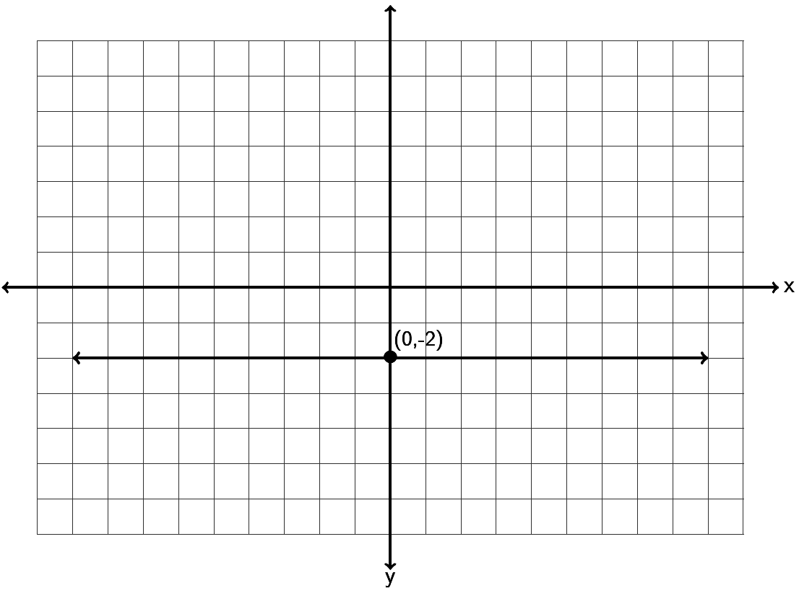

Parallel lines go in the same direction, so they have the same slope. If a line has a slope of 1/3 , then the line parallel to it will also have a slope of 1/3.

Perpendicular lines are lines which meet at a right angle (exactly 90 degrees). Perpendicular lines have slopes that are the opposite or negative reciprocal of each other. Remember a reciprocal is flipping the fraction. The slope of a perpendicular line will not only flip the fraction but will also have the opposite sign. For example if a line has a slope of 2/7 then the perpendicular line will have a slope of -7/2. If a line has a slope of -1/6 then the line perpendicular will have a slope of +6/1 = +6.

Try the following examples with your instructor.

Example 8: A line has a slope of -3/7. What is the slope of a line parallel to it? What is the slope of a line perpendicular to it?

Example 9: A line has a slope of +9. What is the slope of a line parallel to it? What is the slope of a line perpendicular to it?

Applications

At the beginning of this section we looked at IBM stock prices for a 3 month period in 2014. The slope is also the average rate of change. IBM stock had a price of $186.91 at the end of September 2014. Over the next three months the stock price rose and fell and by the end of December the price was $160.44. Over that three month period, what was the average rate of change of the stock price per month?

To answer this question we simply need to find the slope. A couple key things to look at. First of all notice they want to know the change in stock price per month. That is important since it tells us the slope should be price/month. If you remember your slope formula, this implies that the price must be the y-value and month the x-value. Writing the information as two ordered pairs gives us the following.

( month 9 , $186.91 )

( month 12, $160.44)

Letting the first point ( month 9 , $186.91 ) be and the second point   
( month 12, $160.44) be , we can plug into our slope formula and get the following.



But what does this mean? The key is units. Remember in this problem the y-values were in dollars and the x-values were in months. So the numerator of our answer is in dollars and the denominator is in months.

Does this mean 1 month of IBM stock was $8.82? No it does not. Remember slope is a rate of change. It is telling us how much the IBM stock is changing over time. It is also negative, so that tells us the stock price is decreasing. So the slope tells us that IBM stock price was decreasing at a rate of $8.82 per month.



Try the following example with your instructor.

Example 10: A bear that is 50 inches long weighs 365 pounds. A bear 55 inches long weighs 446 pounds. Assuming there is a linear relationship between length and weight, find the average rate of change in pounds per inch.

**Practice Problems Section 7B**

1. Find the slope of the following line by finding the vertical and horizontal change. Be sure to write your answer in lowest terms.

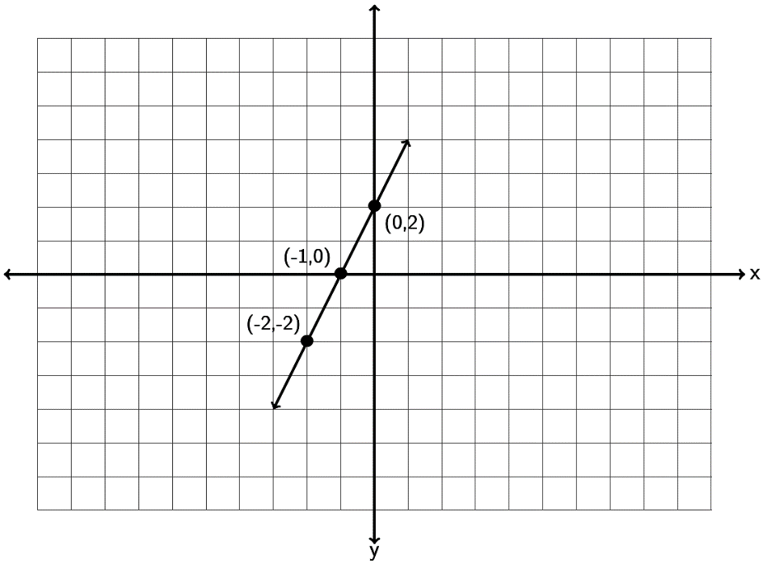  
2. Find the slope of the following line by finding the vertical and horizontal change. Be sure to write your answer in lowest terms.

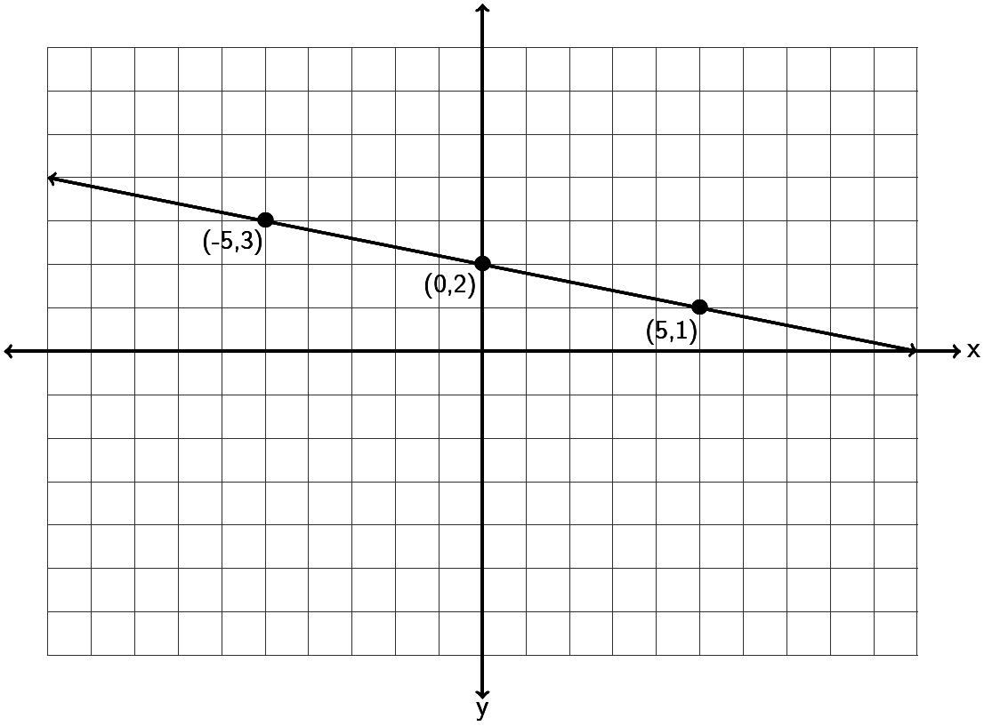

3. Find the slope of the following line by finding the vertical and horizontal change. Be sure to write your answer in lowest terms.

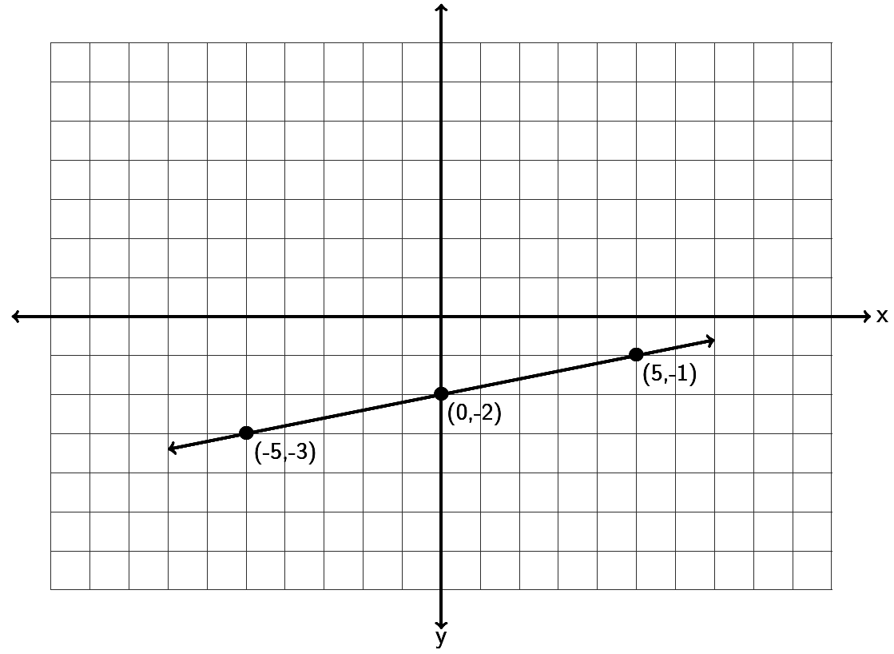

4. Find the slope of the following line by finding the vertical and horizontal change. Be sure to write your answer in lowest terms.

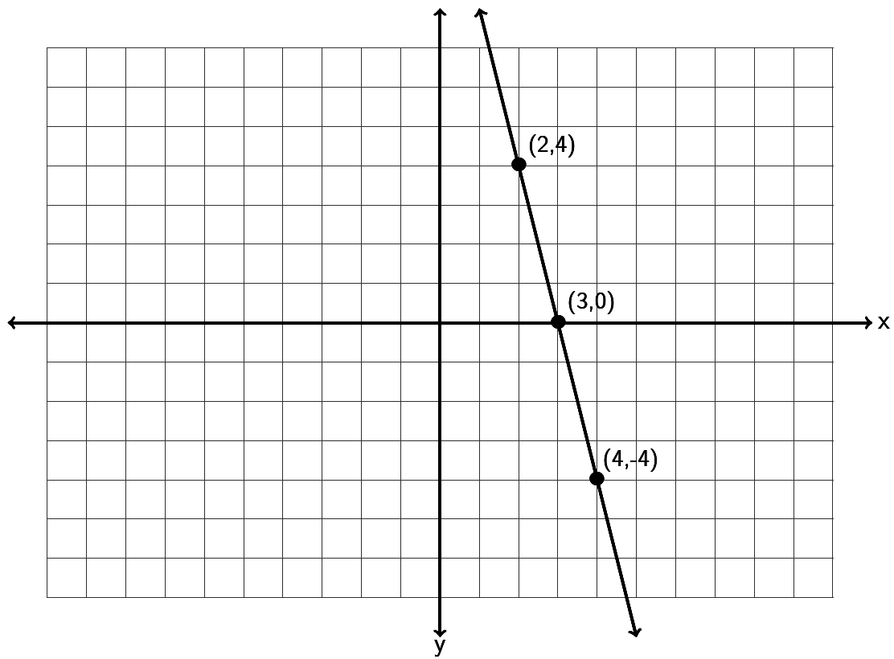

5. Find the slope of the following line by finding the vertical and horizontal change. Be sure to write your answer in lowest terms.

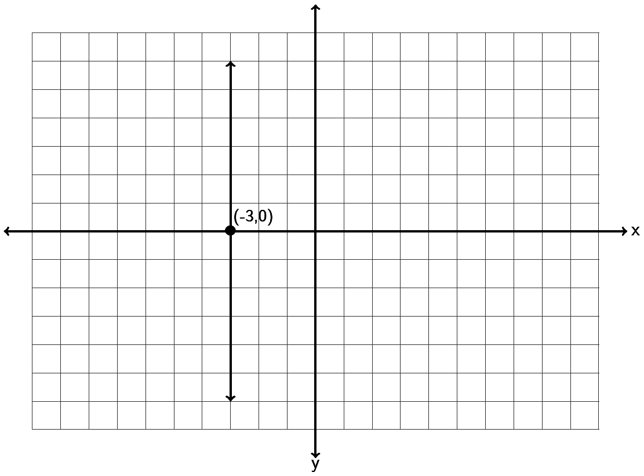

6. Find the slope of the following line by finding the vertical and horizontal change. Be sure to write your answer in lowest terms.

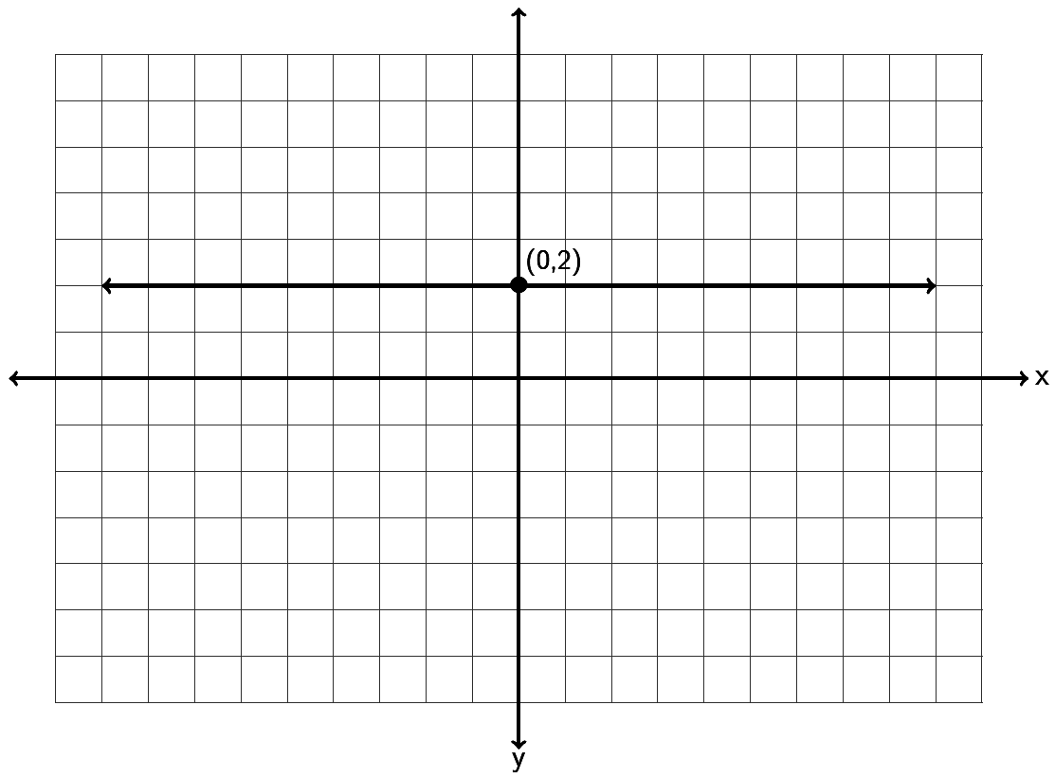

7. Draw a line that goes through the point (1, 2) and has a slope of .





8. Draw a line that goes through the point (-5, 1) and has a slope of .





9. Draw a line that goes through the point (-6, -4) and has a slope of .





10. Draw a line that goes through the point (-4,0) and has a slope of .





11. Draw a line that goes through the point (3 , 1) and has an undefined slope.



12. Draw a line that goes through the point (0 , -3) and has a slope = 0 .



13. Draw a line that goes through the point (-5, -2) and has a slope of .





14. Draw a line that goes through the point (-4, 6) and has a slope of .





15. Draw a line that goes through the point (1, -6) and has a slope of .





16. Draw a line that goes through the point (2,0) and has a slope of .





17. Draw a line that goes through the point (-4 , -2) and has an undefined slope.



18. Draw a line that goes through the point (0 , 5) and has a slope = 0 .



19. Use the slope formula to find the slope of the line between . Be sure to simplify your answer and write it in lowest terms.



20. Use the slope formula to find the slope of the line between . Be sure to simplify your answer and write it in lowest terms.



21. Use the slope formula to find the slope of the line between Be sure to simplify your answer and write it in lowest terms.



22. Use the slope formula to find the slope of the line between . Be sure to simplify your answer and write it in lowest terms.  
23. Use the slope formula to find the slope of the line between . Be sure to simplify your answer and write it in lowest terms.



24. Use the slope formula to find the slope of the line between . Be sure to simplify your answer and write it in lowest terms.



25. Use the slope formula to find the slope of the line between . Be sure to simplify your answer and write it in lowest terms.



26. A line has a slope of +5/8. What is the slope of a line parallel to it? What is the slope of a line perpendicular to it?

27. A line has a slope of -13. What is the slope of a line parallel to it? What is the slope of a line perpendicular to it?

28. A line has a slope of -2/9. What is the slope of a line parallel to it? What is the slope of a line perpendicular to it?

29. A line has a slope of +6. What is the slope of a line parallel to it? What is the slope of a line perpendicular to it?

30. A line has a slope of +2/7. What is the slope of a line parallel to it? What is the slope of a line perpendicular to it?

31. A line has a slope of -9. What is the slope of a line parallel to it? What is the slope of a line perpendicular to it?

32. When a toy store has its employees work 40 hours a week, the profits for that week are $4600. If the store has its employees work 45 hours then the profits for that week are $4180 due to having to pay the employee’s overtime. Write two ordered pairs with x being hours worked and y being profit. What is the average rate of change in profit per hour worked?

33. The longer an employee works at a software company, the higher his or her salary is. Let’s explore the relationship between years worked (x) and salary in thousands of dollars (y). A person that has worked two years for the company makes an annual salary of 62 thousand dollars. A person that has worked ten years for the company makes an annual salary of 67 thousand dollars. Write two ordered pairs and find the average rate of change in salary in thousands per year worked.

34. The older a puppy gets, the more the puppy weighs. Let’s explore the relationship between the number of months old a puppy is and its weight in pounds. At 4 months old, a puppy weighed 6 pounds. At 12 months old the puppy weighed 38 pounds. Write two ordered pairs with x being the age of the puppy in months and y being the weight in pounds. Now find the average rate of change in pounds per month.

35. In week 9, a stock sells for $85. By week 23 the stock sells for $15. Write two ordered pairs with x being the week and y being the stock price. Find the average rate of change in dollars per week.

**Questions 36 – 39: Match the equation in slope intercept form to the graphed line**

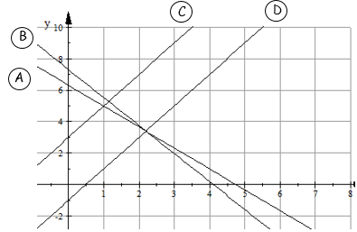

|  |  |
| --- | --- |
| Line | Equation |
| 36. | $$y = 2x – 1$$ |
| 37. | $$y = 6.3 - 1.33x$$ |
| 38. | $$y = -1.78x + 7.3$$ |
| 39. | $$y = 3 + 2x$$ |

**Section 7C – Finding the Equation of a Line**

When we discover a linear relationship between two variables, we often try to discover a formula that relates the two variables and allows us to use one variable to predict the other. At the beginning of this chapter, we said we might like to explore the relationship between the unemployment rate each year and U.S. national debt each year. For example in 2009 the national debt was 11.9 trillion dollars and the unemployment rate was about 9.9 percent. By 2013 the national debt had increased to 16.7 trillion dollars and the unemployment rate had fallen to 6.7 percent. If there is a linear relationship between national debt and unemployment, could we find an equation that might predict the unemployment rate if we know the national debt? Questions such as these are a big part of regression theory in statistics, but how do we find a linear equation such as this?

Slope-Intercept Form

The equation of a line can take many different forms. The one form most widely used and understood is called “Slope-Intercept Form”. It is the equation of a line based on the slope and the y-intercept (where the line crosses the y-axis).

The equation of a line with slope *m* and y-intercept *( 0 , b )* is given by the equation . Note that the *m* and the *b* are numbers we plug in. The equation of a line should have x and y in the equation as we need these to use the formula to calculate things.



For example, find the equation of a line with slope and a y-intercept of . It is important to remember that the *b* is the y-intercept and a point on the y-axis always has 0 as its x-coordinate. So all we would need to do to find the equation is to replace *m* with and replace *b* with 4 and we would get the following:



This is the answer, the equation of the line.

Slope-intercept form is really a great form for the equation of a line. For example, it is very easy to graph lines when we have their equation in slope-intercept form. To graph the equation , we would note that the y-intercept is 4 and the slope is -3/5. So we would start by placing a dot at 4 on the y-axis (vertical axis).



Now since the slope is -3/5 we translate that as:



So we will start at the y-intercept 4 and go down 3 and right 5 and put another dot. Now draw the line.

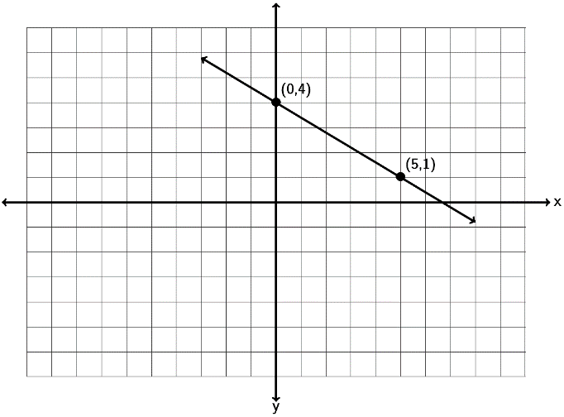

Try a couple examples with your instructor.

Example 1: Graph a line with a y-intercept of ( 0 , -3) and a slope of . What is the equation of the line you drew in slope-intercept form?





Example 2: Graph a line with a y-intercept of ( 0 , +5) and a slope of . What is the equation of the line you drew in slope-intercept form?





Note: It is important to remember that the *b* in the slope-intercept form is the y-intercept and not the y-coordinate of some general point. For example if a line goes through (4,-1) , that does not mean that -1 is the *b*. The *b* must be the y-coordinate when the x is zero. So if the line goes through the point (0 , 2) then the *b* is 2 because (0,2) lies on the y axis.

If an equation is not in slope-intercept form there are a couple ways to graph the line. Look at the following example.

Graph the line .



The first method would be to put the equation in slope intercept form by solving for y. Notice we would get the following.



Since the slope-intercept form of the line is we can simply use the   
y-intercept (0,2) and the slope +2/1. So start at 2 on the y axis and go up 2 and right 1 to get another point.



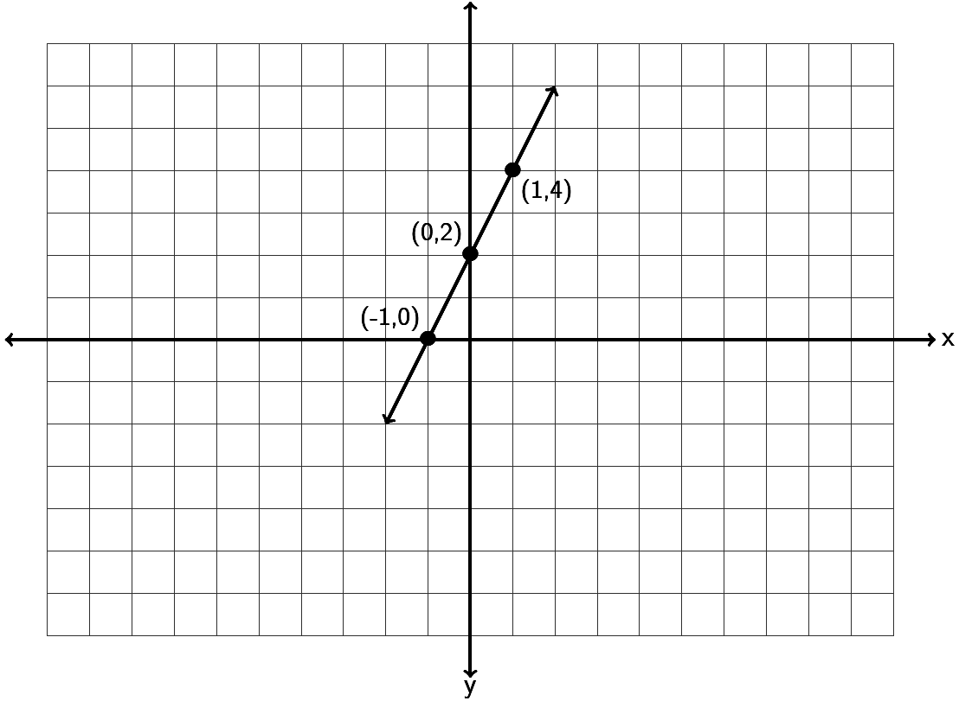

Let’s do the previous problem again, but with a different method. If an equation of a line is in standard form Ax + By = C, often an easy way to graph the line is by finding the x and   
y-intercepts. If you remember x-intercepts have y-coordinate 0, so we would plug in 0 for y and solve for x. y-intercepts on the other hand have x-coordinate zero, so we would plug in 0 for x and solve for y. Once we find the x and y-intercepts we can draw the line.

Look at . To find the x-intercept plug in 0 for y and solve.



So the x-intercept is (-1 , 0)

To find the y-intercept plug in 0 for x and solve.



So the y-intercept is (0 , 2)

Graphing both the x and y-intercepts gives us the following line. Notice it is the same as if we had used the slope-intercept form.



Slope-intercept form can also be used to give the equation of a line when you have the line graphed. Look at the following graph. See if you can find the slope *m* and the y-intercept (0,*b*) and the equation of the line .



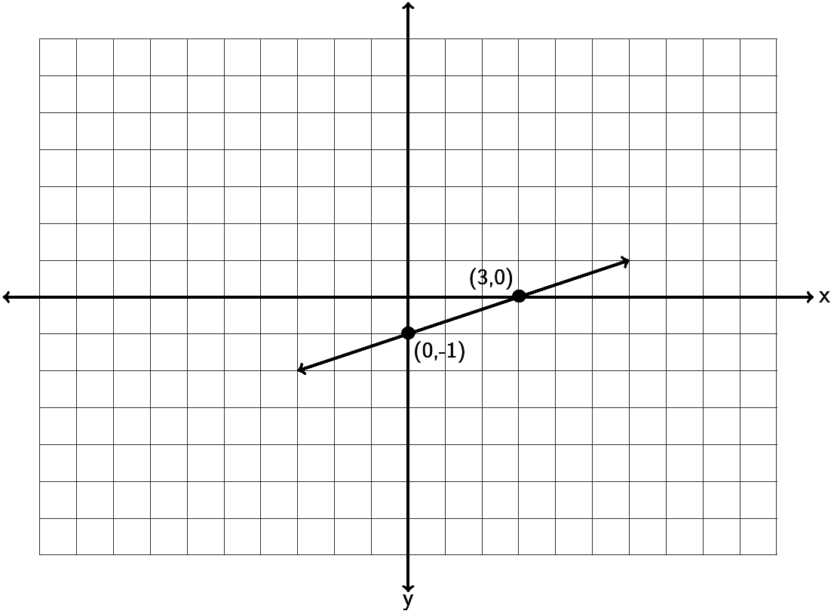

Notice the line crosses the vertical axis (y axis) at -1. Technically the ordered pair for the   
y-intercept is ( 0 , -1 ) but from this we can see that *b = -1.* To find the slope, we measure the vertical and horizontal change. Notice if we start at ( 0 , -1) we can go up 1 (+1 vertical change) and right 3 (+3 horizontal change) before getting another point on the line. Therefore the slope must be +1/3. Hence the equation of this line is . Since adding -1 is the same as subtracting 1 we can also write the equation as .



Try the next one with your instructor.

Example 3: Find the equation of the line in slope-intercept form described by the following line. Remember, you will need to find the slope *m* and the y-intercept *(0,b)* first.

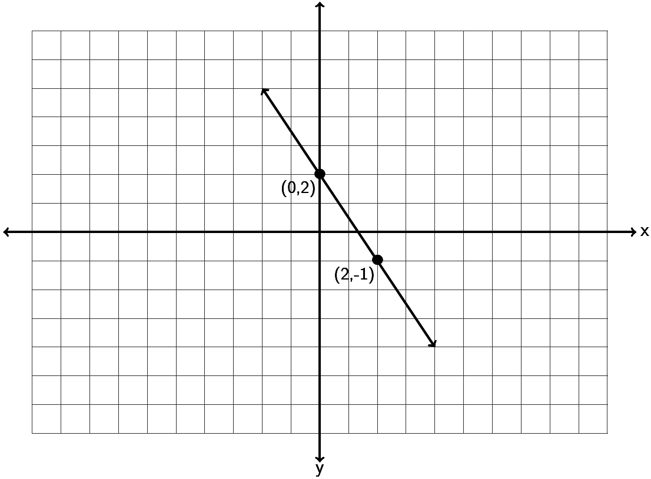

Earlier we said that if the x-coordinate is not zero, then the y-coordinate is not the *b.* What do we do then if we know the slope but only know a point on the line that is not the y-intercept?

There are several ways to find the equation. Probably the easiest way is to use the following formulas.

To find the equation of a line with slope *m* and passing through a point that is not the y intercept use the following:



The equation is where *m* is the slope and .



For example, find the equation of the line with slope and passing through the point  
 ( -1 , -11 ). Again, it is important to note that the point given to us does not lie on the y-axis and therefore -11 is not the *b.* We know the slope, so . To find *b,* plug in the slope *m* ,  
 -1 for and -11 for into the formula



. We will get the following:



So to find the equation of this line we replace *m* with and *b* with and get . Again adding -4 is the same as subtracting 4, so we can also write the equation as .



Let’s look at another example, find the equation of the line with slope and passing through the point ( 3 , 2 ). Again, it is important to note that the point given to us does not lie on the   
y-axis and therefore 2 is not the *b.* We know the slope, so . To find *b,* plug in the slope *m* , 3 for and 2 for into the formula . We will get the following:



So to find the equation of this line we replace *m* with and *b* with and get



Note: Some Algebra classes may reference a “Point-Slope Formula”. This is a formula when you know the slope *m*  and a point . The formula is . In the last problem with a slope of and passing through the point ( 3 , 2 ) we would get



If you simplify this and solve for y, you will get the same answer as we did.



You can find the equation of a line with either method, though we will focus on finding the slope and the y-intercept and plugging into y = mx + b.

Do the next problem with your instructor. Use the formulas and



Example 4: Find the equation of a line with a slope of and passing through the point



What happens when we want to find the equation of a line, but we do not know the slope? We will need to find the slope first and then the y-intercept. Look at the following examples.

Suppose we want to find the equation of a line between (4 , -3) and (6 , -8)? Again, our overall strategy is to find the slope m and the y-intercept (0,b) and plug them into y = mx + b.

Using the slope formula we can calculate the slope and get the following.



Notice that we subtracted the y-coordinates to get the vertical change and the x-coordinates to get the horizontal change. The answer can be written as a fraction or decimal. In algebra classes we tend to leave the slope as a fraction, while in Statistics, we usually write the slope as a decimal.

Now that we know the slope is -2.5, we can use it and either of the two points to find the   
y-intercept using the formula .



So since the *m = -2.5* and the *b = 7* , we get that the equation of the line is y = -2.5x + 7 .

Let’s try another example. Find the equation of a line that is perpendicular to the line and passing through the point ( 1 , -4).



Notice that for this problem we have a point but it is not the y-intercept. We also have a line perpendicular to the line we are trying to find. We were not given the slope. If you remember from the last section, the slopes of perpendicular lines are opposite reciprocals of each other. Look at the given line . Is this line in slope-intercept form? If it is, then the number in front of the x is the slope of this line. Since this is in y =mx + b form, that means the slope of this line is , which also means that the slope of the line we are looking for must be the opposite reciprocal . So now we know that for our line, the slope is . We can plug into the y-intercept formula to find the *b.* Notice we will need a common denominator to find *b.*



So we need to plug in -7/2 for *m* and -1/2 for *b* and we will get an equation of . We could also write the answer in decimal form which would be y = -3.5x – 0.5 .



Let’s look at a last example. Find the equation of a line parallel to and passing through the point (-3,5). As with the previous example we will need to find the slope from the line given. The problem is the equation is not in slope-intercept form y = mx + b. This equation is in standard form. The standard form for the equation of a line has the x and y-terms on the same side and they have also eliminated all fractions and decimals in the equation. The number in front of x is not the slope though, because the equation is not solved for y. So our first step is to solve the equation for y.



Notice a few things. To solve for y, we subtract 2x from both sides so that the y-term is by itself. We then divide by -6 on both sides to get y by itself. When the left hand side is divided by -6 we need to divide all the terms by -6 and simplify.

So the slope of this line is +1/3. Since the line we are looking for is parallel, our line also has a slope of *m =* 1/3.

Now we can plug in our point and the slope into the y-intercept formula and find our y intercept.

.



So the equation is .



Do the following examples with your instructor.

Example 5: Find the equation of a line through the points and .



Example 6: Find the equation of a line perpendicular to and passing through the   
point .



Equations of vertical and horizontal lines

If you remember a vertical line has an undefined slope (does not exist) and a horizontal line has slope = 0, but what about the equations for vertical and horizontal lines? In vertical lines, all the points on the line have the same x-coordinate. For example a vertical line through (6,1) would also go through (6,2) , (6,3) , (6,4) and so on. Since all of them have the same   
x-coordinate 6, the equation of a vertical line would be x = 6. In general, vertical lines have equations of the form “x = constant number.”

In horizontal lines, all the points on the line have the same y-coordinate. For example a horizontal line through (6,1) would also go through (4,1) , (5,1) , (7,1) and so on. Since all of them have the same y-coordinate 1, the equation of a horizontal line would be y = 1. In general, horizontal lines have equations of the form “y = constant number.”

For example, suppose we want to find the equation of a line with zero slope through the point . The only line with zero slope is horizontal. Since horizontal lines have equations   
y = constant number, it is just a matter of figuring out what that number would be. Since it goes through the point we know that all points on the line will also have as their   
y-coordinate. So the equation is simply .



Suppose we want to find the equation of a line perpendicular to y = 8 and passing through the point (7,3). The line y = 8 is a horizontal line through 8, so a line perpendicular to it would have to be vertical. So we are really looking for a vertical line through (7,3). Since vertical lines have formula x = constant number, it is just a matter of figuring what that number is. Since it goes through the point (7,3) then all the points on the vertical line will also have 7 as their   
x-coordinate. So the equation is simply x = 7.

Do the following example problems with your instructor.

Example 7: Find the equation of a line that has undefined slope and goes through the point



Example 8: Find the equation of a line perpendicular to the y axis and goes through the point



Two-variable linear equations have tons of applications in algebra, statistics and even calculus. In statistics we call the study of linear relationships “regression” theory. Look at the following example.

In previous sections, we saw that IBM stock had a price of $186.91 at the end of September 2014. Over the next three months the stock price rose and fell and by the end of December the price was $160.44. We found that this information corresponded to two ordered pairs   
( month 9, $186.91 ) and ( month 12 , $160.44). We also found that the slope between those two points is also called the average rate of change and came out to be about -$8.82 per month. If this linear trend continues, what do we predict will be the price of IBM stock in future months? To make this kind of prediction we will need to find the equation of a line.

So let’s try to find the equation of a line between ( month 9, $186.91 ) and   
( month 12 , $160.44). Once we have the equation of the line, we will be able to use this formula to predict the price of IBM stock in coming months.

We know from previous sections that the slope of the line can be found by using the formula



This tells us that the price of IBM stock is decreasing at a rate of $8.82 per month.

We also know we can find the y-intercept *b* with the formula



Remember the y-intercept occurs when x is zero. So in month zero, the price of IBM stock was predicted to be $266.32 .

So the equation of the line that describes the price of IBM stock would be .  
Use the equation to predict the price of the stock in month 14 (Feb 2015). To answer this all we have to do is plug in 14 for x and find y. Plugging in 14 for x gives   
So if this linear trend continues, we predict the price of IBM stock to be $142.84 in month 14 (Feb 2015).



**Practice Problems Section 7C**

1: Graph a line with a y-intercept of ( 0 , 4) and a slope of . What is the equation of the line you drew in slope-intercept form?





2: Graph a line with a y-intercept of ( 0 , -6) and a slope of . What is the equation of the line you drew in slope-intercept form?





3. Graph a line with a y-intercept of ( 0 , 2) and a slope of . What is the equation of the line you drew in slope-intercept form?





4. Graph a line with a y-intercept of ( 0 , -1) and a slope of . What is the equation of the line you drew in slope-intercept form.





5. Find the equation of the line in slope-intercept form described by the following line? Remember, you will need to find the slope *m* and the y-intercept *(0,b)* first.

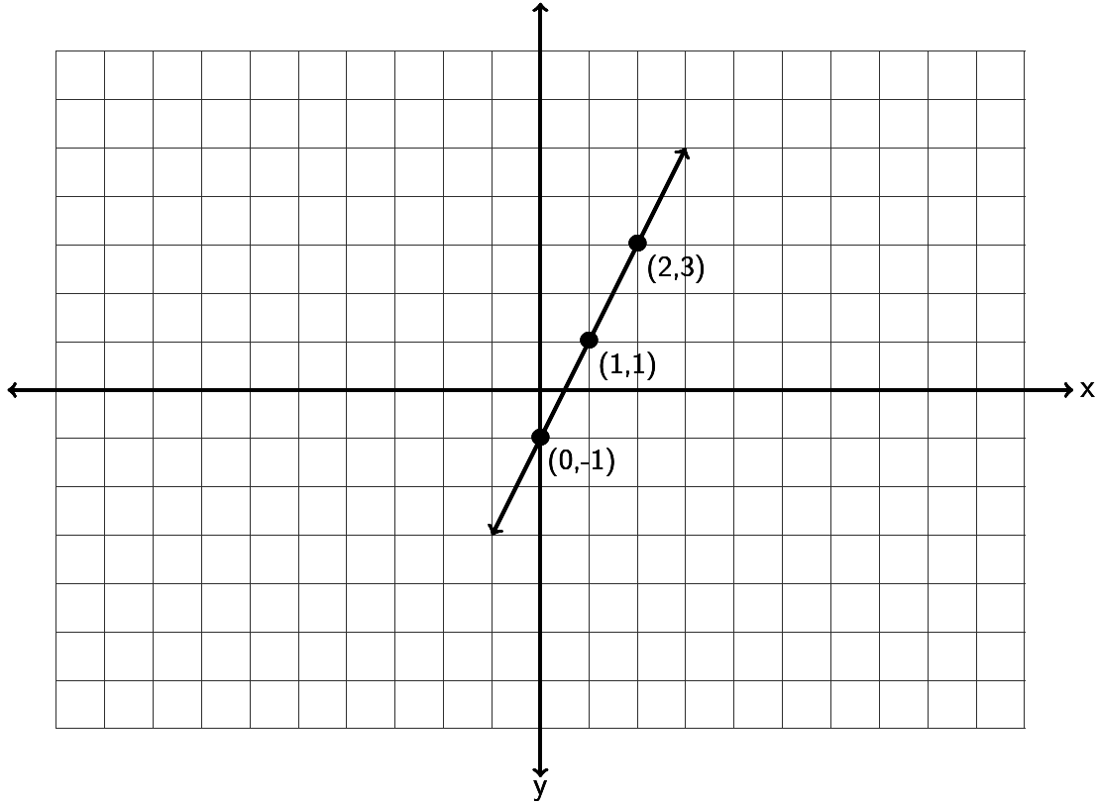

6. Find the equation of the line in slope-intercept form described by the following line. Remember, you will need to find the slope *m* and the y-intercept *(0,b)* first.

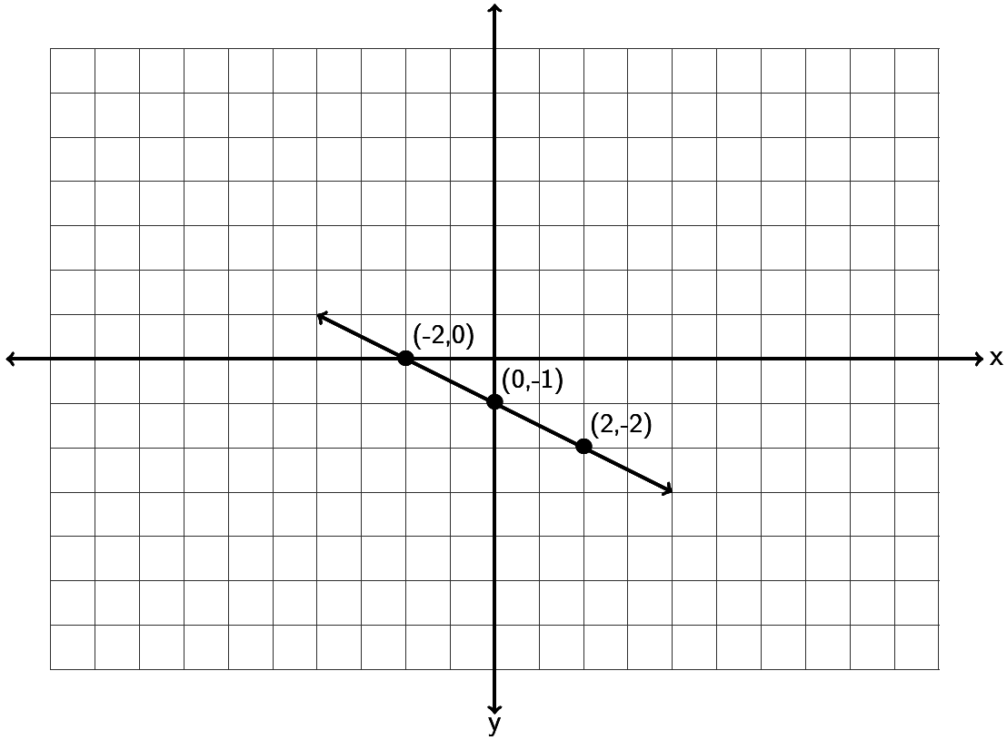

7. Find the equation of the line in slope-intercept form described by the following line. Remember, you will need to find the slope *m* and the y-intercept *(0,b)* first.

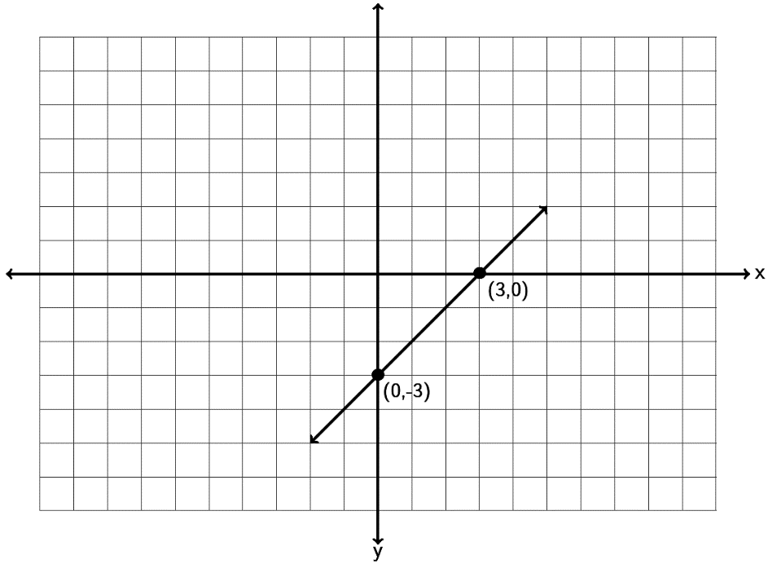

8. Find the equation of a line with a slope of and passing through the point



9. Find the equation of a line with a slope of and passing through the point



10. Find the equation of a line with a slope of and passing through the point



11. Find the equation of a line with a slope of and passing through the point



12. Find the equation of a line with a slope of and passing through the point



13. Find the equation of a line with a slope of and passing through the point



14. Find the equation of a line through the points and .



15. Find the equation of a line through the points and .



16. Find the equation of a line through the points and .



17. Find the equation of a line through the points and .



18. Find the equation of a line through the points and .



19. Find the equation of a line through the points and .



20. Find the equation of a line through the points and .



21. Find the equation of a line perpendicular to and passing through the   
point .



22. Find the equation of a line parallel to and passing through the   
point .



23. Find the equation of a line perpendicular to and passing through the   
point .



24. Find the equation of a line parallel to and passing through the   
point .



25. Find the equation of a line perpendicular to and passing through the   
point .



26. Find the equation of a line perpendicular to and passing through the   
point .



27. Find the equation of a vertical line that goes through the point .



28. Find the equation of a horizontal line that goes through the point .



29. Find the equation of a line with zero slope that goes through the point



30. Find the equation of a line with undefined slope that goes through the point



31. Find the equation of a line parallel to the x axis that goes through



32. Find the equation of a line perpendicular to the x axis that goes through



33. Find the x and y-intercepts of the line 2x – 3y = 6 . Graph the line below. What is the slope of the line? What is the equation of the line?



34. Find the x and y-intercepts of the line -4x + 5y = -20 . Graph the line below. What is the slope of the line? What is the equation of the line?



35. Find the x and y-intercepts of the line 2x – 5y = -10 . Graph the line below. What is the slope of the line? What is the equation of the line?



36. Find the x and y-intercepts of the line -1x + 3y = 6 . Graph the line below. What is the slope of the line? What is the equation of the line?



37. a) A company that makes lawn furniture found their average cost in year 3 to be   
 $47000 and the average cost in year 8 to be $51000. Find the equation of a line that   
 could be used to estimate the companies costs (y) if we knew the year (x).

b) Use your equation in part (a) to predict the average costs in year 11.

38. a) A bear that is 50 inches long weighs 365 pounds. A bear 55 inches long weighs 446   
 pounds. Assuming there is a linear relationship between length and weight, find the   
 equation of a line that we could use to predict the weight (y) of a bear if we knew its   
 length (x).

b) Use your equation in part (a) to predict the weight of a bear that is 52 inches long.

39. a) In week 7, a stock price is $46. By week 11, the stock price has risen to $54.   
 Assuming there is a linear relationship between week and price, find the equation   
 of the line that we could use to predict the stock price (y) if we knew the week (x).

b) Use your equation in part (a) to predict the stock price in week 48.

40. a) When a toy store has its employees work 40 hours a week, the profits for that week   
 are $4600. If the store has its employees work 45 hours then the profits for that   
 week are $4180 due to having to pay the employee’s overtime. Write two ordered   
 pairs with x being hours worked and y being profit. Find the equation of the line we   
 could use to predict profit (y) if we knew the number of hours worked (x).

b) Use your equation in part (a) to predict the profits if the employees work 43 hours   
 a week. (All employees work three hours of overtime.)

41. a) The longer an employee works at a software company, the higher his or her salary is.   
 Let’s explore the relationship between years worked (x) and salary in thousands of   
 dollars (y). A person that has worked two years for the company makes an annual   
 salary of 62 thousand dollars. A person that has worked ten years for the company   
 makes an annual salary of 67 thousand dollars. Write two ordered pairs and find the   
 equation of a line we could use to predict the annual salary (y) if we knew the   
 number of years the person has worked (x).

b) Use your equation in part (a) to predict the annual salary of someone that has   
 worked 20 years for the company.

42. a) At the beginning of this chapter, we said we might like to explore the relationship   
 between the unemployment rate each year and U.S. national debt each year. For   
 example in 2009 the national debt was 11.9 trillion dollars and the unemployment   
 rate was about 9.9 percent. By 2013 the national debt had increased to 16.7 trillion   
 dollars and the unemployment rate had fallen to 6.7 percent. If there is a linear   
 relationship between national debt and unemployment, could we find an equation   
 that might predict the unemployment rate if we know the national debt? If we let   
 x be the national debt in trillions and let y be the unemployment percent we would   
 get the ordered pairs (11.9 , 9.9) and (16.7 , 6.7). What does the slope tell us? What  
 does the y-intercept tell us? What is the equation of the line?

b) If the national debt is 18 trillion dollars, what will we predict the unemployment   
 rate to be?

**Section 7D – Systems of Linear Equations**

Companies often look at more than one equation of a line when analyzing how their business is doing. For example a company might look at a cost equation and a profit equation. The number of items the company needs to make so that the costs and profits are the same is often called the break-even point. But how can we figure out the break-even point when we have two different equations? This is one of the many applications of Linear Systems.

Three Types of Linear Systems

When two lines are drawn on a graph three things can happen. Either the lines will meet at a point, the lines will be parallel and not meet, or the two lines happen to be the same line and would have all their points in common. These three things correspond to the three types of linear systems. The key is that the solutions are only points that lie on both lines.

In a system where the two lines intersect at a point, the one ordered pair (x,y) where the lines meet is the solution we are looking for. Many books call this an independent system of equations or an independent system for short. In the example below, the solution is (3,1).

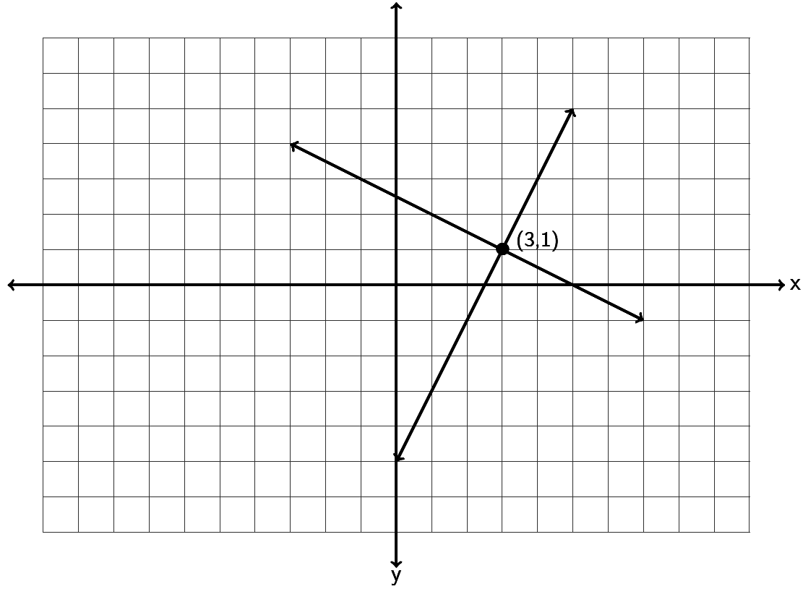

In a system where the two lines are parallel, we see that the lines never meet and no points lie on both lines. So there is “no solution” when the lines are parallel. Many books call this an inconsistent system.

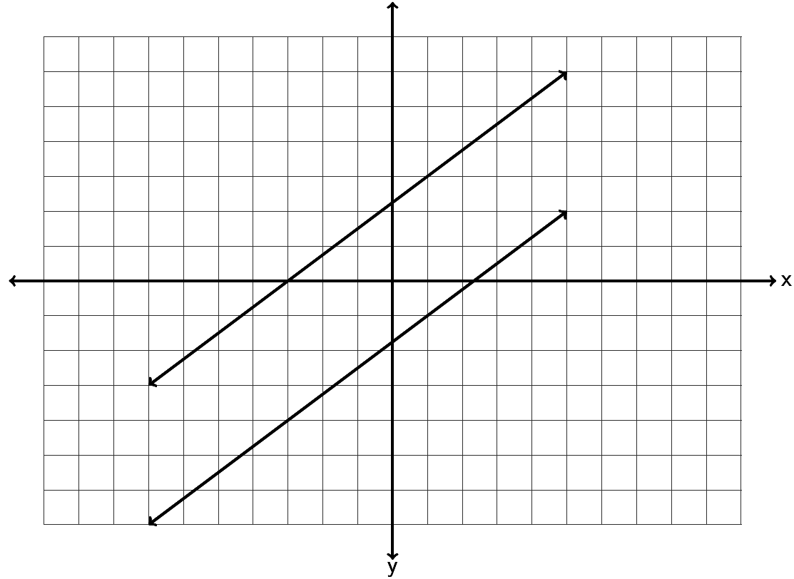

In a system where the two lines happen to be the same line, the two lines have all their points in common. When this happens, the solution is “All points on the line are solutions.” Many books call this a dependent set of equations or a dependent system for short. Notice a dependent system has infinitely many solutions.

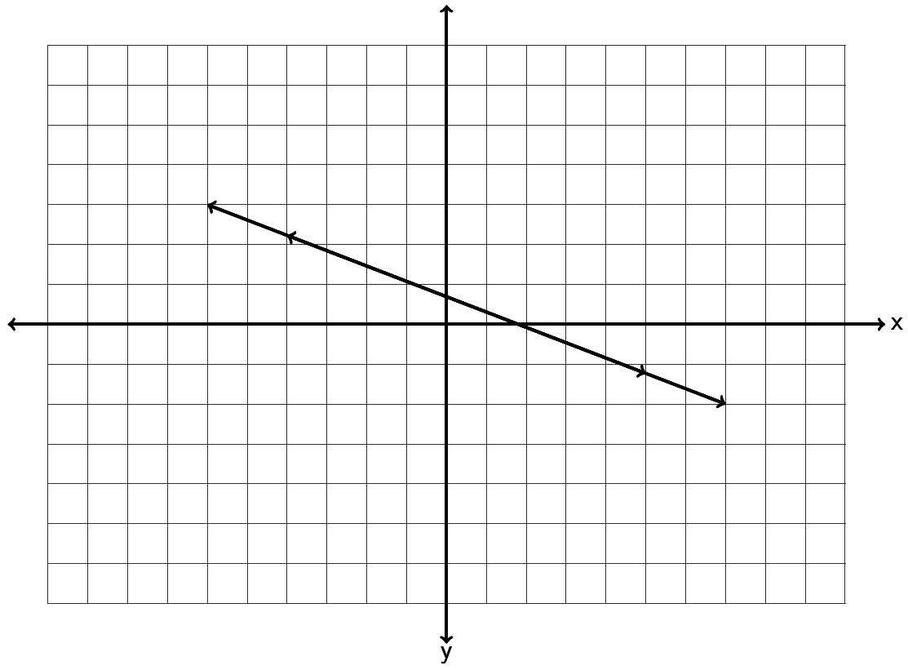

Solving a System by Graphing

To find the solution to a system, we can graph both lines and see if and where they meet. For example, solve the following system by graphing.



Since both equations are in slope-intercept form, we can use the slope and y-intercept to graph each line. The first line has a slope of 3/1 and a y-intercept of (0,-7). So we can start at -7 on the y-axis and go up 3 and right 1. The second line has a slope of ½ and a y-intercept of (0,-2). So we can start at -2 on the y-axis and go up 1 and right 2.

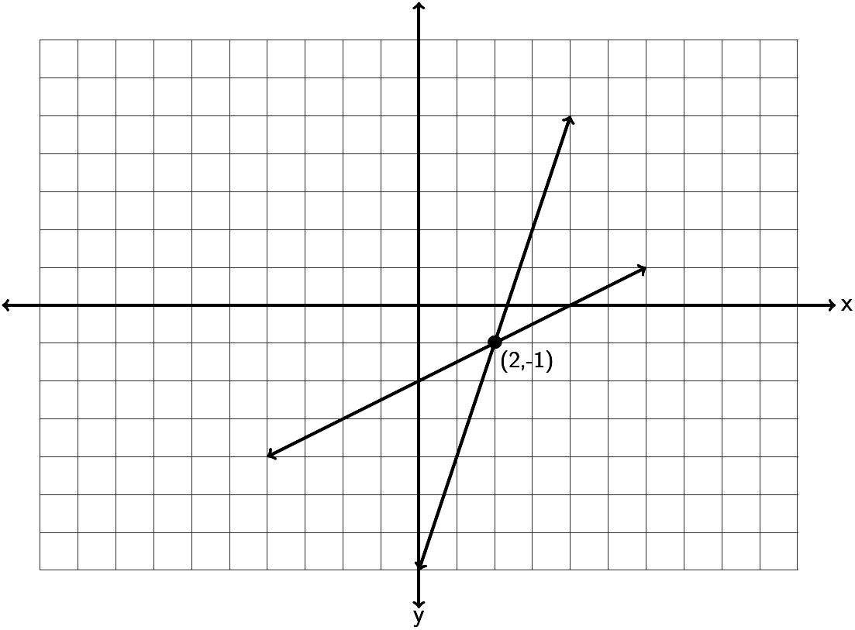

So do the lines intersect and if so where do they intersect? Notice the lines intersect at (2 , -1) so that is the solution to the system. To check the answer plug in 2 for x and -1 for y into both equations. If it makes both equations true, it is the solution.



Let’s try another example. Solve the following system by graphing.



Since the first line is not in slope-intercept form, we can graph it by finding the x and   
y-intercepts. Plugging in 0 for x gives 2y=10 which gives y = 5. So the y-intercept is (0,5). Plugging in y = 0 we get 5x = 10 which gives x = 2. So the x-intercept is (2,0) . We can plot (0,5) and (2,0) and draw the line.

The second line is in slope-intercept form, so we can see the y-intercept is (0,5) and the slope is -5/2. So we will start at 5 on the y-axis and go down 5 and right 2. If you notice this coincides perfectly with the first line we drew.

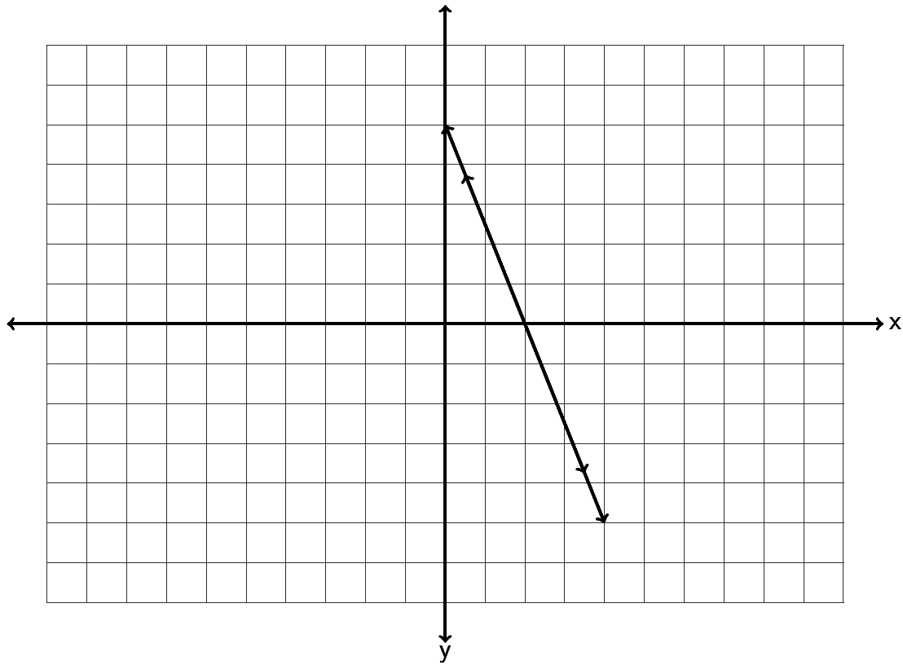

So the two equations we graphed were actually the same line. Since the lines have all their points in common, the solution is “All points on the line are solutions.”

Note: We could have solved this system by looking at the slope-intercept form of the first equation. If we solved the first equation for y we would have gotten the following.



Since both equations have the exact same slope and the exact same y-intercept, they are in fact the exact same line and will have all their points in common.

Look at this example. Solve the following system of equations by inspection. (Just look at the slopes and y-intercepts.)



Notice both equations are in slope-intercept form. Notice they both have the same slope but different y-intercepts. If you recall from the section on slope, these lines are parallel. Notice they have the same slope but they definitely are not the same line. Since the lines are parallel, they will never intersect and the solution to the system is “No Solution.”

Solve the following systems with your instructor either by graphing or by inspection.

Example 1:





Example 2:





Solving linear systems by substitution

If you do not want to solve the system by graphing, there is a way to figure out the answer with algebra. The method is called the “substitution method”. Here are the steps to the substitution method.

Steps to solving a system with Substitution

1. Solve one of the equations for one of the variables. (It can be x or y in either equation. If one of your equations is already in slope-intercept form, then you can just use the y in that equation.)

2. Plug in (substitute) the value of the variable in step 1 into the other equation you have not used yet. (You should be left with an equation with only one letter in it.)

3. Solve the one-variable equation. (If the system only has one ordered pair as the answer, then this will give you either the x or y-coordinate of the answer.)

4. Plug in the value of the variable solved for in step 3 into any of the equations and solve for the remaining variable that you don’t know.

5. Check your ordered pair answer by plugging into both equations and seeing if they both make true statements.

Note: If your system consists of parallel lines, then in step 3, you will get a contradiction equation. (All the variables will disappear and you are left with a false statement.) The solution to the system will be “No Solution.”

Note: If your system consists of two equations for the same line, then in step 3, you will get an identity equation. (All the variables will disappear and you are left with a true statement.) In this case, the solution to the system will be “All points on the line are solutions.”

Look at the following example. Solve the following system with the substitution method.



Step 1: Solve for one of the letters. Since you can choose any variable, choose something easy to solve for. (x in equation 2 looks easy)



Step 2: Now plug in 5y+8 for x in the other equation. Notice the equation only has one letter now.



Step 3: Solve the one-variable equation. Notice we need to use the distributive property.



Step 4: We know that our answer is . We will plug in -1 for y into any of the equations with two variables and solve. Any equation you use will give you the same answer for x.



Step 5: So our answer is . Let’s check the answer by plugging in 3 for x and -1 for y into both equations and see if both of them are true.



Try the following examples of solving with the substitution method with your instructor.

Example 3: Example 4:



Example 5:



**Practice Problems Section 7D**

Solve the following linear systems by inspection. (Hint: Examine the slope and y-intercepts.) You do not have to do any work for these. Just give the solution to the system.

1. 2. 3.



4. 5. 6.



Solve the following linear systems by graphing both lines. You must graph both lines and give the solution to the system.

7. 8. 9.



10. 11. 12.



Solve the following linear systems by using the substitution method.

13. 14. 15.



16. 17. 18.



**Chapter 7 Review**

In chapter 7, we looked at linear relationships between two variables. We saw that we make ordered pairs by labeling one variable as the “x” coordinate and one variable as the “y” coordinate. We learned that we can plot all of these ordered pairs on the “Rectangular Coordinate System”. The x and y-axis break the rectangular coordinate system into 4 quadrants. When we plot many ordered pairs in a situation, a “scatterplot” is created.

Sometimes variables like time and cost have a linear relationship. We can tell this because the scatterplot of the ordered pairs looks like it makes a line. Using any two ordered pairs, we can find the slope “m” (average rate of change) of this line and the y-intecept (0 , b) of this line and use these to find the “Equation of the line” y = mx + b. Here are the formulas for slope and   
y-intercept between the ordered pairs and .



(Slope)



(Y – intercept)



Remember the slope “m” is also called the average rate of change. In fact it is the change in the y-variable divided by the change in the x-variable. The average rate of change is a very important number in analyzing general trends in business and other applications.

Remember the y-intercept “b” actually is the ordered pair (0 , b). It is in fact the place where the line crosses the y-axis. It always has an x-coordinate of 0. In fact the y-intercept is often the initial value in a linear relationship. In cost data for example, the y-intercept is the initial costs to set up the business.

Plugging in the “m” and the “b” into y = m x + b will give the equation of the line. This equation can be used as a formula to help predict y-values for a given x-value.

We also looked at a system of two linear equations. The solution to a linear system is the ordered pair where the two lines cross. If the lines do not cross at all, there is no solution to the linear system. If the two lines turn out to be the same line, then all points on the line are solutions. A linear system can be solved by graphing or by algebraic methods like the substitution method.

To solve a system by graphing, simply graph both lines and see if you can determine the ordered pair where the two lines cross.

To solve a system by substitution, solve for one of the variables (x or y) in either equation. Then plug in the expression for that variable into the other equation you have not used yet. This substitution will eliminate one of the variables and allow you to solve the remaining equation for x or y. After you have found x or y, plug the number back into any equation and find the other variable.

**Review Problems Chapter 7**

1. Graph the ordered pairs (-5 , -2) , (2,0) , (-4, 2) , (0 , -3) , (1 , -3) on the graph provided. Which point is an x-intercept? Which point is a y-intercept? For the other three points, give the quadrant they lie in.



2. Graph the ordered pairs (-1 , 6) , (0,-5) , (-2, -8) , (-2 , 0) , (4 , 5) on the graph provided. Which point is an x-intercept? Which point is a y-intercept? For the other three points, give the quadrant they lie in.



3. Graph the ordered pairs (1.5 , 5.5) , (0 , 2.5) , (-1.25 , -3.25) , (-4.5 , 0) , on the graph provided. Which point is an x-intercept? Which point is a y-intercept? For the other three points, give the quadrant they lie in.





4. Find the slope of the following line by finding the vertical and horizontal change. Be sure to write your answer in lowest terms.

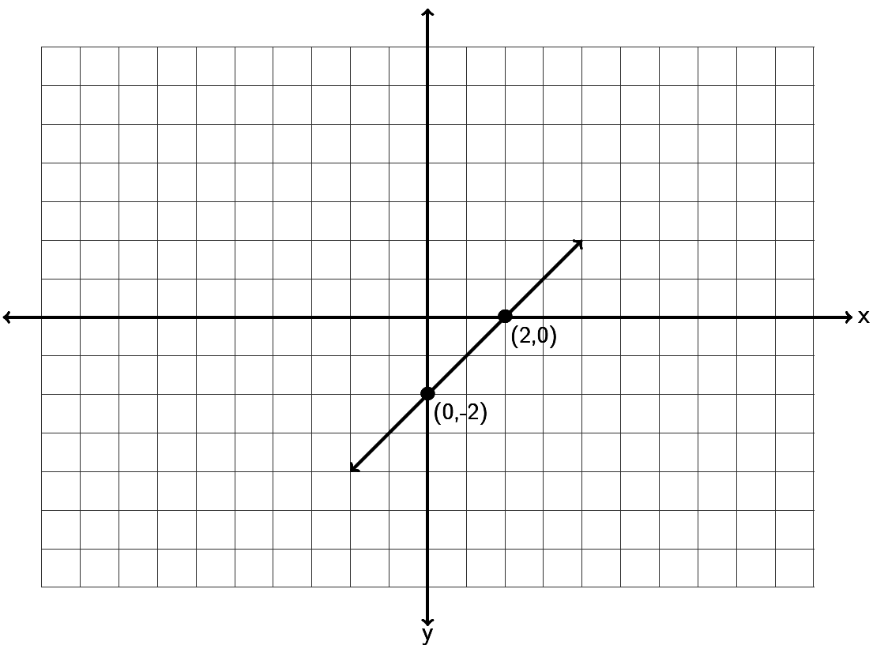

5. Find the slope of the following line by finding the vertical and horizontal change. Be sure to write your answer in lowest terms.

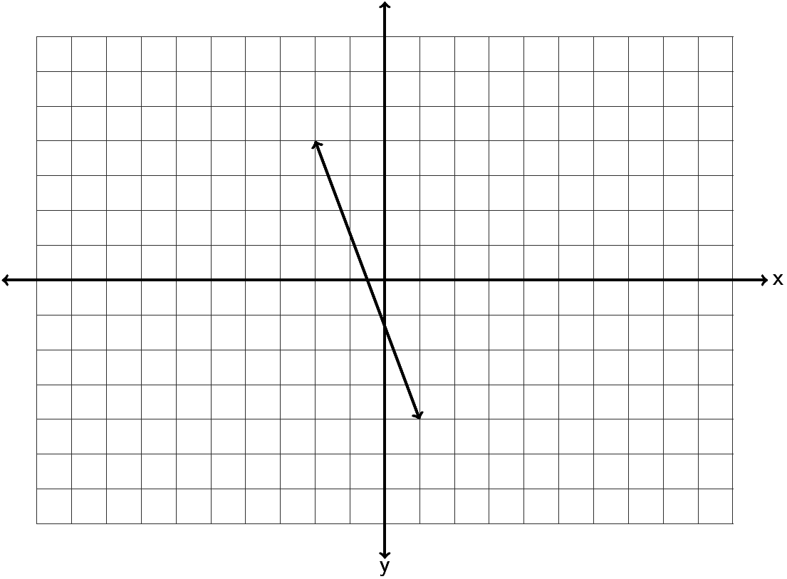

6. Find the slope of the following line by finding the vertical and horizontal change. Be sure to write your answer in lowest terms.

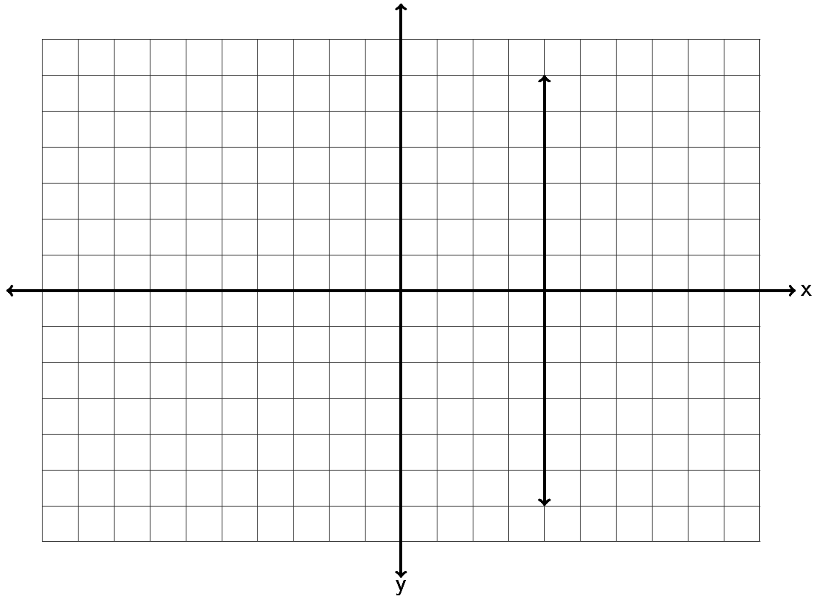

7. Find the slope of the following line by finding the vertical and horizontal change. Be sure to write your answer in lowest terms.

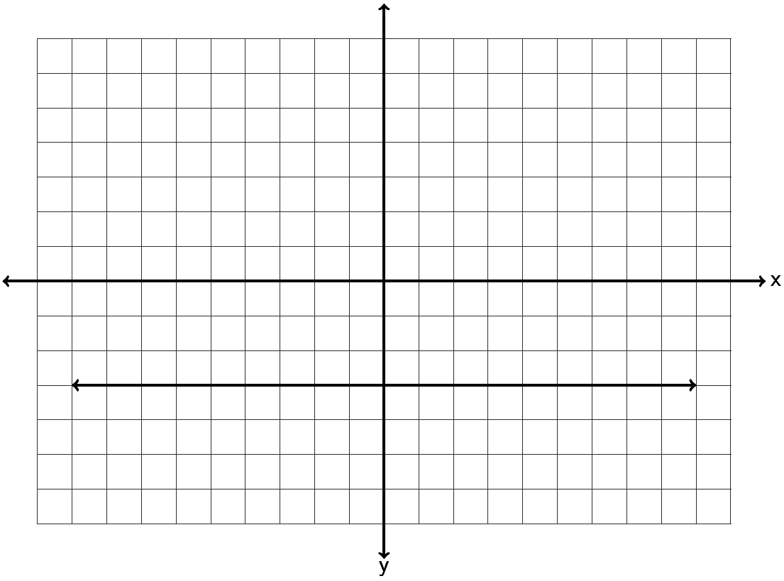

8. Draw a line that goes through the point (-3, -2) and has a slope of .





9. Draw a line that goes through the point (2 , 1) and has a slope of .





10. Draw a line that goes through the point (-5 , 3) and has an undefined slope.



11. Draw a line that goes through the point ( -2 , 4) and has a slope = 0 .



12. Graph the line -1x +4y = -4 by finding the x and y-intercepts.



13. Graph the line 3x - 5y = 15 by finding the x and y-intercepts.



14. Use the slope formula to find the slope of the line between . Be sure to simplify your answer and write it in lowest terms.



15. Use the slope formula to find the slope of the line between . Be sure to simplify your answer and write it in lowest terms.



16. Use the slope formula to find the slope of the line between Be sure to simplify your answer and write it in lowest terms.



17. Use the slope formula to find the slope of the line between . Be sure to simplify your answer and write it in lowest terms.



18. Use the slope formula to find the slope of the line between . Be sure to simplify your answer and write it in lowest terms.



19. A line has a slope of +3/5. What is the slope of a line parallel to it? What is the slope of a line perpendicular to it?

20. A line has a slope of . What is the slope of a line parallel to it? What is the slope of a line perpendicular to it?



21. When a hot dog stand makes 50 hot dogs, the profit for that day is $92. When the hot dog stand makes 45 hot dogs, the profit for that day is $82.80 . Write two ordered pairs with x being the number of hot dogs made and y being profit. What is the average rate of change in profit per hot dog? (Write your answer as a decimal.)

22. The longer an employee works at a coffee company, the higher his or her salary is. Let’s explore the relationship between years worked (x) and salary in thousands of dollars (y). A person that has worked three years for the company makes an annual salary of 32 thousand dollars. A person that has worked seven years for the company makes an annual salary of 34 thousand dollars. Write two ordered pairs and find the average rate of change in salary in thousands per year worked.

23. Graph a line with a y-intercept of ( 0 , 2) and a slope of . What is the equation of the line you drew in slope-intercept form?





24. Graph a line with a y-intercept of ( 0 , -4) and a slope of . What is the equation of the line you drew in slope-intercept form?





25. Graph a line with a y-intercept of ( 0 , 5) and a slope of . What is the equation of the line you drew in slope-intercept form?





26. Find the equation of the line in slope-intercept form described by the following line. Remember, you will need to find the slope *m* and the y intercept *(0,b)* first.

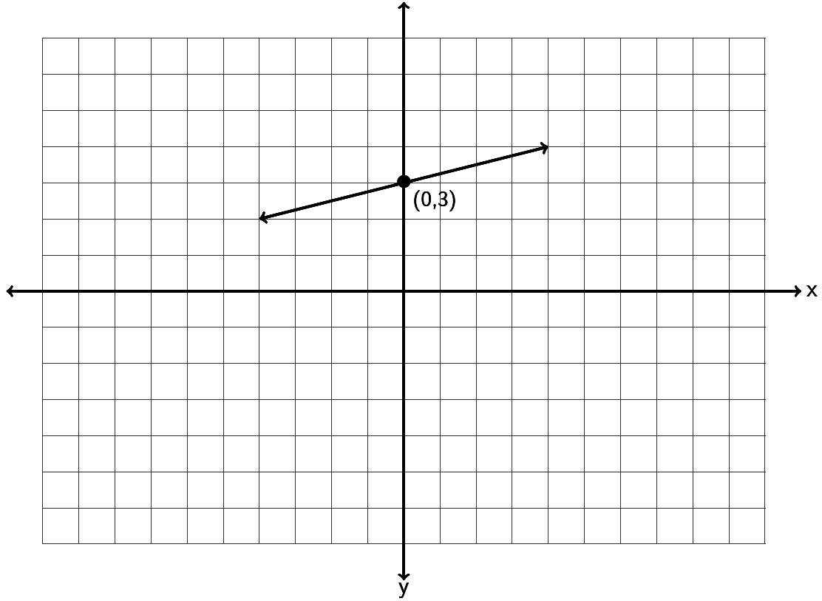

27. Find the equation of the line in slope-intercept form described by the following line. Remember, you will need to find the slope *m* and the y-intercept *(0,b)* first.

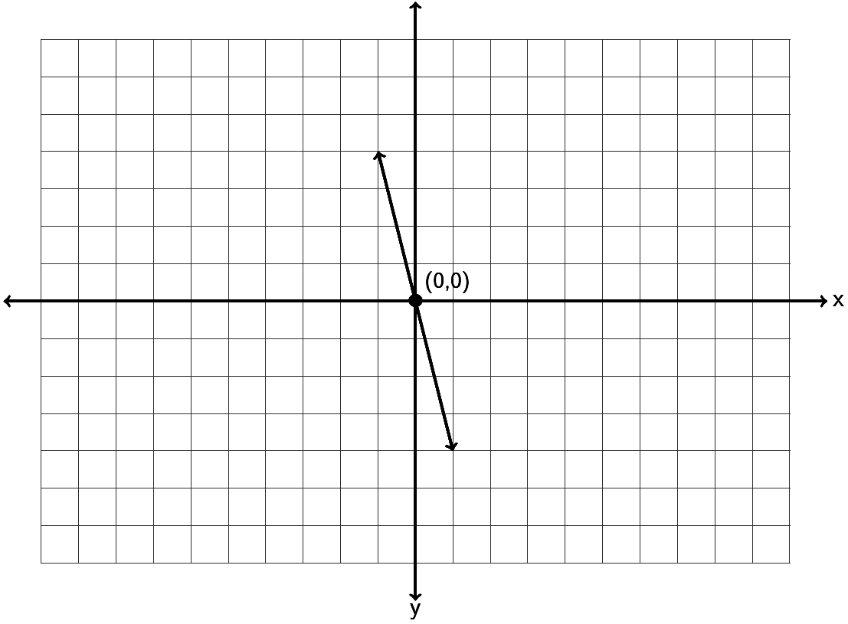

28. Find the equation of the line in slope-intercept form described by the following line. Remember, you will need to find the slope *m* and the y-intercept *(0,b)* first.

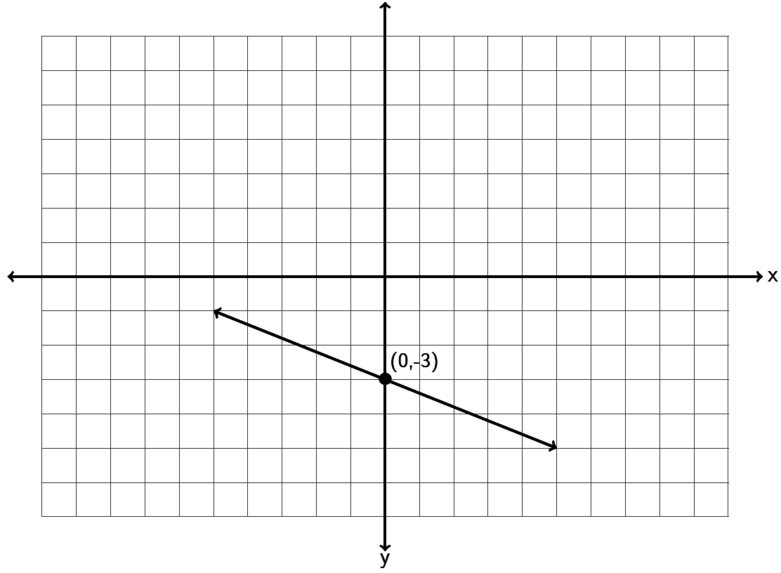

29. Find the equation of a line with a slope of and passing through the point .



30. Find the equation of a line with a slope of and passing through the point .



31. Find the equation of a line with a slope of and passing through the point .



32. Find the equation of a line through the points and .



33. Find the equation of a line through the points and .



34. Find the equation of a line through the points and .



35. Find the equation of a line perpendicular to and passing through the   
point .



36. Find the equation of a line parallel to and passing through the   
point .



37. Find the equation of a vertical line that goes through the point .



38. Find the equation of a horizontal line that goes through the point .



39. Find the equation of a line with zero slope that goes through the point .



40. Find the equation of a line with undefined slope that goes through the point .



41. Find the equation of a line parallel to the y axis that goes through .



42. Find the equation of a line perpendicular to the y axis that goes through .



43. a) A company that makes metal car components looked at their average profit in  
 month 2 to be $32,000 and the average profit in month 7 to be $33,000. Write two  
 ordered pairs of the form (month , profit). Use the two ordered pairs to find the  
 equation of a line that could be used to estimate the companies average profits (y) if   
 we knew the month (x).

b) What does the slope of the line tell us?

c) What does the y-intercept of the line tell us?

d) Use your equation in part (a) to predict the profit in month 13.

44. a) A horse that weighs 1100 pounds can carry about 230 pounds. A horse that weighs  
 1400 pounds can carry about 290 pounds. Write two ordered pairs of the form  
 (weight of horse , pounds horse can carry). Use the two ordered pairs to find the  
 equation of a line that we could use to predict the number of pounds a horse can  
 carry (y) if we knew the weight of the horse (x).

b) What does the slope of the line tell us?

c) Use your equation in part (a) to predict the how much a horse weighing 1300 pounds  
 can carry?

The following linear systems have been written in slope-intercept form. Solve the following linear systems by inspection. (Hint: Examine the slope and y-intercepts.) You do not have to do any work for these. Just give the solution to the system.

45. 46. 47.



Solve the following linear system by graphing both lines. You must graph both lines and give the solution to the system.

48.





Solve the following linear systems by graphing both lines. You must graph both lines and give the solution to the system.

49.





50.





Solve each the following linear systems by using the substitution method.

51.



52.



53.



**Preparing for Algebra and Statistics *(3rd Edition)***

**Appendix A - Answer Keys for Chapters 1-7**

**Chapter 1 Answers**

**1A**

1. 70 3. 122 5. 360 7. 770 9. 354 11. 804  
13. 1,327 15. 187 17. 174 19. 7,548 21. 2,811 23. 1,863  
25. 555 27. 559 29. 4,958 31. 454 33. 27,204 35. 428  
37. $608 39. $2,848 41. 5,464 43. $8,141 45. 72 ft 47. 408 ft  
49. $619 51. $1,153

**1B**

1. 52 3. 266 5. 240,000 7. 1,896   
 9. 17,639 11. 120,420 13. 104,468 15. 65,888   
17. 52,800,000 19. 1,512 21. 3,915 23. 3,600,000  
25. 152,306 27. 16,040 29. 934 31. 574   
33. 9,734 35. 64,800,000 37. 81 39. 36   
41. 32 43. 169 45. 625 47. 0  
49. 112 51. 180 53. 2,125 55. 96 in  
57. 452 ft 59. 1,440 cubic in 61. 512 cubic mm 63. $870  
65. 78 pounds

**1C**

1. 17 3. 0 5. Undefined 7. 2,635   
 9. 1 11. 0 13. Undefined 15. 382  
17. 0 19. 11 R 2 21. 7 R 6 23. 8 R 1  
25. 3 R 11 27. 187 29. 70 31. 16 R 3  
33. 266 R 10 35. 384 R 8 37. 30 R 8 39. 192 R 13  
41. 44 R 24 43. 59 R 3 45. 153 R 117 47. 17 ft  
49. 5 mo R $710 51. 9 days R $1 53. 7 (unusual) 55. 3 (unusual)

**1D**

1. 1 3. 4 5. 7 7. 5 9. 10 11. 11  
13. 20 15. 12 17. 30 19. 50 21. 70 23. 53  
25. 61 27. 154 29. 208 31. 39 33. 42 35. 50  
37. 1 39. 4 41. 5 43. 15

**Chapter 1 Review**

1. 94 3. 1,447 5. 1,516 7. 113   
 9. 649 11. 412 13. 108 15. 12,000   
17. 9,600,000 19. 4,745 21. 3,552 23. 86,670  
25. 0 27. 234 29. 48 R 1 31. 16  
33. 13 35. 5 37. 11 R 1 39. 1  
41. 55 43. 196 45. 4 47. 11  
49. 30 51. 2 53. 6 55. $70  
57. $10,603 59. 1,728 sq in 61. 11 63. 13

**Chapter 2 Answers  
  
2A**

1. 0.082 3. 0.0099 5. 0.05 7. 0.378   
 9. 0.0058 11. 0.00175 13. 0.78 15. 9.6  
17. 0.587 19. 1.4 21. 73 23. 0.1  
25. 3.7451 27. $359.02 29. $75 31. $482  
33. 0.335 35. 4 37. 1.294 39. 17.628  
41. 13.8369 43. 17.338 45. 116.003 47. 16.4017  
49. 0.528 51. 9.45 53. 4.419 55. 2.831  
57. 3.553 59. 0.262 61. 0.628 63. 15.452  
65. 29.725 67. 8.203 69. $82.37 71. $2168.23  
73. 4.5 mi 75. 62.7 in 77. 21.2 79. $12.48  
81. $1176.21

**2B**

1. 3.8 3. 2183 5. 456 7. 1290   
 9. 3.58 11. 5.7 13. 336 15. 3.791  
17. 1,000,000,000 19. 4,538,000,000 21. 721,680,000 23. 48,600,000,000  
25. 88,462,000 27. 3,096,000 29. 0.00084 31. 14  
33. 0.00168 35. 0.000102 37. 2.294 39. 0.2508  
41. 0.5588 43. 0.216 45. 0.0336 47. 0.0016  
49. 3.61 51. 0.0081 53. 0.11767 55. 0.07168  
57. 0.00064 59. 6.1544 sq mm 61. 26.4074 63. $100,814.40  
65. 1.728 cu cm 67. 55.3896 cu ft

**2C**

1. 0.0198 3. 0.00051 5. 0.0317 7. 0.138   
 9. 0.72 11. 0.557 13. 0.799 15. 0.07851  
17. 0.00000558 19. 0.43 21. Undefined 23. 0.0361  
25. 32.55 27. 0.007 29. 99.428 31. 0.007  
33. 0.138 35. 0.5425 37. 0.09 39.   
41. 0.154375 43. 1.85 45. 12,000 47.   
49. 51. 0.375 53. 0.12 55. 0.0625  
57. 59. 17 mo 61. 117 pills, yes, 2.96 mg left over   
63. 1.56 65.



**2D**

1. 3. 5. 7.   
 9. 11. 13. 15.   
17. 19. 21. 23.   
25. 27. 29. 31.   
33. 35. 37. 1,480 39. 4,975,000,000  
41. 0.0925 43. 76,000 45. 2,590,000 47. 0.0315  
49. Small numbers have a negative exponent. Large numbers have a positive exponent.  
51. 0.000003578 , smaller 53. 227,900,000 km 55.   
57. In scientific notation the first number must be between 1 and 10. (0.08 is not)



**2E**

1. 4 3. 1 5. 2 7. 4   
 9. 3 11. 5 13. 6 15. 3  
17. 3 19. 3 21. 4 23. 2  
25. 5 27. 5 29. 1 31. 11.0  
33. 3.1 35. 77.99 37. 20 39. 2.64  
41. 231 43. 54.9 45. 199 47. 1.13  
49. 1.9 51. 10 53. 1.4 55. 4.5  
57. 940 59. 4,000 61. 3 63. 6,000

**2F**

1. 1.7 or 1.8 3. 7.2 or 7.3 5. 8.8 or 8.9 7. 4.7 or 4.8   
 9. 9.7 or 9.8 11. 6.1 or 6.2 13. 9.8 or 9.9 15. 6.6 or 6.7  
17. 4.2 or 4.3 19. 4.8 or 4.9 21. 11.7 or 11.8 23. 8.1 or 8.2  
25. 9.1 27. 9.9 29. 12.1 31. 2.3 or 2.4  
33. 2.9 35. 9.2132 37. 39. 11.27  
41. 0.5717 43. 0.650232 45. 2.6 or 2.7 47. 2.7 or 2.8  
49. $6,050



**2G**

1. Mean = 83.46 3. Mean = $7.87   
 Median = 87.4 Median = $7.95   
 Range = 24.8 Range = $1.70

5. Mean = 8.18 7. Mean = 16,453.56 sq km  
 Median = 8.0 Median = 13,957.1 sq km  
 Range = 11.5 Range = 30,971.3 sq km

9. Mean = 709.47 kilowatt hours 11. Mean = 87.85  
 Median = 623.15 kilowatt hours Median = 87.75  
 Range = 737.1 kilowatt hours Range = 13.3

13. Mean = $943.28 15. Mean = 275.38 pounds  
 Median = $832.93 Median = 262.25 pounds  
 Range = $942.55 Range = 90.5 pounds

17. Mean = $1125.76 19. Mean = 95.179 cents  
 Median = $824.75 Median = 96.01 cents  
 Range = $1925.01 Range = 21.17 cents

**Chapter 2 Review**

1. 3.015 3. 10.168 5. 65.775 7. 11.69  
11. 0.412 13. 11.4 15. 121.5 17. 84  
19. 46.8 21. 0.3552 23. 8.64 25. 0  
27. 0 29. 31. 0.9 33. 1.83  
35. 5.3 37. 0.4675 39. 0.0196 41. 0.07  
43. 1.4 45. 1.380 47. 49. 11,600,000  
51. 6 53. 21.4 55. 20 57. 9.2 or 9.3  
59. 3.7 61. 4.9 63. 17.28 sq in 65. 10.2  
67. $2142.45 69. Mean = $3.20 , Median = $3.17 , Range = $1.04



**Chapter 3 Answers**

**3A**

1. 3. 5. 7.   
 9. 11. 13. 15.   
17. 19. 21. 23.   
25. 27. 29. 31.   
33. 35. 37. 39.   
41.   
43. Each whole is broken up into 5 parts. If we have a total of 13 parts, it will make 2 whole with 3 parts left over.



45. Each whole is broken up into 7 parts. If we have a total of 31 parts, it will make 4 whole with 3 parts left over.

47. Each whole is broken up into 10 parts. If we have a total of 97 parts, it will make 9 whole with 7 parts left over.

**3B**

1. 3. 5. 7.   
 9. 11. 13. 15.   
17. 19. 21. 23.   
25. 27. 29. 31.   
33. 35. 37. 39.   
41. 43. 45.



**3C**

1. 0.75 3. 5. 7. 0.875   
 9. 11. 0.44 13. 15.   
17. 19. 9.5 21. 23.   
25. 14.21875 27. 29. 31.   
33. 35. 37. 39.   
41. 43. 45. 47.   
49. 51. 53. 55.   
57. 59. 61. 63.



**3D**

1. 3. 5. 7.   
 9. 11. 13. 15.   
17. 19. 21. 30 23.   
25. 27. 29. 31.   
33. 35. 21,060 children 37. $2,050 39. 8,448 cu cm  
41. 616 ft



**3E**

1. 14 3. 5. 7.   
 9. 11. 13. 15.



17. 19. 4 21. 23.   
25. 35 27. 29. cup sugar 31. cups sugar  
33. 7 cups cocoa 35. 120,000 cu ft



**3F**

1. 39 in 3. 3,200 g 5. gal 7. 7,500 pounds  
 9. 26.67 cm 11. 40 mph 13. 2,468 mg 15. 7 kg  
17. 49.6 mph 19. yd 21. 5.6 L 23. 29 cups  
25. ton 27. 0.2159 m 29. 95.55 fps 31. 23.32 pounds  
33. 207 in 35. 72.88 fps 37. 574 ft 39. 25 CC per min



**3G**

1. 1 3. 5. 7.   
 9. 11. 13. 15.   
17. 19. 21. 23.



25. 27. 29. 31.   
33. 35. 37. 39.



41. 43. pound sugar 45. inch



**3H**

1. 3. 5. 7.   
 9. 11. 13. 15.   
17. 19. 21. 23.   
25. 27. 29. 31.   
33. 35. Liter



**Chapter 3 Review**

1. 3. 5. 7.   
 9. 11. 13. 15.   
17. 0.1875 19. 4.68 21. 23.   
25. 27. 29. 24 31.   
33. 35. 37. 39.   
41. 43. 45. 6 in 47. 80 kph  
49. 0.5645 g 51. $184 53. 14 cups flour



**Chapter 4 Answers**

|  |  |  |  |  |  |  |  |  |  |  |  |  |  |  |
| --- | --- | --- | --- | --- | --- | --- | --- | --- | --- | --- | --- | --- | --- | --- |
| **4A** |  |  |  |  | |  | | |  |  |  | |  | |
| 1. | negative | 2. | negative | 3. | | positive | | | 4. | negative | 5. | | positive | |
| 6. | negative | 7. | negative | 8. | | positive | | | 9. | positive | 10. | | negative | |
| 11. | negative | 12. | negative | 13. | | positive | | | 14. | 7 | 15. | | 12 | |
| 16. | 17 | 17. | 18 | 18. | | 23 | | | 19. | 16 | 20. | | 8.5 | |
| 21. | 7.44 | 22. | 2.9 | 23. | | 19 | | | 24. | 32 | 25. | | 49 | |
| 26. | $5\frac{1}{4}$ | 27. | $7\frac{2}{5}$ | 28. | | $9\frac{1}{8}$ | | | 29. | 5.7 | 30. | | $2\frac{3}{4}$ | |
| 31. | 5.913 | 32. | -22 | 33. | | -3.5 | | | 34. | -6.25 |  | |  | |
|  |  |  |  |  | |  | | |  |  |  | |  | |
| **4B** |  |  |  |  | |  | | |  |  |  | |  | |
| 1. | -19 | 2. | -6 | 3. | | -22 | | | 4. | -2 | 5. | | -15 | |
| 6. | 0 | 7. | -28 | 8. | | -25 | | | 9. | -56 | 10. | | -15 | |
| 11. | -40 | 12. | 33 | 13. | | -62 | | | 14. | -25 | 15. | | -71 | |
| 16. | 0 | 17. | -135 | 18. | | -787 | | | 19. | -8.31 | 20. | | -1.74 | |
| 21. | -1.029 | 22. | -9.39 | 23. | | -16.31 | | | 24. | 0.1803 | 25. | | - | |
| 26. | $\frac{23}{35}$ | 27. | - | 28. | | $3\frac{5}{12}$ | | | 29. | - | 30. | | - | |
| 31. | $62 loss | 32. | -9 $℉$ | 33. 61 ft below  sea level | | | | 34. 21 $℉$ | | | 35. | | $5,607 | |
| 36. | -9 | 37. | $514.30 |  | |  | | |  |  |  | |  | |
|  |  |  |  |  | |  | | |  |  |  | |  | |
| **4C** |  |  |  |  | |  | | |  |  |  | |  | |
| 1. | -6 | 2. | -18 | 3. | | 1 | | | 4. | 13 | 5. | | -6 | |
| 6. | 20 | 7. | -9 | 8. | | -23 | | | 9. | 0 | 10. | | -9 | |
| 11. | -27 | 12. | 0 | 13. | | -20 | | | 14. | -5 | 15. | | 7 | |
| 16. | 29 | 17. | 4 | 18. | | -9 | | | 19. | -40 | 20. | | -88 | |
| 21. | 0 | 22. | -15 | 23. | | -37 | | | 24. | 0 | 25. | | -0.109 | |
| 26. | $-\frac{5}{6}$ | 27. | 3.09 | 28. | | $\frac{13}{40}$ | | | 29. | -2.37 | 30. | | - | |
| 31. | The second diver is 13 feet deeper than the first. | | | | | | | |  |  |  | |  | |
| 32. | Mt. Everest is 8,934 meters taller than Death Valley. | | | | | | | | 33. | Mark lost $38 more than Ryan. | | | | |
| 34. | Aria’s electric bill is $39 more for July than that for June. | | | | | | | | | |  | |  | |
| 35. | 496 degrees | 36. | - 9 $℃$ | 37. | | -$13,699 | | | 38. | -53 points |  | |  | |
|  |  |  |  |  | |  | | |  |  |  | |  | |
|  |  |  |  |  | |  | | |  |  |  | |  | |
| **4D** |  |  |  | |  | |  | |  |  |  | |  | |
| 1. | -14 | 2. | 65 | | 3. | | -96 | | 4. | -48 | | 5. | | -99 |
| 6. | 42 | 7. | -5 | | 8. | | 7 | | 9. | 0 | | 10. | | 0 |
| 11. | -3 | 12. | -5 | | 13. | | -96 | | 14. | undefined | | 15. | | 9 |
| 16. | -135 | 17. | 240 | | 18. | | -84 | | 19. | -175 | | 20. | | -161 |
| 21. | 420 | 22. | -5 | | 23. | | 16 | | 24. | 0 | | 25. | | 0 |
| 26. | -4 | 27. | -137 | | 28. | | -76 | | 29. | undefined | | 30. | | 212 |
| 31. | -6.12 | 32. | $-\frac{1}{6}$ | | 33. | | 0.0645 | | 34. | -11.4 | | 35. | | $-\frac{1}{6}$ |
| 36. | 0.168 | 37. | 15 months | | 38. | | -27 $℉$ | | 39. | 12.5 hours | | 40. | | -18 |
| 41. | -$50,000 per month | 42. | $x=3.3665$ | | 43. | | $x=53.156$ | | 44. | $$x=-10.8$$ | |  | |  |
|  |  |  |  | |  | |  | |  |  |  | |  | |
| **4E** |  |  |  | |  | |  | |  |  |  | |  | |
| 1. | -81 | 2. | -16 | | 3. | | 144 | | 4. | 16 | 5. | | -216 | |
| 6. | -400 | 7. | -8 | | 8. | | 100 | | 9. | -64 | 10. | | -1 | |
| 11. | -343 | 12. | 169 | | 13. | | 81 | | 14. | -64 | 15. | | -125 | |
| 16. | 10,000 | 17. | -225 | | 18. | | -36 | | 19. | 5 | 20. | | -48 | |
| 21. | 3 | 22. | 209 | | 23. | | -5 | | 24. | -9 | 25. | | -42 | |
| 26. | -4 | 27. | 24.8 $℉$ | | 28. | | 8.6 $℉$ | | 29. | -3 $℃$ | 30. | | -19 $℃$ | |
| 31. | $14,660 | 32. | Lose $3887.20 | | 33. | | $19780 | | 34. | Made $1,600 | 35. | | -4 yards | |
| **Chapter 4 Review** | |  |  | |  | |  | |  |  |  | |  | |
| 1. | negative | 2. | negative | | 3. | | positive | | 4. | positive | 5. | | negative | |
| 6. | 11 | 7. | 24 | | 8. | | 19 | | 9. | -55 | 10. | | -5.5 | |
| 11. | -9 | 12. | 403 | | 13. | | -2.5084 | | 14. | $-\frac{3}{4}$ | 15. | | -30 | |
| 16. | 23 | 17. | 0 | | 18. | | -9 | | 19. | -17.3 | 20. | | -1 $\frac{3}{8}$ | |
| 21. | -108 | 22. | 36 | | 23. | | -4.68 | | 24. | -16 | 25. | | -0.099 | |
| 26. | 0 | 27. | 0 | | 28. | | - 0. $5\overline{3}$ or - $\frac{8}{15}$ | | 29. | $-\frac{7}{10}$ | 30. | | 2.39 | |
| 31. | undefined | 32. | 0.91 | | 33. | | -169 | | 34. | 16 | 35. | | -34 | |
| 36. | -12 | 37. | $358 loss | | 38. | | 21.2 $℉$ | | 39. | -2 $℃$ |  | |  | |
| 40. | 40 hours --- $1,291.45; 35 hours --- $1,244.2 | | | | | | | |  |  |  | |  | |

**Chapter 5 Answers**

**5A**

1. Numerical Coefficient = 9 ; Variable = L ; 1st Degree

3. Numerical Coefficient = 18 ; No Variable part ; Degree Zero (Constant)

5. Numerical Coefficient = ; Variable = ; 2nd Degree



7. Numerical Coefficient = ; Variable = ; 5th Degree



9. Numerical Coefficient = 25 ; No Variable part ; Degree Zero (Constant)

11. Numerical Coefficient = ; Variable = ; 2nd Degree



13. Numerical Coefficient = ; Variable = ; 4th Degree



15. Numerical Coefficient = ; Variable = ; 3rd Degree



17. Numerical Coefficient = ; Variable = ; 6th Degree



19. Numerical Coefficient = ; Variable = ; 8th Degree



21. Numerical Coefficient = ; Variable = ; 4th Degree



23. Numerical Coefficient = ; Variable = ; 6th Degree



25. ; 1 term ; Monomial 27. ; 1 term ; Monomial



29. ; 1 term ; Monomial 31. ; 2 terms ; Binomial



33. ; 2 terms ; Binomial 35. ; 3 terms ; Trinomial



37. ; 3 terms ; Trinomial 39. ; 2 terms ; Binomial



41. ; 2 terms ; Binomial



**5B**

1. 3. 5. 7.



9. 11. 13. 15.



17. 19. 21. 23.



25. 27. 29. 31.



33. 35. 37. 39.



41. 43. 45. 47.



49.



**5C**

1. 3. 5. 7.



9. 11. 13. 15.



17. 19. 21. 23.



25. 27. 29. 31.

33. 35. 37. 39.

**5D**

1. 3. 5. 7.



9. 11. 13. 15.



17. 19. 21. 23.



25. 27. 29. 31.



33. 35. 37. 39.



41. 43. 45. 47.

49.

**5E**

1. 3. 5. 7.



9. 11. All Real Numbers 13. 15.



17. All Real Numbers 19. 21. All Real Numbers 23.



25. 27. No Solution 29. All Real Numbers 31.



33. 35. 37. 39.



41. 43. 45. 47. All Real Numbers



**5F**

1. 3. 5.



7. 9. 11. or



13. 15. 17.



19. 21. No Solution 23.



**5G**

1. correctly 3. correctly 5. incorrectly 7. correctly

9. incorrectly 11. correctly 13. correctly 15. correctly

17. correctly 19. incorrectly 21. correctly

23.



25.



27.



29.



31.



33.



35.



37.



39.



41.



43. 45. 47. 49.

51. 53. 55. 57.

59. 61. 63. 65.

67. All real numbers 69. $-5<x<2$

**Chapter 5 Review**

1. ; 1 term ; Monomial 3. ; 1 term ; Monomial



5. ; 2 terms ; Binomial 7. ; 2 terms ; Binomial



9. ; 2 terms ; Binomial



11. 13. 15. All Real Numbers



17. 19. 21.



23. 25. 27.



29. 31. Incorrectly 33. Correctly



35. Incorrectly

37.



39.



41.



43.



45.



47. 49. 51. 53.

55. 57. 59.

**Chapter 6 Answers**

|  |  |  |  |  |  |  |  |  |  |
| --- | --- | --- | --- | --- | --- | --- | --- | --- | --- |
| **6A** |  |  |  |  |  |  |  |  |  |
| 1. | 28 ft | 3. | 10 cm | 5. | 8 ft | 7. | $10,000 | 9. | 5.4 kilograms |
| 11. | $9$ ft | 13. | 20 months | 15. | 140 calories | 17. | 50.9 hours |  |  |
|  |  |  |  |  |  |  |  |  |  |
| **6B** |  |  |  |  |  |  |  |  |  |
| 1. | 75 % | 3. | $12\frac{1}{2}$% | 5. | $38\frac{8}{9}$% | 7. | 70 % | 9. | $83\frac{1}{3}$% |
| 11. | 43 % | 13. | 5.4 % | 15. | 2.2 % | 17. | 35.2 % | 19. | $\frac{7}{20}$ |
| 21. | $\frac{37}{50}$ | 23. | $\frac{17}{25}$ | 25. | $\frac{1}{3}$ | 27. | 0.239 | 29. | 0.087 |
| 31. | 0.042 | 33. | 0.581 | 35. | 250 deer | 37. | 365.7 people | 39. | 25 times |
| 41. | Brown Hair | 43. | 6 Students | 45. | 4% | 47. | 30% more older adults than young adults | 49. | 7994 |
| 51. | ICU | 53. | 320 | 55. | 63 | 57. | 87 | 59. | 10% more patients went to Telemetry than the ICU. |
| 61. | 1104 | 63. | 11230 | 65. | 8% more married than divorced | 67. | 264 | 69. | 114,530 |
| 71. | 23.98% |  |  |  |  |  |  |  |  |
|  |  |  |  |  |  |  |  |  |  |
| **6C** |  |  |  |  |  |  |  |  |  |
| 1. | $1,600 | 3. | $475,000 | 5. | $4,300 | 7. | 4.5 % | 9. | 4 years |
| 11. | $600 | 13. | 9.5 % | 15. | 50 % | 17. | 30 % | 19. | 30 % |
|  |  |  |  |  |  |  |  |  |  |
| **6D** |  |  |  |  |  |  |  |  |  |
| 1. | 5 | 2. | 8 | 3. | 65 |  |  |  |  |
| 4. | Smaller number: 56, Larger number: 62 | | | | |  |  |  |  |
| **5.** | 19 | | | | | | |  |  |
| **7.** | 7 | | | | | | |  |  |
| **9.** | 90 | | | | | | |  |  |
| **11.** | First number: 15, Second number: 6, Third number 13 | | | | | | |  |  |
| 12. | 39 daisies, 26 roses, 13 sunflowers | | | | |  |  |  |  |
| 13. | Largest angle: 92 degrees, Middle angle: 65 degrees, Smallest angle: 23 degrees | | | | | | | | |
| 14. | 14 boys, 29 girls | | | | | | | | |
| 15. | Liberals: 46 students, Conservatives: 23 students, Moderates: 18 students | | | | | | | | |
| 16. | 200 baseball cards, 67 football cards | | | | | | | | |
| 17. | 59 cars, 17 minivans, 51 SUVs | | | | | . |  | | |
| 18. | 8 twenty dollar bills, 14 five dollar bills, 7 one dollar bills | | | | | | | | |
| 19. | 5 quarters, 8 dimes, 11 nickels | | | | | 20. | 80 pennies, 43 nickels, 40 dimes | | |
| 21. | Length: 80.9 ft, Width: 50 ft | | | | |  |  |  |  |
|  |  | | |  |  |  |  |  |  |
| **Chapter 6 Review** | | | |  |  |  |  |  |  |
| 1. | 11 ft | 3. | 23 cm | 5. | $20,000 | 7. | 80 % | 9. | $57\frac{1}{7}$% |
| 11. | 12.7 % | 13. | 0.63 % | 15. | $\frac{9}{20}$ | 17. | $\frac{4}{75}$ | 19. | 0.025 |
| 21. | 0.0035 | 23. | 61.2 % | 25. | 5.5 % | 27. | 3.5 % | 29. | $400 |
| 31. | $16.1 | 33. | 19 % | 35. | 7,188 FT ; 3,620 PT | 37. | 36 bags house ; 9 bags French ; 8 bags decaf |  |  |

39. Democrat 41. 19.29% (98/508) 43. 142 45. Snapchat

**Chapter 7 Answers**

**7A**

1.

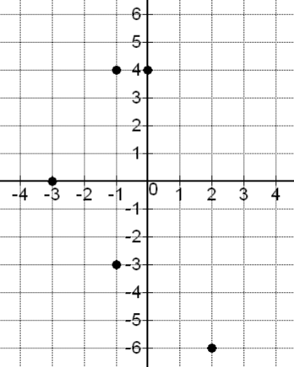

x-intercept: (-3, 0)

y-intercept: (0, 4)

(2, -6) : Quadrant 4

(-1, 4) : Quadrant 2

(-1, -3) Quadrant 3

3.

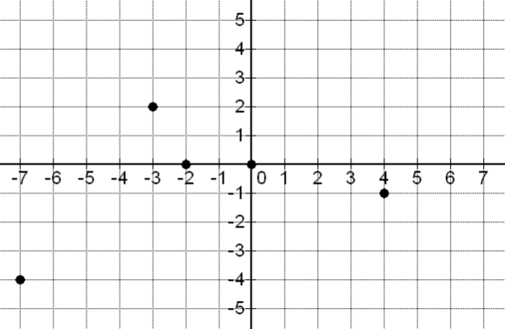

x-intercept: (-2, 0), (0, 0)

y-intercept: (0, 0)

(-3, 2): Quadrant 2

(-7, -4): Quadrant 3

(4, -1): Quadrant 4

7.

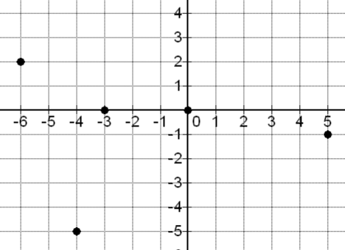

x-intercept: (-3, 0), (0, 0)

y-intercept: (0, 0)

(-6, 2): Quadrant 2

(-4, -5): Quadrant 3

(5, -1): Quadrant 4

5.

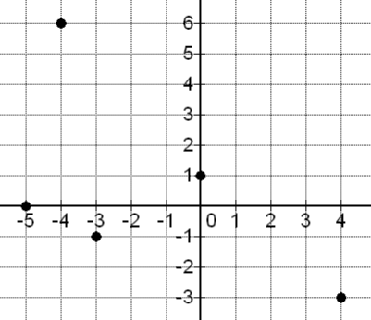

x-intercept: (-5, 0)

y-intercept: (0, 1)

(-3, -1): Quadrant 3

(4, -3): Quadrant 4

(-4, 6): Quadrant 2

11.

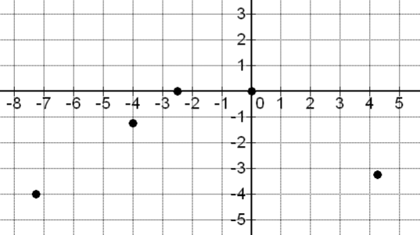

x-intercept: (-2.5, 0), (0, 0)

y-intercept: (0, 0)

(-4, -1.25): Quadrant 3

(-7.25,-4): Quadrant 3

(4.25, -3.25): Quadrant 4

9.

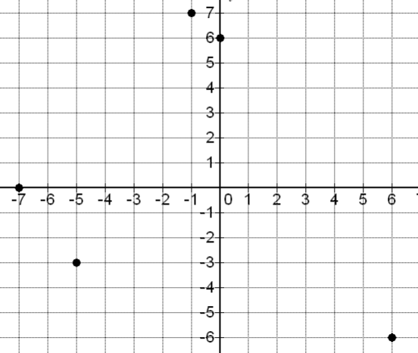

x-intercept: (-7, 0)

y-intercept: (0, 6)

(6, -6): Quadrant 4

(-1, 7): Quadrant 2

(-5, -3): Quadrant 3

13. a) From the top-left,

(0 , 24), (1, 22), (2, 21), (3, 19), (4, 18), (6, 17), (7, 16),   
 (9, 13), (10, 10), (11, 7), (12, 6), (14, 3), (16,0)

The x-intercept is (16,0) . The y-intercept is (0, 24).

b) Yes, the points seem to be close to a line that goes down from the left to right.

c) Decreases

d) Increases

**7B**

|  |  |  |  |  |  |  |  |  |  |
| --- | --- | --- | --- | --- | --- | --- | --- | --- | --- |
| 1. | 2 | 3. | $\frac{1}{5}$ | 5. | undefined |  |  |  |  |

9.

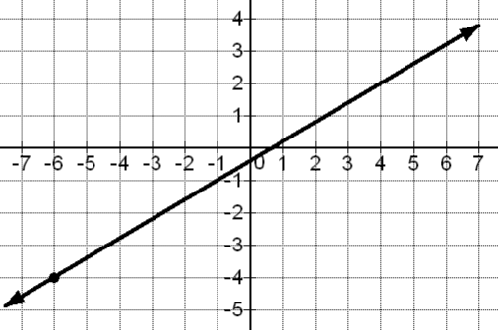

7.

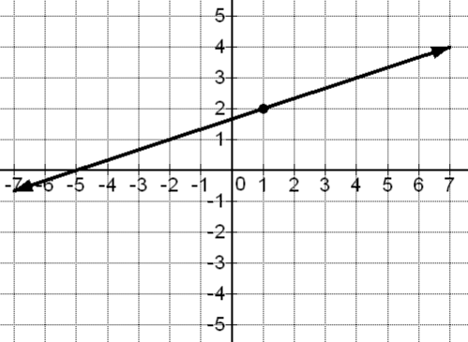

13.

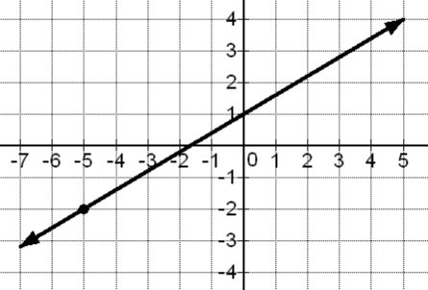

11.

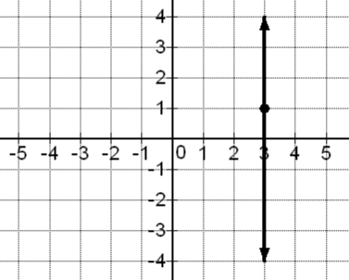

15.

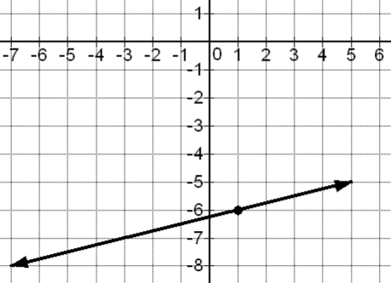

17.

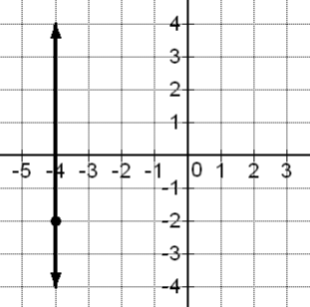

|  |  |  |  |  |  |  |  |  |  |
| --- | --- | --- | --- | --- | --- | --- | --- | --- | --- |
| 19. | $-1\frac{1}{2}$ | 21. | – 4 | 23. | 0 | 25. | $$\frac{1}{11.6} or \frac{5}{58}$$ |  |  |
| 27. | parallel: -13, perpendicular: $\frac{1}{13}$ | | | 29. | parallel: 6, perpendicular: $-\frac{1}{6}$ | | |  |  |
| 31. | parallel: -9, perpendicular: $\frac{1}{9}$ | | | 33. | (2, 62), (10, 67), slope = $\frac{5}{8}$ or $\frac{0.625 thous\$}{1 year}$ | | | | |
| 35. | (9, 85), (23, 15), slope = -5 or | | | | |  |  |  |  |

37. A 39. C

**7C**

3.

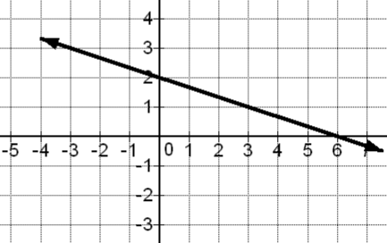

$y=-\frac{1}{3}x+2$

1.

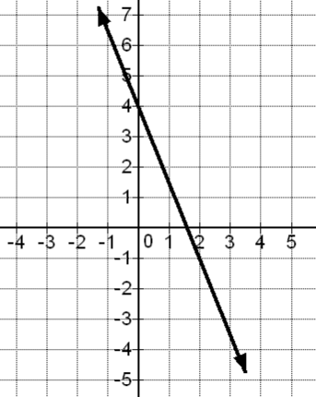

$y=-\frac{5}{2}x+4$

|  |  |  |  |  |  |  |  |
| --- | --- | --- | --- | --- | --- | --- | --- |
| 5. | $y=2x-1$ | 7. | $y=x-3$ | 9. | $y=5x-48$ | 11. | $$y=-6x-64$$ |
| 13. | $y=12x-275$ | 15. | $y=-6x-39$ | 17. | $y=-4x+12$ | 19. | $y=-x+7.7$ |
| 21. | $y=-5x-13$ | 23. | $y=1\frac{1}{3}x+23$ | 25. | $y=-\frac{1}{8}x-9\frac{3}{8}$ | 27. | $x=-9$ |
| 28. | $y=5$ | 29. | $y=7$ | 30. | $x=13$ | 31. | $y=-12$ |
| 32. | $x=-4$ |  |  |  |  |  |  |

35.

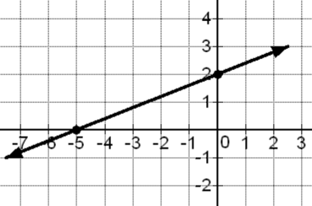

x-intercept = (-5,0)  
y-intercept = (0 , 2)  
Slope = $\frac{2}{5}$

Equation: $y=\frac{2}{5}x+2$

33.

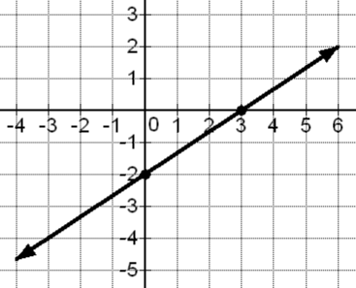

x-intercept = (3,0)  
y-intercept = (0,-2)  
Slope = $\frac{2}{3}$

Equation: $y=\frac{2}{3}x-2$

|  |  |  |  |
| --- | --- | --- | --- |
| 37. | a) $y=800x+44600$ b) $53,400 | 39. | a) $y=2x+32$ b) $128 |
| 41. | a) $y=\frac{5}{8}x+60\frac{3}{4}$ or $y=0.625x+60.75$ b) 73.25 thousand dollars or $ 73,250 | | |

**Section 7D** *(No Answer Key Available)*

**Chapter 7 Review**

1. Point (2,0) is an x-intercept, (0,-3) is a y – intercept.

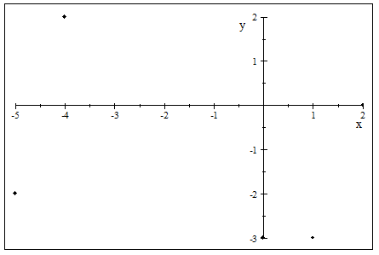

3. Point (-4.5,0) is an x-intercept, (0,2.5) is a y – intercept.

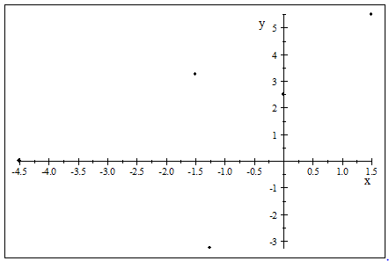

5. 7.

9. 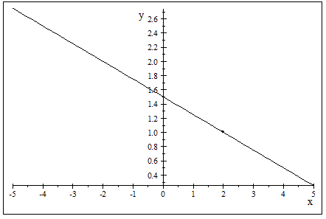

11. 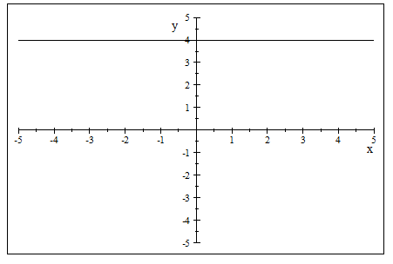

13. 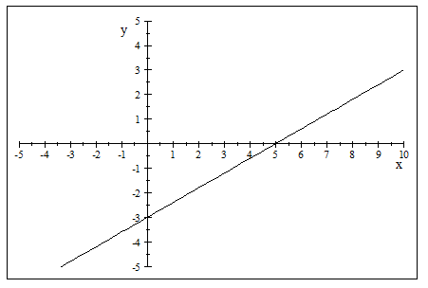

15. 17. 19.

21.

23. 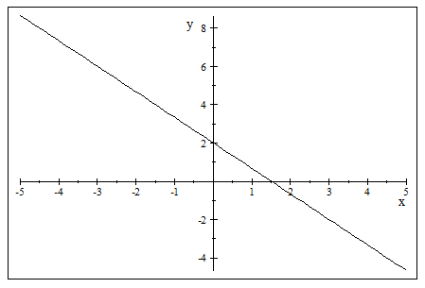

25. 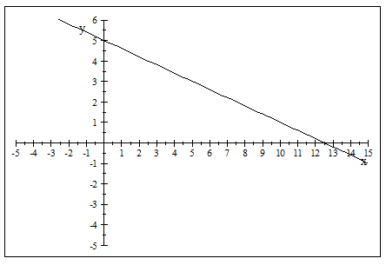

27. 29. 31. 33.

35. 37. 39. 41.

43. (a) ; (b) ;

For every month, the company’s profit is predicted to increase, on average, by $200.

(c) $(0 , 31600)$;

In month zero, the company is predicted to make a profit of $31,600

(d) $34,200

45. Infinitely many solutions. (Dependent)

47.

49. Infinitely many solutions. (Dependent) 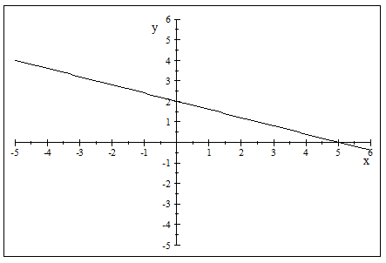

51. 53. No solution. (Inconsistent)