GRADING RUBRIC PROJECT#3 REPORT (100 points total)
- Name, project title, & section number (1 point)
- Anti-cheating statement (1 point)
- StatKey Graphs (3 points each)
Categorical Data Summary Statistics (counts and proportions)
Histogram of Quantitative Data (Should have 5 bars to determine shape of quantitative data.)
Quantitative Data Summary Statistics (Showing sample size, mean, standard deviation, etc.)
T-distribution with two-tail Critical Values and degrees of freedom.
- Confidence Interval and Margin of Error Interpretation Sentences (3 points each)
- Checking Conditions and Explaining Why. (2 points each)
- All Calculations (2 point each)
- All Other Questions (1 point each)
--------------------------------------------------------------------------------------------------------------------------------------------
NOTE: All of the graphs and summary statistics must NOT be too small. They must be readable. Without readable StatKey graphs and statistics, your instructor will NOT be able to grade your project!
CONFIDENCE INTERVAL PROJECT: Answer the following questions. This is what you will turn in to your instructor to be graded. There are 100 points possible.
Put your name, title, and cheating statement at the top of your report.
First and Last Name
Intro Stats Confidence Interval Project
Instructor’s Name
Section# for your class
Semester and Year
Confirm that you did not cheat. If true, write the following:
I did not cheat on this project. I did the work myself. I did not use any AI like ChatGPT on this project. No one else did this work for me.
PROJECT PART 1: ONE-POPULATION PROPORTION (%) CONFIDENCE INTERVAL DIRECTIONS
Put the categorical column of data (column of words) assigned to you into StatKey.
- Go to www.lock5stat.com, click on “StatKey”, and then click on “One Categorical Variable” under the descriptive statistics and graphs menu.
- Click the “Edit Data” button. Push Control A and delete to delete out any data listed.
- Highlight your assigned column of categorical (words) data. Then push “control C” to copy. Or you can right-click and copy.
- Go back to the edit data screen in StatKey, and paste the assigned column of categorical data into StatKey. This is raw categorical data, so you will need to check the box that says “raw data”. If you have the title, check the box that says “Data has a header row”. If you do not have the column title, do not check that box that says “Data has a header row”. Then push the “OK” button.

- You should now see a bar chart and the summary statistics with the counts and proportions for each category. Take a picture of the categorical summary statistics. Do not make the picture too small. Make sure the statistics and categories are readable.
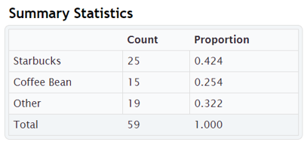
PART 1 QUESTIONS: ONE-POPULATION PROPORTION (%) CONFIDENCE INTERVAL.
- What was the categorical data (column of words) assigned to you? (Example: My categorical data was random sample of COC stat students favorite coffee shop.)
- Show the StatKey summary statistics picture for your assigned categorical data.
- Pick one category from the categorical data assigned to you. (Example: I am interested in COC stat students that prefer Starbucks.)
- What is count and total (n) for the category you picked from the data assigned to you. (Example: The count for COC stat students in the data that prefer Starbucks is 25 and the total sample size is 59.)
- Does the category you picked from the data assigned to you pass the at least ten successes condition. Explain why. (Example: Data passes the at least ten successes condition because there were 25 COC stat students in the data that prefer Starbucks.)
- Does the category you picked from the data assigned to you pass the at least ten failures condition. Explain why. (Example: Data passes the at least ten failures condition because there were 59 – 25 = 34 COC stat students in the data that do not prefer Starbucks.)
- The categorical data assigned to you passes the random and independent conditions. Does the data pass all of the conditions for a one-population proportion confidence interval? Explain why. (Explain: The data passes all of the conditions since it is random, independent, and has at least ten successes (25) and failures (34).)
- What is the sample proportion ($\hat{p}$) listed in the StatKey Summary Statistics for the category you picked in the data assigned to you. (Example: The sample proportion for COC Stat Students in the data that prefer Starbucks was 0.424)
- Calculate the standard error for the confidence interval using the formula.
Example Standard Error = $\sqrt{\frac{\hat{p}×\left(1-\hat{p}\right)}{n}}$ = $\sqrt{(0.424×(1-0.424)÷59})≈$ 0.0865514

- For a 95% confidence level, we will use the critical value Z-score = 1.96
Calculate the margin of error by multiplying your standard error by 1.96 and round your answer to the thousandths place (three places to the right of the decimal).
Example Margin of Error = $Z_{c}×$ Standard Error $≈$ 1.96 $×$ 0.0865514 $≈$ 0.170
- Write a sentence explaining the meaning of the margin of error. (Example: The sample proportion for COC Stat Students in the data that prefer Starbucks could be of as much as 0.170 (17.0%) from the population proportion.)
- Use the sample proportion ($\hat{p}$) and the margin of error to calculate the confidence interval lower limit.
Example Lower Limit = Sample Proportion – Margin of Error $≈$ 0.424 – 0.170 $≈$ 0.254
- Convert your Lower Limit into a percentage. (Example: 0.254 $×$ 100% $≈$ 25.4%)
- Use the sample proportion ($\hat{p}$) and the margin of error to calculate the confidence interval upper limit.
Example Upper Limit = Sample Proportion + Margin of Error $≈$ 0.424 + 0.170 $≈$ 0.594
- Convert your Upper limit into a percentage. (Example: 0.594 $×$ 100% $≈$ 59.4%)
- Your population is all COC Stat Students and you used a 95% confidence level. Write the confidence interval sentence to explain what your confidence interval says about the population percentage.
(Example: I am 95% confident that the population percentage of COC stat students that prefer Starbucks is between 25.4% and 59.4%.)

PART 2 QUESTIONS: TWO-POPULATION PROPORTION (%) CONFIDENCE INTERVAL.
- Pick two categories you from the categorical data assigned to you. (Example: I am interested in comparing the percentage COC stat students that prefer Starbucks and and the percentage of COC stat students that prefer Coffee Bean.)
- What are the counts and total (n) for the two categories you picked from the data assigned to you. (Example: The count for COC stat students in the data that prefer Starbucks was 25. The count for COC stat students in the data that prefer Coffee Bean is 15. The total sample size is 59.)
- Do the two categories you picked from the data assigned to you pass the at least ten successes condition. Explain why. (Example: Data passes the at least ten successes condition because there are 25 COC stat students in the data that prefer Starbucks and 15 that prefer Coffee Bean. Both were larger than ten.)
- Do the two categories you picked from the data assigned to you pass the at least ten failures condition. Explain why. (Example: Data passes the at least ten failures condition because there are 59 – 25 = 34 COC stat students in the data that do not prefer Starbucks and there are 59 – 15 = 44 that prefer Coffee Bean. Both are larger than ten.)
- The categorical data assigned to you passes the random and independent conditions. Does the data pass all of the conditions for a one-population proportion confidence interval? Explain why. (Explain: Both samples pass all of the conditions since they are random, independent, and have at least ten successes (25 & 15) and at least ten failures (34 & 44).)
- What are the two sample proportions (${\hat{p}}_{1} \& {\hat{p}}_{2}$) listed in the StatKey Summary Statistics for the two categories you picked from the data assigned to you. (Example: The sample proportion of COC stat students in the data the prefer Starbucks is 0.424 and the sample proportion of COC stat students in the data that prefer Coffee Bean is 0.254)
- What is population 1 and what is population 2?
Example Population 1: All COC stat students that prefer Starbucks.
Example Population 2: All COC stat students that prefer Coffee Bean.

- Calculate the difference between the sample proportions (${\hat{p}}_{1}-{\hat{p}}_{2}$).
Example: Proportion Difference = 0.424 – 0.254 = 0.170

- Calculate the standard error for the confidence interval using the formula.
Example Standard Error = $\sqrt{\left[\left(\frac{{\hat{p}}_{1}×\left(1-{\hat{p}}_{1}\right)}{n_{1}}\right)+\left(\frac{{\hat{p}}_{2}×\left(1-{\hat{p}}_{2}\right)}{n_{2}}\right)\right]}$
= $\sqrt{(\left(0.424×\left(1-0.424\right)÷59\right)+\left(0.254×\left(1-0.254\right)÷59\right))}≈$ 0.085737874

- For a 95% confidence level, we will use the critical value Z-score = 1.96
Calculate the margin of error by multiplying your standard error by 1.96 and round your answer to the thousandths place (three places to the right of the decimal).
Example Margin of Error = $Z_{c}×$ Standard Error $≈$ 1.96 $×$ 0.085737874 $≈$ 0.168
- Write a sentence explaining the meaning of the margin of error. (Example: The sample proportion difference between COC stat students in the data that prefer Starbucks and COC stat students in the data that prefer Coffee Bean could be of as much as 0.168 (16.8%) from the population proportion difference.)
- Use the difference between the sample proportions (${\hat{p}}_{1}-{\hat{p}}_{2}$) and the margin of error to calculate the confidence interval lower limit.
Example Lower Limit = Sample Proportion Difference – Margin of Error $≈$ 0.170 – 0.168 $≈$ +0.002
- Convert your Lower Limit into a percentage. (Example: 0.002 $×$ 100% $≈$ 0.2%)
- Use the difference between the sample proportions (${\hat{p}}_{1}-{\hat{p}}_{2}$).and the margin of error to calculate the confidence interval upper limit.
Example Upper Limit = Sample Proportion Difference + Margin of Error $≈$ 0.170 + 0.168 $≈$ +0.338
- Convert your Upper limit into a percentage. (Example: 0.338 $×$ 100% $≈$ 33.8%)
- Are your lower and upper limits both negative, both positive, or have opposite signs? What does this tell us about the populations? Remember (+,+) means that population 1 is higher than population 2, (-,-) means that population 1 is lower than population 2, and (-,+) means that population 1 and population 2 are not significantly different. (Example: The lower and upper limits are both positive. This tells us that population 1 (COC stat students that prefer Starbucks) is significantly higher than population 2 (COC stat students that prefer Coffee Bean).)
- Your population is all COC stat students and you used a 95% confidence level. Use the two-population confidence interval sign rules to write the confidence interval sentence to explain your confidence interval in context. (Example: I am 95% confident that the population percentage of COC stat students that prefer Starbucks is between 0.2% and 33.8% higher than those that prefer Coffee Bean.)
PART 3: ONE-POPULATION MEAN AVERAGE CONFIDENCE INTERVAL DIRECTIONS
Put the quantitative column of data assigned to you (column of numbers) into StatKey.
- Go to www.lock5stat.com, click on “StatKey”, and then click on “One Quantitative Variable” under the descriptive statistics and graphs menu.
- Click the “Edit Data” button. Push Control A and then delete to delete out any data listed.
- Go back to your Excel or Tables spreadsheet. Highlight your assigned column of quantitative (numerical measurement) data. Then push “control C” to copy. Or you can right-click and copy.
- Go back to the edit data screen in StatKey, and paste the assigned column of quantitative data into StatKey. This is one column of numerical data, so you do not have an “identifier” column. Make sure the box that says “First Column is Identifier” is not checked. If you have the title, check the box that says “Data has a header row”. If you do not have the column title, do not check that box that says “Data has a header row”. Then push the “OK” button.
- Click on the “Histogram” button. Use the slider on the bottom right to change the number of buckets (bars) to 5 bars. You may need to keep sliding the buckets slider back and forth. Make sure your histogram has 5 bars. Take a picture of your histogram.
- Next to the Histogram you will see the quantitative summary statistics window with the mean, standard deviation, and sample size. Take a picture of the quantitative summary statistics window. Do not make the picture too small. Make sure all of the numbers are readable.
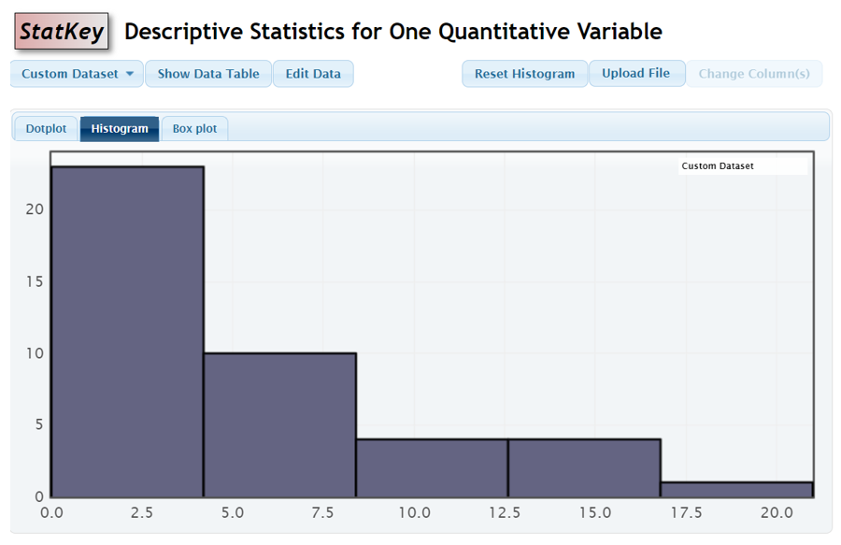

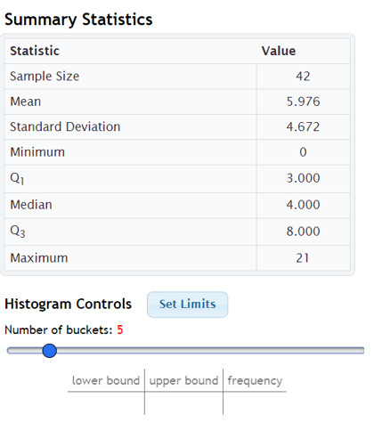
PART 3: ONE-POPULATION MEAN AVERAGE CONFIDENCE INTERVAL QUESTIONS TO ANSWER.
- What was the quantitative (numerical measurement) data assigned to you? (Example: The quantitative data is the number of exercise hours per week by a random sample of COC stat students.)
- What were the units of your quantitative data? (Example: Hours per week of exercise.)
- Show the StatKey 5-bar histogram for your quantitative data.
- What is the shape of your quantitative data, normal (close to bell shaped), skewed right (long right tail), or skewed left (long left tail)? (Example: The COC stat student exercise data was skewed right.)
- Show the StatKey picture showing your quantitative summary statistics.
- What is the sample size (n) for your quantitative data? (Example: The sample size (n) is 42.)
- Does the data pass the 30 or normal condition? Explain why. (Example: The sample size is 42, so even though the data is skewed right, the data passes the 30 or normal condition.)
- The sample data was collected randomly, so passes the random and independent conditions. Does the data pass all of the conditions for a mean average confidence interval? (Example: The data passes all of the conditions since it is random, independent, and passes the 30 or normal condition.
- Calculate your degrees of freedom (df = n – 1). (Example: Degrees of Freedom = 42 – 1 = 41.)
- Go to www.lock5stat.com and open Statkey. Under the Theoretical Distributions menu click on “t”. Type in your degrees of freedom and click OK. Then click on “Two-Tail”. Show the StatKey picture of the T-distribution.
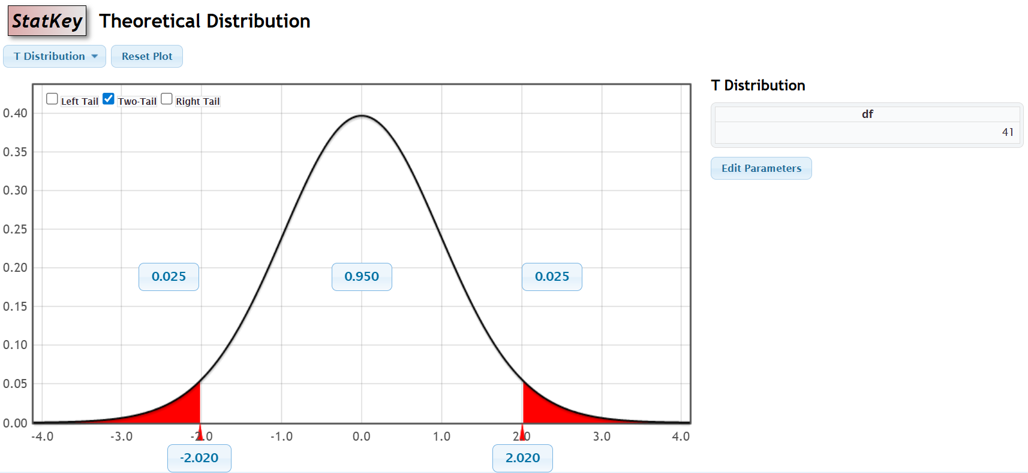
- What are the critical values located in the bottom boxes of the T-distribution? Example: The critical values are -2.020 and +0.020.
- What is the sample mean average ($\overline{x}$) for your quantitative data including the units? (Example: The sample mean average ($\overline{x}$) is 5.976 hours of exercise per week.)
- What is the sample standard deviation (s) for your quantitative data including the units? (Example: The sample standard deviation (s) is 4.672 hours of exercise per week.)
- Use the following formula to calculate the standard error including the units.
Example: Standard Error = $\frac{s}{\sqrt{n}}$ $≈$ 4.672 $÷$ $\sqrt{42}$ $≈$ 0.72090525 hours of exercise per week
- Use the positive critical value and standard error to calculate the margin of error including the units.
Example: Margin of Error = Critical Value $×$ Standard Error $≈$2.020 $×$ 0.72090525 $≈$ 1.456 hours of exercise per week.
- Write a sentence explaining the meaning of the margin of error in context. (Example: The sample mean average exercise per week by COC stat students could be off as much as 1.456 hours of exercise per week from the population mean average.

- Use the sample mean average ($\overline{x}$) and the margin of error to calculate the confidence interval lower limit. Include the units.
Example Lower Limit = Sample Mean Average – Margin of Error $≈$ 5.976 – 1.456 $≈$ 4.520 hours of exercise per week.

- Use the sample mean average ($\overline{x}$) and the margin of error to calculate the confidence interval upper limit. Include the units.
Example Lower Limit = Sample Mean Average + Margin of Error $≈$ 5.976 + 1.456 $≈$ 7.432 hours of exercise per week.

- Your population is all COC stat students and you used a 95% confidence level. Write the one-population mean average confidence interval sentence to explain what the confidence interval tells us about the population mean average. (Example: I am 95% confident that the population mean average amount of exercise per week for COC stat students is between 4.520 hours per week and 7.432 hours per week.

